Week 3 : Reinforcement Questions

Qu 1:
Find one or more pictures of a vacuum tube and explain how it works.
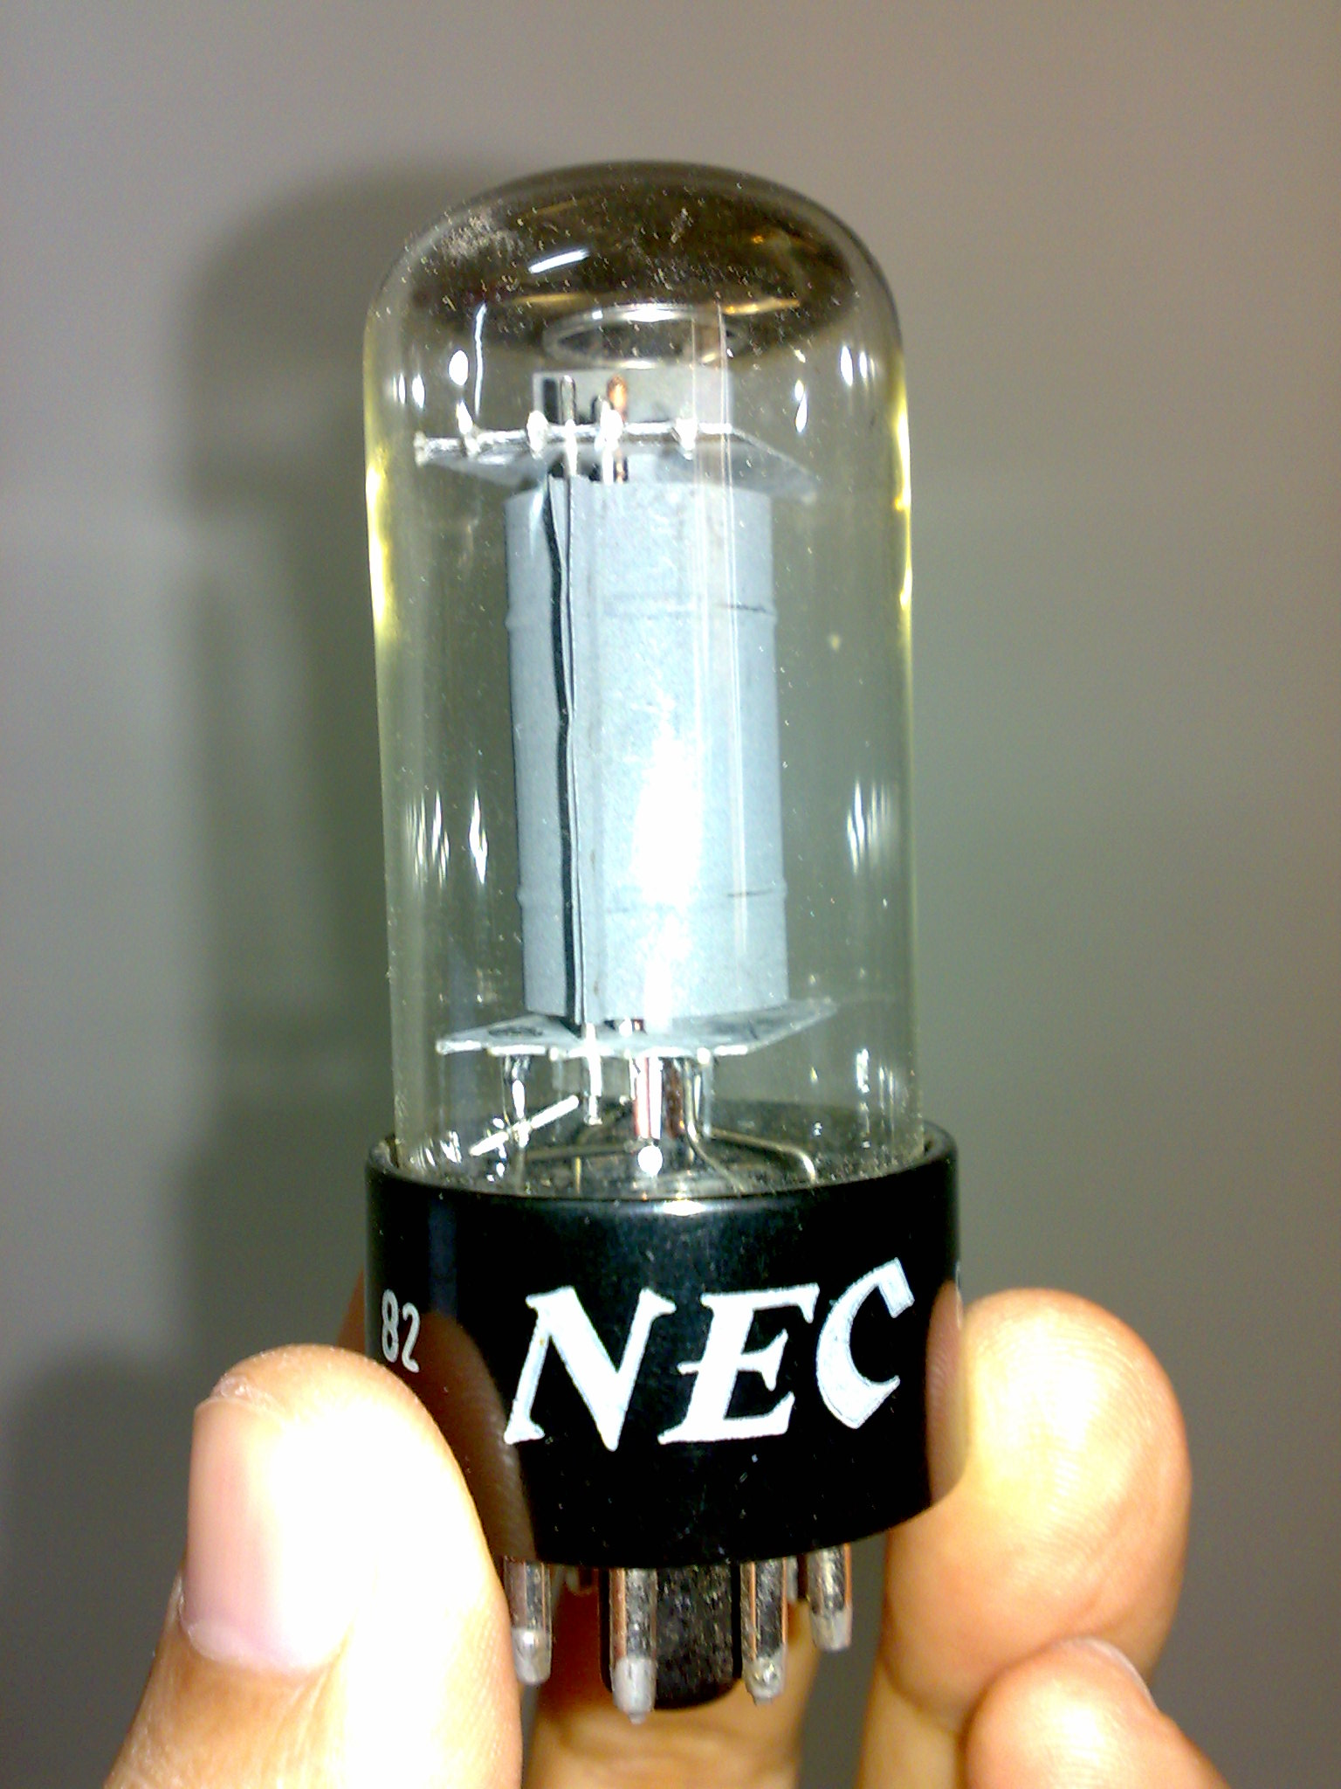
A vacuum tube consists of a glass tube containing a filament and an anode inside a vacuum. Electrons heat the filament, and flow through the vacuum onto the anode, which is made positive to attract electrons. A plate is placed between the filament and the anode, generating a DC current.
A vacuum tube can be used as an AC/DC converter, an amplifier, or an electronic switch, depending on the design of the plate inside the tube
A switch is useful for making computers. A switch is created by making the grid either positive or negative. If the grid is positive, current will flow towards the anode. If the grid is negative, current will flow back to the filament.

Qu 2:
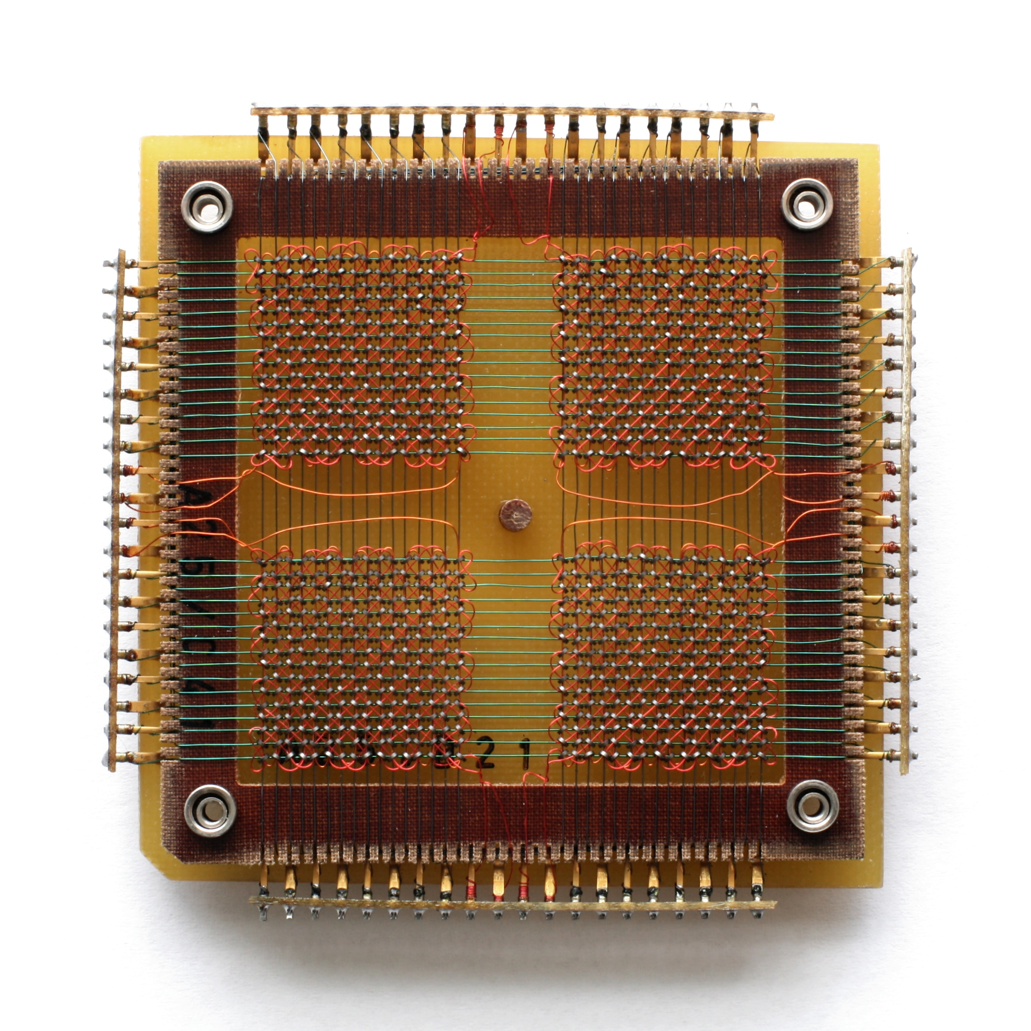
Find one or more pictures of a magnetic core and explain how it works
A magnetic core was used in a computer to store data and form a memory. Memory would consist of thousands of magnetic rings (cores), with wires run through the middle of them. By running the current through particular wires, cores could be magnetized either clockwise or anti-clockwise. One direction would represent a 1 and the other a 0. Another wire would be used to detect the orientation of a core, thus ‘reading’ the stored value. This reading process would reset the core to 0, so the reading is called destructive readout.

Qu 3:
Investigate the contributions of the following individuals to computer science and technology:
Charles Babbage
He described the first programmable computer in 1837. Babbage’s Analytical Engine could read in a simple program written on punched cards, which would then be processed by a mechanical calculator. The Engine could also store results by punching new cards. The Engine was never completed during Babbage’s lifetime.
Ada Lovelace
She is thought to be the first computer programmer. She documented how to use Babbage’s Analytical Engine, and wrote the first algorithm intended to be executed by it.
Tommy Flowers
He designed Colossus, the world’s first electronic programmable computer. Colossus was designed to break the codes of German radio transmissions during the Second World War. The mark I device used 1,500 vacuum tubes, and was first run in November 1943.
Alan Turing
He developed a formal definition of a general purpose computer – the Turing machine. Most modern computing languages must be ‘turing-complete’, meaning they fulfil a set of requirements set up by Turing, and that have been proved to allow the language in question to express any conceivable algorithm. He worked at Bletchley Park duing WW2, devising various ways to decrypt German ciphers. After the war he designed ACE, one of the first stored-program computers. He also devised the Turing test – a test of artificial intelligence that asks whether a listener could tell between the AI’s responses and those of a human.
Steve Wozniak
He desigend the first and second Apple personal computers – the Apple I (1976) and the Apple II (1977). The Apple Is were hand built by Wozniak. They shipped as fully assembled computers, while the majority of the competition arrived as kits that had to be assembled.
Paul Allen
He co-founded the Microsoft Corporation with Bill Gates in 1975. Allen supervised a deal to buy the QDOS operating system, which they then provided to IBM under a contract. This contract was the main source of Microsoft’s later success.

Qu 4:
Convert the following denary numbers into binary, octal and hexadecimal
A) 59
Binary: 111011
Octal: 73
Hex: 3B
B) 217
Binary: 11011001
Octal: 331
Hex: D9
C) 831
Binary: 1100111111
Octal: 1477
Hex: 33F

Qu 5: Convert the following binary numbers into decimal numbers.
(i) 110000111 = 391
(ii) 110011 = 51
(iii) 1001111 = 79
(iv) 11000001 = 193
(v) 1100110.1110 = 102.875

Qu 6. Convert the following octal numbers into decimal numbers.
- 175 = 125
- 54 = 44
- 567 = 375
- 701 = 449

Qu 7. Convert the following hexadecimal numbers into decimal numbers.
- E16 = 918
- 389 = 329
- 4AB = 427
- FF = 256

Qu 8. Perform the following binary additions
A. 11110 B. 100110 C. 101110
+ 1110 + 1101 + 101
101100 110011 110011
Qu 9. Perform the following binary multiplications
A. 11110 B. 100110 C. 101110
x 1110 x 1101 x 101
101100 111101110 10010110000

Qu 10: What is the denary value being stored in the 8 bit binary value 11111110 if the format of the data is
a) unsigned binary = 254
b) sign and magnitude = -126
c) 2's complement? = -2

Qu 11: Represent -77 in
a) sign and magnitude = 11001101
b) 2's complement = 10110011

Qu 12: a. convert the following address and the subnet mask (written in denary) into their equivalent binary bits
b. Perform bitwise logical AND between the two
c. Convert the answer to an address in denary

address: 140.179.240.200
subnet mask: 255.255.000.000

address: 10001100.10110011.11110000.11001000
subnet mask: 11111111.11111111.00000000.00000000
AND: 10001100.10110011.00000000.00000000
Address: 140.179.0.0

Qu 13:
If floating point numbers are represented according to the IEEE standard for 32-bit numbers with bits ordered sign bit most significant bit, exponent, and significand last, then work out the bit patterns for
-infinity: 1 11111111 00000000000000000000000
128: 0 10000110 00000000000000000000000
-0.625: 1 01111101 00000000000000000000000

Qu 14:
Identify the binary and hex representations of Y, z, and ? in ASCII

Qu 15:
Identify the infinity symbol and the Greek letter ∑ as Unicode

Qu 16:
Investigate the difference between .wav files and .mp3 files in terms of sound quality and file size

Qu 17:
Identify six raster/pixel mapped graphic formats and three vector graphics file formats

Qu 18:
Explain how run-length encoding works as a compression technique. Explain how run-length encoding could fail to compress an image.

Qu 19
Explain how RGB and HSB values are represented and what is the difference between the two schemes.

Qu 20
Explain the difference between lossless and lossy compression techniques.

