A2D: Re-imagining the pixel

The idea
I ran on the “Custom Pixel” theme, putting myself in the shoes of a mechanical inventor with no access to CRT/LED/Polarising displays. How would I make my own display without all of that modern technology?
My idea was to create a “Card Stunt” style of rendering pixels. We would have blank cards, and orient them towards 3 red, green and blue lights, with the angle of the card giving the card colour and the distance from the lights giving them brightness.
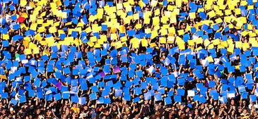
Figure 1 Card stunt
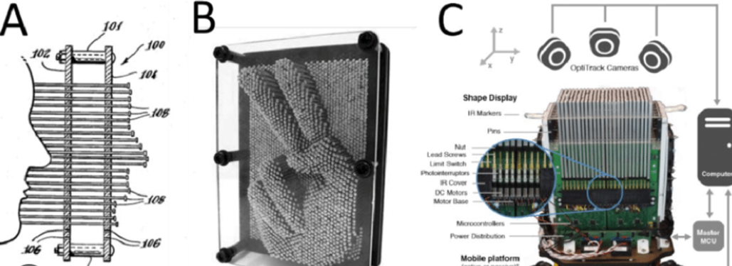
Figure 2 Mechanical Pincushion Device
This required using the 3d webgl mode of p5, something I had stumbled across and was curious about.
We could then use this to recreate images and maybe even videos. With the user being able to convert their own images to “cardStuntized” versions.

Implementation
I split implementation into three parts:
- Image processing
- Colour by angle
- Brightness by depth
- Video (stretch)

Image processing
Image processing was trivial, I only had to be able to average pixels to downsample it. I implemented a basic UI and found some good images for testing it out with.

Colour by angle
The harder part would be colour by angle, I wasn’t even sure this would work. P5 doesn’t “store” geometry the same way other 3D renderers do, everything is drawn fresh each frame. A lot of calculation was going to happen each frame, a lot of (simple quad mesh) generation etc. I was very concerned that trading off resolution and framerate would be an issue, and we wouldn’t even get an image out of it.
There was also the issue of rotations, 3D rotations are complicated things and I was aiming to do this without too much library fuss. I resorted to simple newtonian rotations (linear), which does make some panels rotate oddly (twisting on their z-axis) but is imperceptible on the final image.
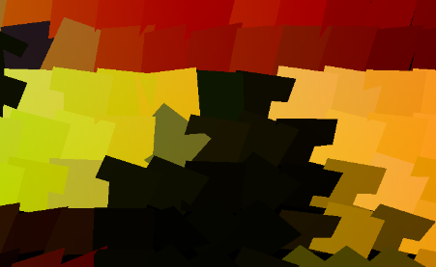
Figure 3 Planes at odd angles when zoomed in due to simplistic rotation logic
I also encountered issues with the images looking “speckly”, with black flecks showing through from the background. This was because as panels rotated their apparent width/height got smaller, showing gaps in the image. I fixed this by “oversizing” the panels, not a problem in a virtual world, but probably an issue if you wanted to make a device that did this for real!
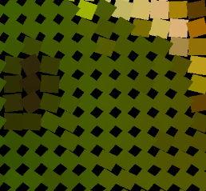
Figure 4 Gaps between panels (with overSize turned off)
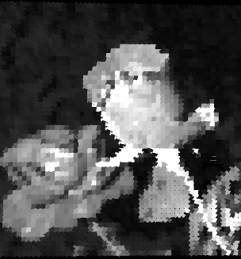
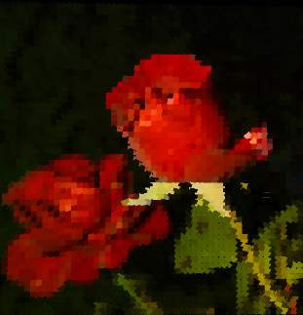
For this test I used panels that were still being “coloured” black and white
Developing this was far faster than I expected, p5 has material shaders already set up, rotations could be improved but still worked well without implementing quaternions.
Figure 5 Lights set to White, White, White (“Ambient”)
Figure 6 Lights set to RGB

Brightness by depth
Simply making the panels move backwards and forwards to control brightness was trivial, however there were some unexpected complications here:
Oversized panels meant that z-order mattered, I was essentially doing this “painter’s algorithm” style, and so distance pixels were now going to be partially hidden by closer (brighter ones).
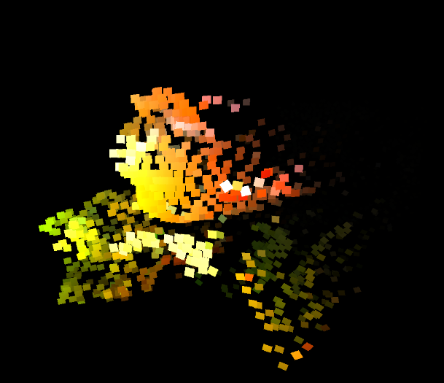
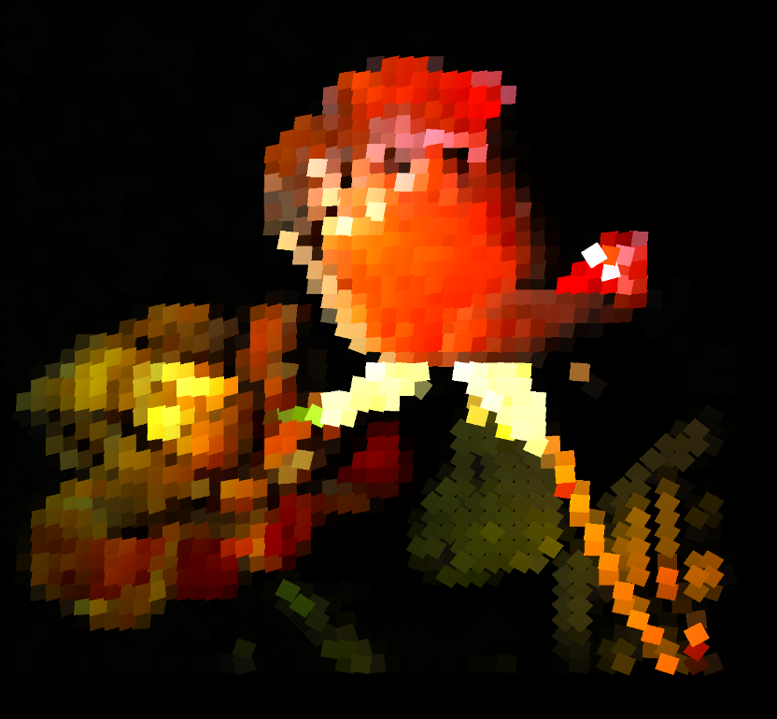
Colour separation became a concern far sooner than I expected. As the panel got further from the RGB lights the angular difference between the lights reduced. Each panel now had to rotate a different amount based on depth, and darker panels struggled to be lit properly. Computation snowballed and the image quality degraded.
Figure 7 The same image using brightness by depth at two different camera angles

Reflecting on implementation
Most of this went fairly well, I had to adapt to challenges as they arose, but as I was experimenting with a lot of new things I expected that. I was surprised at how fast the colour part of this came together, but that was countered by how challenging it was to get brightness by depth and colour working together!
I also made some of the material for the slides in P5 and was happy with how easy it was to make them. I’d like to incorporate this into other explainers, readmes etc for creating fast animations. There are aspects of it that are better than using e.g. AfterEffects (primarily how intuitive it is to simply put code portions into the explainers). This is probably the biggest strength of p5js in my view. I was also impressed by how easy it was to handle 3D and 2D canvases within the same sketch.
There were several areas that could’ve been improved. The plane angles should’ve been stored in an array (instead of calculated per frame), and lerping positions/orientations would’ve aided the demonstration by tying it to the physical basis (cards a
I used AI to create some of the more bulky UI elements for the explainer slides. It saved me time for those tedious UI sections, but I avoided using it for the main task. In reflection, this was the right call – the code produced by AI was a poorly organized big block of spaghetti. For anything more complex (or requiring ongoing maitenance) than a slideshow animation, this would have quickly become untenable.

