Einsteinium

Copyright 2013 by Brian Hill
Built for Haiku R1/Alpha4

Thank you for downloading Einsteinium. This installation package will install Einsteinium onto your Haiku system and configure Einsteinium to start automatically when Haiku boots.

Installation instructions:

To install Einsteinium, double click the Install.sh file. The prompt below will appear:

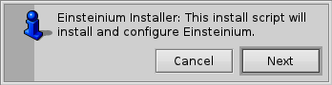
Click the “Next” button to start the Installation. You do have the option to cancel the install by clicking the “Cancel” button, which will display the following message and stop the install process:

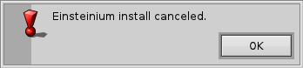
After clicking the “Next” button, this prompt will appear:

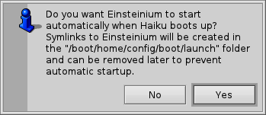
I recommend you click “Yes” to create symlinks in the “/boot/home/config/boot/launch” folder which will start Einsteinium automatically when Haiku boots. You can always remove these symlinks later if you do not wish to have Einsteinium start automatically. If you click “No”, then no symlinks will be created.

After clicking “Yes” or “No” the installation process is complete and this message will be displayed:

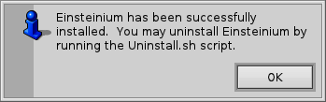
The Einsteinium Preferences application will be run automatically after install is complete, giving you a chance to poke around the settings. Be sure to read the ReadMe file for a full description of Einsteinium's features.

The Einsteinium application files as well as documentation and the Uninstall.sh script have been installed into /boot/apps/Einsteinium.

