Blender Animation

Production Diary

IMMERSIVE STUDIOS

ASSESSMENT 2

Xihao Chen | 30053752

2022

Table of Contents

Part 1 – Research and Identify 3D Software 2

Animation and 3D Model Choice 2

Research (Blender) 2

Research (Maya) 4

Part 3 - Prepare for Production 5

Reference Materials 5

12 Principles of Animation (Alan Becker) 5

Animating Run Cycles (Alan Becker) 5

Forward Roll Animation Reference 6

Part 4 – Animated 3D Model 7

References 8

# Part 1 – Research and Identify 3D Software

## Animation and 3D Model Choice

The animation will be a forward roll action with a 3D model of Patrick sourced from Brian’s “Character Development” class for implementation purposes.

Given the shape of the Patrick 3D model, the forward roll is based on a parkour roll where the weight of the character is transferred onto the character’s shoulder.

A follow-through animation in the form of a short run cycle will ensure a smooth transition between each roll the Patrick 3D model executes.

### Research (Blender)

Blender is a free, open source 3D creation suite with a focus on modelling, rigging, animation, rendering, compositing and more features.

The program’s application programming interface (API) is built from the Python 3.0 programming language, with C and C++ used for its internal functionality and engines respectively. Users may customise the program by writing code to fulfil specialised roles, often featuring in Blender’s future releases.

The animation and rigging features of Blender provides users with the ability to create dynamic animations. Along with its character pose animation editor, Blender includes support for nonlinear animation (for independent movements) and forward/inverse kinematics. The rigging tools include weight painting to fine-tune the armature weights on 3D models, bone groups to organise armature components and constraints with inherent properties for further control of animations.

#### Navigation

In Blender, the 3D viewport is a visual representation of assets in the working file. As projects may include 3D models and scenes spanning an extremely large area, the user can navigate the 3D viewport in 3D space via panning, zooming and rotating it.

* **Panning** involves the translation of the 3D viewport - The orientation of the viewport is unchanged but allows movement to see different parts of a scene from the same angle. A user may pan the viewport via holding **Shift** anddragging the mouse with the **Middle Mouse Button** (MMB) pressed.
* **Zooming** involves making the subject larger or smaller in the 3D viewport without moving the viewport forward, simulating a camera lens adjusting for wide, medium or close-up shots. A user may zoom in and out of the 3D viewport via holding **Ctrl** and dragging with **MMB** pressed down or scrolling the mouse wheel. An alternative navigation procedure is using the hotkeys **NumpadPlus** and **NumpadMinus** to zoom in/out respectively.
* **Rotating** involves manipulating the 3D viewport around the point of interest on a combination of the X, Y and X axis. A user may rotate the 3D viewport by dragging the mouse with **MMB** pressed down. Rotation is based on the current position of the viewport in relation to the assets.

#### Workflow Improvements

To improve workflow efficiency, users may press hotkeys, use alternative navigation procedures and input procedures while using Blender as shortcuts.

* An alternative navigation procedure for 3D viewport panning is using the hotkeys **Numpad 4, 8, 6, 2** for incremental panning steps in the respective direction.
* An alternative input for 3D viewport rotation is by using the hotkeys **Numpad** **1, 3 7** for the front, side and top views respectively. Holding **Ctrl** while pressing the Numpad hotkeys 3D viewport to the opposite view (e.g. **Ctrl** + **1** switches to the back view).
* Using **Shift** + **A** in edit mode opens the “Add” dropdown menu, which allows a user to quickly add meshes and other objects into the Blender scene.

### Research (Maya)

Autodesk Maya is an industry-standard 3D computer graphics software for creating realistic characters and special effects for video game, film and TV series projects.

The program displays a virtual workspace (scene) to the user, which may be saved in a variety of formats (e.g. the default file type is .mb). Maya features a node graph architecture where scene elements have its own node, complete with attributes and customisation. As such, a scene is based on a network of interconnecting nodes to produce a visual representation, with nodes sharing information.

Autodesk Maya features animation layers, similar to the layers system found in Photoshop. The layers act as non-destructive edits to add/blend multiple animations without destroying the original animation. Its usefulness provides animators with the ability to incremental changes on the fly without having to create multiple versions of the working file.

# Part 3 - Prepare for Production

## Reference Materials

### Diagram Description automatically generated12 Principles of Animation (Alan Becker)

The “12 Principles of Animation” video covers each of the 12 animation principles in a visual format. These principles are a fundamental aspect for animators to use for producing realistic animations. By applying these principles to the Blender animation, the 3D Patrick model will simulate physics, timing and the visual appeal of the forward roll animation in an accurate manner.

YouTube link: <https://www.youtube.com/watch?v=uDqjIdI4bF4>

### Text Description automatically generatedAnimating Run Cycles (Alan Becker)

Alan Becker’s “Animating Run Cycles” video details a visual breakdown of how run cycles are created in animation. It is a variation of his walk cycle video where minor adjustments were made to simulate running. The video will assist with applying a run cycle animation to the 3D Patrick model as the follow-through animation alongside the rolling animation.

YouTube link: <https://www.youtube.com/watch?v=jggdbxTJPG4>

### Forward Roll Animation Reference

The “Forward Roll Animation Reference” video is a motion reference for a forward roll action. The video will assist with the correct position of the Patrick 3D model armature points alongside the animation principles covered in the Alan Becker reference materials.

YouTube link: <https://www.youtube.com/watch?v=MWHP6Z5HRkU>

# Part 4 – Animated 3D Model

## Error Troubleshooting

An error I encountered while creating the 3D roll animation was the incorrect rotation of the 3D Patrick model. Instead of rotating a full 360 degrees at the end keyframes, the model rotated 180 degrees in reverse. After some unsuccessful attempts to correct the automatic reverse rotation, I referred to Stack Exchange and the Blender documentation for assistance.

I discovered that Blender automatically interpolates frames within a specific range, which caused the unexpected, reversed rotation behaviour. Adding intermediate keyframes before the middle of the roll animation solved the rotation issue, with the 3D Patrick model rotating a full 360 degrees as intended.

## Support Screenshots

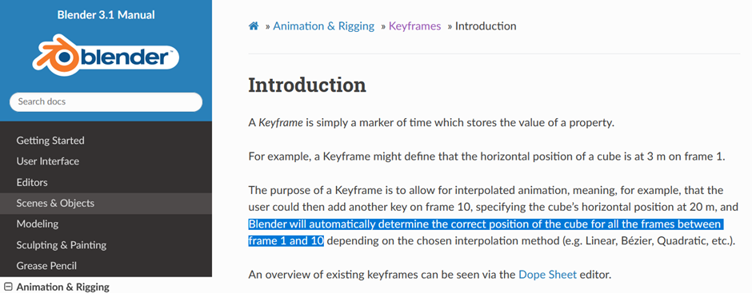

Figure 1 Blender documentation regarding automatic Interpolation of keyframes, which may cause unexpected behaviours.

Figure 2 User feedback regarding the rotation error, suggesting intermediate keyframes

# References

Becker, A. (2015, May 1). *ALAN BECKER - Animating Run Cycles*. Retrieved from YouTube: https://www.youtube.com/watch?v=jggdbxTJPG4

Becker, A. (2017, 31 May). *12 Principles of Animation (Official Full Series)*. Retrieved from YouTube: https://www.youtube.com/watch?v=uDqjIdI4bF4

Blender Foundation. (n.d.). *The Freedom to Create*. Retrieved from Blender: https://www.blender.org/about/

endlessreference. (2011, September 25). *Forward Roll: Athletic Male: Grid Overlay - Animation Reference Body Mechanics*. Retrieved from YouTube: https://www.youtube.com/watch?v=MWHP6Z5HRkU