Computer Networks

Software Defined Network (SDN) Mini Project Report

Name: Moorty Perepa

SRN: PES2UG24CS248

Section: E

Project Codebase (Screenshots)
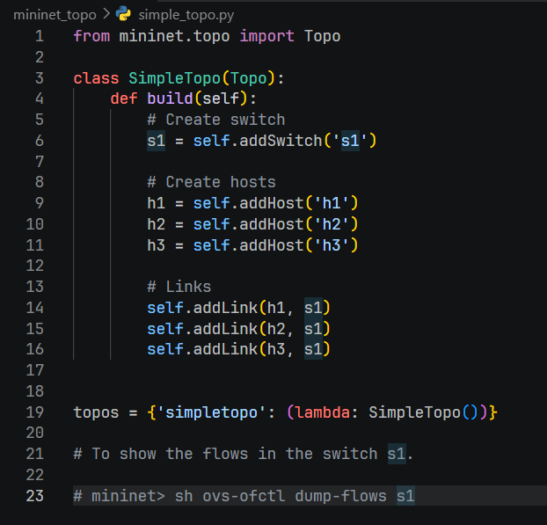
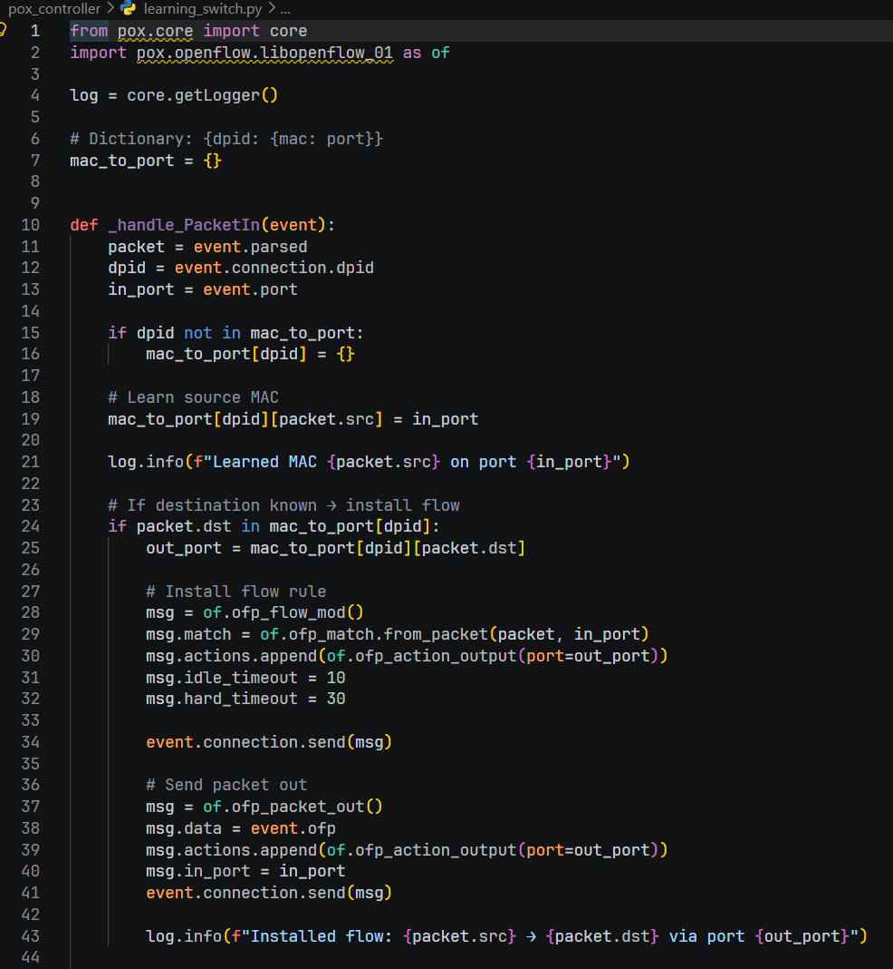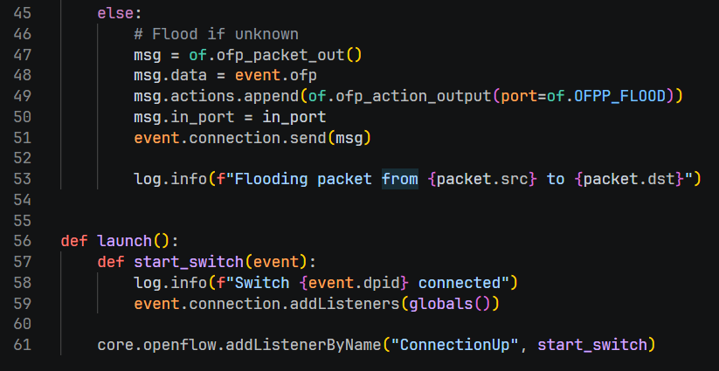
Output (Screenshots):

The End

