What I used during creation of the project:

Spring MVC, Security
PostgreSQL Database
Apache Tiles
Javax Mail
Hibernate Validator
CSS, JSP, HTML

Main Page:



Registration page:


I used Hibernate validator to validate login/password and made check for existing user.
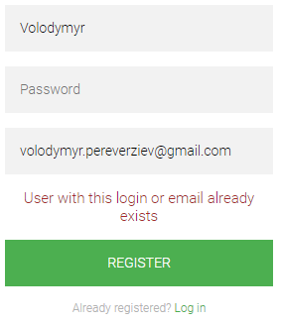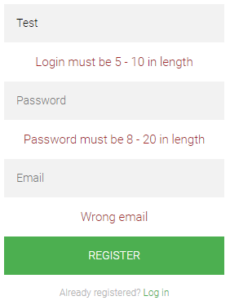
After successful registration your account is inactive, you can’t log in. It is mandatory to check your email and active your account via link you get.
ID is unique and made using UUID.

After that you are able to log in and change your password via form.
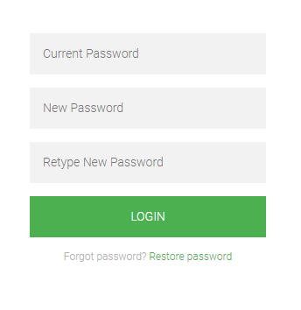

In case if you forgot your password, you can restore it.
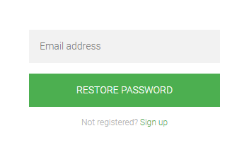
You get link with unique id where you can set your new password.
