## DriverPass System Diagrams and Technical Requirements

### UML Use Case Diagram

*[In Module Six, you were asked to complete a use case diagram based on your system design. If you would like to make any adjustments to your diagram, please do so. Please insert your use case diagram here. Check to make sure that you included appropriate components and symbols and that your design meets the client’s needs.]*

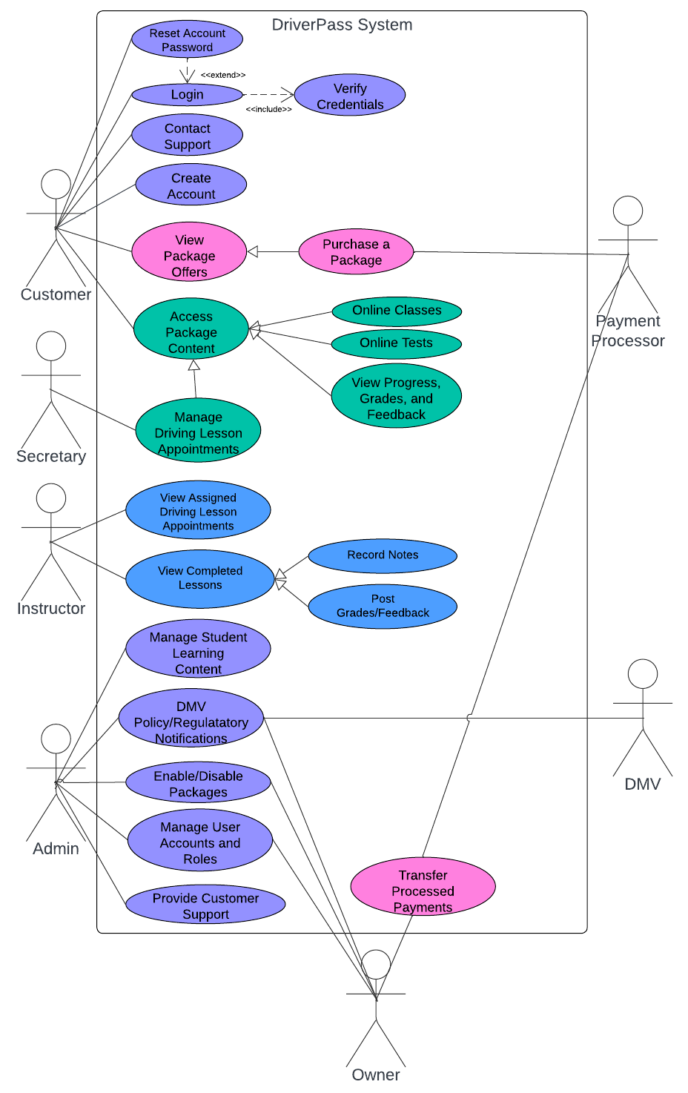

### UML Activity Diagrams

*[You were asked to choose* ***two*** *use cases and create* ***two*** *activity diagrams, one for each use case. Please insert* ***both*** *of your activity diagrams here. Check to make sure that you included appropriate components and symbols and that your design meets the client’s needs.]*

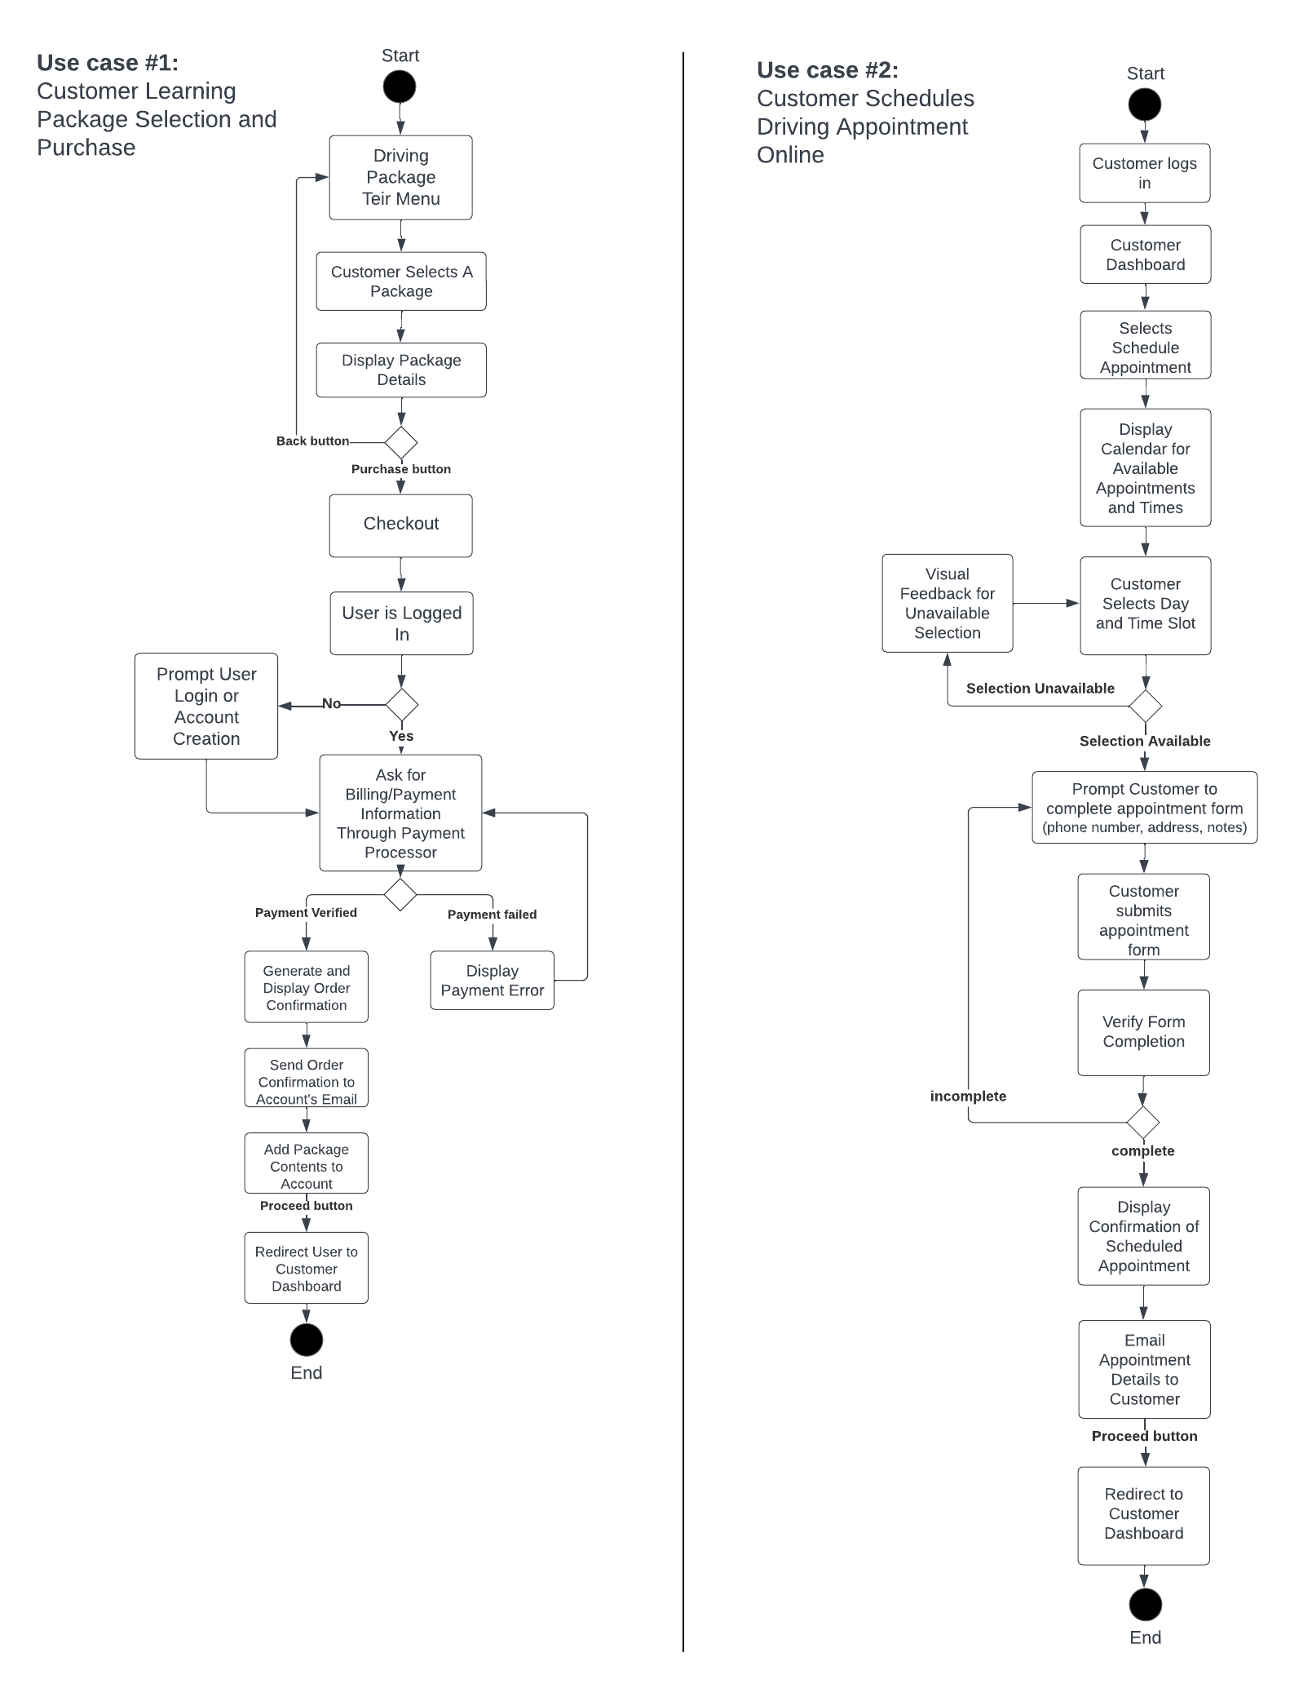

### UML Sequence Diagram Use case: Customer books Driving Lesson Appointment

*[You were asked to create a sequence diagram based on* ***one*** *of the use cases you chose. Please insert your sequence diagram here. Check to make sure that you included appropriate components and symbols and that your design meets the client’s needs.]*

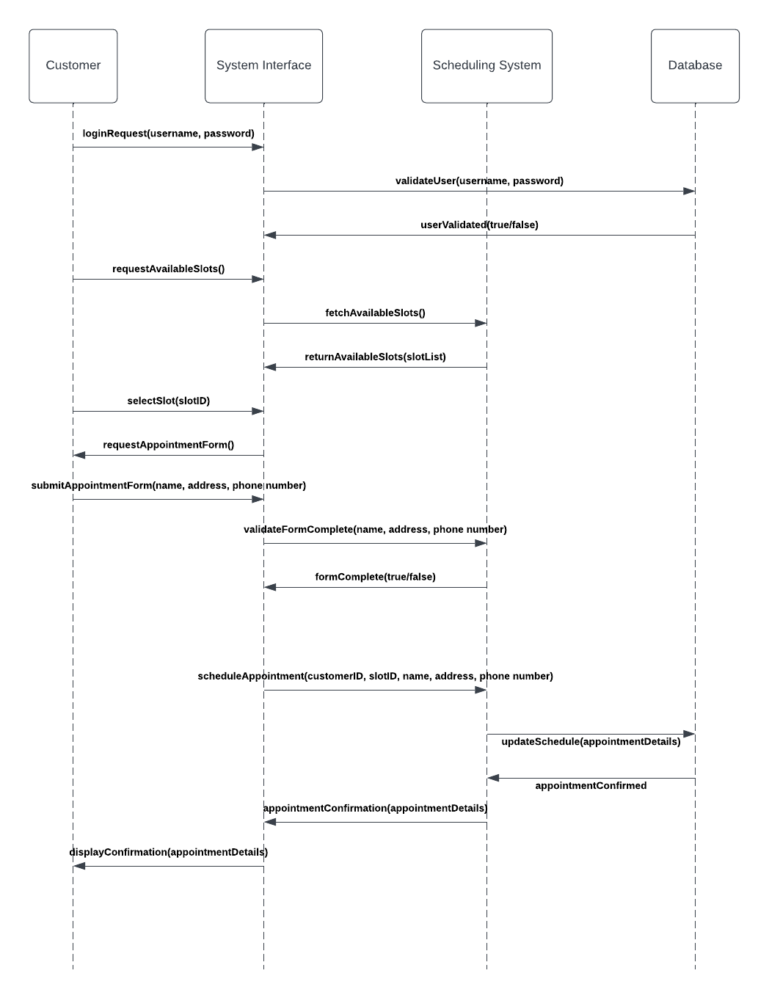

### UML Class Diagram

*[You were asked to create a class diagram based on the different classes and attributes needed for your system design. You are* ***not*** *required to include methods, but you may if you wish. Please insert your class diagram here. Check to make sure that you included appropriate components and symbols and that your design meets the client’s requirements.]*

## Technical Requirements

*[Based on the diagrams you have created, describe the technical requirements of your system. These requirements should address the required hardware, software, tools, and infrastructure necessary for your system design.]*

**Required Hardware**

* AWS Elastic Compute Cloud (EC2) for servers to ensure scalability.
* AWS Elastic Load Balancing to evenly distribute website traffic between EC2 instances.

**Software**

* Amazon RDS for database services with MySQL for data storage.
* AWS Lambda for serverless operations, such as automated email notifications for customer purchases/appointments.

**Tools**

* Amazon CloudWatch for monitoring, logging, and setting alarms on application and infrastructure performance.
* Use AWS Backup for centralized backup across AWS services, including EC2, RDS, and S3

**Infrastructure**

* AWS Identity and Access Management (IAM) for managing access to AWS services securely.