Future Tech Design: 7 Unbelievable Tech That Will Blow Your Mind

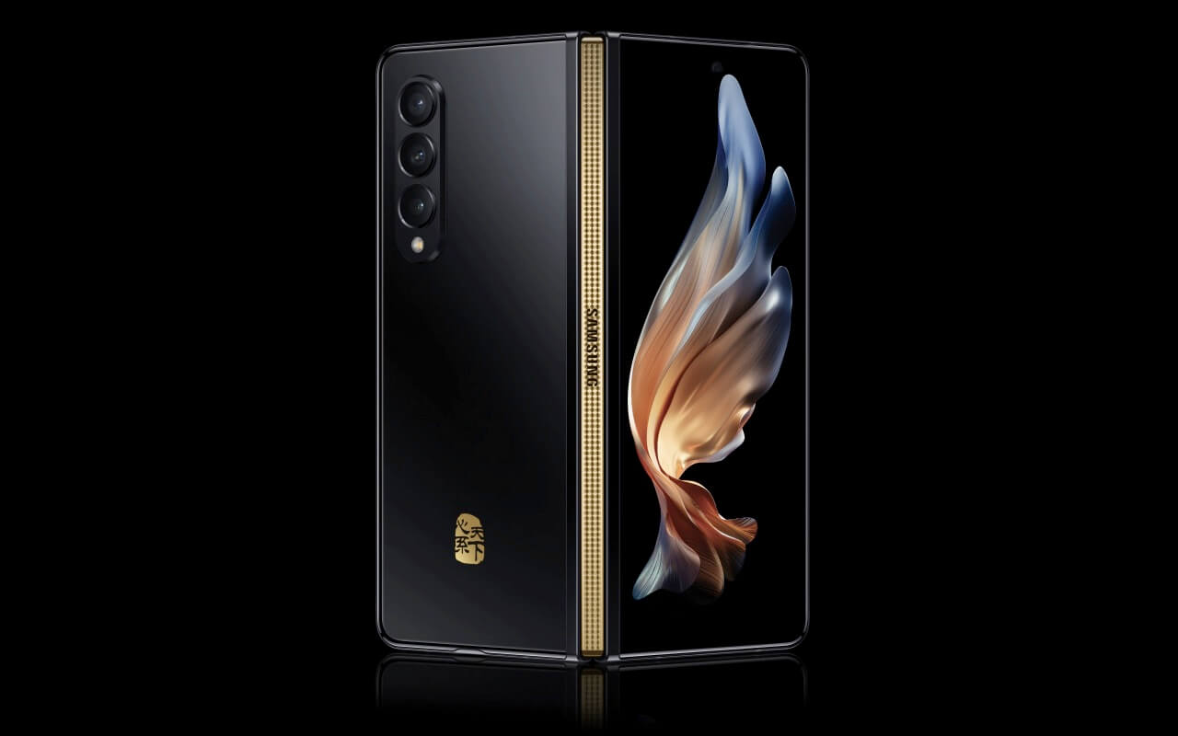

# Unbelievable Tech Design In Smartphones

Ten years ago. Samsung released a trailer of a concept folding smartphone. It was completely CGI. It looked like something out of a siphon movie. Like there was no way on earth that it was actually going to happen and yet I’m having right now holding a Samsung phone that is that, but even better. And so it's called me thinking. What's next? So I have scoured the web pouring through company documents, research, and patents that they filed to bring you the seven coolest smartphones and future tech designs that we know companies are actually working on behind the scenes. So numbers have and you've all seen foldable phones right now. They're all kind of the same from the outside, but what about five years down the line.

## Oppo Slide Phone

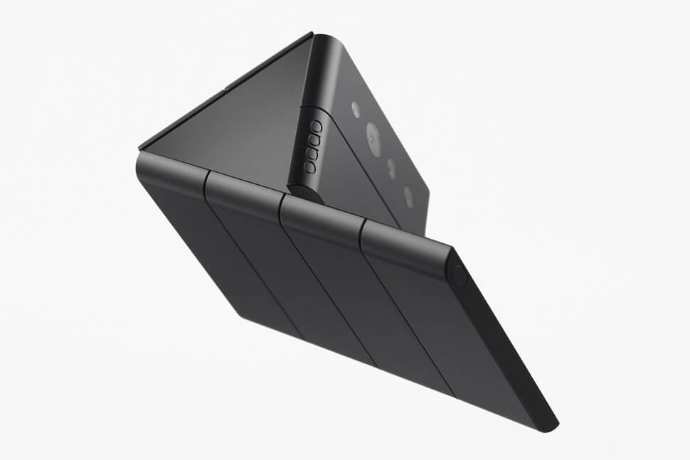

Well, oppo thinks that they have the answer with the slide phone. It's still affordable, but instead of being split into two sections, this thing is split into 8 and because the screen is flexible, you can fold it along any one of those sections. You can tell oppo, put a lot of thought into this. They even turned their rock patents into ailer and you can see in that trailer how it's small like a credit card when completely folded.

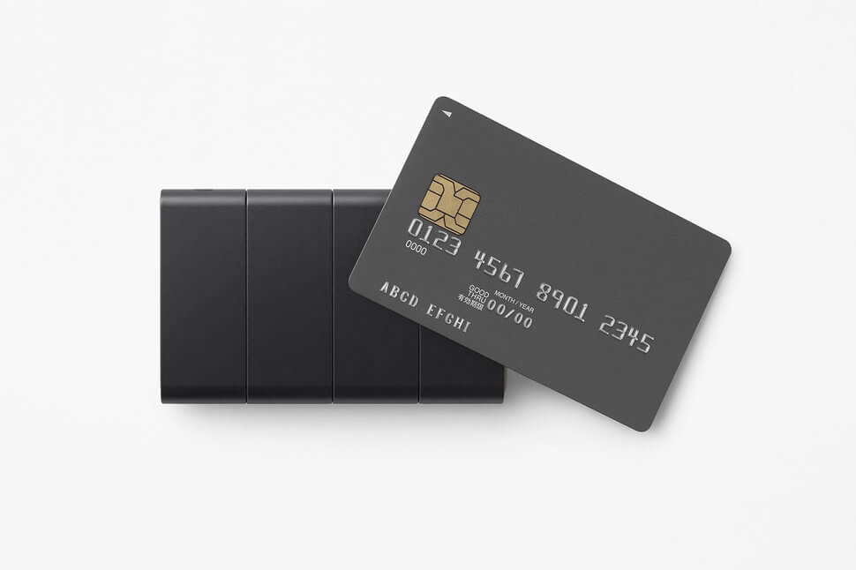

How if you unfold, say two sections can split off if you unfold some more. It makes the cameras face the front so you can take selfies and then how when it's completely unfolded. It is wide enough to be able to do three separate tests at once. I do have concerns like the fact that yes displays they are flexible. Batteries aren't are you going to split the battery into each separate miniature segments, but I do rate up over the out of the box thinking and I actually do think there is a reasonable chance of something like this does come to market in a few years.

## 6. Huawei 270 Degree Curve

Now another company that's almost famous for the thinking out of the box. And the last ten years, one of the key focus areas has been screen coverage. Their flagship phones were originally completely flat.

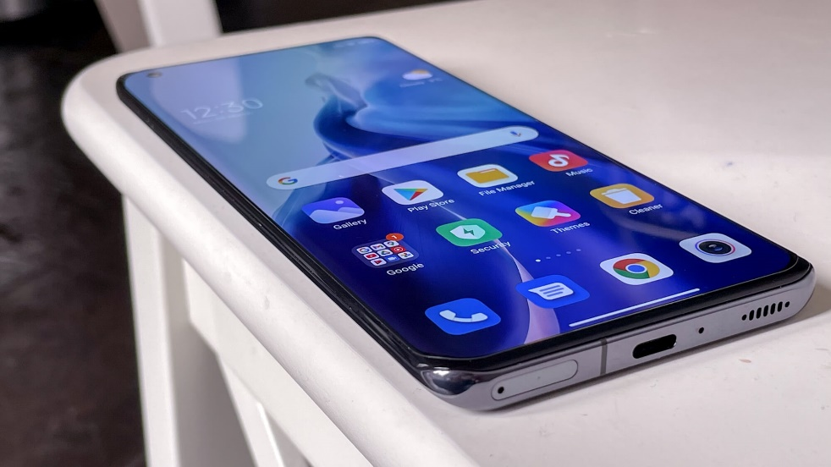

They then made them curved. They then made them super curved with their waterfall display technology and I found out that they're also testing the idea of an all round 270-degree curve head with an under-screen selfie camera to make the entire panel uninterrupted. It's called the art display and what did you get the concern of accidental screen touches on the sides if the company figures out how to eliminate them with intelligent software. I think the concept has enormous potential with the right quality of vibration motor. You can make digital buttons simulate the feeling of physical buttons and the benefit of them being digital is that they can change based on the app that you're in. You could have media and volume controls while you're watching videos.

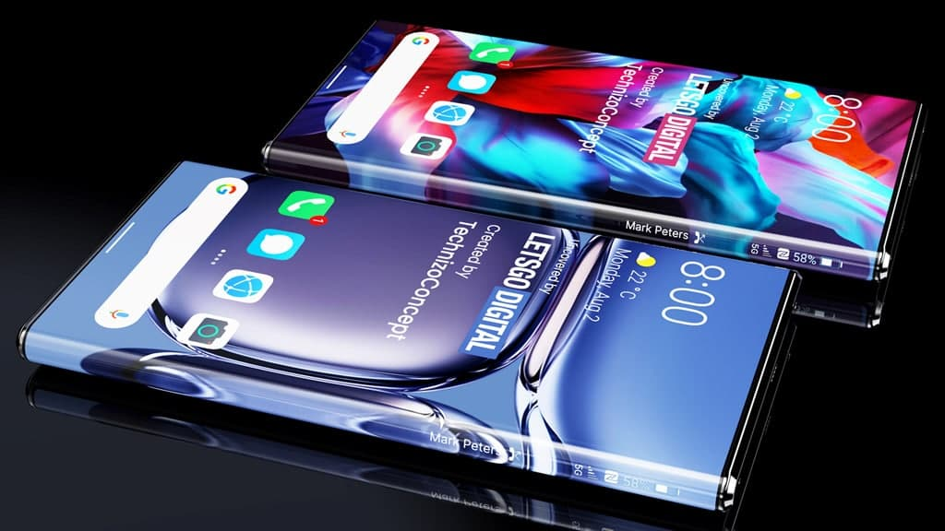

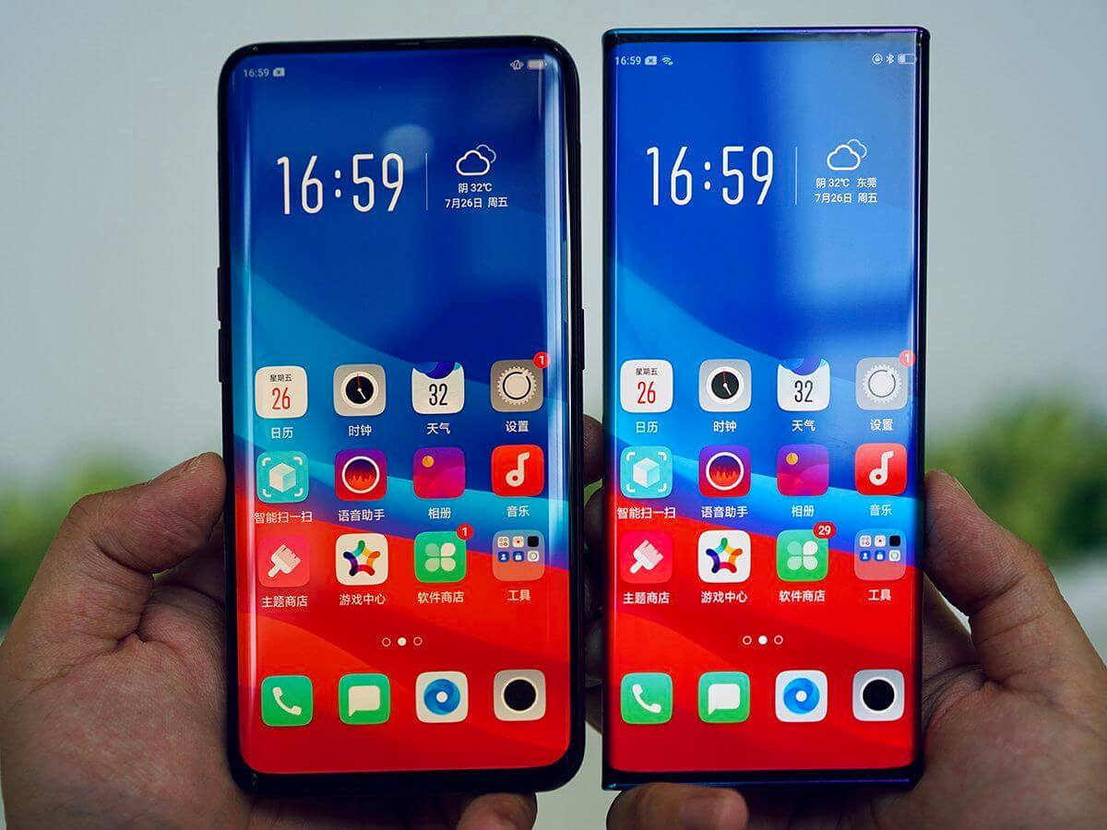

You could have shoulder buttons while you're playing games, you could have your notifications while the phone is in standby. The only slight killed joy here is the fact that this whole architecture sleeping is always patient and because the US banner has made it almost impossible for this company to do anything we got to wait for someone else to buy the patent before we can see anything come of it. But it gets crazier because behind closed doors.

## 5. Samsung Transparent Phone

Samsung is working on a transparent phone. I mean, companies have been trying to figure out this concept for decades.

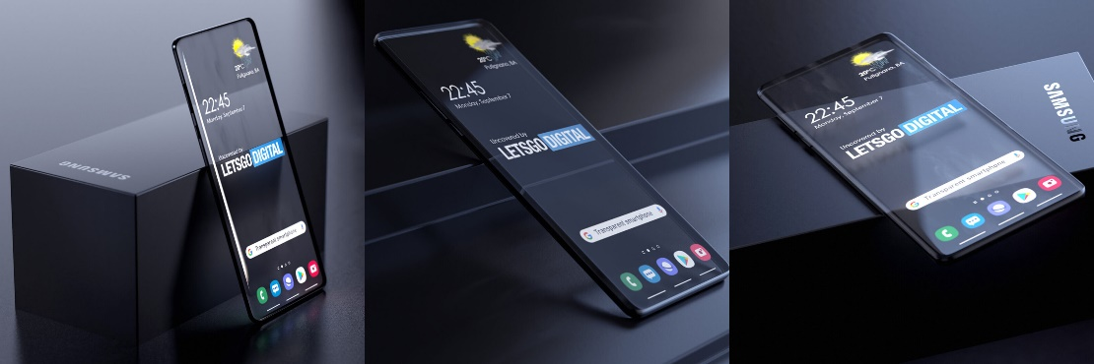

Just a couple of years ago, Samsung filed for a patent that not just described what their transparent film would look like, but also how it would work. they documented how they would use a transparent luminous panel that would have pixels just as bright as their normal screens. But ones that are invisible in their own and their mind and companies have now developed practically transparent batteries and transparent cabling which would be able to create a complete see-through middle section of the point. This completely wild idea is plausible now. But, I don't think we'll ever see one on the store shelves for the simple fact that transparency is a gimmick. It doesn't really have any benefit apart from looking cool and they don’t sell phones because smartphones are such expensive items and because people tend to only buy one of them. Which they'll need to rely on to access their entire digital lives. It's not the kind of product where you want to compromise just to have a more unique-looking and compromise. If you would have to go for a transparent phone.

You'd have to have a lower capacity battery,

And much smaller camera sensors in less optimal positions. There was so much that would have to be. I can't see anyone who still kind of wants one.

## 4. VIVO Flying Camera

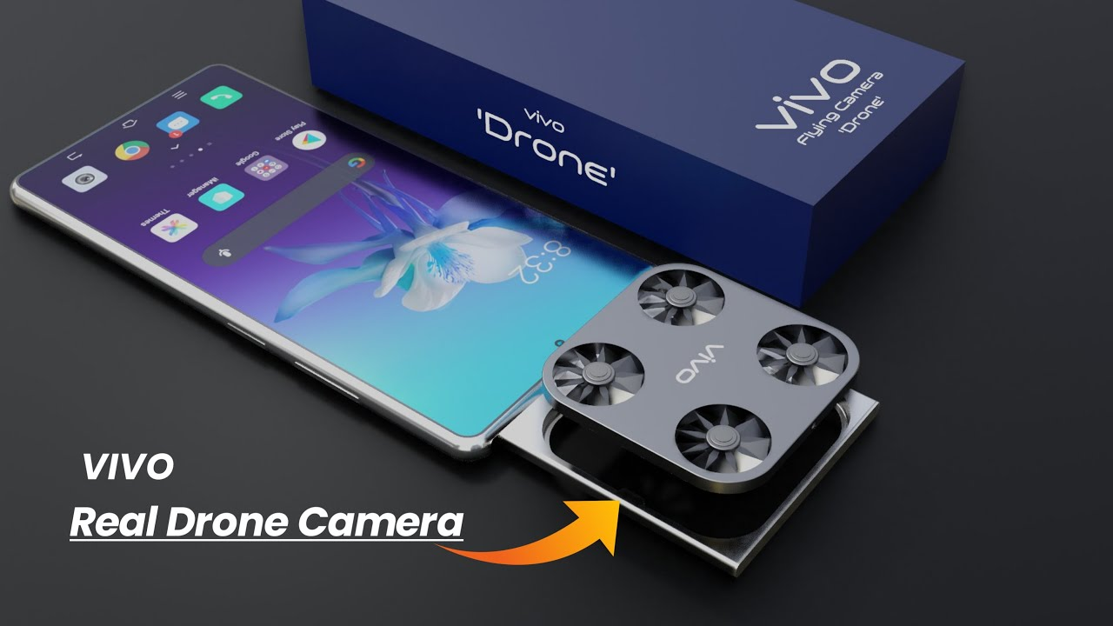

Over the last decade, this company has kind of built a reputation just going to the absolute extreme.

They made the world's tennis smartphone,

the world's first full-screen smartphone,

and the world's most stabilized camera on his mother. Now if we look at their patents, they're playing with the idea of a drone camera smarter. Allow me to drone on. So you'd have your phone and then with the press of a button that bill will eject a trade from which the tiny little drone launches and that drone is basically your camera. It could follow you around and capture everything that you see it could work for them in front of you and take a shot of you and everyone else that you will you can see why this idea has sent people into a bit of a frenzy with over 50 million views on a wordless video. But only teases a render of it. However. It's a really dumb idea. And for Vivos own sake, I kind of hope that they scrap, before it reaches production mainly because it's trying to solve a problem that doesn't exist. All you need to do to take a photo right now is to hold your arm out and click a button. But introducing a drone into the mix, it creates like 50 new variables. You all of a sudden have to start

factoring in a second battery that needs company topping up,

preparedness against the wind direction, getting it stuck in a tree. The list goes on and you can pretty much replicate the function out of this drone by just asking someone else to take the photo but for a future camera system that is not just cool future tech design but also useful.

## 3. HUAWEI 3d Scanning Camera

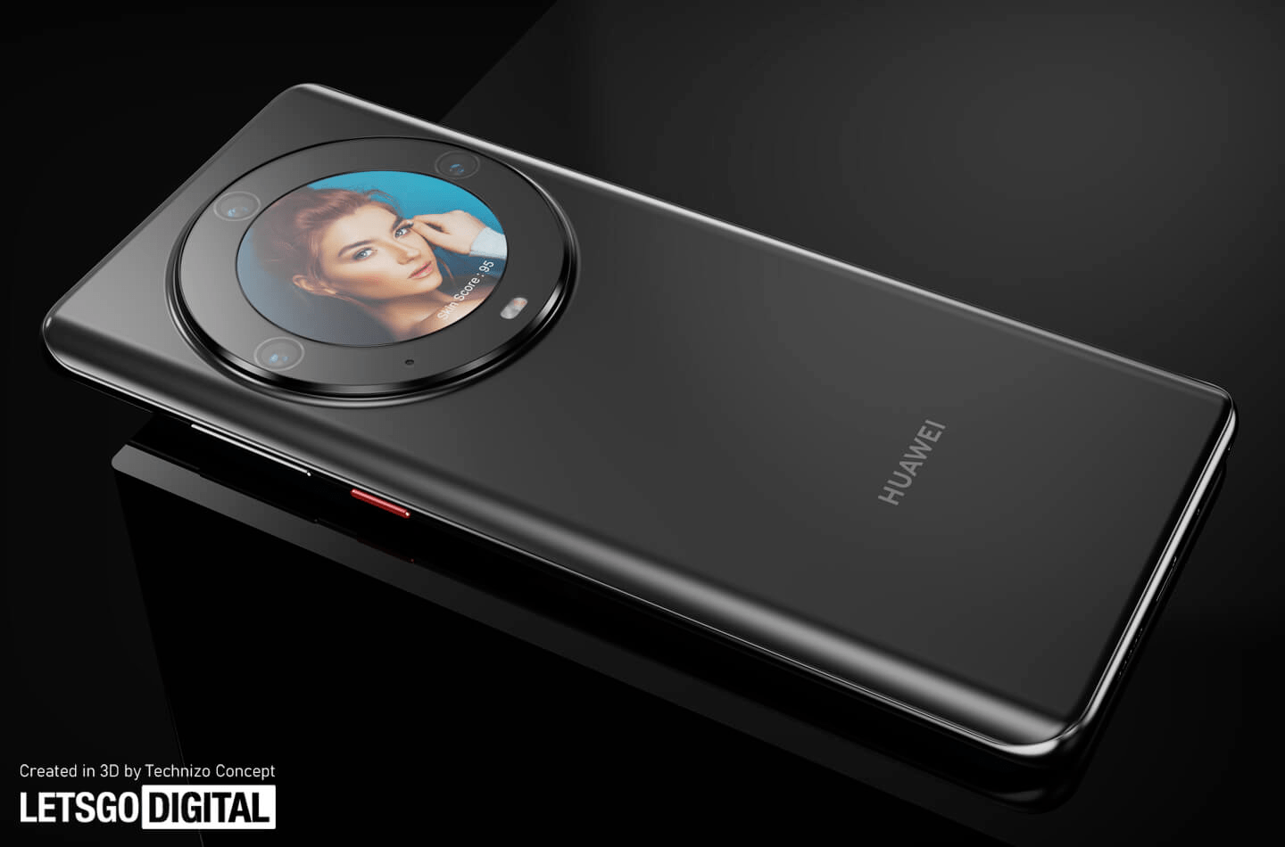

I found a fascinating unbelievable tech project that Huawei is working on just a few months ago, Huawei patented a 3d scanning camera system which features a screen in the middle to act as a mirror of sorts and that's planned by three cameras which are far enough apart from each other to be able to create A 3D model. Skip it, is super weird. The companies filed a 43-page document all about how it will be able to tell you everything from how well you provide sunscreen to whether you've actually removed your makeup properly to even the texture of your skin, your paws, Your Sports, your wrinkles, and how to actually improve. I am struggling to imagine queuing up to buy something that's just going to tell me how ugly I am but is yet another reminder of how capable authors could be in just a few years. All right, just before number one, then it's time for an unbelievable tech device that has been talked about for years.

## 2. Apple Foldable iPhone

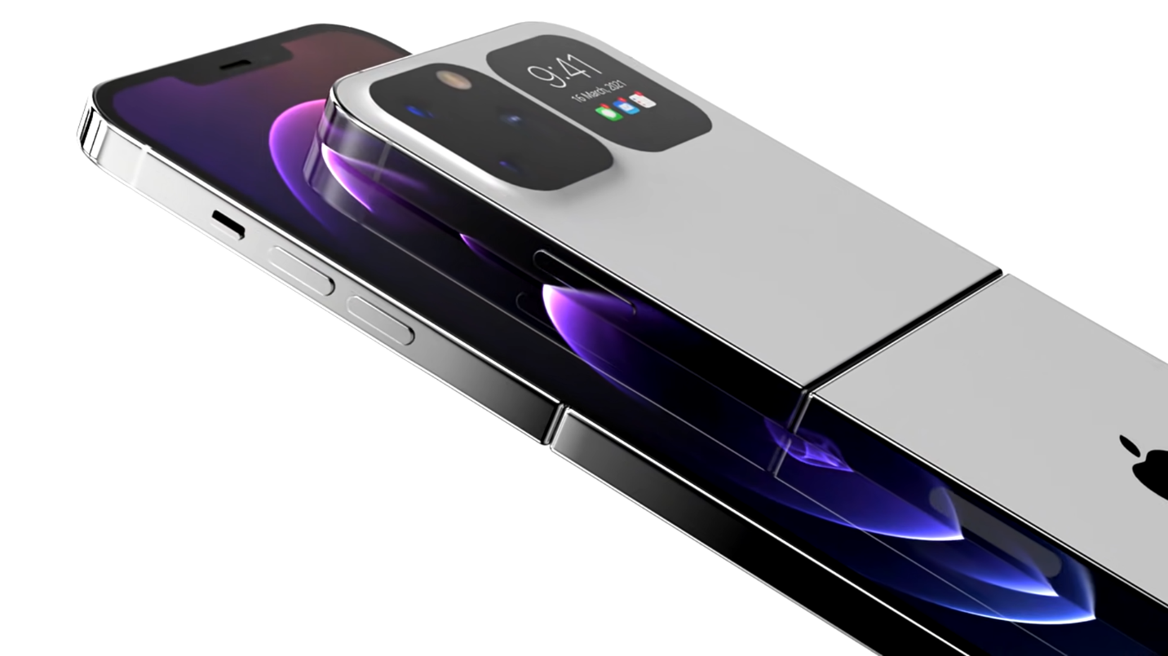

Piles of papers and patents and rumors have talked about a foldable iphone in the future and it turns out we have basically confirmation that Apple has actually built 2 working prototypes internally one bookstore volleyball similar to Samsung z volunteers, one clamshell volleyball, like Samsung z Flip series and what the analysts are saying is that between the two. Apple prefers the clown show. And if we look at others, It shows how they're considering using sapphire for a crack resistant display. How?, tthey’re planning to make a hinge that doesn't leave a crease behind when unfolded and as much as this does sound like. I think if by the end of this year, we see that the foldable market has grown yet again.

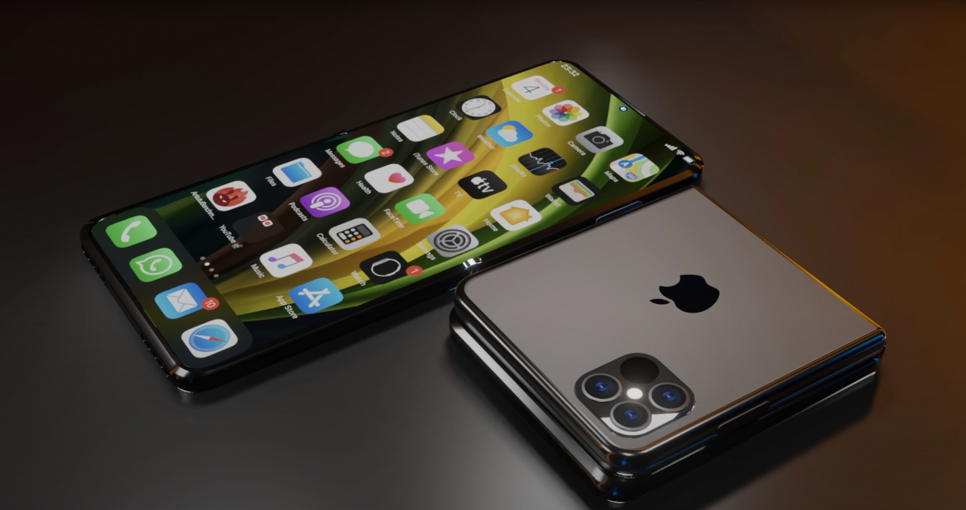

Apple will commit to a clamshell vulnerable. If the demand keeps growing, they'll kind of have but also that they won't release it until they can do it the apple way like they’re never going to be the first company to release new experimental tech just because it's called when people sell the phone. They need to be absolutely sure that it's ready for the mass market and so they will wait until there are no glaring reliability issues and also until there's a very clear purpose for having affordable for a mainstream user and both of those things point towards a 2025 launch alongside the iphone 17 future tech design.

## Samsung Tetris Phone

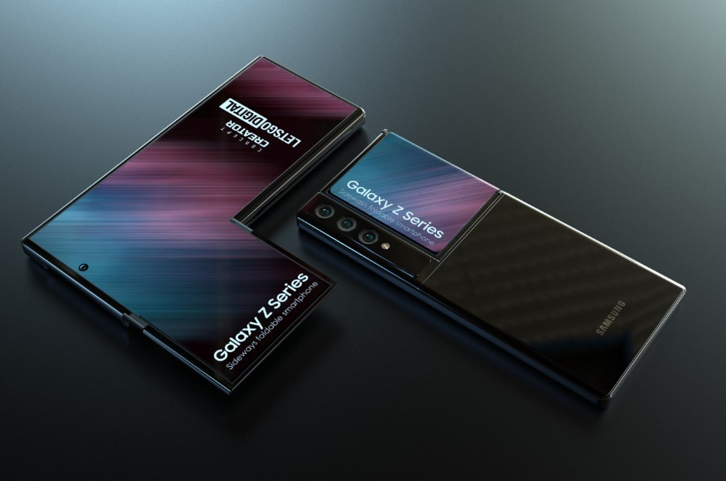

Are you ready for the weirdest unbelievable tech mobile you've ever seen in your life. ?his is Samsung's Tetris phone. No prizes for guessing where that name came. It's actually a surprising good idea. So basically one big screen on the front, just like a normal phone except at the top that screen goes much wider and bends around the back and there's a lot of companies who played with this idea of a second screen on the back of their phones. Can be super useful for notifications or taking photos with your camera. But in the past, they've either been too low quality to see clearly too small to be able to do anything that useful on so large that the phone itself becomes impractical to use. But this is like the perfect middle ground and because the back display is part of the front display, you get the exact same high resolution, high quality panel all the way around the screen stops partway down phone.

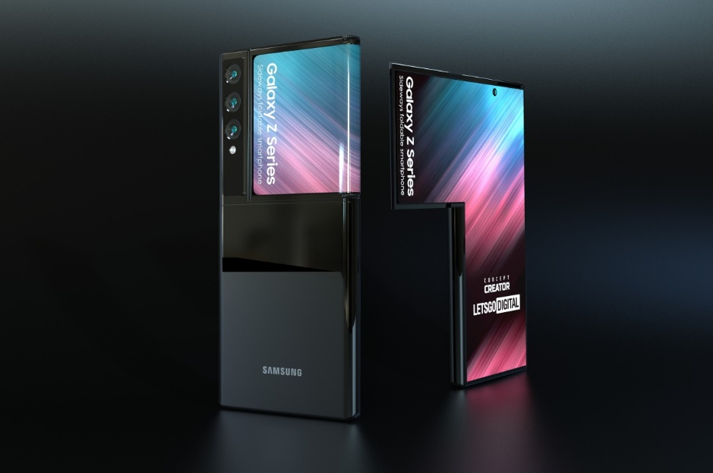

You still have a place to naturally rest your fingers without touching it when you can even use this bit of screen on the side as interactive notification bar in some sense patent. They did also show the back screen being able to kind of flip out to the front, but to be honest, I don't think you need that if they release this phone as it is right here. I think it would be a winner.