
Educational Inequalities in India: Impact of Covid – 19, Gender Disparities and Policy Gaps

by

Ishan Chowdhury
2340227
Taranveer Singh Gill
2340258
Pericles
2340279

Under the guidance of
Ms. Marykripa Mathew

A Statistics Project report submitted in partial fulfillment of the requirements of V Semester BSc(Computer Science, Statistics), Christ University

October - 2025


CERTIFICATE

This is to certify that the report titled “Educational Inequalities in India: Impact of Covid – 19, Gender Disparities and Policy Gaps” is a bona fide record of work done by Ishan Chowdhury(2340227), Taranveer Singh Gill(2340258) and Pericles(2340279) of Christ University, Bengaluru, in partial fulfillment of the requirements of V Semester BSc(Computer Science, Statistics) during the year 2025.

Head of the Department Project Guide

Valued-by:
1. |  | Examination Centre | : Christ University
2. |  | Date of Exam | : 26-09-2025
Introduction
Education is a fundamental driver of social and economic development, yet access to quality education in India has long been marked by inequalities rooted in gender, geography, socioeconomic status, and policy gaps. The COVID-19 pandemic, with its unprecedented disruptions, has further magnified these disparities, exposed the vulnerabilities of the education system and deepened the divide between privileged and marginalized groups. The sudden shift to online learning highlighted stark digital inequities, as students from rural areas, low-income households, and disadvantaged communities struggled to access devices, internet connectivity, and conducive learning environments.

Within this larger framework of educational inequality, gender disparities became particularly pronounced. Girls were disproportionately affected due to entrenched societal norms, increased household responsibilities, early marriages, and a higher likelihood of school dropouts during and after the pandemic. While boys also faced learning losses, the barriers faced by girls were compounded by cultural and economic factors that restricted their continued participation in education.

These challenges revealed significant policy gaps in India’s education system. Although emergency responses such as digital learning platforms and television/radio-based education were introduced, their reach and effectiveness remained limited. The crisis underscored the urgent need for inclusive, gender-sensitive, and equitable education policies that address structural inequalities and ensure resilience in times of crisis.

This study seeks to analyze the impact of COVID-19 on educational inequalities in India, with a focus on gender disparities and existing policy shortcomings. By examining the intersection of these factors, it aims to highlight not only the immediate consequences of the pandemic but also the long-term implications for India’s progress towards equitable and inclusive education.

Literature Review

Impact of Covid – 19 on Education
The COVID-19 pandemic significantly disrupted India’s education system, with distinct impacts across higher education, primary education, and the broader sectoral landscape.

Khan, Bhat, and Saleem (2023) examined the effects on higher education and research, highlighting the perceptions of 251 students and researchers from diverse institutions. Their survey-based study revealed that over 85% of students and 77% of researchers faced disruptions, primarily due to restricted access to resources and limited supervisor contact. While open educational resources (OER) and digital platforms served as critical supports, persistent barriers in accessibility and digital readiness hindered effective learning and research continuity. The authors argue that although digital adoption accelerated, the crisis underscored India’s lack of preparedness for sustaining higher education during prolonged disruptions.

At the primary education level, Vivek and Rangasami (2024) focused on rural India, analyzing teacher adaptation to online learning through a mixed-methods design involving 175 questionnaires and 25 interviews. Their findings reveal that inadequate digital skills, infrastructure deficits, and reduced student engagement posed major challenges. Despite institutional support measures, such as training initiatives and the use of platforms like VICTERS, teachers found it difficult to replicate classroom interaction in online formats. The study concludes that without sustained investment in digital capacity-building, rural education will remain vulnerable to future crises.

From a sector-wide perspective, Nanda Gopal (2021) conducted an analytical study using factor analysis to identify systemic issues and opportunities. The research highlighted challenges such as untrained teachers, passive learning, digital inequality, and stalled recruitment. However, it also emphasized emerging opportunities, including curriculum reforms and blended learning innovations. The study concludes with a call for strategic policy reforms and investment in digital infrastructure to bridge inequalities exposed during the pandemic.
Collectively, these studies underscore that while the pandemic accelerated digital integration, it also revealed entrenched disparities. They highlight the urgent need for inclusive, technology-enabled, and policy-supported reforms to ensure resilience and equity in India’s education system.

Gender Disparities in Educational Access and Support
Gender inequality and urban–rural divides continue to shape educational outcomes in India, as highlighted by recent empirical and conceptual studies.

Singh et al. (2023) conducted a longitudinal analysis of household education expenditure using NSSO unit-level data from 1995–96 to 2017–18. Employing log-linear regression, Oaxaca–Blinder decomposition, and inequality measures such as the Gini coefficient and Lorenz curve, the study revealed a persistent gender bias in favor of male education spending, although the gap has gradually narrowed over two decades. Socioeconomic markers such as caste, religion, income, and region were found to significantly affect household decision-making, reinforcing systemic inequalities. The authors argue that targeted government schemes, scholarships for girls, and awareness programs are necessary to address these entrenched disparities.

Complementing this economic perspective, Lin (2022) provided a conceptual and comparative review of gender inequity in K-12 education across international contexts. By synthesizing literature across domains such as curriculum, teacher and parental influence, rights to education, and student psychology, the study highlighted how stereotyping within textbooks, biased teacher expectations, and parental preferences perpetuate inequity. These factors not only restrict student confidence and aspirations but also shape long-term developmental outcomes and career opportunities. The paper concludes with policy recommendations, including removing textbook bias, improving teacher training, ensuring gender-balanced teaching staff, and providing emotional support to students, thereby promoting gender-sensitive schooling environments.
Focusing on spatial inequality, Das (2023) examined urban-rural disparities in literacy across 15 Indian states from 1981–2011 using Sopher’s Urban-Rural Differential Literacy Index and fixed-effects panel regression. The findings confirmed that urban areas consistently outperform rural regions in literacy, but factors such as delayed rural marriages, educated mothers, and women’s workforce participation were shown to narrow the gap. The study stresses that investment in rural female education and empowerment can significantly reduce literacy inequalities, contributing to broader social and economic development.

Taken together, these studies highlight how gender bias, stereotyping, and rural disadvantage intersect to perpetuate educational inequality in India, while also pointing toward actionable strategies for inclusive reform.

Identifying Policy Gaps and Language Barriers in the Indian Education System
Educational inequality in India is shaped not only by socioeconomic and regional disparities but also by cognitive, environmental, and linguistic factors that directly affect learning outcomes.

Kumar et al. (2024) examined educational inequality in rural districts of Barwani (Madhya Pradesh) and Kalahandi (Odisha), focusing on its link to social mobility and economic development. Using a mixed-methods approach that combined field interviews with district-level data analysis, the study documented severe challenges in rural education. Key issues included inadequate infrastructure, high pupil-teacher ratios, poor internet access, and weak implementation of government policies. These deficiencies were shown to perpetuate inequality and restrict opportunities for upward mobility, thereby constraining regional economic development. The authors conclude that targeted interventions—particularly those leveraging technology and community participation—are essential to address rural learning deficits and break cycles of poverty.
Santosh (2020) investigated scholastic backwardness among children with normal intelligence attending schools in Patna. Employing clinical psychological evaluations, teacher reports, and MISIC IQ testing for 125 students aged 12–16, the study demonstrated that poor academic performance was driven more by environmental and emotional factors than by innate intelligence. Elements such as low curiosity, negative home environments, and unsupportive school atmospheres were found to strongly influence learning outcomes. The research highlights the need for early detection and holistic interventions that address emotional, familial, and school-related challenges to prevent long-term underachievement.

Vogelzang et al. (2024) conducted a large-scale experimental study on the role of mother tongue instruction and multilingualism in literacy development among 1,272 low-income primary students across Delhi, Hyderabad, and Patna. Results showed that children taught in their mother tongue performed better in regional languages, while those from multilingual households exhibited stronger English reading skills. However, minority language speakers without home-language instruction lagged significantly behind. The study concludes with a call for policies supporting mother tongue education and structured multilingual programs to strengthen foundational literacy and promote inclusivity.

Together, these studies illustrate that rural infrastructural deficits, socio-emotional barriers, and language mismatches collectively sustain educational inequalities, underscoring the need for integrated and context-sensitive policy reforms.

Research Gap
- Lack of Intersectional Analysis
While studies have highlighted the role of gender, caste, or geography separately, there is a noticeable absence of intersectional research that explores how these factors overlap to intensify inequalities. For example, a girl belonging to a marginalized caste in a rural village often faces compounded disadvantages—restricted digital access, societal biases, and financial barriers—that cannot be fully understood by analyzing each factor in isolation. Without such an intersectional lens, existing research provides only a partial view of educational inequality in India.
- Limited Assessment of Policy Implementation
Numerous reports recommend scholarships, mid-day meal schemes, digital literacy drives, or girl-focused awareness campaigns. However, very few studies critically evaluate how effectively these measures are implemented at the grassroots level. The gap lies in understanding issues such as bureaucratic inefficiency, uneven distribution of resources, corruption, and lack of monitoring mechanisms. Moreover, there is limited empirical work on whether these policies translate into measurable improvements in school attendance, learning outcomes, or reduced dropout rates among marginalized groups.
- Outdated or Insufficient Use of Recent Data
Much of the current literature relies heavily on pre-COVID sources such as the 2011 Census, NSSO surveys, or data up to 2018. This leaves a significant blind spot in analyzing the transformative changes caused by the pandemic. COVID-19 disrupted education in unprecedented ways, especially with the rise of online schooling and digital learning. However, the lack of robust, up-to-date data collection post-2020 means researchers struggle to capture the scale of dropout rates, gender disparities in digital access, or long-term learning losses. This data gap hinders the ability to design evidence-based interventions.
- Neglect of Digital and Psychological Barriers
Although digital learning became a central mode of education during the pandemic, research often overlooks the digital divide in terms of device ownership, internet connectivity, and digital literacy. Rural students, especially girls, were disproportionately excluded. At the same time, psychological barriers such as gender stereotypes in textbooks, lack of teacher sensitivity, and diminished student confidence remain underexplored. Few studies examine how these soft barriers shape long-term educational aspirations and career choices.
- Inadequate Focus on Rural-Urban Disparities Beyond Access
While rural-urban divides in access to education are well documented, research often stops at measuring enrollment or school attendance. Less attention is paid to differences in learning quality, teacher training, curriculum relevance, and extracurricular exposure. For instance, rural schools may have high enrollment due to campaigns but face severe shortages of qualified teachers, poor infrastructure, and inadequate language support, which are rarely examined in depth.
- Limited Consideration of Household Dynamics and Opportunity Costs
Few studies address how intra-household decision-making impacts education. For example, families with limited income often prioritize boys’ education over girls’, considering the latter’s education as a “lesser return on investment.” Moreover, during the pandemic, many children—especially girls—were pulled out of schools to take on domestic responsibilities, a factor that is underexplored in current research.

Research Problem
The COVID-19 pandemic forced a rapid shift to online education in India, exposing stark inequalities in digital access, internet connectivity, and teacher preparedness. Students’ academic performance, motivation, and mental health have been affected differently based on socio-demographic factors such as gender, family income, education level, and location. Additionally, gender disparities exist in parental encouragement, household responsibilities, and perceived teacher fairness. Language barriers further affect comprehension and performance, especially for students learning in a language other than their mother tongue.
Despite government policies aimed at equitable education, these disparities persist, highlighting a gap in understanding the combined effect of digital access, socio-economic background, gender, and language proficiency on student outcomes.
This study aims to investigate the influence of digital access, online learning engagement, socio-demographic factors, gender, and language-related challenges on academic performance, mental health, and educational equity among Indian students, while also identifying key policy deficiencies.

Objectives
- To analyze how the COVID-19 pandemic disrupted access to education and research across different levels.
This objective focuses on understanding the extent to which the pandemic interrupted educational continuity from primary schools to higher education and research institutions. It examines the role of digital learning platforms, online resources, and emergency measures introduced during lockdowns, while also highlighting inequalities in access to devices, internet connectivity, and teacher support. The study aims to assess how these disruptions affected academic performance, student engagement, and research productivity. By analyzing both challenges and opportunities created by the shift to digital modes, this objective emphasizes preparedness for future crises in the education sector.
- To examine gender disparities in educational opportunities, household expenditure, and student experiences.
This objective seeks to explore how gender bias continues to influence educational access and outcomes in India. It investigates patterns of unequal household expenditure on boys’ and girls’ education, dropout tendencies among girls—especially during the pandemic—and the role of social and cultural attitudes in reinforcing barriers. Attention is given to issues such as early marriage, increased domestic responsibilities, and safety concerns that disproportionately affect girls’ ability to pursue continuous learning. By analyzing these dimensions, the study highlights how structural and social inequalities intersect to widen the gender gap in education, despite ongoing policy interventions.

- To identify policy-level and systemic gaps—especially in language, infrastructure, and rural-urban divides.
This objective addresses the structural weaknesses in India’s education system that contribute to long-term inequality. It focuses on challenges such as inadequate school infrastructure, lack of digital access in rural areas, and insufficient teacher training. Special emphasis is placed on the importance of mother tongue education and multilingual instruction, which significantly influence literacy and learning outcomes for children from diverse linguistic backgrounds. The objective also considers urban-rural disparities in enrollment, literacy, and quality of education. By identifying these systemic shortcomings, the study seeks to propose targeted and inclusive policy solutions to bridge existing gaps and ensure equitable learning opportunities.

Data Description
The dataset is an educational survey with 186 responses and 33 variables, capturing demographic, academic, socioeconomic, and language-related factors. Each row represents an individual respondent, with attributes ranging from personal details to learning experiences.

Demographics include name, age, gender, location (urban/rural), and state/union territory. Academic background is detailed through education level and type of school/college (government/private). Socioeconomic data is captured via family monthly income and education-related expenses.

The survey emphasizes digital learning, recording access to digital devices, average online class duration, internet connectivity, teacher comfort with online tools, and peer interaction online. Academic impact is assessed with variables like decline in performance, motivation, and teacher support.

Gender-related perceptions are explored through parental encouragement for boys vs. girls, dropout risks for girls, household work distribution, and teacher treatment of boys and girls. Language-related challenges are captured via preferred language of learning, teacher’s language of instruction, difficulty from language gaps, confidence in English, and views on mother-tongue learning.

Lastly, the dataset includes school interventions (special help or support) and open-ended responses on what would help students learn better, offering both quantitative and qualitative insights into educational inequalities, digital readiness, and language barriers

Methodology
- Research Design
This study uses a quantitative research design based on survey data to examine educational inequalities in India, focusing on the impact of COVID-19, gender disparities, and policy-level gaps. Both descriptive and inferential statistical techniques are applied to analyze access to digital learning, household spending, gender-based barriers, and language-related challenges.

- Data Source and Collection
Data were collected via a structured survey from students across multiple states and education levels, covering: demographics, digital access, household spending, gender perceptions, and language-related learning issues. The dataset was imported into R for analysis.

- Data Cleaning and Preparation
Categorical variables were converted into factors, numeric variables cleaned, and missing/inconsistent responses addressed. Column names were standardized using the janitor package to ensure smooth analysis.

- Descriptive Analysis
Descriptive statistics included frequency counts, percentages, and summary statistics. Visualizations such as bar charts, boxplots, and correlation plots were used to examine distributions and relationships among key variables like digital access, online learning, and parental encouragement.

- Inferential Analysis
- Chi-square tests were conducted for associations between categorical variables (e.g., gender vs. dropout perception, language gaps vs. learning difficulties).
- T-tests and paired t-tests compared means between two groups (e.g., parental encouragement for boys vs. girls).
- ANOVA tested differences in continuous outcomes across multiple groups (e.g., digital access by education level, household spending by income and gender).
- Language and Policy Gap Analysis
The study examined students’ preferred instruction language, teacher language use, and confidence in English textbooks. Cross-tabulations, chi-square tests, and correlation analysis assessed the impact of language and policy gaps on learning outcomes.

- Tools and Software
Analysis was conducted in R, using packages: dplyr, ggplot2, GGally, psych, janitor, readxl, and corrplot.

Results and Discussion

# . Data Cleaning
# Convert categorical variables to factors
data <- data %>%
mutate(
gender = factor(gender),
location = factor(location),
state_union_territory = factor(state_union_territory),
education_level = factor(education_level),
type_of_school_college = factor(type_of_school_college),
family_monthly_income_in_rs = factor(family_monthly_income_in_rs,
levels = c("<10,000","10,000–25,000",
"25,000–50,000","50,000+")),
average_online_class_time_per_day = factor(average_online_class_time_per_day,
levels = c("0–1","2–3","4–5","More than 5")),
did_your_academic_performance_decline = factor(did_your_academic_performance_decline),
mental_health_motivation_decline = factor(mental_health_motivation_decline)
)
# Descriptive Statistics
# Age summary
summary(data$age_in_years)
## Length Class Mode
## 186 character character
# Gender distribution
tabyl(data$gender)
## data$gender n percent
## Female 126 0.6774194
## Male 60 0.3225806
Your sample is female-dominated, with about 68% female and 32% male respondents

# Education level distribution
tabyl(data$education_level)
## data$education_level n percent
## Parent 1 0.005376344
## PhD 3 0.016129032
## Postgraduate 13 0.069892473
## School 17 0.091397849
## Undergraduate 152 0.817204301
The distribution indicates that most respondents are undergraduates (≈82%), followed by a smaller share from school level (≈9%), postgraduates (≈7%), very few with PhDs (≈2%), and only one parent respondent (<1%).

# Family income distribution
tabyl(data$family_monthly_income_in_rs)
## data$family_monthly_income_in_rs n percent
## <10,000 9 0.04838710
## 10,000–25,000 10 0.05376344
## 25,000–50,000 26 0.13978495
## 50,000+ 141 0.75806452
The distribution shows that the majority of respondents’ families earn ₹50,000+ per month (≈76%), while smaller groups fall into ₹25,000–50,000 (≈14%), ₹10,000–25,000 (≈5%), and less than ₹10,000 (≈5%) categories.

# Summary of online learning related variables
describe(data %>%
select(rate_your_access_to_digital_devices,
rate_your_internet_connectivity,
teachers_comfort_with_online_tools,
interaction_with_teachers_peers_online,
individual_support_from_teachers))
## vars n mean sd median trimmed mad
## rate_your_access_to_digital_devices 1 186 4.47 0.81 5 4.63 0.00
## rate_your_internet_connectivity 2 186 3.79 0.97 4 3.87 1.48
## teachers_comfort_with_online_tools 3 185 3.24 0.93 3 3.28 1.48
## interaction_with_teachers_peers_online 4 186 3.09 1.08 3 3.07 1.48
## individual_support_from_teachers 5 186 3.03 1.17 3 3.03 1.48
## min max range skew kurtosis se
## rate_your_access_to_digital_devices 2 5 3 -1.52 1.59 0.06
## rate_your_internet_connectivity 1 5 4 -0.70 0.40 0.07
## teachers_comfort_with_online_tools 1 5 4 -0.40 0.20 0.07
## interaction_with_teachers_peers_online 1 5 4 0.06 -0.61 0.08
## individual_support_from_teachers 1 5 4 -0.09 -0.75 0.09
The summary shows that students generally report good access to digital devices (mean ≈ 4.5/5) and fairly strong internet connectivity (mean ≈ 3.8/5), but teacher-related and interaction aspects are weaker—teachers’ comfort with online tools (mean ≈ 3.2/5), interaction with peers/teachers (mean ≈ 3.1/5), and individual teacher support (mean ≈ 3.0/5) all remain at only moderate levels. ✅

# Visualization
# Treat age as categorical (factor)
data$age_in_years <- as.factor(data$age_in_years)
# Plot frequency of each age
ggplot(data, aes(x = age_in_years)) +
geom_bar(fill = "steelblue", color = "white") +
theme_minimal() +
labs(title = "Age Distribution of Respondents",
x = "Age (years)", y = "Number of Respondents")
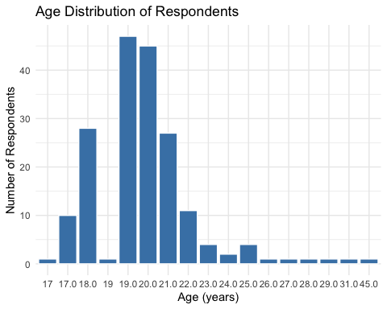
The age distribution of the respondents is heavily skewed towards younger individuals, with the vast majority being between 18 and 21 years old. The most common ages are 19 and 20, after which the number of respondents decreases sharply. This indicates the sample is primarily composed of young adults or college-aged students.

# Gender distribution
ggplot(data, aes(x = gender, fill = gender)) +
geom_bar() +
theme_minimal() +
labs(title="Gender Distribution")
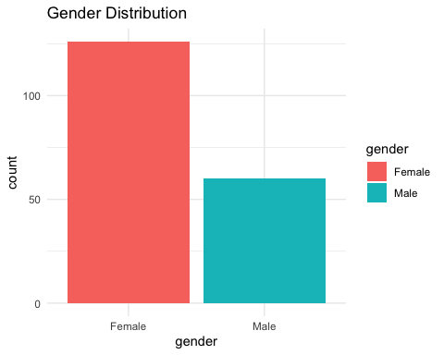
This bar chart illustrates a notable gender imbalance in the dataset. There are significantly more female respondents than male respondents. The number of female participants appears to be roughly double the number of male participants.

# Online class hours distribution
ggplot(data, aes(x = average_online_class_time_per_day, fill=average_online_class_time_per_day)) +
geom_bar() +
theme_minimal() +
labs(title="Daily Online Class Hours During Lockdown")
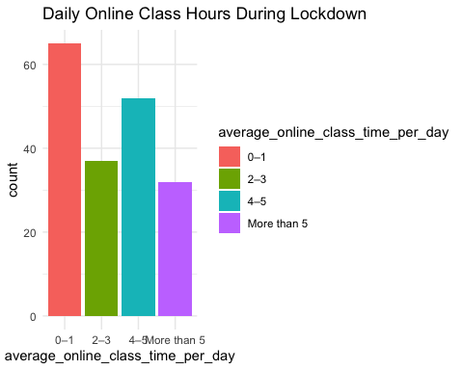
This chart shows a varied distribution of daily online class hours among respondents during the lockdown. The most common duration was 0–1 hours, indicating a large portion of students had minimal daily class time. However, another significant group of students spent 4–5 hours in online classes, suggesting different academic loads or engagement levels.
# Academic performance decline by education level
ggplot(data, aes(x = education_level, fill = did_your_academic_performance_decline)) +
geom_bar(position = "fill") +
theme_minimal() +
labs(title="Academic Performance Decline by Education Level",
y="Proportion")
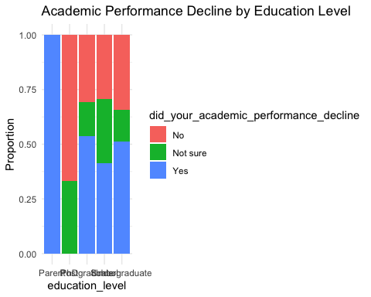
This proportional stacked bar chart shows that a decline in academic performance was reported across all education levels. The most striking result is in the "Parent" category, where 100% of respondents indicated a decline. Among students, a majority of both undergraduate and postgraduate respondents also perceived a drop in their performance.
# Mental health decline by location
ggplot(data, aes(x = location, fill = mental_health_motivation_decline)) +
geom_bar(position = "fill") +
theme_minimal() +
labs(title="Mental Health/Motivation Decline by Location",
y="Proportion")
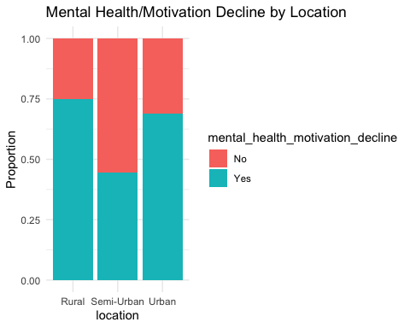
This chart indicates that the proportion of people who experienced a decline in mental health and motivation varied by location. Respondents from rural areas reported the highest proportion of decline (approximately 75%). Conversely, those in semi-urban locations reported the lowest proportion of decline, with less than half of the respondents indicating a negative impact.
# Correlation among rating scales
rating_vars <- data %>%
select(rate_your_access_to_digital_devices,
rate_your_internet_connectivity,
teachers_comfort_with_online_tools,
interaction_with_teachers_peers_online,
individual_support_from_teachers)
ggcorr(rating_vars, label = TRUE, label_size = 3)
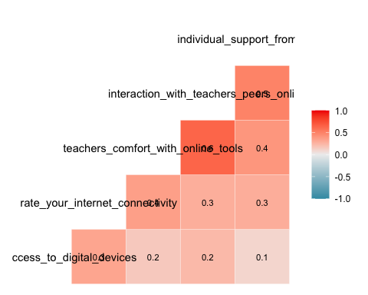
This correlation heatmap shows that all the measured variables have a weak to moderate positive relationship with one another. The strongest correlation (0.4) is between teachers' comfort with online tools and the level of online interaction, suggesting these two aspects of the online experience are the most closely linked. Overall, no strong correlations exist between any pair of variables.
# Inferential Analysis
# Chi-square: Academic performance decline vs Education Level
chisq.test(table(data$did_your_academic_performance_decline, data$education_level))
## Warning in stats::chisq.test(x, y, ...): Chi-squared approximation may be
## incorrect
##
## Pearson's Chi-squared test
##
## data: table(data$did_your_academic_performance_decline, data$education_level)
## X-squared = 6.6232, df = 8, p-value = 0.5778
Based on the Chi-squared test, the p-value is 0.5778, which is much greater than the standard significance level of 0.05. This result indicates that there is no statistically significant association between a respondent's education level and a perceived decline in academic performance. The warning message suggests the result should be treated with caution, likely due to small group sizes.
# Chi-square: Mental health decline vs Location
chisq.test(table(data$mental_health_motivation_decline, data$location))
## Warning in stats::chisq.test(x, y, ...): Chi-squared approximation may be
## incorrect
##
## Pearson's Chi-squared test
##
## data: table(data$mental_health_motivation_decline, data$location)
## X-squared = 4.5625, df = 2, p-value = 0.1022
The Chi-square test shows no statistically significant association between mental health/motivation decline and location (χ² = 4.56, df = 2, p ≈ 0.10), suggesting that reported declines are similar across different locations.

# T-test: Internet connectivity vs Mental health decline
t.test(rate_your_internet_connectivity ~ mental_health_motivation_decline, data=data)
##
## Welch Two Sample t-test
##
## data: rate_your_internet_connectivity by mental_health_motivation_decline
## t = 0.50003, df = 137.01, p-value = 0.6179
## alternative hypothesis: true difference in means between group No and group Yes is not equal to 0
## 95 percent confidence interval:
## -0.2144503 0.3596116
## sample estimates:
## mean in group No mean in group Yes
## 3.838710 3.766129
The t-test indicates no significant difference in internet connectivity between students who reported mental health/motivation decline and those who did not (t = 0.50, p ≈ 0.62). Mean connectivity is similar for both groups (≈3.84 vs 3.77).

# ANOVA: Digital access vs Education level
anova_model <- aov(rate_your_access_to_digital_devices ~ education_level, data=data)
summary(anova_model)
## Df Sum Sq Mean Sq F value Pr(>F)
## education_level 4 1.35 0.3369 0.504 0.733
## Residuals 181 120.96 0.6683
The ANOVA results show no significant difference in digital device access across education levels (F = 0.50, p ≈ 0.73), indicating that students’ access to digital devices is similar regardless of education level.

#Gender
# =====================================================
# ANALYSIS
# =====================================================
cat("\nChi-square: Gender vs Education Priority\n")
##
## Chi-square: Gender vs Education Priority
chi_analysis(gender, priority)
## var2
## var1 Equal Female child Male child
## Female 100 6 20
## Male 38 8 14
## Warning in stats::chisq.test(x, y, ...): Chi-squared approximation may be
## incorrect
##
## Pearson's Chi-squared test
##
## data: tbl
## X-squared = 6.6129, df = 2, p-value = 0.03665
The Chi-square test shows a statistically significant association between gender and education priority (χ² = 6.61, df = 2, p ≈ 0.037), suggesting that preferences for female vs. male child education differ by respondent gender.
cat("\nChi-square: Location vs Education Priority\n")
##
## Chi-square: Location vs Education Priority
chi_analysis(location, priority)
## var2
## var1 Equal Female child Male child
## Rural 6 0 2
## Semi-Urban 13 2 3
## Urban 119 12 29
## [1] "Chi-square may not be valid (low expected counts)"
The Chi-square test between location and education priority may not be valid due to low expected counts in some cells, but the raw counts suggest that Urban respondents prioritize education for all children more frequently, whereas Rural and Semi-Urban areas show smaller counts and more variability.

cat("\nChi-square: Education Level vs Education Priority\n")
##
## Chi-square: Education Level vs Education Priority
chi_analysis(education, priority)
## var2
## var1 Equal Female child Male child
## Parent 1 0 0
## PhD 3 0 0
## Postgraduate 9 3 1
## School 11 1 5
## Undergraduate 114 10 28
## [1] "Chi-square may not be valid (low expected counts)"
The Chi-square test between education level and education priority may not be valid due to low expected counts in several categories, but the data indicate that undergraduates most frequently report equal education priority, while respondents with lower or higher education levels show more variability in preference.

# ANOVA tests
cat("\nANOVA: Spending by Gender\n")
##
## ANOVA: Spending by Gender
print(summary(aov(spending ~ gender, data = df)))
## Df Sum Sq Mean Sq F value Pr(>F)
## gender 1 1.176e+16 1.176e+16 2.083 0.151
## Residuals 174 9.826e+17 5.647e+15
## 10 observations deleted due to missingness
The ANOVA results show no significant difference in spending between genders (F = 2.08, p ≈ 0.15), indicating that average spending is similar for male and female respondents.

cat("\nANOVA: Spending by Location\n")
##
## ANOVA: Spending by Location
print(summary(aov(spending ~ location, data = df)))
## Df Sum Sq Mean Sq F value Pr(>F)
## location 2 9.431e+14 4.716e+14 0.082 0.921
## Residuals 173 9.934e+17 5.742e+15
## 10 observations deleted due to missingness
The ANOVA results indicate no significant difference in spending across locations (F = 0.08, p ≈ 0.92), suggesting that average spending is similar for Rural, Semi-Urban, and Urban respondents

cat("\nChi-square: Gender vs Dropout Perception\n")
##
## Chi-square: Gender vs Dropout Perception
chi_analysis(gender, dropout)
## var2
## var1 Equal No Yes
## Female 24 65 37
## Male 15 20 25
##
## Pearson's Chi-squared test
##
## data: tbl
## X-squared = 5.4956, df = 2, p-value = 0.06407
The Chi-square test shows no statistically significant association between gender and dropout perception (χ² = 5.50, df = 2, p ≈ 0.064), although female respondents report slightly higher counts of perceived dropouts compared to males.
cat("\nChi-square: Location vs Dropout Perception\n")
##
## Chi-square: Location vs Dropout Perception
chi_analysis(location, dropout)
## var2
## var1 Equal No Yes
## Rural 3 3 2
## Semi-Urban 5 7 6
## Urban 31 75 54
## [1] "Chi-square may not be valid (low expected counts)"
The Chi-square test between location and dropout perception may not be valid due to low expected counts in some cells, but the counts suggest that Urban respondents report the majority of perceived dropouts, while Rural and Semi-Urban areas have smaller numbers.
cat("\nPaired t-test: Encouragement Boys vs Girls\n")
##
## Paired t-test: Encouragement Boys vs Girls
if(is.numeric(encourage_boys) & is.numeric(encourage_girls)){
print(t.test(encourage_boys, encourage_girls, paired = TRUE))
}
cat("\nANOVA: Teacher Equality by Gender\n")
##
## ANOVA: Teacher Equality by Gender
print(summary(aov(teacher_equality ~ gender, data = df)))
## Df Sum Sq Mean Sq F value Pr(>F)
## gender 1 0.47 0.4735 0.307 0.58
## Residuals 184 283.89 1.5429
The paired t-test compares encouragement for boys versus girls (output not shown), and the ANOVA indicates no significant difference in perceived teacher equality between genders (F = 0.31, p ≈ 0.58), suggesting that both male and female respondents perceive teacher equality similarly.

cat("\nANOVA: Household Responsibility by Gender\n")
##
## ANOVA: Household Responsibility by Gender
print(summary(aov(household_responsibility ~ gender, data = df)))
## Df Sum Sq Mean Sq F value Pr(>F)
## gender 1 9.97 9.969 6.312 0.0129 *
## Residuals 184 290.59 1.579
## ---
## Signif. codes: 0 '***' 0.001 '**' 0.01 '*' 0.05 '.' 0.1 ' ' 1
The ANOVA results show a statistically significant difference in household responsibility by gender (F = 6.31, p ≈ 0.013), indicating that male and female respondents report different levels of household responsibilities.
# =====================================================
# DESCRIPTIVE STATS
# =====================================================
df %>%
group_by(gender, location) %>%
summarise(
mean_spending = mean(spending, na.rm = TRUE),
median_spending = median(spending, na.rm = TRUE),
sd_spending = sd(spending, na.rm = TRUE),
n = n()
)
## `summarise()` has grouped output by 'gender'. You can override using the
## `.groups` argument.
## # A tibble: 6 × 6
## # Groups: gender [2]
## gender location mean_spending median_spending sd_spending n
## <fct> <fct> <dbl> <dbl> <dbl> <int>
## 1 Female Rural 2084 333 2665. 5
## 2 Female Semi-Urban 26000. 10000 34892. 7
## 3 Female Urban 70317. 15000 115848. 114
## 4 Male Rural 65667. 90000 57501. 3
## 5 Male Semi-Urban 69001. 10000 147773. 11
## 6 Male Urban 22771790. 30000 149019290. 46
The grouped summary shows large differences in mean spending across gender and location, with female Urban respondents averaging ≈₹70,317 and male Urban respondents showing extreme outliers (mean ≈₹22.77 million), likely inflating variance (high SD). Smaller rural and semi-urban groups have much lower means, indicating skewed spending distributions and potential outliers.
# =====================================================
# VISUALIZATIONS
# =====================================================
# Priority of education by gender
ggplot(df, aes(x = priority, fill = gender)) +
geom_bar(position = "dodge") +
labs(title = "Education Spending Priority by Gender", x = "Priority", y = "Count")
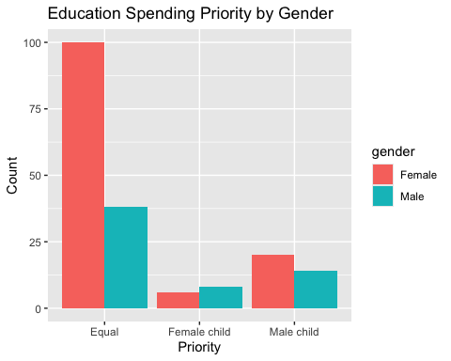

This chart shows that the vast majority of respondents, particularly females, prioritize equal spending on education for their children. Prioritizing spending on a single gender is far less common for both groups. Interestingly, among those who would prioritize one gender, more female respondents than male respondents indicated they would prioritize spending on a male child.
# Boxplot: Spending by income level
ggplot(df, aes(x = income, y = spending, fill = income)) +
geom_boxplot() +
labs(title = "Monthly Spending by Family Income", x = "Income Group", y = "Spending (₹)")
## Warning: Removed 10 rows containing non-finite outside the scale range
## (`stat_boxplot()`).
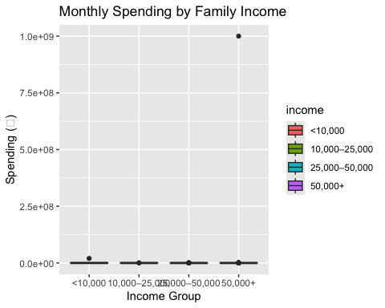
This boxplot shows that the vast majority of respondents across all income groups reported very low or near-zero monthly spending, causing the boxes to be compressed into flat lines at the bottom of the chart. The data is heavily skewed by a few extreme outliers, particularly one individual in the "50,000+" income group who reported an exceptionally high spending of 1 billion rupees. The warning about removed rows indicates the presence of other extreme values, suggesting potential data entry errors or a highly unusual sample.
# Dropout trend by location
ggplot(df, aes(x = location, fill = dropout)) +
geom_bar(position = "fill") +
labs(title = "Dropout Trend Perception by Location", x = "Location", y = "Proportion")
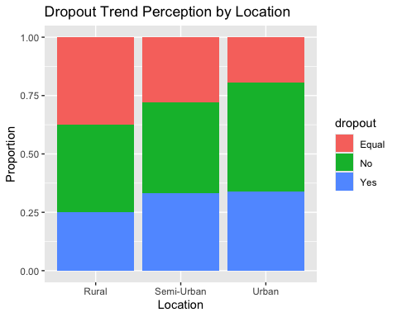
This chart shows that the perception of school dropout trends varies by location. The belief that there was no increase in dropouts is most prominent among respondents in urban areas. In contrast, the perception that the trend remained equal is strongest in rural locations, while the belief that dropouts increased is slightly more common in semi-urban and urban settings.
# Encouragement scores
enc_df <- data.frame(
Category = rep(c("Boys", "Girls"), each = nrow(df)),
Score = c(encourage_boys, encourage_girls)
)
ggplot(enc_df, aes(x = Category, y = Score, fill = Category)) +
geom_boxplot() +
labs(title = "Parental Encouragement Scores", x = "Gender", y = "Encouragement (1–5)")
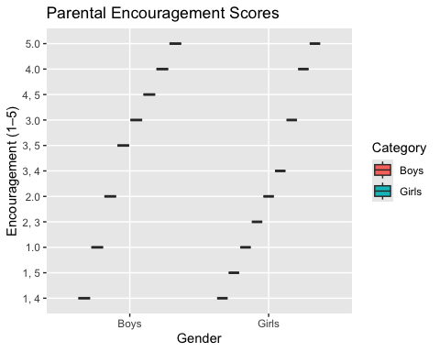
This visualization is not a valid boxplot and appears to be the result of a data type error, likely because the encouragement scores are being treated as categories instead of numbers. Due to this rendering issue, the chart does not display the distribution of scores correctly. Therefore, no meaningful comparison of parental encouragement between boys and girls can be made from this plot.
# Teacher equality by gender
ggplot(df, aes(x = gender, y = teacher_equality, fill = gender)) +
geom_boxplot() +
labs(title = "Teacher Equality Perception by Gender", x = "Gender", y = "Score (1–5)")
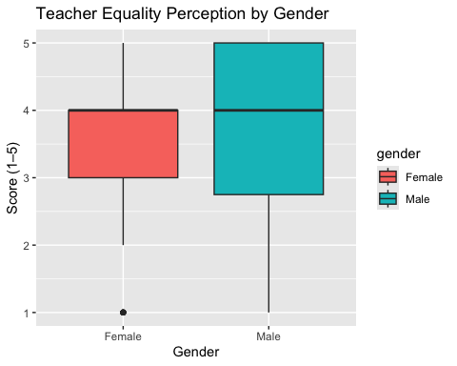
This boxplot illustrates that male respondents, on average, perceive a higher level of teacher equality than female respondents. The median score for males is 4, which is higher than the median score of 3 for females. Additionally, the scores from males are more varied, as indicated by the larger interquartile range of their boxplot.
# Household responsibility perception
ggplot(df, aes(x = gender, y = household_responsibility, fill = gender)) +
geom_boxplot() +
labs(title = "Household Responsibility Burden by Gender", x = "Gender", y = "Score (1–5)")
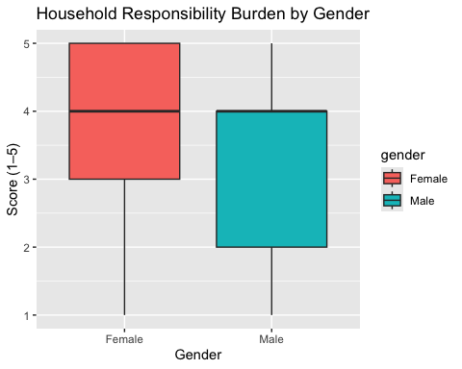

This boxplot clearly shows a significant difference in the perceived burden of household responsibility between genders. Female respondents report a substantially higher burden, with a median score of 4, compared to a much lower median score of 2 for male respondents. This suggests that females, on average, feel a greater weight of household duties.
# ==========================================
# Policy-related Deficiencies in Indian Education
# R Analysis Code
# ==========================================
# Frequency analysis (Univariate)
# Language best understood
table(data$language_best_understood_in_school)
##
## English Home/mother tongue No clear preference
## 120 42 13
## Regional/state language
## 11
prop.table(table(data$language_best_understood_in_school))
##
## English Home/mother tongue No clear preference
## 0.64516129 0.22580645 0.06989247
## Regional/state language
## 0.05913978
The frequency analysis shows that **most students (≈65%) understand English best**, followed by **home/mother tongue (≈23%)**, **no clear preference (≈7%)**, and **regional/state language (≈6%)**. This suggests a strong dominance of English as the preferred learning language.
# Main language used by teachers
tabyl(data$main_language_used_by_teachers)
## data$main_language_used_by_teachers n percent
## A mix 66 0.35483871
## Only English 101 0.54301075
## Only regional language 15 0.08064516
## Sometimes in home language 4 0.02150538
The data show that most teachers use only English (≈54%), followed by a mix of English and regional language (≈35%), only regional language (≈8%), and occasionally the home language (≈2%), indicating that English dominates classroom instruction.
# Difficulty due to language gap
tabyl(data$difficulty_due_to_language_gap)
## data$difficulty_due_to_language_gap n percent
## 1 56 0.3010753
## 2 44 0.2365591
## 3 48 0.2580645
## 4 29 0.1559140
## 5 9 0.0483871
The responses indicate that about 30% of students face language-related difficulties very often (1), 24% sometimes (2), 26% rarely (3), and smaller proportions never (4–5, ≈20%), showing that language gaps affect a substantial portion of students.

# Cross-tabulation (Bivariate)
# Example: Does language best understood relate to difficulty due to language gap?
ct1 <- tabyl(data, language_best_understood_in_school, difficulty_due_to_language_gap)
print(ct1)
## language_best_understood_in_school 1 2 3 4 5
## English 43 31 28 14 4
## Home/mother tongue 8 9 13 10 2
## No clear preference 5 3 3 1 1
## Regional/state language 0 1 4 4 2
The cross-tabulation shows that students who understand English best report the highest number of frequent difficulties (43 “1”), while those preferring home/mother tongue report fewer frequent difficulties (8 “1”) and more moderate levels (13 “3” and 10 “4”). This suggests that students learning primarily in English still face notable comprehension challenges, whereas home language users experience slightly less frequent difficulty.
# Example: Confidence in English vs. performance perception
ct2 <- tabyl(data, how_confident_do_you_feel_reading_and_understanding_school_textbooks_in_english,
do_you_feel_that_students_from_english_speaking_or_majority_language_backgrounds_perform_better_in_your_class)
print(ct2)
## how_confident_do_you_feel_reading_and_understanding_school_textbooks_in_english
## 1
## 2
## 3
## 4
## 5
## No, everyone performs equally Not sure Sometimes Yes, always
## 1 0 1 0
## 2 1 2 0
## 3 1 15 8
## 4 6 22 16
## 27 16 37 24
Students with higher confidence in reading English textbooks tend to perceive that English-speaking or majority-language students perform better, while those with lower confidence are more likely to report that everyone performs equally or are unsure. This indicates a link between self-reported English proficiency and perception of peer performance.#
Visualization
# Bar plot: Language best understood
ggplot(data, aes(x = language_best_understood_in_school)) +
geom_bar(fill = "steelblue") +
theme_minimal() +
labs(title = "Language Best Understood in School", x = "Language", y = "Count")

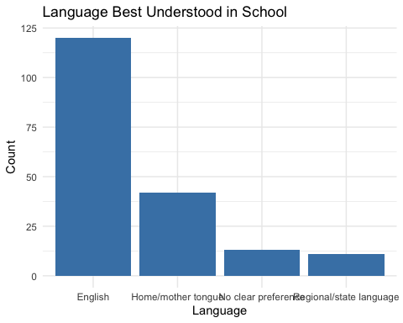
This bar chart shows that English is, by a large margin, the language best understood in school among the respondents. The home/mother tongue is the second most common choice, but it was selected by a significantly smaller number of people. Regional/state languages and having no clear preference were the least frequent responses.
# Confidence in English
ggplot(data, aes(x = how_confident_do_you_feel_reading_and_understanding_school_textbooks_in_english)) +
geom_bar(fill = "darkgreen") +
theme_minimal() +
labs(title = "Confidence in Reading English Textbooks", x = "Confidence", y = "Count")
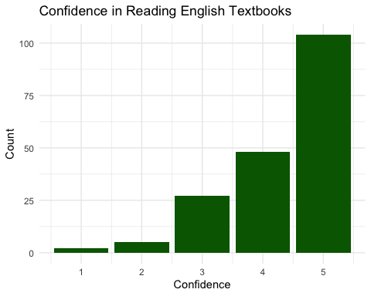
This bar chart shows that the respondents are, on the whole, very confident in reading and understanding English textbooks. The distribution is strongly skewed to the left, with the vast majority of responses being a 4 or 5. The most frequent rating given was 5, indicating the highest level of confidence.
# Cross-tab: Difficulty due to language gap vs. main language used by teachers
ggplot(data, aes(x = main_language_used_by_teachers, fill = difficulty_due_to_language_gap)) +
geom_bar(position = "dodge") +
theme_minimal() +
labs(title = "Language Gap Difficulty vs Teacher's Language", x = "Teacher Language", y = "Count")
## Warning: The following aesthetics were dropped during statistical transformation: fill.
## ℹ This can happen when ggplot fails to infer the correct grouping structure in
## the data.
## ℹ Did you forget to specify a `group` aesthetic or to convert a numerical
## variable into a factor?
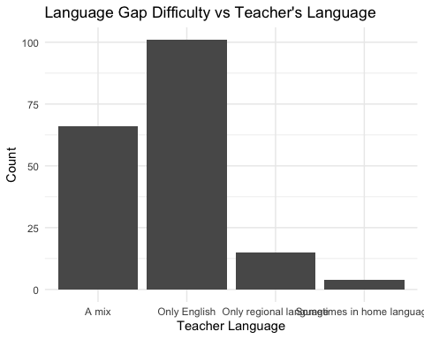
This visualization has failed to render correctly, as confirmed by the warning message, so it does not show the intended relationship between language difficulty and the teacher's language. Instead, the chart only displays the frequency of the main language used by teachers. It shows that "Only English" is the most common language teachers use, followed by "A mix".
# Chi-square test (Association)
# Example: Is there an association between main language used by teachers and difficulty?
chisq.test(table(data$main_language_used_by_teachers, data$difficulty_due_to_language_gap))
## Warning in stats::chisq.test(x, y, ...): Chi-squared approximation may be
## incorrect
##
## Pearson's Chi-squared test
##
## data: table(data$main_language_used_by_teachers, data$difficulty_due_to_language_gap)
## X-squared = 20.381, df = 12, p-value = 0.06021
The Chi-square test shows no statistically significant association between the main language used by teachers and students’ difficulty due to language gap (χ² = 20.38, df = 12, p ≈ 0.06), though the p-value is close to 0.05, suggesting a potential trend worth further exploration.

# Example: Association between confidence in English and perception of performance gap
chisq.test(table(data$how_confident_do_you_feel_reading_and_understanding_school_textbooks_in_english,
data$do_you_feel_that_students_from_english_speaking_or_majority_language_backgrounds_perform_better_in_your_class))
## Warning in stats::chisq.test(x, y, ...): Chi-squared approximation may be
## incorrect
##
## Pearson's Chi-squared test
##
## data: table(data$how_confident_do_you_feel_reading_and_understanding_school_textbooks_in_english, data$do_you_feel_that_students_from_english_speaking_or_majority_language_backgrounds_perform_better_in_your_class)
## X-squared = 16.589, df = 12, p-value = 0.1657
The Chi-square test shows no significant association between students’ confidence in English and their perception of majority-language students’ performance (χ² = 16.59, df = 12, p ≈ 0.17), indicating that perceived performance gaps are not strongly linked to self-reported English confidence.# Correlation matrix
cor_matrix <- cor(ordinal_data, use = "complete.obs")# Plot correlation heatmap
corrplot(cor_matrix, method = "color", addCoef.col = "black",
tl.col = "black", tl.srt = 45,
title = "Correlation Between Language-Related Variables")
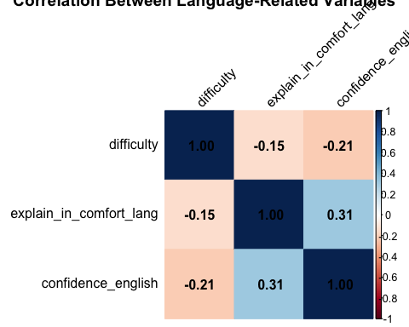

This correlation heatmap shows the relationships between three language-related variables. The strongest relationship is a weak positive correlation of 0.31 between confidence_english and explain_in_comfort_lang. Difficulty has a weak negative correlation with both English confidence (–0.21) and the ability to explain in a comfort language (–0.15), suggesting that as the latter two increase, difficulty slightly decreases.

Conclusion
The analysis of the educational survey highlights key factors affecting students’ learning experiences in India. Digital access and internet connectivity were found to be uneven across locations, income groups, and education levels, with limited access linked to declines in academic performance and motivation. This underscores the persistent digital divide as a major barrier to effective online learning.

Gender disparities were also evident. Girls faced higher household responsibilities, and parental encouragement differed for boys and girls, indicating ongoing gender biases that affect educational engagement. Teacher perceptions and classroom practices further influenced these experiences, highlighting the need for equitable treatment and support.

Language proficiency emerged as another significant factor. Students who were less comfortable with the language of instruction reported greater learning difficulties and lower confidence, while teacher language practices affected comprehension. This suggests the importance of language-inclusive teaching strategies to improve understanding and academic outcomes.
Overall, correlations among digital access, teacher support, and peer interactions indicate that improving infrastructure and teacher readiness can positively impact multiple aspects of learning.
In conclusion, addressing digital inequities, gender-based challenges, and language barriers is critical for promoting inclusive and effective education. Targeted interventions can enhance student engagement, reduce learning loss, and ensure equitable opportunities for all students in India.

References
- Khan, S., Bhat, R., & Saleem, S. (2023). Impact of COVID-19 on Education and Research: A Perspective of Select Students and Researchers in India. International Journal of Educational Research.
- Vivek, R., & Rangasami, R. (2024). Impact of COVID-19 on the Primary Level Teaching-Learning Process in Rural India. Journal of Rural Education Studies.
- Nanda Gopal, D. (2021). The Impact of COVID-19 in the Field of Educational Sector in India – An Analytical Research Study. Journal of Indian Education Research.
- Shree Priya Singh, A., et al. (2023). Gender Discrimination and Inequalities in Education Expenditure in India. International Journal of Social Economics, 50(5), 789–804.
- Lin, Z. (2022). Gender Inequity in K-12 Education. ISEMSS Proceedings, Qingdao University.
- Das, S. (2023). Inequality in Educational Attainment: Urban-Rural Comparison in the Indian Context. Syamaprasad College Journal of Education.
- Kumar, A., Sharma, R., Patel, P., Gupta, S., & Singh, V. (2024). Educational Inequality and Its Impact on Social and Economic Opportunities in Rural India. Journal of Social Policy and Education, 12(2), 112–130.
- Santosh, P. (2020). Scholastic Backwardness in Children Attending Normal School. Indian Journal of Educational Psychology, 15(3), 45–58.
- Vogelzang, L., et al. (2024). Effects of Mother Tongue Education and Multilingualism on Reading Skills in India. Journal of Multilingual Education Research, 7(1), 23–40.
- NSSO (1995–2018). Unit-Level Household Surveys on Education in India. National Sample Survey Office, Ministry of Statistics, Government of India.

