Spectral sensors
AS72651-BLGT
https://www.mouser.co.uk/ProductDetail/ams-OSRAM/AS72651-BLGT?qs=YCa%2FAAYMW03SsE5ip4GyWw%3D%3D
AS72652-BLGM
https://www.mouser.co.uk/ProductDetail/ams-OSRAM/AS72652-BLGM?qs=byeeYqUIh0MwQKd6yzDQEA%3D%3D
AS72653-BLGM
https://www.mouser.co.uk/ProductDetail/ams-OSRAM/AS72653-BLGM?qs=byeeYqUIh0N5Q0CaJCwXCA%3D%3D

4MB Flash
https://www.mouser.co.uk/c/?q=AT25SF041

Diagram
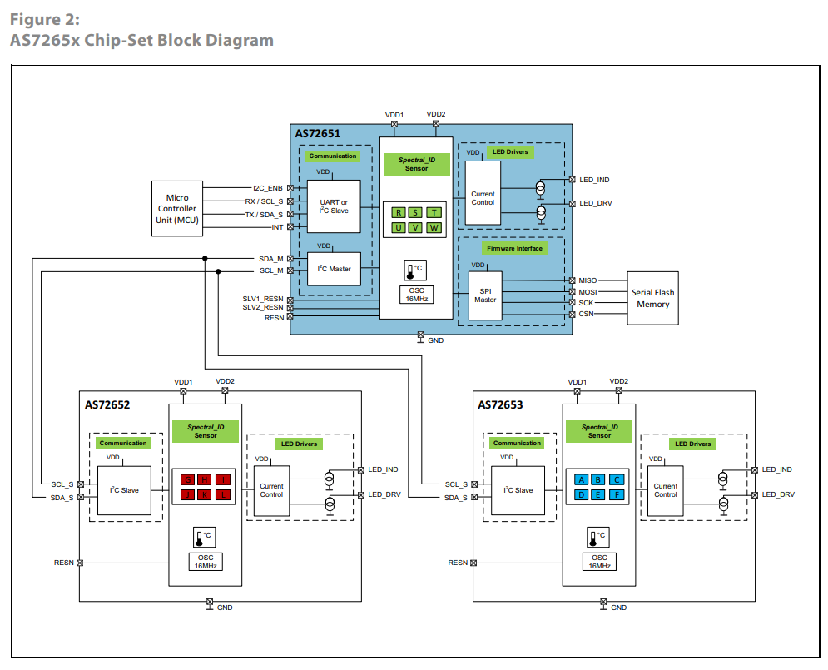
Design considerations
The AS72651 device needs a flash memory to store the firmware and the data. The flash memory should be at least 2-Mbits operating at SPI mode 0 with byte write supported.
The LED, D11 in the typical schematic, is recommended for debugging purpose. During AS72651 power up, D11 should be on for a short time and off. If D11 is blinking, it indicates there is an issue with accessing the flash memory content.

Schematic
file:///C:/Users/User/OneDrive%20-%20University%20of%20Bath/Mission%20Pegasus/Sparkfun/AS7265x%20Schematic%20Generation_2.pdf

Firmware

Connectors

PC104 layers
Samtec ESQ-126-39-G-D
https://www.mouser.co.uk/ProductDetail/Samtec/ESQ-126-39-G-D?qs=Cqqh%252BS766wm7W672HSOlSA%3D%3D

Raspberry pi to main board
https://www.mouser.co.uk/ProductDetail/SchmartBoard/920-0135-01?qs=WBUF01kN13lvFiBwxduHPw%3D%3D

Spark fun Github

https://github.com/sparkfun/Qwiic_Spectral_Sensor_AS7265x

Questions

VDD1 VDD1
INT and RST help, why not on the qwik connect
All on one board?
No LEDs

RST ADDR

Trust schematic or datasheet

Get MOUSR numbers for 10 boards

Sensors on opposite sides

Pi zero, boards

Farnell

Raspberry Pis in space

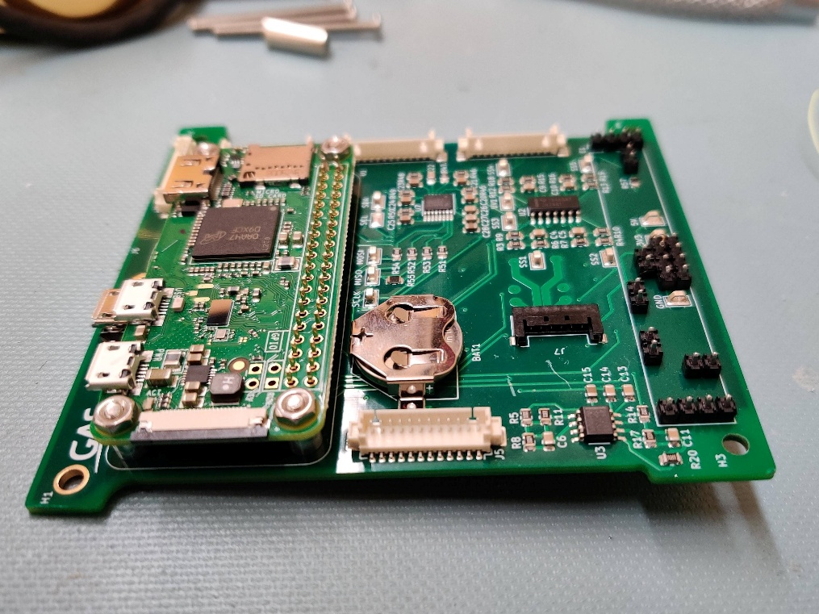
https://nepp.nasa.gov/docs/papers/2021-Guertin-Raspberry-Pi-Guideline-CL-21-5641.pdf

Watchdog

DFRobot Beetle Board

Software

https://github.com/SmallSatGasTeam/CubeWorks
2 x20 pins connection
https://thepihut.com/products/break-away-0-1-2x20-pin-strip-dual-male-header?variant=27740137489&country=GB&currency=GBP&utm_medium=product_sync&utm_source=google&utm_content=sag_organic&utm_campaign=sag_organic

https://www.mouser.co.uk/ProductDetail/SchmartBoard/920-0199-01?qs=5aG0NVq1C4wO2QQoWinwcA%3D%3D

Board to board

https://www.mouser.co.uk/ProductDetail/Amphenol-FCI/68021-120HLF?qs=QKvFUfBIyQLKTXbLGClQCQ%3D%3D
https://www.mouser.co.uk/ProductDetail/Molex/10-88-3201?qs=yq6dHiFsY%2FwBE5jk1c6zoQ%3D%3D

PCB Receptacle, Board-to-Board, 2.54 mm, 2 Rows, 40 Contacts, Female Receptacle
https://uk.farnell.com/molex/90152-2140/conn-r-a-rcpt-40pos-2row-2-54mm/dp/3865288

https://www.mouser.co.uk/ProductDetail/Molex/503376-4010?qs=6kT3pPPHxnUcJRrksBOx%2Fg%3D%3D

https://www.mouser.co.uk/ProductDetail/Molex/70247-4051?qs=L7RdmAxh%252BcMhqlOlB5RHog%3D%3D

