Scheduling CSP

Aravind Sundaresan – sundrsn2 (3 Units)

Krish Masand – masand2 (3 Units)

1. Setting up the Environment

To make our search method more intuitive, we created Class, Semester, and Simulation objects.

Class objects store all characteristics of a class, such as fall price, spring price, credit hours, and an ArrayList of prerequisites.

Semester objects store an ArrayList of Classes, an integer value which determines if it is a fall or spring semester (fall if not divisible by 2, spring if divisible by 2), the total number of hours that each Class in the semester adds up to, and the total cost that the cost of each Class in the semester adds up to.

Simulation objects contain most of the methods used for searching for classes, as Simulation objects set up the entire environment and instantiate the Class and Semester objects when necessary. A Simulation object is what takes in one of the actual text files provided, parses the data and assigns it to the right areas. It assigns the first value to an integer that holds the number of courses, the second value to the minimum credit requirement for each semester, and the third value to the maximum credit requirement for each semester. It similarly goes through every other line and assigns proper values. When creating Class objects, the methods creates the Class objects based on each line in the input file that describes the Class, and then adds that Class to an ArrayList of all Classes. It then revisits each Class in the ArrayList when it reaches the lines that assign prerequisites to each Class. It reaches the second to last line, sets the first value to the number of courses that the student is interested in, and then adds each value in the line after that to an ArrayList that contains the number of each course that the student is interested in. Lastly, it takes in the last line, which is assigned to an integer called “budget,” which is actually never used because we did not have to keep track of the budget.

CSP Classification:

Variables: Classes, Semesters

Constraints: Credit Hours, Prerequisites

Domain: Simulations

1.1 Creating the Schedule

Our backtracking search primarily uses two methods: The Simulation object’s “*add*” and the Semester object’s “*add*.” These two methods are utilized by the Simulation object’s “*schedule”* method to create a working schedule.

Semester’s *add* operates by taking in a Class object and returning the Class object that it added to the Semester’s *classes* ArrayList(they may not be the same Class). It then checks to see if adding the Class would overflow the Semester object that’s adding the class (making sure that adding the class would not lead to the Semester object exceeding the maximum allowed credit hours). After it has checked for this, it then checks if any of the Class’s prerequisites have already been added to that Semester. If they have, the method returns null, and what happens next in this situation is handled by Simulation’s *add* (to quickly summarize, it adds that particular Class to the next possible Semester that does not already have any of its prerequisites). The method then checks if any of the Class’s prerequisites have not been taken yet by checking the Class’s remaining prerequisites. If there are prerequisites, the method is called recursively on the next prerequisite (this is why the original Class that the method takes in may not be the Class that the method returns). If there are no prerequisites left to be taken, the class is added to the Semester.

Simulation’s *add* uses Semester’s *add* along with other tools to add a Class to the next available Semester. It takes in a Class object and returns nothing. *add* starts off by checking to see if the ArrayList of Semester objects is empty, and if it is, it adds an empty Semester object to the ArrayList. It then adds a Class to the next available Semester using Semester’s *add*. If the Class that is returned is null, we know that one of the Class’s prerequisites is already in that available Semester, so we attempt to add it to the next available Semester that does not have one of its prerequisites. If one does not exist, a new Semester object is created, and the Class is put in that Semester. After a Class was successfully added, we add that Class to an ArrayList of Classes that have been taken.

Using these two methods, the *schedule* method first adds all of the courses that the student is interested in. These are added in order as provided in the input text file. During this process, each prerequisite for all of the courses is also added, as part of Semester’s recursive *add* function. After this, it is possible that some of the Semesters that have been created may not fulfill the minimum number of credit hours. To fulfill the minimum number of credit hours, we then add any class that has not been added using another implementation of Simulation’s *add* that never creates new Semesters (it takes in the Class we want to add and the number of the Semester we want to add it to, instead of just a Class object). After that class or its prerequisite has been added (depending on what Semester’s recursive *add* function returns), we check to see if the minimum number of credit hours has been met. If it hasn’t, we continue to add Classes (skipping a Class that might potentially go past the maximum limit instead of just hitting the minimum number of credit hours). If it has, we move on the next Semester until every Semester is fulfilled.

1.2 Results

First Scenario:

2347 3

2 9 8

2 3 5

3 1 2 4

638 907 802

Second Scenario:

6432 3

4 8 19 12 7

6 11 14 1 4 15 3

3 13 1 6

1549 3391 1492

Third Scenario:

11010 5

4 27 8 13 28

4 20 25 8 13

5 14 28 12 3 13

4 30 15 7 3

4 16 21 17 8

2152 718 2809 2690 2641

Fourth Scenario:

15959 7

4 2 38 14 26

4 34 14 2 12

5 28 31 17 3 19

4 9 19 38 12

6 17 13 2 38 12 14

4 18 13 38 12

5 3 13 17 38 12

2218 1734 2855 1408 3193 1766 2785

War Game

Aravind Sundaresan – sundrsn2 (3 Units)

Krish Masand – masand2 (3 Units)

2.0 Setting up the Environment

We developed our environment intuitively by creating both Board, Square, Player objects, where the Board class allows the user to create a board with whatever starting values they want, and with all Squares on the board set to unclaimed. The Square objects were made with two parameters, the points on the Square, and who the square belonged to. The board was created using a 2 dimensional array of type Square. The Player class specified what color the player was, and what agent the player would be using to win the game, Minimax or Alpha-Beta. A Player and a Square could either be of color green or blue, and two agents are required to start a game. The Board could be initialized in any of the 5 boards that were specified to test.

Boards are constructed to be 6 by 6, and default two 1 point in each square, and the color “n”, for no color. Throughout the game,

Minimax and AlphaBeta agents were created as separate classes, with MinimaxObjects and AlphaBetaObjects to aid in packaging data to return from methods. The Board was passed into both of these agents, and they were able to make “moves” to modify the board on each of their turns. They made moves by executing the takeOver() method in the Board class, allowing them to take over a Square on the Board.

Simulations were executed by constructing 5 different boards: Keren, Narvik, Sevastopol, Smolensk, and Westerplatte. 4 pairs of agents for each board were created for a total of 40 simulations: Minimax vs. Minimax, Alpha-Beta vs Alpha-Beta, Minimax vs Alpha-Beta (Minimax first), and Minimax vs Alpha-Beta (Alpha-Beta first). These simulations recorded who won the game (obviously), the final score, the number of expanded nodes, the average nodes expanded per move, and the average amount of time per move in seconds.

2.1 Minimax and Alpha-Beta Agents

Here are the simulations for the 5 boards, and the results displayed numerically and graphically.

I. Keren

A) Minimax vs Minimax

Winner: Green

|  |  |  |
| --- | --- | --- |
|  | Minimax (green) | Minimax (blue) |
| Final Score | 21 | 15 |
| Expanded Nodes | 186967 | 209306 |
| Average Nodes per Move | 10387 | 11628 |
| Average Time per Move | 1.13 | 1.26 |

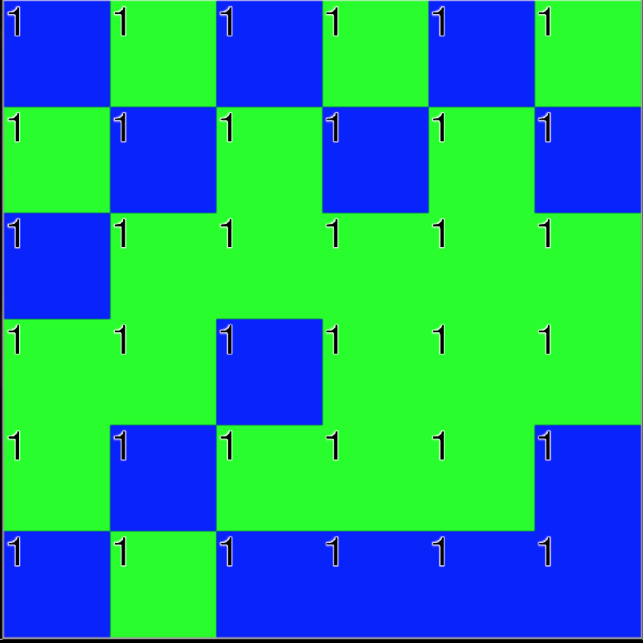

B) Alpha-Beta vs Alpha-Beta

Winner: Tie

|  |  |  |
| --- | --- | --- |
|  | Alpha-Beta (green) | Alpha-Beta (blue) |
| Final Score | 18 | 18 |
| Expanded Nodes | 18391 | 22163 |
| Average Nodes per Move | 1022 | 1231 |
| Average Time per Move | 0.21 | 0.23 |

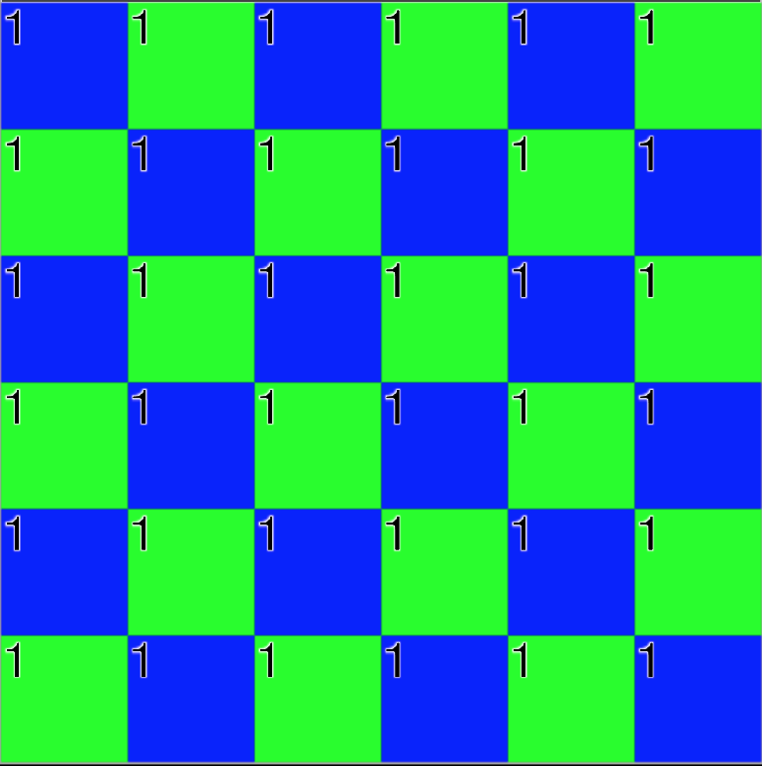

C) Minimax vs Alpha-Beta (Minimax first)

Winner: Green

|  |  |  |
| --- | --- | --- |
|  | Alpha-Beta (green) | Minimax (blue) |
| Final Score | 22 | 14 |
| Expanded Nodes | 19956 | 209306 |
| Average Nodes per Move | 1109 | 11628 |
| Average Time per Move | 0.24 | 1.63 |

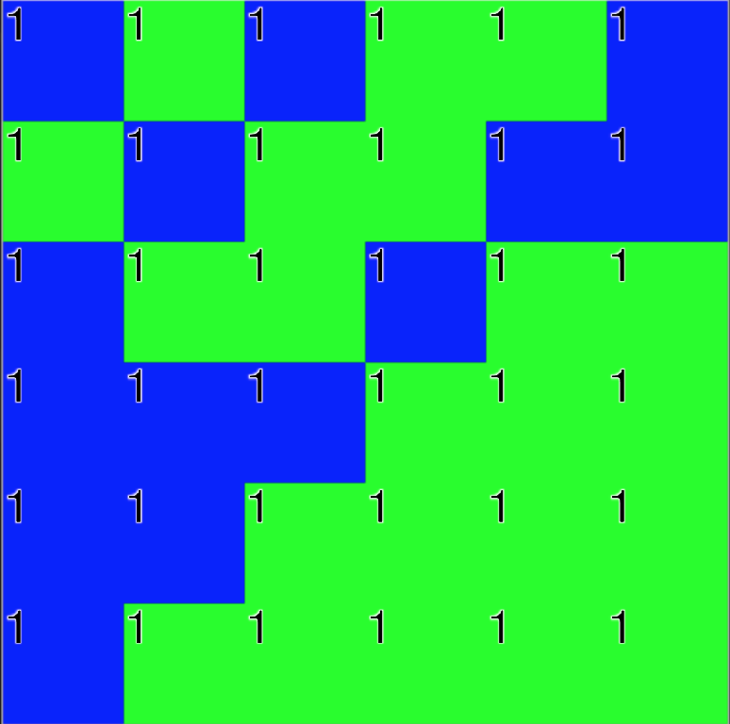

D) Alpha-Beta vs Minimax (Alpha-Beta first)

Winner: Tie

|  |  |  |
| --- | --- | --- |
|  | Minimax (green) | Alpha-Beta (blue) |
| Final Score | 18 | 18 |
| Expanded Nodes | 186967 | 22163 |
| Average Nodes per Move | 10387 | 1231 |
| Average Time per Move | 1.40 | 0.22 |

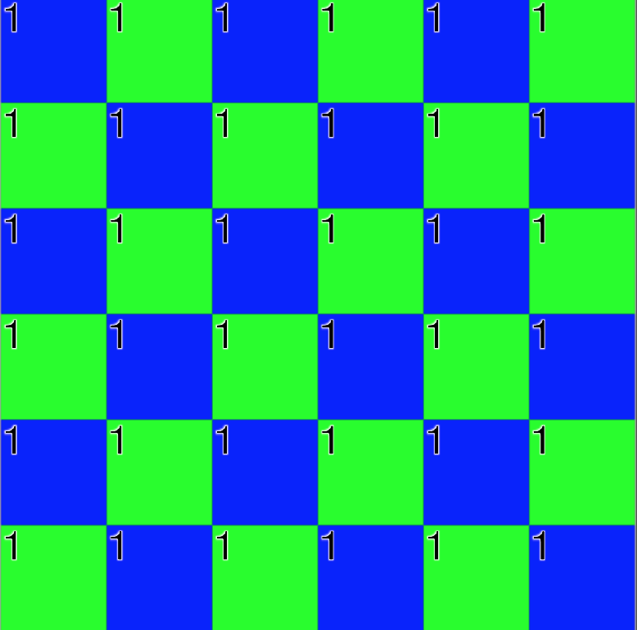

II. Narvik

A) Minimax vs Minimax

Winner: green

|  |  |  |
| --- | --- | --- |
|  | Minimax (green) | Minimax (blue) |
| Final Score | 1096 | 704 |
| Expanded Nodes | 186967 | 209306 |
| Average Nodes per Move | 10387 | 11628 |
| Average Time per Move | 1.16 | 1.23 |

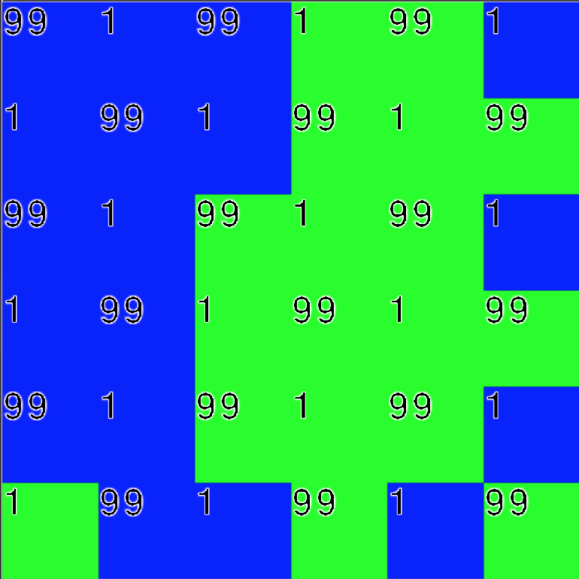

B) Alpha-Beta vs Alpha-Beta

Winner: Tie

|  |  |  |
| --- | --- | --- |
|  | Alpha-Beta (green) | Alpha-Beta (blue) |
| Final Score | 900 | 900 |
| Expanded Nodes | 59725 | 52294 |
| Average Nodes per Move | 3318 | 2905 |
| Average Time per Move | 0.54 | 0.52 |

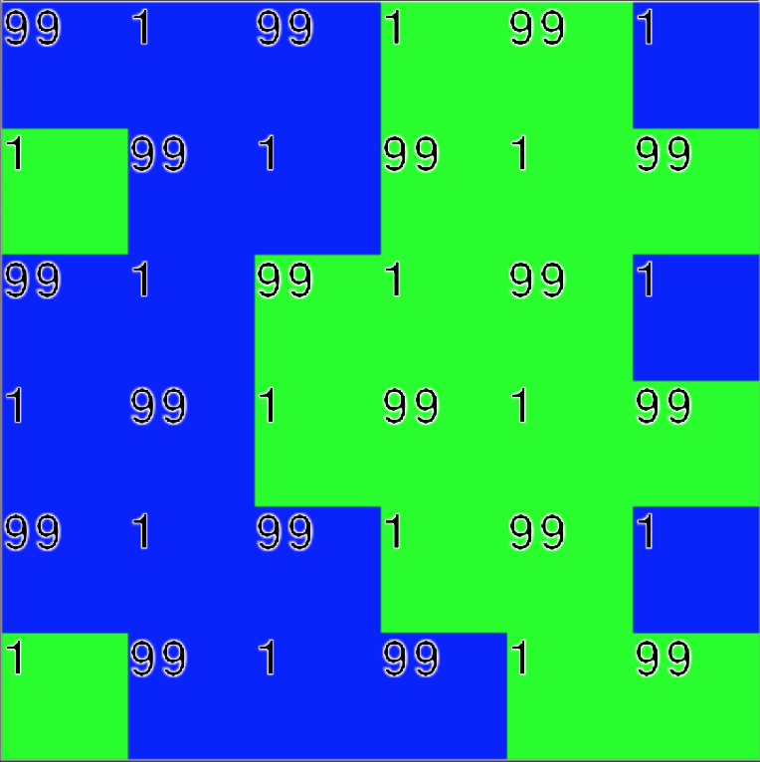

C) Minimax vs Alpha-Beta (Minimax first)

Winner: green

|  |  |  |
| --- | --- | --- |
|  | Alpha-Beta (green) | Minimax (blue) |
| Final Score | 901 | 899 |
| Expanded Nodes | 57782 | 209306 |
| Average Nodes per Move | 3210 | 11628 |
| Average Time per Move | 0.66 | 1.74 |

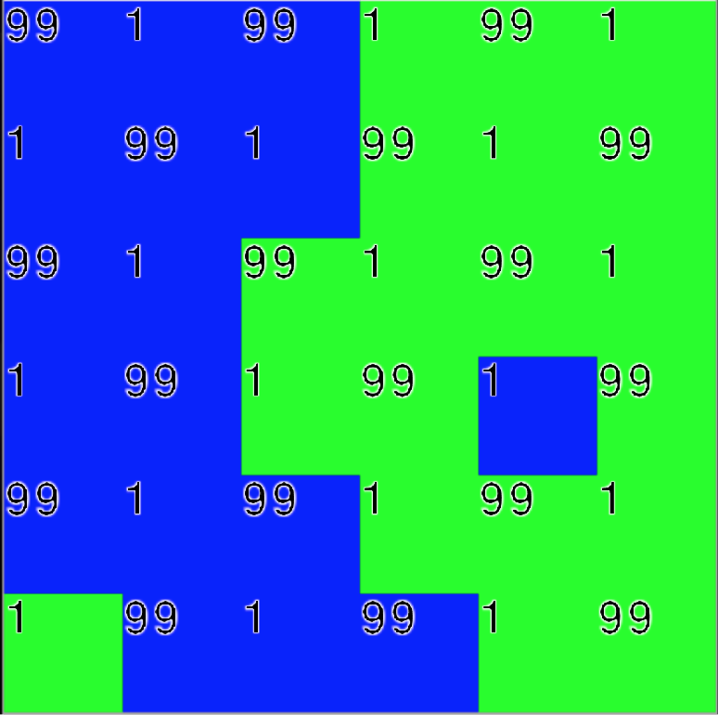

D) Alpha-Beta vs Minimax (Alpha-Beta first)

Winner: blue

|  |  |  |
| --- | --- | --- |
|  | Minimax (green) | Alpha-Beta (blue) |
| Final Score | 703 | 1097 |
| Expanded Nodes | 186967 | 51055 |
| Average Nodes per Move | 10387 | 2836 |
| Average Time per Move | 1.53 | 0.34 |

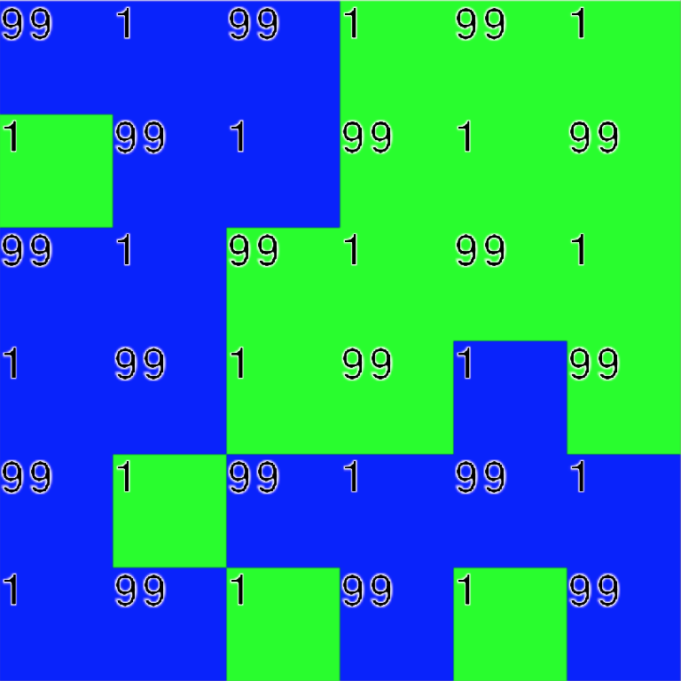

III. Sevastopol

A) Minimax vs Minimax

Winner: blue

|  |  |  |
| --- | --- | --- |
|  | Minimax (green) | Minimax (blue) |
| Final Score | 152 | 226 |
| Expanded Nodes | 186967 | 209306 |
| Average Nodes per Move | 10387 | 11628 |
| Average Time per Move | 1.43 | 1.54 |

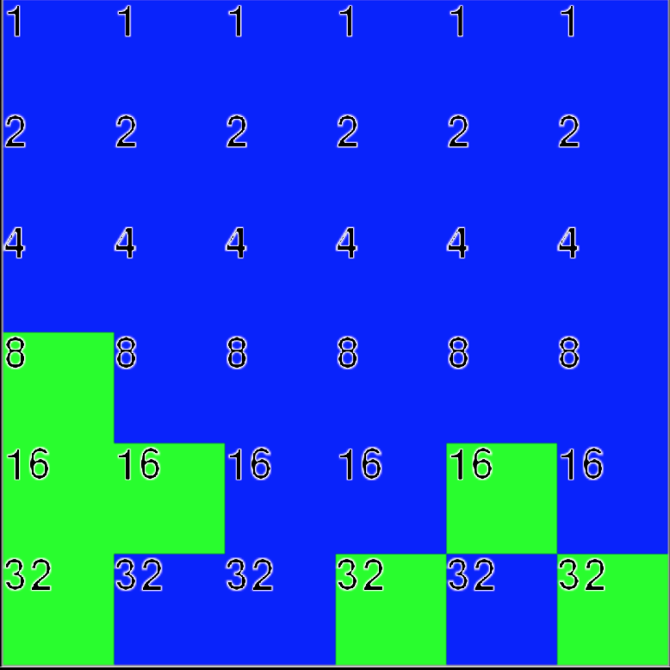

B) Alpha-Beta vs Alpha-Beta

Winner: blue

|  |  |  |
| --- | --- | --- |
|  | Alpha-Beta (green) | Alpha-Beta (blue) |
| Final Score | 188 | 189 |
| Expanded Nodes | 3256779 | 3610558 |
| Average Nodes per Move | 180932 | 200587 |
| Average Time per Move | 44.21 | 43.66 |

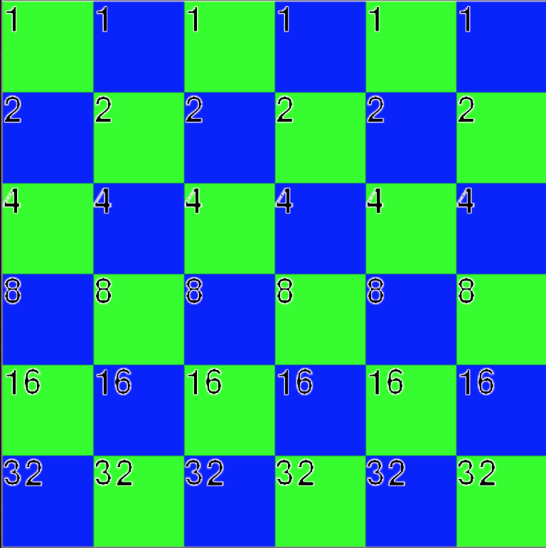

C) Minimax vs Alpha-Beta (Minimax first)

Winner: green

|  |  |  |
| --- | --- | --- |
|  | Alpha-Beta (green) | Minimax (blue) |
| Final Score | 230 | 148 |
| Expanded Nodes | 2917545 | 209306 |
| Average Nodes per Move | 162086 | 11628 |
| Average Time per Move | 44.60 | 3.16 |

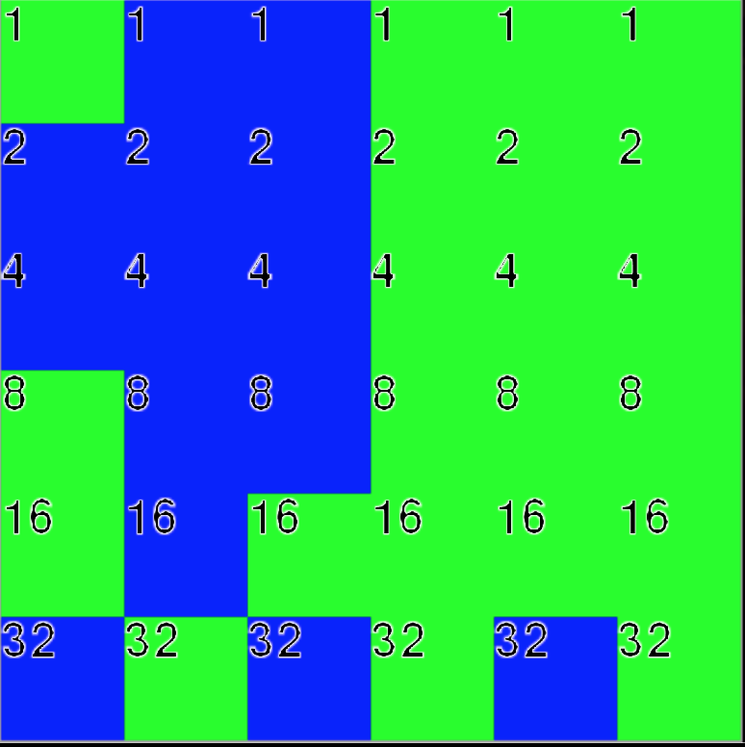

D) Alpha-Beta vs Minimax (Alpha-Beta first)

Winner: blue

|  |  |  |
| --- | --- | --- |
|  | Minimax (green) | Alpha-Beta (blue) |
| Final Score | 159 | 219 |
| Expanded Nodes | 186967 | 3844125 |
| Average Nodes per Move | 10387 | 213562 |
| Average Time per Move | 1.16 | 30.17 |

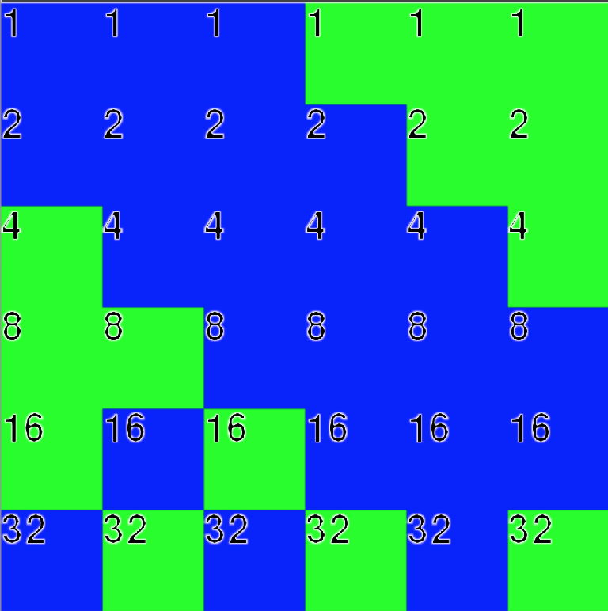

IV. Smolensk

A) Minimax vs. Minimax

Winner: green

|  |  |  |
| --- | --- | --- |
|  | Minimax (green) | Minimax (blue) |
| Final Score | 1118 | 535 |
| Expanded Nodes | 186967 | 209306 |
| Average Nodes per Move | 10387 | 11628 |
| Average Time per Move | 1.14 | 1.30 |

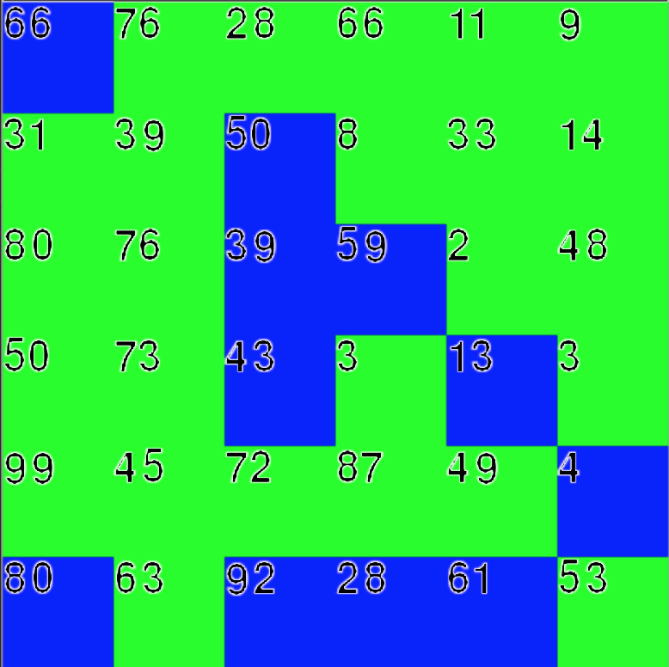

B) Alpha-Beta vs Alpha-Beta

Winner: blue

|  |  |  |
| --- | --- | --- |
|  | Alpha-Beta (green) | Alpha-Beta (blue) |
| Final Score | 763 | 890 |
| Expanded Nodes | 326671 | 236180 |
| Average Nodes per Move | 18148 | 13232 |
| Average Time per Move | 4.11 | 3.17 |

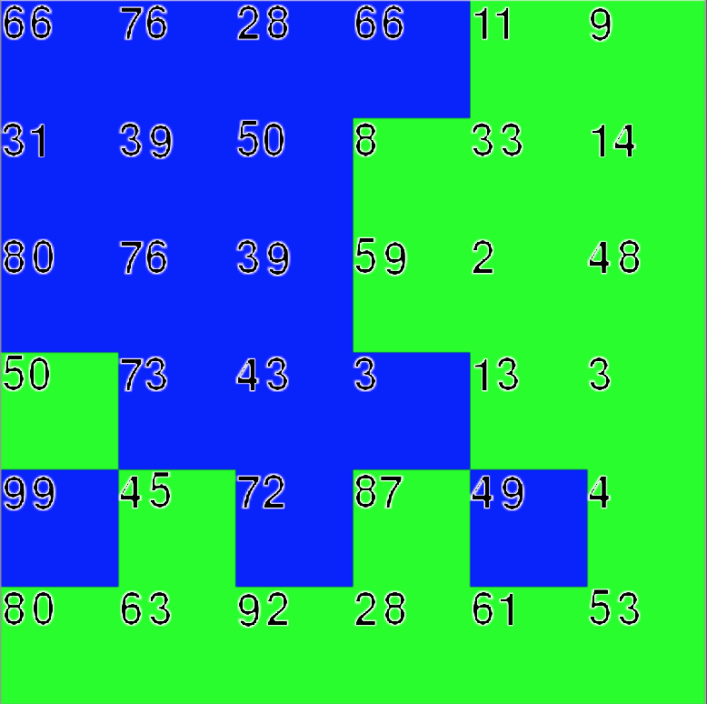

C) Minimax vs Alpha-Beta (Minimax first)

Winner: green

|  |  |  |
| --- | --- | --- |
|  | Alpha-Beta (green) | Minimax (blue) |
| Final Score | 1008 | 645 |
| Expanded Nodes | 760054 | 209306 |
| Average Nodes per Move | 42225 | 11628 |
| Average Time per Move | 7.89 | 2.23 |

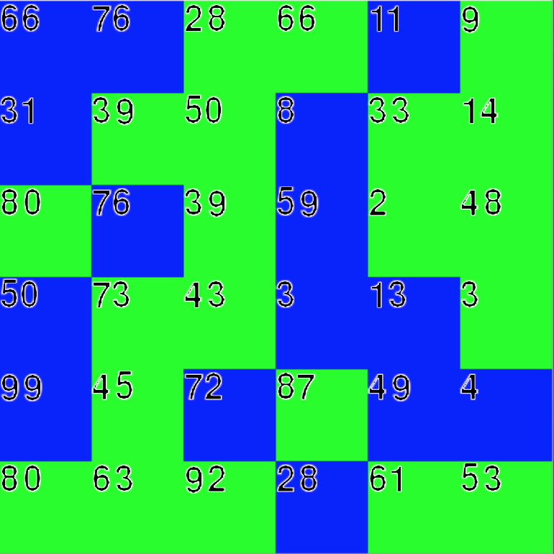

D) Alpha-Beta vs Minimax (Alpha-Beta first)

Winner: blue

|  |  |  |
| --- | --- | --- |
|  | Minimax (green) | Alpha-Beta (blue) |
| Final Score | 670 | 983 |
| Expanded Nodes | 186967 | 196498 |
| Average Nodes per Move | 10387 | 10917 |
| Average Time per Move | 1.96 | 2.35 |

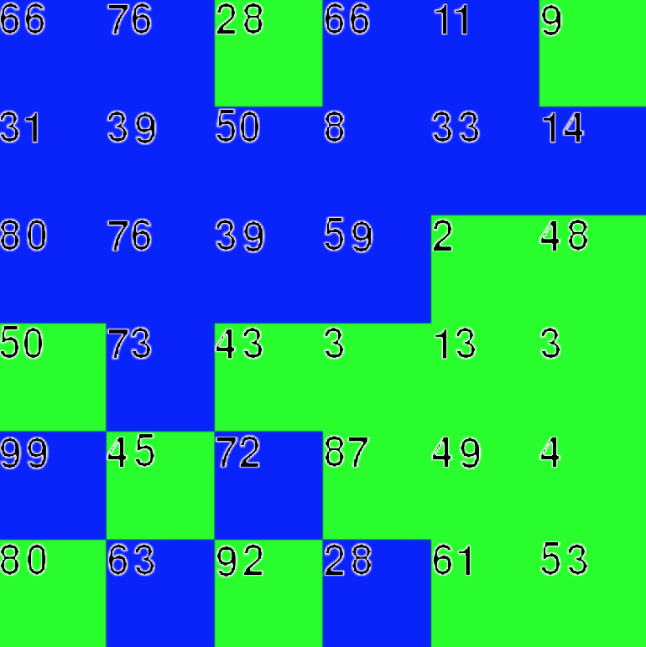

V. Westerplatte

A) Minimax vs Minimax  
winner: green

|  |  |  |
| --- | --- | --- |
|  | Minimax (green) | Minimax (blue) |
| Final Score | 41 | 31 |
| Expanded Nodes | 186967 | 209306 |
| Average Nodes per Move | 10387 | 11628 |
| Average Time per Move | 1.13 | 1.27 |

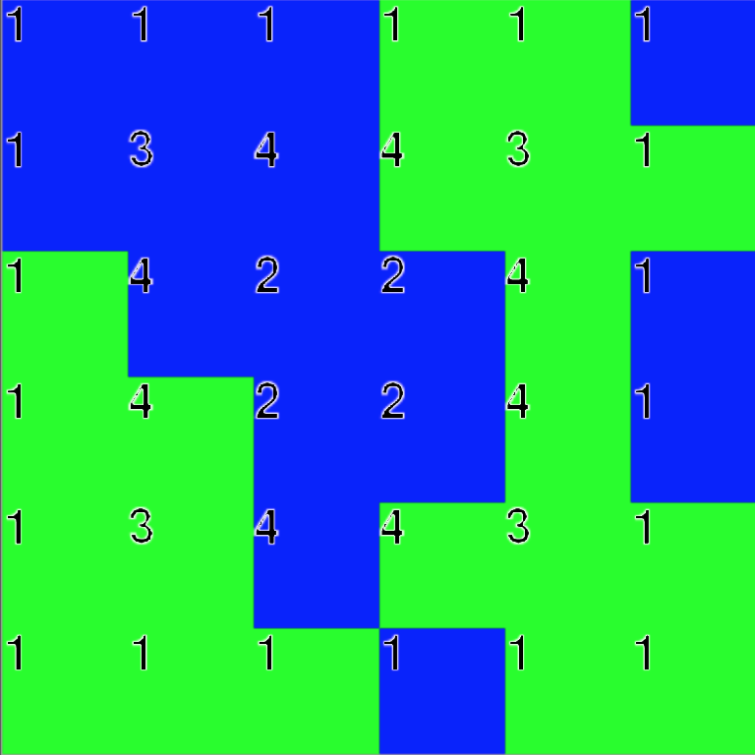

B) Alpha-Beta vs Alpha-Beta

Winner: green

|  |  |  |
| --- | --- | --- |
|  | Alpha-Beta (green) | Alpha-beta (blue) |
| Final Score | 39 | 33 |
| Expanded Nodes | 151515 | 258006 |
| Average Nodes per Move | 8418 | 14334 |
| Average Time per Move | 1.67 | 2.54 |

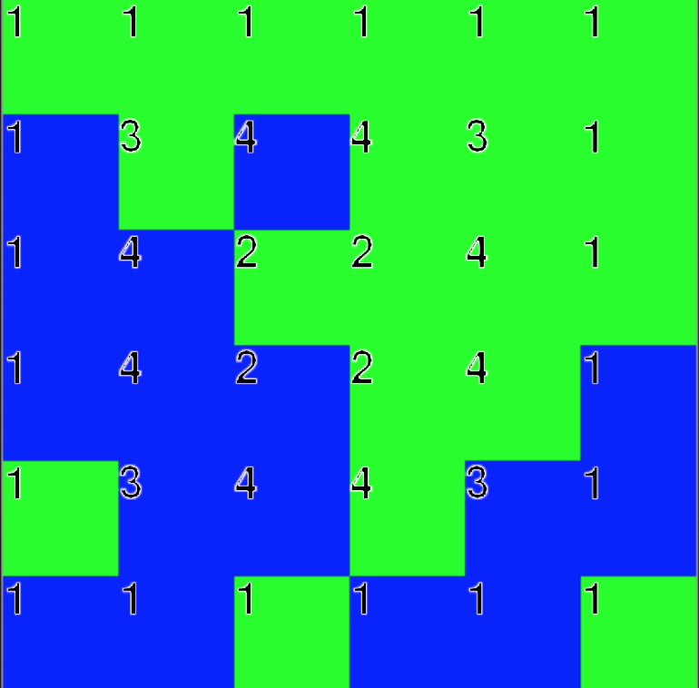

C) Minimax vs Alpha-Beta (Minimax First)

Winner: green

|  |  |  |
| --- | --- | --- |
|  | Alpha-Beta (green) | Minimax (blue) |
| Final Score | 39 | 33 |
| Expanded Nodes | 2248 | 209306 |
| Average Nodes per Move | 12493 | 11628 |
| Average Time per Move | 2.44 | 2.11 |

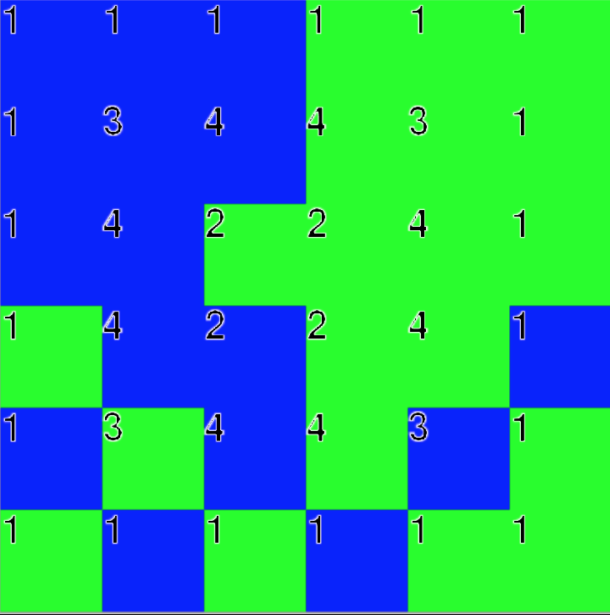

D) Alpha-Beta vs Minimax (Alpha-Beta first)

Winner: green

|  |  |  |
| --- | --- | --- |
|  | Minimax (green) | Alpha-Beta (Blue) |
| Final Score | 38 | 34 |
| Expanded Nodes | 186967 | 289998 |
| Average Nodes per Move | 10387 | 16111 |
| Average Time per Move | 2.05 | 3.21 |

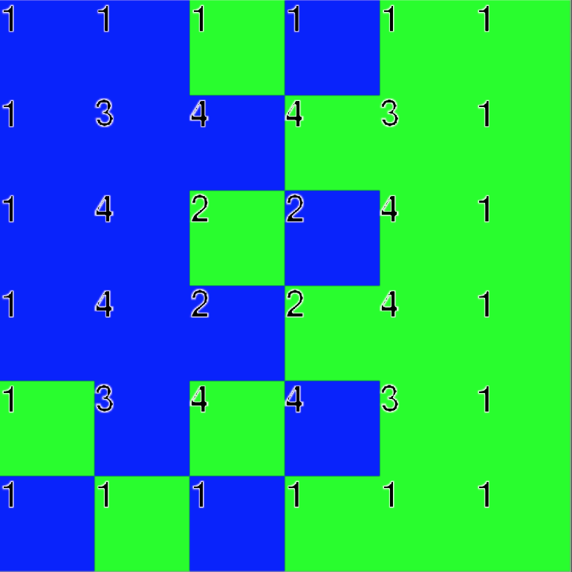

On average, Alpha-Beta expanded much fewer nodes than Minimax did. The time taken for Alpha-Beta moves was also drastically lower than the move time for Minimax on higher-point boards. Alpha-Beta won more matchups than Minimax did, giving a safe assumption that Alpha-Beta pruning is a more efficient backtracking search algorithm than Minimax search.

Contributions

Krish Masand:

Krish developed all of part 1, proofed part 2 code, and wrote half of the report.

Aravind Sundaresan:

Aravind developed all of part 2, proofed part 1 code, and wrote half of the report.