**1) Purpose Statement**

* The goals of this particular site is to be a user-friendly and “programming-friendly” site that can give the MEDLIFE members and any potential students who are interested in the MEDLIFE organization at Indiana University to have a professional experience, while a well-rounded understanding of what we have to offer as a student-run organization. The programming-friendly part is to create code that is somewhat easy to understand that the person who is inheriting my work can work with it even though they might have not background in coding.
* The scope for this project is quite large because I’ll have to at minimum implement an a calendar, membership page, volunteer page(sign-ups to google sheets), service learning page(informative page), and a about page. I would also like to implement a exec member page, album page and a social events page.
* The intended audience are for MEDLIFE members and potentially and new members

**2) Sitemap / Navigation**

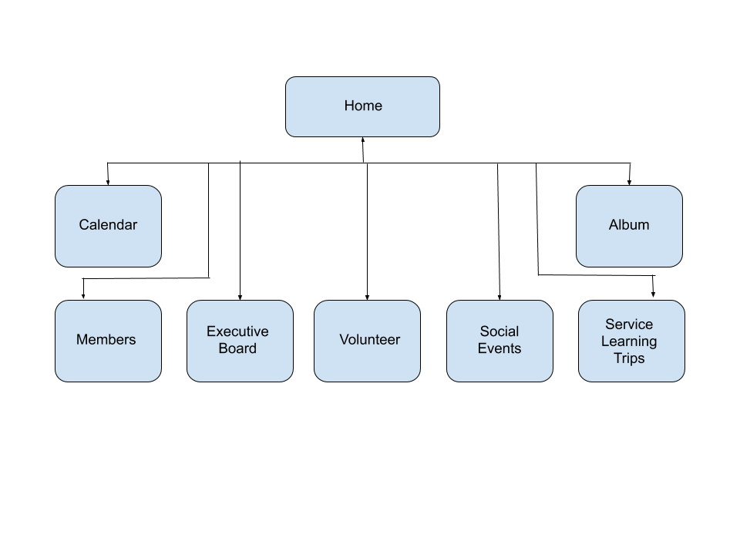

* **Flow chart or bulleted list** outline of the navigation / page structure
  + **Home**
  + **Calendar**
  + **Members**
  + **Executive Board**
  + **Volunteer**
  + **Social Events**
  + **Service Learning Trips**
  + **Album**
* **Sketch (in grayscale) or wireframe** showing a *layout* for each of the final pages.

**3) Content**

* Create a **check list** of elements needed for your site - this includes all the text, images, videos, graphics, etc.. *You might consider breaking this down by pages / modules.*
  + Navigation Bar
  + Embedded one of our Youtube videos on the website.
  + Maximize the images we have taken from our trips and show them in the site without having an overcrowded or jumbled look
    - Implement a carousel/gallary for each trip we have on the album page
    - Implement a carousel for executive board page
  + Text about what our organization is about as well as explanations for volunteering and service-learning trip policies.
  + Implement a Calendar with all the meetings, events, and volunteering
* Describe where you're going to find your resources, especially those that are visual, like photographs and videos.
  + Fortunately, I have a lot fo the resources provided for me. We have at least three albums of photos each with over 500+ images that I can use and that were taken by professionals.
  + The youtube video was created by us and as an executive board member I have access and permission to use our content
  + The only content I’d imagined I would need to possible ask for permission are the country stamps the official MEDLIFE organization has (we are a chapter under them).
  + Carousels I would use probably something like slick.js, glide.js, or whichever carousel fits the style I need
  + Google calendar already has a way to embed their calendar ready for me. I just need to embed it safely
  + The navigation bar, I’ll likely take reference to our code pen examples.
* Indicate what content is most important, and what might be less important
  + The most important contents are Home/About page, volunteer page, service learning page, calendar, and membership page. I could combine the calendar into another page, but I was planning to make the calendar page a calendar and announcement page.
* Indicate as you are able to: interface / interactive elements like a gallery, form, directory, slideshow, timeline, etc.. that you would like to try to implement
  + Mainly carousel and galleries are the interactive elements I want to implement

**4) Brand / Look and Feel / 'Style Tiles'**

* Describe in a couple of paragraphs the look and feel you'd like to achieve
  + The look I would like to achieve is to make it make look professional, clean, and timeless. I believe there will already be a lot of texture with the images I am provided with that adding texture to the pages, even if they are subtle might be overwhelming. We have so many pictures of the beautiful nature, culture, arts, architecture, and animals of South America. I might even use one of the pictures as a background. If not, I thought maybe solid colors below, but with very small details, like shadows, border radius, and hovering. As a chapter under the international MEDLIFE organization, we do have restriction on what we can do with the logo and have created our final version below.
  + What I am most worried about is developing a unique color-scheme that would look professional and not seem outdated. I guess in a way I do want a modern look, but white or dark(black/grey) pages are so common and I am biased towards them. My biggest challenge is to create a home/about page that is impactful enough that expresses how much we value service, that students want to be a part of our organization. The rest of the pages are meant to be informative or easy access pages for students to signup for our events, methods of contact, and our trips.
* Design and include a**logo - or say what you will do instead**
  + 
* Include a'**style tile'** or a "*Styles Section"* in your document showing:
  + **color scheme(s)**(screen shot from color.adobe.com or similar)
    - 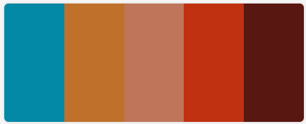
  + **typography choice(s)** (you may need to screen shot from Google fonts)
    - I won’t know until I work on it, but I am a fan of the serif fonts. Might just use the same font as the medlifemovement.com website.
    - 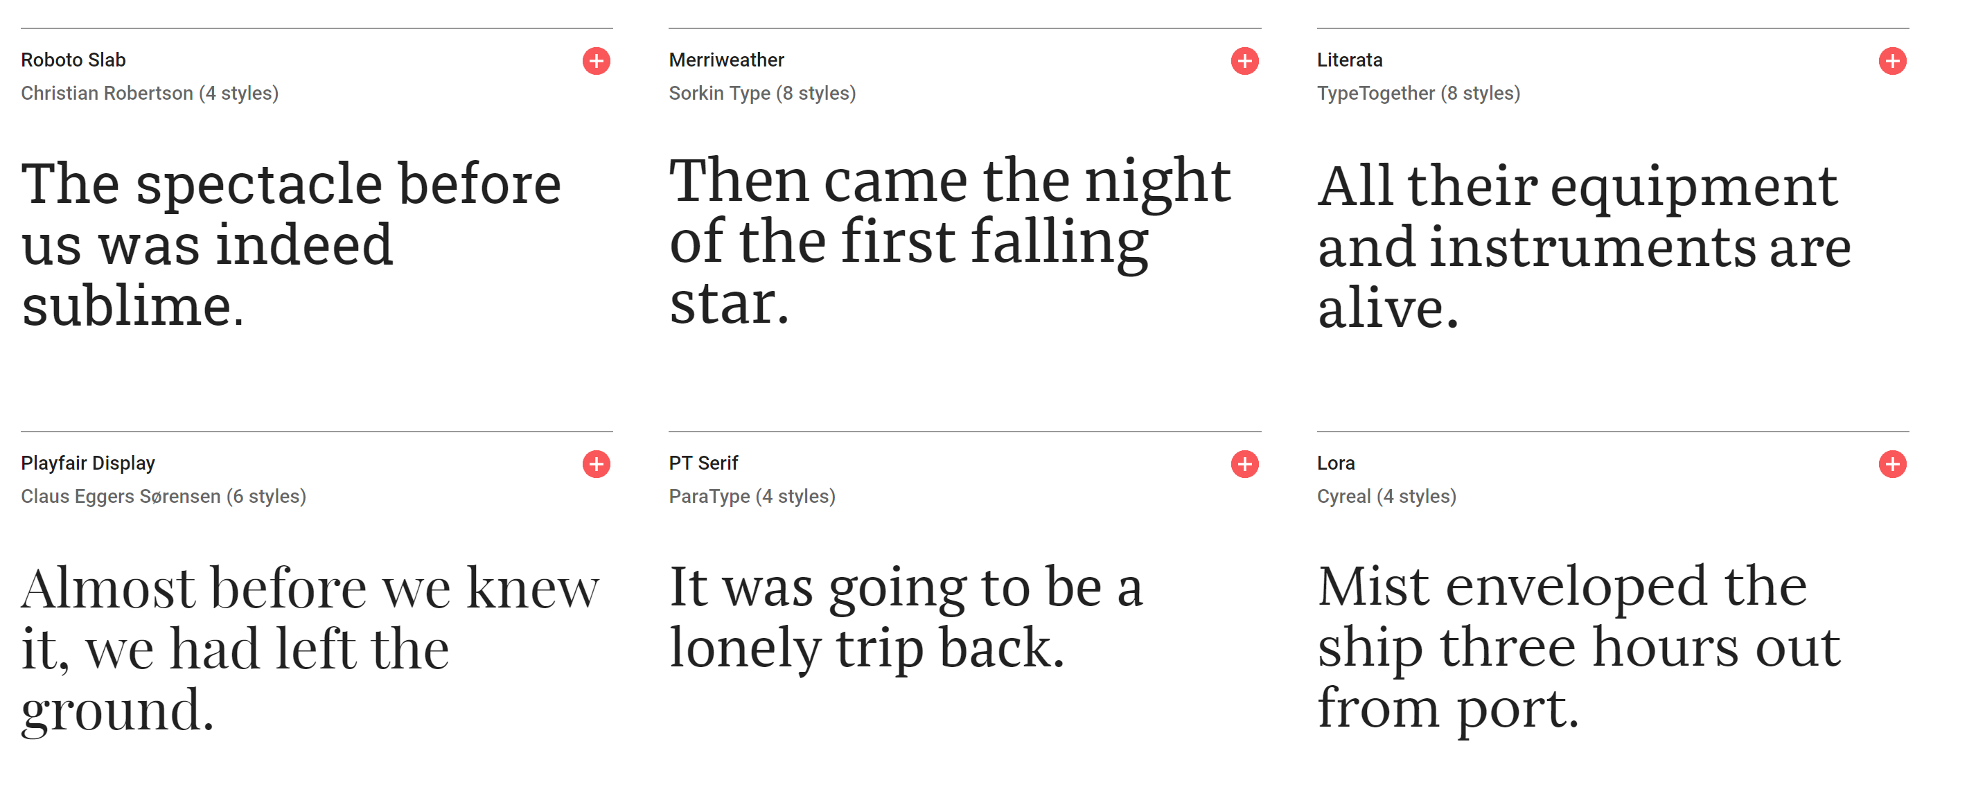
  + **textures / patterns**(paste in or screenshot)
    - A dirty old room

      Description automatically generated
  + **design elements**(like a repeating element or detail)
    - Some repeating elements will be the navigation bar, logo, color scheme, and the photos of South America..
  + **6 descriptors**
    - Friendly(Approachable)
    - Service-oriented
    - Professional
    - Inclusive
    - Experienced
    - Impactful