# Ex:05 Implement Programs for Estimating & Eliminating Trend in Time Series Data - Aggregation, Smoothing

## Aim

To estimate and eliminate trends in time series data using aggregation and smoothing techniques, helping in better data analysis and forecasting.

## Procedure

1. Load the dataset containing time series data.

2. Perform data preprocessing to clean and format the dataset.

3. Apply aggregation techniques to identify trends.

4. Use moving average smoothing to eliminate trends.

5. Visualize the original and processed time series data.

6. Interpret the results and analyze the trend adjustments.

## Code Implementation

The following Python program demonstrates trend estimation and elimination using aggregation and smoothing techniques in time series data:

import pandas as pd  
import matplotlib.pyplot as plt  
from statsmodels.tsa.seasonal import seasonal_decompose  
  
# Load dataset  
file_path = r"C:\Users\HDC0422251\Downloads\API_SP.DYN.TFRT.IN_DS2_EN_csv_v2_162 (1)\API_SP.DYN.TFRT.IN_DS2_EN_csv_v2_162.csv"  
  
df = pd.read_csv(file_path, skiprows=4)  
df = df[['Country Name]  
  
# Select data for India  
df = df[df['Country Name'] == 'India'].T  
df.columns = ['Birth Rate']  
df = df.iloc[1:].astype(float)  
df.index = pd.to_datetime(df.index)  
  
# Apply Rolling Mean for Aggregation  
df['Rolling Mean'] = df['Birth Rate'].rolling(window=5).mean()  
  
# Apply Exponential Moving Average (Smoothing)  
df['EMA'] = df['Birth Rate'].ewm(span=5, adjust=False).mean()  
  
# Trend Estimation using Seasonal Decomposition  
decomposition = seasonal_decompose(df['Birth Rate'], model='additive', period=10)  
df['Trend'] = decomposition.trend  
  
# Plot results  
plt.figure(figsize=(12, 6))  
plt.plot(df.index, df['Birth Rate'], label='Original', color='blue')  
plt.plot(df.index, df['Rolling Mean'], label='Rolling Mean (Aggregation)', color='red')  
plt.plot(df.index, df['EMA'], label='Exponential Moving Average (Smoothing)', color='green')  
plt.plot(df.index, df['Trend'], label='Trend Estimation', color='black', linestyle='dashed')  
  
plt.xlabel('Year')  
plt.ylabel('Birth Rate')  
plt.title('Trend Estimation and Smoothing of Birth Rate Data')  
plt.legend()  
plt.grid()  
plt.show()  
  
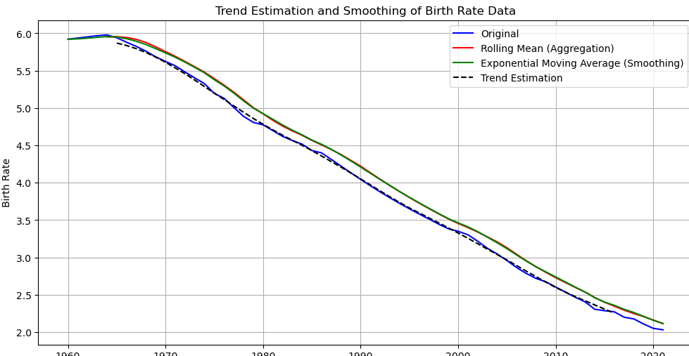

## Result

The program to implement programs for estimating & eliminating trend in time series data- aggregation, smoothing has been executed sucessfully