# Ex:06 Implement Program to Apply Moving Average Smoothing for Data Preparation and Time Series Forecasting

## Aim

To implement a program for applying moving average smoothing for data preparation and time series forecasting.

## Procedure

- Load the time series dataset.

- Visualize the original time series data.

- Apply moving average smoothing techniques.

- Plot the smoothed data alongside the original data.

- Interpret the impact of smoothing on forecasting.

- Analyze results and conclusions.

## Code

import pandas as pd

import numpy as np

import matplotlib.pyplot as plt

# Load dataset

file_path = r"C:\Users\HDC0422251\Downloads\API_SP.DYN.TFRT.IN_DS2_EN_csv_v2_162 (1)\API_SP.DYN.TFRT.IN_DS2_EN_csv_v2_162.csv"

df = pd.read_csv(file_path, skiprows=4) # Skip metadata rows

df = df[['Country Name]

# Select data for India

df = df[df['Country Name']

# Handle missing values by forward filling

df['Moving Average'] = df['Birth Rate'].rolling(window=window_size).mean()

df['Exponential Moving Average'] = df['Birth Rate'].ewm(span=5, adjust=False).mean()plt.figure(figsize=(12, 6))

plt.ylabel('Birth Rate')

plt.title('Moving Average Smoothing for Time Series Data')

plt.legend()

plt.grid()

plt.show()

# Future Forecasting using Moving Average

future_years = pd.date_range(start=df.index[-1] + pd.DateOffset(years=1), periods=5

future_forecast = df['Moving Average'].iloc[-1] # Use last moving average value

# Creating a future forecast DataFrame

future_df = pd.DataFrame({'Year': future_years, 'Forecasted Birth Rate': [future_forecast] * len(future_years)})

print(future_df)

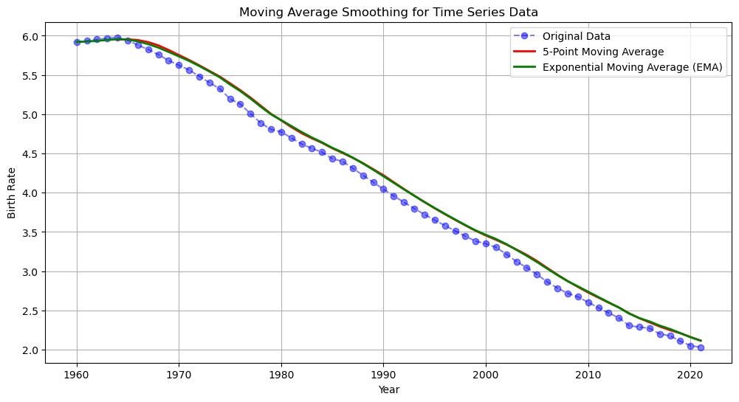

## Result

The following visualization represents the effect of moving average smoothing on time series data.