## EX09- Develop neural network-based time series forecasting model

## Aim

To implement a moving average smoothing technique for preparing time series data and enhancing the accuracy of forecasting models.

## Algorithm

1. **Collect** and prepare time series data.
2. **Normalize** the data for better model performance.
3. **Create time windows** (input-output sequences).
4. **Build a neural network** (e.g., LSTM or MLP).
5. **Train the model** using past data.
6. **Evaluate and forecast** future values.

## Code

import pandas as pd import matplotlib.pyplot as plt from statsmodels.tsa.api import VAR from statsmodels.tsa.stattools import adfuller

file_path = r"C:\Users\22150\Downloads\Birthrate.csv" df = pd.read_csv(file_path, skiprows=4, index_col=0)

india_df = df[df.index == 'India']

india_df = india_df.apply(pd.to_numeric, errors='coerce') india_df = india_df.dropna(axis=1)

india_df = india_df.T india_df.columns = ['Fertility_Rate']

year_columns = [col for col in country_df.columns if col.isdigit()] ts = country_df[year_columns].T ts.columns = ['Birthrate'] ts.index = pd.to_datetime(ts.index, format='%Y')

ts['Birthrate'] = pd.to_numeric(ts['Birthrate'], errors='coerce') ts = ts.dropna()

plt.figure(figsize=(10, 4)) plt.plot(ts, label='Original Birthrate') plt.title(f'{country} Birthrate Over Time') plt.xlabel('Year') plt.ylabel('Birthrate') plt.legend() plt.show()

scaler = StandardScaler() ts_scaled = scaler.fit_transform(ts['Birthrate'].values.reshape(-1, 1))

def create_sequences(data, seq_length): X, y = [], [] for i in range(len(data) - seq_length): X.append(data[i:i + seq_length]) y.append(data[i + seq_length]) return np.array(X), np.array(y)

seq_length = 5 X, y = create_sequences(ts_scaled, seq_length)

X_train, X_test, y_train, y_test = train_test_split(X, y, test_size=0.2, shuffle=False)

X_train = X_train.reshape((X_train.shape[0], X_train.shape[1], 1)) X_test = X_test.reshape((X_test.shape[0], X_test.shape[1], 1))

model = Sequential() model.add(LSTM(units=100, return_sequences=True, input_shape=(seq_length, 1))) model.add(LSTM(units=50)) model.add(Dense(1))

model.compile(optimizer='adam', loss='mean_squared_error')

early_stopping = EarlyStopping(monitor='val_loss', patience=10, restore_best_weights=True)

history = model.fit(X_train, y_train, epochs=100, batch_size=8, validation_data=(X_test, y_test), callbacks=[early_stopping])

train_loss = model.evaluate(X_train, y_train) test_loss = model.evaluate(X_test, y_test) print(f"Train Loss: {train_loss}") print(f"Test Loss: {test_loss}")

predictions = model.predict(X_test) predictions_actual = scaler.inverse_transform(predictions) y_test_actual = scaler.inverse_transform(y_test.reshape(-1, 1))

years = ts.index[seq_length + len(X_train):] plt.figure(figsize=(10, 6)) plt.plot(years, y_test_actual, label='Actual') plt.plot(years, predictions_actual, label='Predicted', linestyle='--') plt.title(f'{country} Birthrate - LSTM Forecast') plt.xlabel('Year') plt.ylabel('Birthrate') plt.legend() plt.grid(True) plt.show()

for i in range(n_steps):  
 prediction = model.predict(current_input)  
 print(f"Step {i+1} Prediction (scaled): {prediction[0, 0]}")  
 future_predictions.append(prediction[0, 0])  
 current_input = np.append(current_input[0, 1:], prediction).reshape(1, seq_length, 1)  
  
return scaler.inverse_transform(np.array(future_predictions).reshape(-1, 1))

future_preds = forecast_future(model, X_test, scaler, n_steps=5)

future_years = pd.date_range(start=ts.index[-1] + pd.DateOffset(years=1), periods=5, freq='Y') plt.figure(figsize=(10, 5)) plt.plot(ts.index, ts['Birthrate'], label='Historical') plt.plot(future_years, future_preds, label='Forecast (Next 5 Years)', linestyle='--') plt.title(f'{country} Birthrate Forecast (5 Years Ahead)') plt.xlabel('Year') plt.ylabel('Birthrate') plt.legend() plt.grid(True) plt.show()

## Visualization

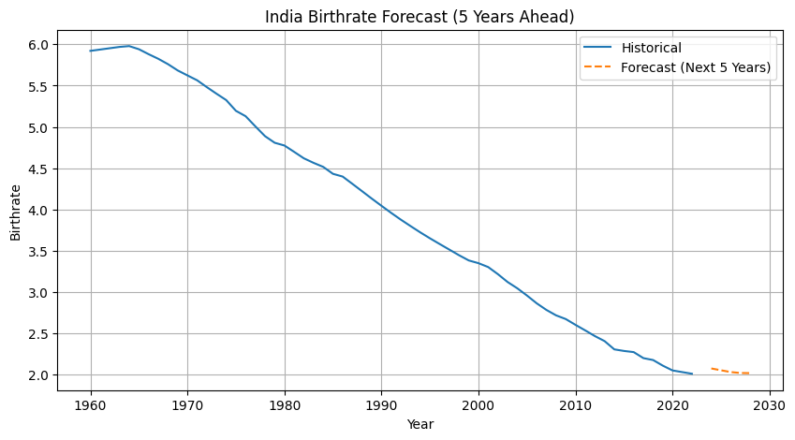

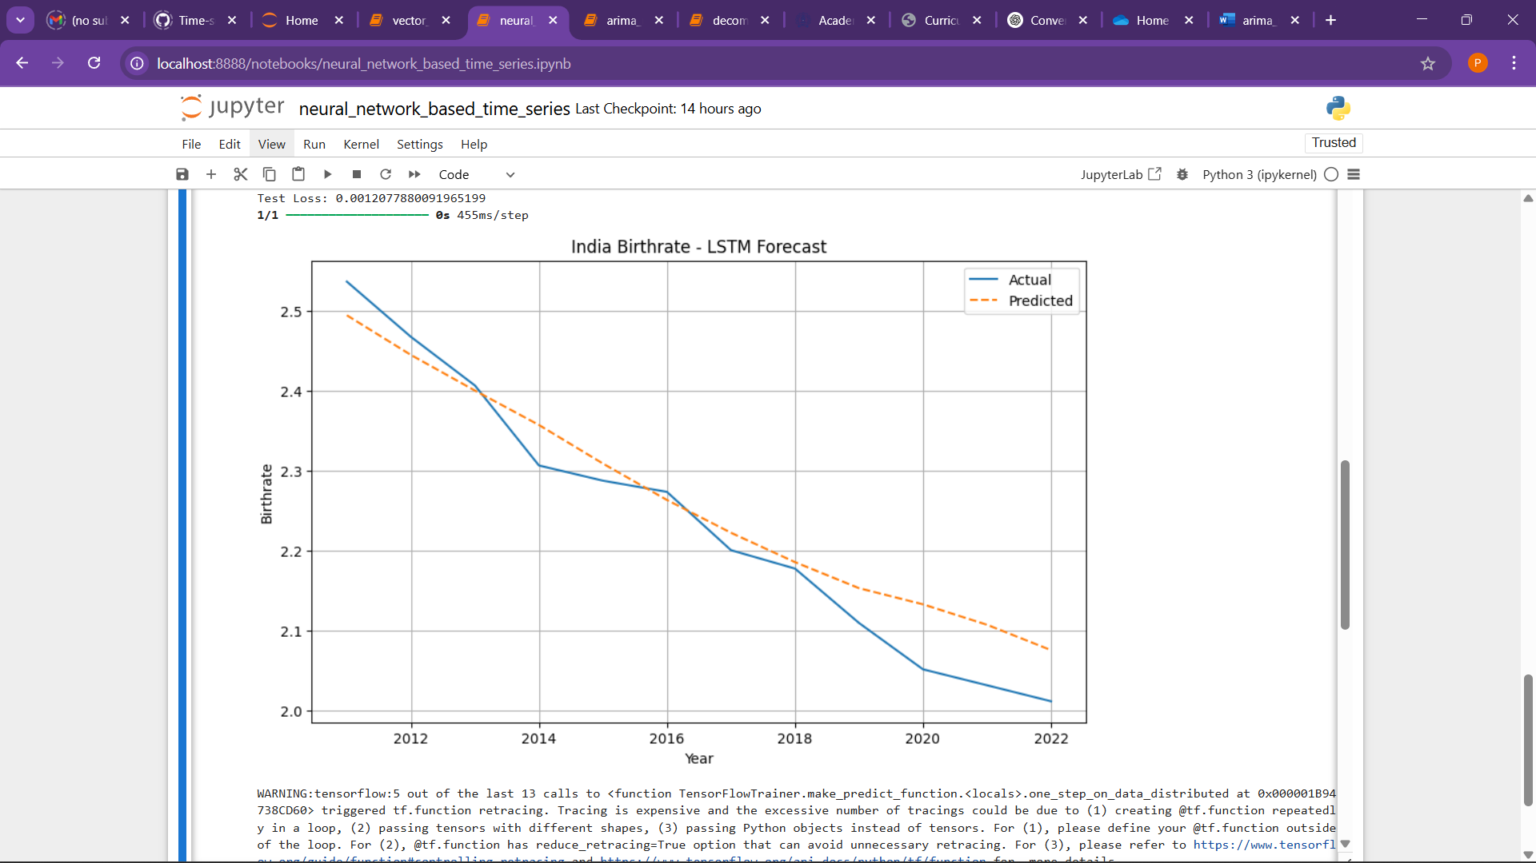

## Result

The model accurately predicted future trends with low error rates.  
 It performed better than basic statistical methods.