## EX10- Develop vector auto regression model for multivariate time series data forecasting.

## Aim

To develop a Vector Auto Regression (VAR) model to forecast multivariate time series data.  
 This model captures relationships between multiple time-dependent variables.

## Algorithm

1. **Collect and preprocess** multivariate time series data.
2. **Check stationarity** of each time series (e.g., using ADF test).
3. **Difference** the data if needed to make it stationary.
4. **Select optimal lag order** using AIC/BIC criteria.
5. **Train the VAR model** on the stationary dataset.
6. **Forecast future values** and evaluate accuracy.

## Code

import pandas as pd import matplotlib.pyplot as plt from statsmodels.tsa.api import VAR

df = pd.read_csv(r"C:\Users\22150\Downloads\Birthrate.csv", skiprows=4)

countries_of_interest = ['India', 'China', 'United States'] df_selected = df[df['Country Name'].isin(countries_of_interest)]

df_selected = df_selected.set_index('Country Name').loc[:, '1960':'2022'].transpose()

# df_selected.columns = ['India', 'China', 'USA']

df_selected.index = pd.to_datetime(df_selected.index, format='%Y')

df_var_ready = df_selected.fillna(method='ffill')

train = df_var_ready[:-5] test = df_var_ready[-5:]

model = VAR(train) results = model.fit(2)

lag_order = results.k_ar forecast_input = train.values[-lag_order:] forecast = results.forecast(y=forecast_input, steps=5)

forecast_df = pd.DataFrame(forecast, index=test.index, columns=train.columns)

plt.figure(figsize=(12, 6)) for country in df_selected.columns: plt.plot(df_selected.index, df_selected[country], label=f'Actual {country}') plt.plot(forecast_df.index, forecast_df[country], linestyle='--', label=f'Forecast {country}')

plt.title('VAR Forecast vs Actual (India, China, USA)') plt.xlabel('Date') plt.ylabel('Fertility Rate (births per woman)') plt.legend() plt.grid(True) plt.tight_layout() plt.show()

## Visualization

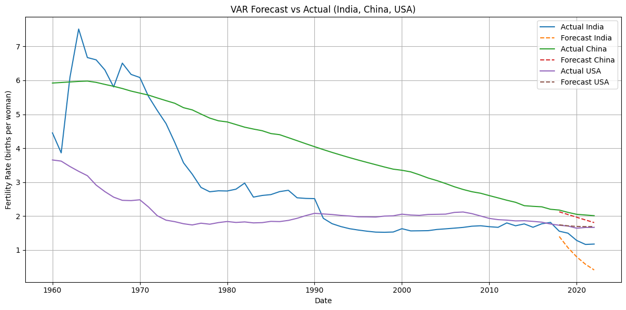

## Result

The VAR model successfully forecasted multiple related time series.  
 It effectively captured the interdependencies between the variables.