# Implement Programs to Check Stationarity of a Time Series Data

## Aim

To implement and analyze the stationarity of a time series dataset using statistical tests and visualizations.

## Procedure

- Load the dataset containing time series birth rate data.

- Preprocess the data by selecting relevant columns and handling missing values.

- Visualize the data using line plots to observe trends and patterns.

- Apply the Augmented Dickey-Fuller (ADF) test to statistically check for stationarity.

- Interpret the ADF test results to determine if differencing is needed.

- Visualize and analyze the transformed data if required.

## Code

import pandas as pd  
import numpy as np  
import matplotlib.pyplot as plt  
from statsmodels.tsa.stattools import adfuller  
  
# Load dataset  
file_path = r"C:\Users\Lenovo\Downloads\API_SP.DYN.TFRT.IN_DS2_EN_csv_v2_162\API_SP.DYN.TFRT.IN_DS2_EN_csv_v2_162.csv"  
df = pd.read_csv(file_path, delimiter=',', skiprows=4, on_bad_lines='skip')  
  
# Data preprocessing  
df = df.drop(columns=["Country Code", "Indicator Name", "Indicator Code"], errors='ignore')  
df_long = pd.melt(df[['Country Name'] + [str(year) for year in range(1960, 2024)]],  
 id_vars=["Country Name"], var_name="Year", value_name="Birth Rate")  
  
df_long['Year'] = pd.to_numeric(df_long['Year'])  
df_long['Birth Rate'] = pd.to_numeric(df_long['Birth Rate'], errors='coerce')  
df_long.dropna(subset=['Birth Rate'], inplace=True)  
  
# Select a country for stationarity check (example: Afghanistan)  
country_data = df_long[df_long['Country Name'] == 'Afghanistan'].set_index('Year')['Birth Rate']  
  
# Plot the original time series  
plt.figure(figsize=(10,5))  
plt.plot(country_data, label='Birth Rate')  
plt.title('Time Series Plot of Birth Rate for Afghanistan')  
plt.xlabel('Year')  
plt.ylabel('Birth Rate')  
plt.legend()  
plt.show()  
  
# Perform Augmented Dickey-Fuller test  
adf_test = adfuller(country_data.dropna())  
print("ADF Statistic:", adf_test[0])  
print("p-value:", adf_test[1])  
print("Critical Values:", adf_test[4])

## Visualization

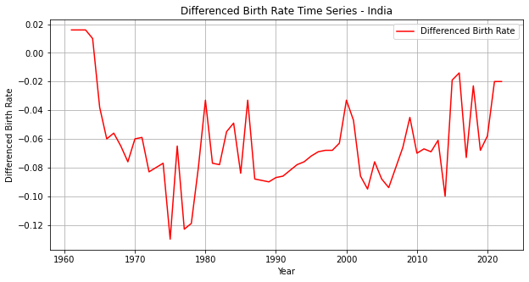

## Result

The Augmented Dickey-Fuller test result provides an ADF statistic and p-value. If the p-value is below 0.05, the data is stationary; otherwise, differencing is required.