**Practical-3**

**Task-1**

**Aim:**Write a program that uses the os module to display the current user's username, home directory, and operating system platform. And Create a function that utilizes the os module to display the total system memory, free memory, and the percentage of free memory available.

**Theoretical Background:**

* The os module in Node.js provides functions to retrieve information about the operating system. By using this module, a program can display the current user's username, home directory, and operating system platform, as well as retrieve system memory information such as total memory, free memory, and the percentage of free memory available.

**Source Code:**

const os = require('os');

console.log('Username:', os.userInfo().username);

console.log('Home Directory:', os.homedir());

console.log('Platform:', os.platform());

const totalMemory = os.totalmem();

const freeMemory = os.freemem();

const percentageFree = ((freeMemory / totalMemory) * 100).toFixed(2);

console.log('Total Memory:', formatBytes(totalMemory));

console.log('Free Memory:', formatBytes(freeMemory));

console.log('Percentage Free:', percentageFree + '%');

function formatBytes(bytes) {

const units = ['B', 'KB', 'MB', 'GB', 'TB'];

const index = Math.floor(Math.log2(bytes) / 10);

const size = (bytes / Math.pow(1024, index)).toFixed(2);

return size + ' ' + units[index];

}

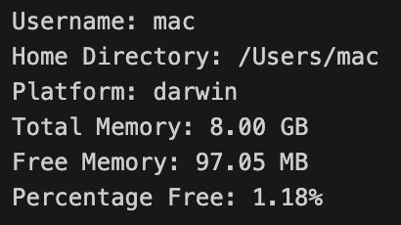

**Output:**

**Task-2**

**Aim:**Experiment with chalk,upper-case any other External Modules.

**Theoretical Background:**

* Chalk: Chalk is an external module that provides an easy way to add colors and formatting to the console output in Node.js, enhancing the visual presentation of text.
* Upper-case: The upper-case module is an external module that allows you to convert text to uppercase, providing a simple utility for transforming strings to uppercase characters.

**Source Code:**

import chalk from 'chalk';

import { upperCase } from 'upper-case';

const message = 'Hello, World!';

console.log(chalk.blue('This is a blue text.'));

console.log(chalk.green.bold('This is a bold green text.'));

console.log(chalk.bgYellowBright.black('This is a text with a yellow background.'));

console.log('Original Message:', message);

console.log('Uppercase Message:', upperCase(message));

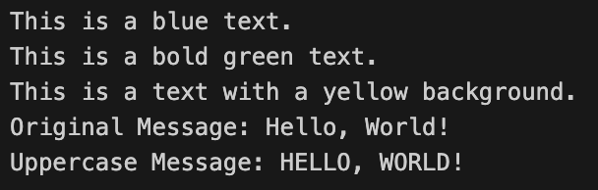

**Output:**

**Task-3**

**Aim:**Create your own custom module and import/export it to the main module.

**Theoretical Background:**

* Creating a custom module in JavaScript allows you to encapsulate and organize reusable code. By using the export keyword to expose functions, variables, or objects, and the import statement to access them in other modules, you can create modular and maintainable code structures.

**Source Code:**

//exported module in pr3_3_1.mjs file

export function sum(a, b) {

return a + b;

}

// main.js

import { sum} from './pr3_3_1.mjs';

console.log('Sum:', sum(5, 3));

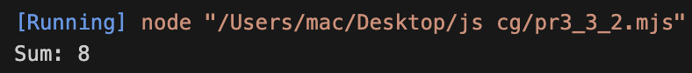

**Output:**

**Learning Outcome:**

* Understanding more in javascript technologies(CO1).