**Taita Taveta**

Nestled in the southern part of Kenya lies Taita Taveta County, a land brimming with natural wonders and cultural heritage. From the iconic Tsavo National Park to the enchanting Taita Hills, this region offers a tapestry of experiences that captivate the senses and enrich the soul. In this detailed exploration, we delve into seven of Taita Taveta's most prominent tourist attractions, uncovering their unique features, historical significance, and the impact they have on local communities and global travelers alike**.**

**Tsavo East National Park**

Tsavo East National Park, one of Kenya's oldest and largest national parks, is a prime attraction in Taita Taveta County. Encompassing an impressive 13,747 square kilometers, it offers a vast wilderness for visitors to explore. Known for its diverse wildlife and iconic landscapes, Tsavo East is home to approximately 12,000 elephants, making it one of the country's most important elephant habitats. The park also boasts a wide array of other species, including lions, leopards, buffalo, giraffes, and numerous bird species.

One of the park's highlights is the Galana River, which attracts large herds of animals, particularly during the dry season. Visitors can enjoy game drives along the riverbanks, providing ample opportunities for wildlife sightings. Additionally, the park is renowned for its striking scenery, characterized by open plains, rocky outcrops, and the scenic Yatta Plateau, the world's longest lava flow.

For adventurous travelers, Tsavo East offers unique experiences such as guided bush walks and birdwatching safaris. The park's diverse habitats, ranging from savannah to semi-arid bushland, provide an ideal environment for outdoor activities. With its rich biodiversity and stunning landscapes, Tsavo East National Park offers an unforgettable safari experience for visitors to Taita Taveta County. 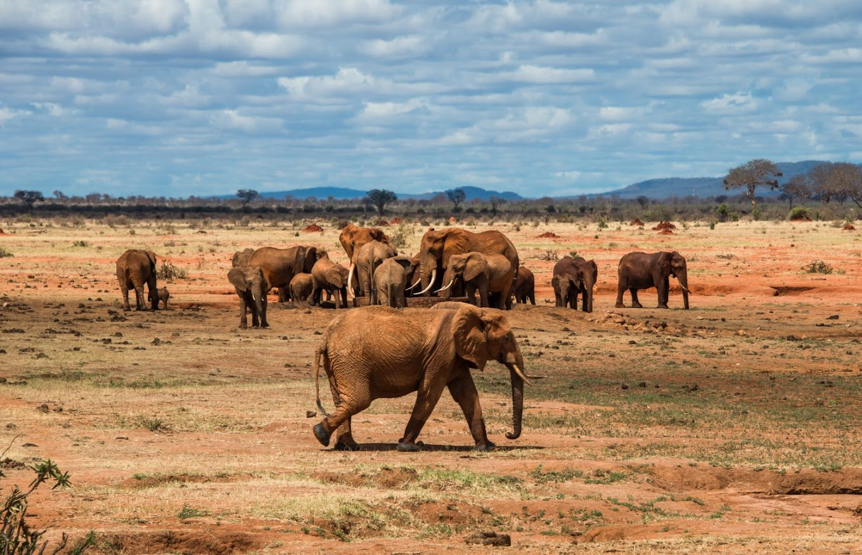

**Tsavo West National Park**

Adjacent to Tsavo East, Tsavo West National Park offers a contrasting but equally captivating landscape for travelers to explore. Covering an area of 9,065 square kilometers, this park is renowned for its rugged terrain, volcanic landscapes, and diverse wildlife. One of the park's most iconic features is the ***Mzima Springs***, a series of natural springs that gush crystal-clear water from underground sources. These springs support a thriving ecosystem, attracting a variety of animals, including hippos, crocodiles, and a myriad of bird species. Visitors can observe wildlife from the underwater observatory, providing a unique perspective on aquatic life in Tsavo.

In addition to the Mzima Springs, Tsavo West is home to other notable attractions, such as the ***Shetani Lava Flows***, a dramatic expanse of black lava rock formed by volcanic activity. The park also features the ***Ngulia Rhino*** Sanctuary, a protected area dedicated to the conservation of black rhinos.For those seeking adventure, Tsavo West offers opportunities for guided nature walks, rock climbing, and camping under the stars. With its diverse landscapes and abundant wildlife, Tsavo West National Park offers a memorable safari experience for visitors to Taita Taveta County.

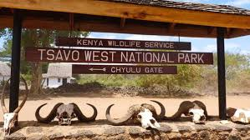

**Taita Hills Wildlife Sanctuary**

Nestled in the scenic Taita Hills, the Taita Hills Wildlife Sanctuary is a private conservancy renowned for its rich biodiversity and stunning landscapes. Spanning over 28,000 acres, the sanctuary is home to a variety of wildlife, including elephants, lions, leopards, and numerous bird species.One of the sanctuary's highlights is the unique Salt Lick Lodge, an architectural marvel perched on stilts overlooking a natural salt lick. This elevated vantage point provides unparalleled views of wildlife congregating at the salt lick, offering guests a front-row seat to the action.

In addition to game drives and guided walks, visitors to Taita Hills Wildlife Sanctuary can enjoy cultural experiences, such as visits to local Taita communities and traditional dance performances. The sanctuary also offers opportunities for conservation education, allowing visitors to learn about the efforts to protect the region's natural heritage. With its combination of wildlife viewing, scenic beauty, and cultural experiences, Taita Hills Wildlife Sanctuary offers a truly immersive safari experience for travelers visiting Taita Taveta County. Whether exploring the bush on game drives or relaxing in the comfort of the Salt Lick Lodge, visitors are sure to be enchanted by the magic of this unique sanctuary.

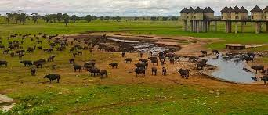

**Lake Jipe**

Lake Jipe is a picturesque freshwater lake located in the southwestern part of Taita Taveta County, straddling the border between Kenya and Tanzania. Covering an area of approximately 28 square kilometers, Lake Jipe is a haven for birdwatchers and nature enthusiasts. The lake is fed by the Lumi River and serves as an important habitat for a diverse range of bird species, including African fish eagles, kingfishers, herons, and pelicans.

Visitors to Lake Jipe can enjoy boat safaris, fishing excursions, and birdwatching tours while taking in the tranquil surroundings and scenic beauty of the lake. The surrounding wetlands and swamps are also home to various wildlife, including hippos, crocodiles, and small antelope species.

The community-owned Lake Jipe Conservation Area provides opportunities for eco-tourism and sustainable development, with local communities benefiting from tourism activities through revenue sharing and employment opportunities. Visitors can stay at eco-friendly lodges and campsites situated along the shores of Lake Jipe, offering a unique and immersive experience in this pristine wilderness area.

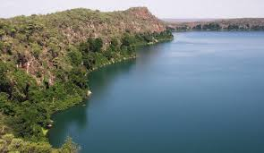

**Mwatate Conservation Area**

Established in 2004, Mwatate Conservation Area is a community-led initiative aimed at conserving the region's natural resources while promoting sustainable tourism development. Covering an area of 20,000 hectares, this multi-use conservancy is managed by local communities in collaboration with conservation organizations. Recent socioeconomic surveys have shown that ecotourism activities in Mwatate Conservation Area have provided employment opportunities for over 300 community members, contributing to poverty alleviation and community empowerment. Visitors can participate in guided hikes, cultural tours, and community-led conservation projects, gaining insight into the traditional lifestyles and conservation practices of the local communities.

**Mzima Springs**

Nestled within Tsavo West National Park, Mzima Springs is a verdant oasis that offers respite from the arid landscapes of the surrounding savannah. Fed by an underground reservoir originating from the Chyulu Hills, these natural springs gush millions of liters of crystal-clear water daily, creating a haven for wildlife and a scenic attraction for visitors.

Mzima Springs is renowned for its resident hippos, which can often be seen basking in the sun or submerged in the cool waters. The springs also support a diverse array of aquatic life, including Nile crocodiles, fish, and various bird species. Recent surveys conducted by conservation organizations indicate the presence of endangered species such as the lesser kudu and the fringe-eared oryx in the vicinity of Mzima Springs, highlighting its ecological significance.

Visitors can explore the springs via elevated walkways that offer close-up views of the underwater world, with opportunities for photography and wildlife observation. Interpretive signage provides insights into the hydrology and ecology of the springs, enhancing the educational value of the experience. Additionally, revenue generated from tourism supports conservation efforts aimed at protecting the springs and their surrounding habitats.

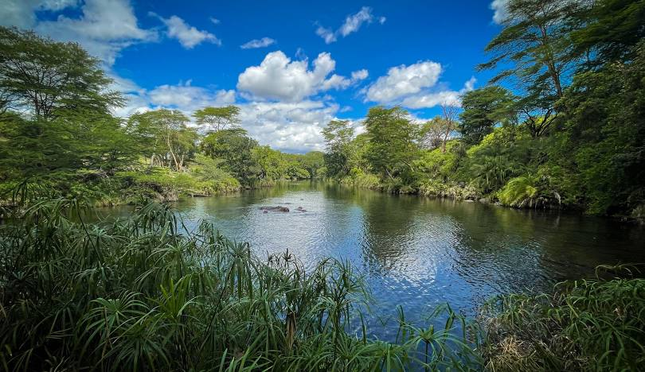

**Ngangao Forest**

Enveloped in mist and rich biodiversity, Ngangao Forest stands as a verdant jewel amidst the rugged terrain of the Taita Hills. Covering an area of approximately 19 square kilometers, this montane forest is characterized by towering trees, lush undergrowth, and a cacophony of birdcalls that fill the air.

Ngangao Forest is home to a rich array of flora and fauna, including endemic species found nowhere else on earth. Recent botanical surveys have identified over 200 plant species within the forest, many of which possess medicinal properties and cultural significance to the local Taita community. The forest also harbors a diverse range of animal life, including the endangered Taita thrush and the Taita white-eye, both of which are endemic to the region.

Visitors to Ngangao Forest can embark on guided nature walks led by knowledgeable local guides who share their expertise on the forest's ecology, traditional uses of plants, and efforts to conserve this unique ecosystem. The forest trails offer opportunities for birdwatching, photography, and immersion in the tranquility of nature, providing a welcome escape from the hustle and bustle of modern life.

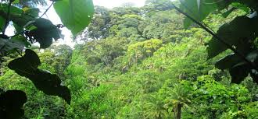

**Sarova Taita Hills Game Lodge**

Nestled in the heart of the Taita Hills Wildlife Sanctuary, Sarova Taita Hills Game Lodge offers a luxurious retreat amidst the pristine wilderness of Taita Taveta County. The lodge boasts spacious rooms, elegant furnishings, and panoramic views of the surrounding landscape, providing guests with a comfortable and immersive safari experience.

Sarova Taita Hills Game Lodge is renowned for its warm hospitality and impeccable service, with a dedicated team of staff committed to ensuring the comfort and satisfaction of every guest. The lodge offers a range of amenities, including a swimming pool, spa, and various dining options serving delectable cuisine inspired by local and international flavors.

Guests can embark on game drives, guided nature walks, and cultural excursions led by experienced guides who share their knowledge of the area's wildlife, history, and culture. The lodge also supports various community development initiatives aimed at empowering local communities and promoting sustainable tourism practices, ensuring that the benefits of tourism are shared equitably among all stakeholders.



**Lumo community wildlife conservancy.**

Nestled in the heart of Taita Taveta County, the LUMO Community Wildlife Conservancy stands as a beacon of community-driven conservation efforts in Kenya. Spanning an area of approximately 125 square kilometers, this conservancy represents a unique partnership between local communities and conservation organizations, aimed at preserving the region's rich biodiversity while promoting sustainable development. One of the key conservation initiatives within the LUMO Conservancy is the protection of endangered species, including the African elephant, black rhinoceros, and Grevy's zebra. By implementing anti-poaching measures and habitat restoration programs, the conservancy strives to safeguard these iconic species and ensure their long-term survival in the wild.

The LUMO Community Wildlife Conservancy is home to a diverse array of wildlife species, making it a prime destination for nature enthusiasts and wildlife photographers. Visitors to the conservancy have the opportunity to embark on guided game drives and walking safaris, led by experienced local guides who possess intimate knowledge of the area's flora and fauna.Among the notable wildlife species found within the conservancy are elephants, buffaloes, giraffes, lions, leopards, and a variety of antelope species. Birdwatchers will also delight in the chance to spot numerous avian species, including raptors, waterfowl, and colorful songbirds.

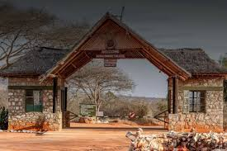

**Potential tourism projects and programs for investment**

Top of Form

Taita Taveta County, located in Kenya, has a rich diversity of natural resources and cultural heritage that can be leveraged for tourism development. Here are some potential tourism investment opportunities in Taita Taveta County:

1. **Eco-Tourism:** Taita Taveta County is home to diverse ecosystems, including the Taita Hills, Tsavo West National Park, and part of Tsavo East National Park. Investing in eco-friendly lodges, campsites, and guided tours that emphasize conservation and sustainable practices could attract nature lovers and adventure seekers.
2. **Cultural Tourism:** The county has a rich cultural heritage, including the Taita people's traditions, language, and historical sites like the Wundanyi Cultural Centre and the Kasigau Corridor. Investments in cultural tourism experiences such as homestays, cultural festivals, and guided heritage tours can showcase the unique traditions of the region.
3. **Adventure Tourism:** Taita Taveta offers opportunities for adventurous activities such as hiking, rock climbing, mountain biking, and bird watching. Developing adventure tourism facilities and services, including adventure camps, trails, and equipment rental, can attract adrenaline junkies and outdoor enthusiasts.
4. **Community-Based Tourism:** Collaborating with local communities to develop tourism initiatives can create economic opportunities while preserving cultural and environmental resources. Investments in community-owned accommodations, craft markets, and cultural experiences can provide authentic interactions for tourists and a sustainable income for residents.
5. **Wildlife Conservation:** Tsavo National Park is known for its diverse wildlife, including elephants, lions, and giraffes. Supporting wildlife conservation efforts through investments in anti-poaching initiatives, wildlife research, and community outreach programs can contribute to the preservation of biodiversity while attracting responsible tourists interested in wildlife safaris.
6. **Health and Wellness Tourism:** The serene natural environment of Taita Taveta County provides an ideal setting for health and wellness retreats. Investing in spa resorts, yoga retreats, and wellness centers that offer relaxation, meditation, and holistic healing experiences can appeal to wellness-conscious travelers seeking rejuvenation.
7. **Agro-Tourism:** Taita Taveta County's fertile agricultural lands and traditional farming practices present opportunities for agro-tourism ventures. Investments in farm stays, agricultural tours, and farm-to-table experiences can showcase the region's agricultural heritage while promoting sustainable farming practices and supporting local farmers.
8. **Infrastructure Development:** Improving transportation infrastructure, including roads, airports, and public transportation, can facilitate easier access to tourist destinations within the county. Investments in hospitality infrastructure such as hotels, restaurants, and recreational facilities can enhance the overall tourist experience and attract higher-end visitors.

By strategically investing in these tourism opportunities, Taita Taveta County can diversify its economy, create jobs, and promote sustainable development while preserving its natural and cultural heritage.