Solver Performance & Coaching
Ben Mwaura · April 2026
You completed 296 valuations this month, with a client rating of 4.77/5. The chart below shows your numbers; time is the one area to focus on this month. Concrete steps below.
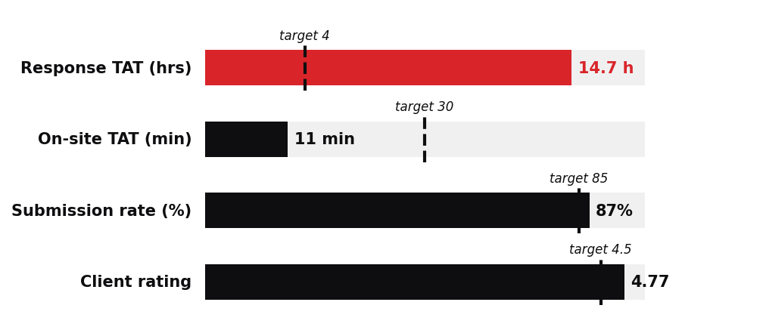
Working Faster — Time
Median response TAT 14.7 h against a 4-hour target. On-site 11 min against 30 minutes.
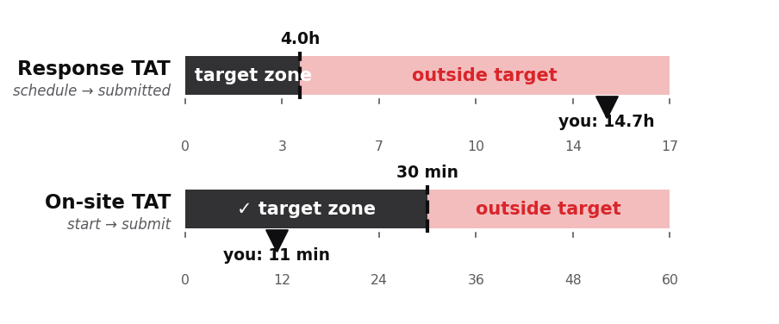
Three habits that work:
1. Accept or decline within 5 minutes of dispatch
2. Same on-site flow every time: Photos → Exterior → Interior → Submit
3. If a job hasn't moved in 24 hours, close it or escalate — no silent dragging
This week: pick one stuck job from last week. What stopped it? That's the pattern to fix.

