Solver Performance & Coaching
Brian King'ori · April 2026
You completed 141 valuations this month, with a client rating of 4.38/5. You're hitting your targets across the board — excellent consistency.
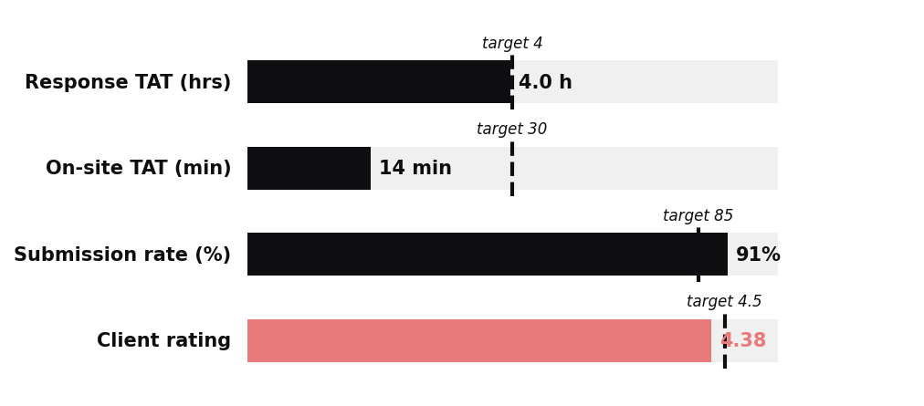
Keep Going
You're hitting your targets across the board — that's the result of consistent habits, not luck.
What stays the same
The boring fundamentals that got you here. Pre-visit prep, photo discipline, client greeting — don't change a thing.
Where to grow next
- Take harder jobs (fleet, heavy commercial, post-accident) — the team needs depth
- Mentor newer solvers — 20 minutes on a call saves them weeks
- Spot patterns — you see more vehicles than most, flag what you notice
Strong work this month. Keep it up.

