Solver Performance & Coaching
Hamza Afzal · April 2026
You completed 19 valuations this month. The chart below shows your numbers; submission rate is the one area to focus on this month. Concrete steps below.
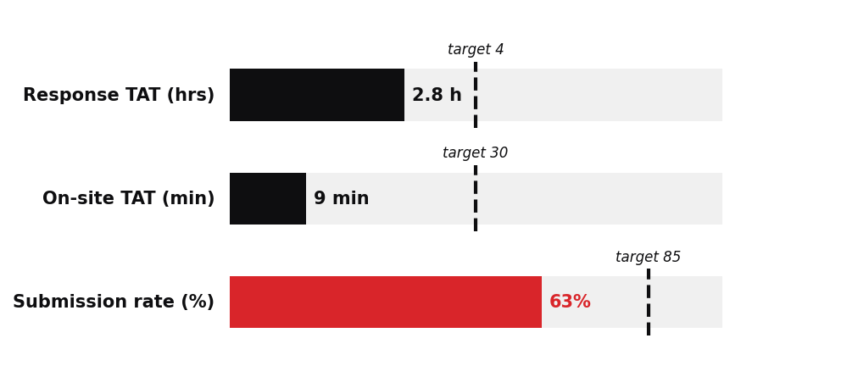
Closing More Jobs — Submission Rate
Submitted 19 of 30 assigned (63.3%) against an 85% target.
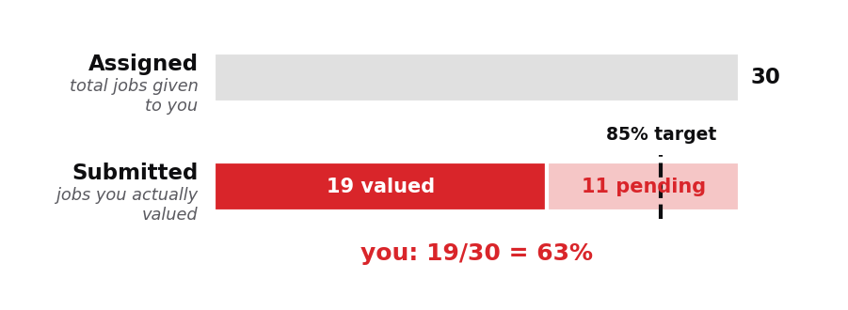
Top pending reasons: "Not picking" (4); "Not ready" (3); "No documents" (1).
Three habits that close the gap:
1. Before traveling, do a confirmation call — kills 'No documents' pendings
2. For 'Not picking' jobs, try once more at a different hour before giving up
3. Set a specific next-attempt time on pendings — 'tomorrow 9 AM', not 'later'
This week: for every pending, write the next-attempt time on the spot. You'll convert about half. Keep going.

