BANK LOAN ANALYSIS

QUERY DOCUMENT

**KPIs**

**Total Loan Applications**

SELECT COUNT (id) AS Total_Loan_Applications FROM bank_loans



**Month-To-Date (MTD) Loan Applications**

SELECT COUNT (id) AS MTD_Total_Loan_Applications

FROM bank_loans

WHERE YEAR (issue_date) = YEAR ('2021-12-31')

AND MONTH (issue_date) = MONTH ('2021-12-31')

AND DAY (issue_date) <= DAY ('2021-12-31')



**Previous Month-To-Date**

SELECT COUNT (id) AS PMTD_Total_Loan_Applications

FROM bank_loans

WHERE (YEAR (issue_date) = YEAR (DATEADD (MONTH, -1, '2021-12-31'))

AND MONTH (issue_date) = MONTH (DATEADD (MONTH, -1, '2021-12-31'))

AND DAY (issue_date) <= DAY ('2021-12-31'))



**Total Funded Amount**

SELECT SUM (loan_amount) AS Total_Funded_Amount FROM bank_loans



**MTD Total Funded Amount**

SELECT SUM (loan_amount) AS MTD_Total_Funded_Amount FROM bank_loans

WHERE YEAR (issue_date) = YEAR ('2021-12-31')

AND MONTH (issue_date) = MONTH ('2021-12-31')

AND DAY (issue_date) <= DAY ('2021-12-31')



**PMTD Total Funded Amount**

SELECT SUM (loan_amount) AS PMTD_Total_Funded_Amount FROM bank_loans

WHERE (YEAR (issue_date) = YEAR (DATEADD (MONTH, -1, '2021-12-31'))

AND MONTH (issue_date) = MONTH (DATEADD (MONTH, -1, '2021-12-31'))

AND DAY (issue_date) <= DAY ('2021-12-31'))



**Total Loan Paid**

SELECT SUM (total_payment) AS Total_Loan_Payment FROM bank_loans



**MTD Total Loan Paid**

SELECT SUM (total_payment) AS MTD_Total_Loan_Payment FROM bank_loans

WHERE YEAR (issue_date) = YEAR ('2021-12-31')

AND MONTH (issue_date) = MONTH ('2021-12-31')

AND DAY (issue_date) <= DAY ('2021-12-31')



**PMTD Total Loan Paid**

SELECT SUM (total_payment) AS PMTD_ Total_Loan_Payment FROM bank_loans

WHERE (YEAR (issue_date) = YEAR (DATEADD (MONTH, -1, '2021-12-31'))

AND MONTH (issue_date) = MONTH (DATEADD (MONTH, -1, '2021-12-31'))

AND DAY (issue_date) <= DAY ('2021-12-31'))



**Average Interest Rate**

SELECT ROUND (AVG (int_rate), 4)*100 AS Avg_Interest_Rate FROM bank_loans



**MTD Average Interest**

SELECT ROUND (AVG (int_rate), 4)*100 AS MTD_Avg_Interest_Rate

FROM bank_loans

WHERE YEAR (issue_date) = YEAR ('2021-12-31')

AND MONTH (issue_date) = MONTH ('2021-12-31')

AND DAY (issue_date) <= DAY ('2021-12-31')



**PMTD Average Interest**

SELECT ROUND (AVG (int_rate), 4)*100 AS PMTD_Avg_Interest_Rate FROM bank_loans

WHERE (YEAR (issue_date) = YEAR (DATEADD (MONTH, -1, '2021-12-31'))

AND MONTH (issue_date) = MONTH (DATEADD (MONTH, -1, '2021-12-31'))

AND DAY (issue_date) <= DAY ('2021-12-31'))



**Average Debt-To-Income Ratio (DTI)**

SELECT ROUND (AVG (dti), 4) *100 AS Avg_DTI FROM bank_loans



**MTD Average DTI**

SELECT ROUND (AVG (dti), 4)*100 AS MTD_Avg_DTI FROM bank_loans

WHERE YEAR (issue_date) = YEAR ('2021-12-31')

AND MONTH (issue_date) = MONTH ('2021-12-31')

AND DAY (issue_date) <= DAY ('2021-12-31')



**PMTD Average DTI**

SELECT ROUND (AVG (dti), 4) *100 AS PMTD_Avg_DTI FROM bank_loans

WHERE (YEAR (issue_date) = YEAR (DATEADD (MONTH, -1, '2021-12-31'))

AND MONTH (issue_date) = MONTH (DATEADD (MONTH, -1, '2021-12-31'))

AND DAY (issue_date) <= DAY ('2021-12-31'))



**GOOD LOAN ISSUED**

**Good Loan Percentage**

SELECT ROUND (CAST (COUNT (CASE WHEN loan_status = 'Fully Paid' OR loan_status = 'Current' THEN id END) *100.0

/ COUNT (id) AS DECIMAL (18, 2)), 2) AS Good_Loan_Percentage

FROM bank_loans



**Good Loan Applications**

SELECT COUNT (id) AS Good_Loan_Applications FROM bank_loans

WHERE loan_status = 'Fully Paid' OR loan_status = 'Current'



**Good Loan Funded Amount**

SELECT SUM (loan_amount) AS Good_Loan_Funded_amount FROM bank_loans

WHERE loan_status = 'Fully Paid' OR loan_status = 'Current'



**Good Loan Payment**

SELECT SUM (total_payment) AS Good_Loan_amount_received FROM bank_loans

WHERE loan_status = 'Fully Paid' OR loan_status = 'Current'



**BAD LOAN ISSUED**

**Bad Loan Percentage**

SELECT ROUND (CAST (COUNT (CASE WHEN loan_status = 'Charged Off' THEN id END) * 100.0 /

COUNT (id) AS DECIMAL (18, 2)), 2) AS Bad_Loan_Percentage

FROM bank_loans



**Bad Loan Applications**

SELECT COUNT (id) AS Bad_Loan_Applications FROM bank_loans

WHERE loan_status = 'Charged Off'



**Bad Loan Funded Amount**

SELECT SUM (loan_amount) AS Bad_Loan_Funded_amount FROM bank_loans

WHERE loan_status = 'Charged Off'



**Bad Loan Payment**

SELECT SUM (total_payment) AS Bad_Loan_amount_received FROM bank_loans

WHERE loan_status = 'Charged Off'



**LOAN STATUS**

SELECT

loan_status

COUNT (id) AS Total_Loan_Applications,

SUM (total_payment) AS Total_Loan_Paid,

SUM (loan_amount) AS Total_Funded_Amount,

ROUND (AVG (int_rate * 100), 4) AS Average_Interest_Rate,

ROUND (AVG (dti * 100), 4) AS Average_DTI

FROM

bank_loans

GROUP BY

loan_status

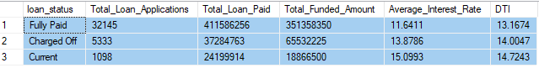

**OVERVIEW**

**Monthly Trend**

SELECT

MONTH (issue_date) AS Month_Number,

DATENAME (MONTH, issue_date) AS Month_Name,

COUNT (id) AS Total_Loan_Applications,

SUM (loan_amount) AS Total_Funded_Amount,

SUM (total_payment) AS Total_Loan_Payment

FROM bank_loans

GROUP BY MONTH (issue_date), DATENAME (MONTH, issue_date)

ORDER BY MONTH (issue_date)

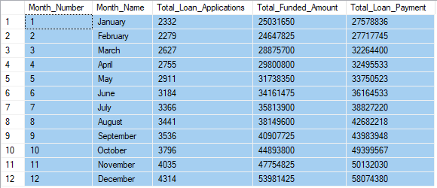

**State**

SELECT

address_state AS State,

COUNT (id) AS Total_Loan_Applications,

SUM (loan_amount) AS Total_Funded_Amount,

SUM (total_payment) AS Total_Loan_Paid

FROM bank_loans

GROUP BY address_state

ORDER BY address_state

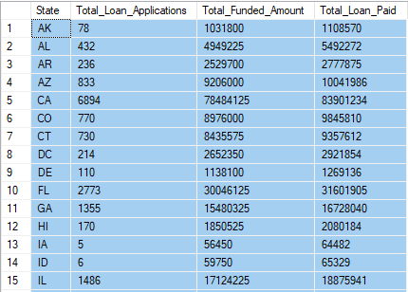 *(truncated)*

**Term**

SELECT

term AS Term,

COUNT (id) AS Total_Loan_Applications,

SUM (loan_amount) AS Total_Funded_Amount,

SUM (total_payment) AS Total_Loan_Paid

FROM bank_loans

GROUP BY term

ORDER BY term



**Employee Length**

SELECT

emp_length AS Employee_Length,

COUNT (id) AS Total_Loan_Applications,

SUM (loan_amount) AS Total_Funded_Amount,

SUM (total_payment) AS Total_Loan_Paid

FROM bank_loans

GROUP BY emp_length

ORDER BY COUNT (id) DESC

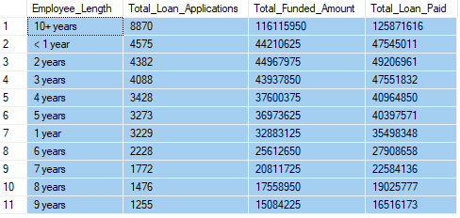

**Purpose**

SELECT

purpose AS Purpose,

COUNT (id) AS Total_Loan_Applications,

SUM (loan_amount) AS Total_Funded_Amount,

SUM (total_payment) AS Total_Loan_Paid

FROM bank_loans

GROUP BY purpose

ORDER BY COUNT (id) DESC

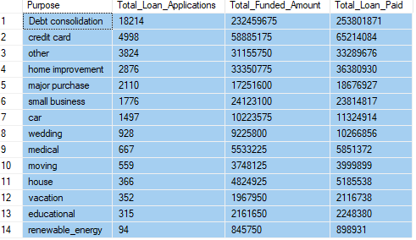

**Home Ownership**

SELECT

home_ownership AS Home_Ownership,

COUNT (id) AS Total_Loan_Applications,

SUM (loan_amount) AS Total_Funded_Amount,

SUM (total_payment) AS Total_Loan_Paid

FROM bank_loans

GROUP BY home_ownership

ORDER BY COUNT (id)

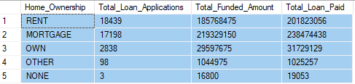

*Note: We have applied multiple Filters on all the dashboards. You can check the results for the filters as well by modifying the query and comparing the results.*