

Programme

Master of Software Engineering – 180 credits

Course

Quantum Computing MSE802
(Level 8, 15 credits, Version 1)

SHOR’S ALGORITHM

Name: Perisha Dharel
Student ID: 270629406
Course: MSE802 – Quantum Computing
Assessment Title: Shor’s Algorithm and the Future of Quantum Cryptography
Date: 15 June, 2025

Contents
1. Introduction 1
2. Purpose of the Report 1
3. Overview of the tasks covered 2
4. Quantum Computing Principles 2
4.1 Superposition 2
4.2 Entanglement 3
4.3 Quantum Gates 4
4.4 Qubits vs Classical Bits 5
4.4.1 Importance of Qubit Manipulation in Shor’s Algorithm 7
5. Shor’s Algorithm 8
5.1 Purpose of Shor’s Algorithm 8
5.2 Mathematical Basis 8
5.3 Advantage Over Classical Algorithms 10
6. Applications and Technologies 11
6.1 Real-World Application 11
6.2 Current Quantum Computing Platforms 11
6.3 Challenges and Limitations 13
7. Future Outlook 14
7.1 Future Developments 14
7.2 Long-Term Industry Applications 15
7.3 Future Trends and Ethical Implications in Quantum Computing 16
7.4 Conclusion: The Need for Responsible Innovation 18
8. Summary of the Findings 19
9. References 20

Table of Figures
Figure 1: Superposition 3
Figure 2: Entanglement 4
Figure 3: Quantum Gates 5
Figure 4: Qubit vs Classical Bits 6
Figure 5: Classical Bit vs Quit 6
Figure 6: Flowchart of Shor’s Algorithm 10
Figure 7: Comparison of Quantum Hardware Platforms and Their Architectural Trade-offs 12

Introduction

In 1994, Peter Shor introduced a groundbreaking algorithm for integer factorization that significantly outperforms classical methods when run on a quantum computer (Shor, 1994). This algorithm presents more than just computational efficiency—it directly challenges the foundations of modern public-key cryptography, such as RSA, which relies on the difficulty of factoring large composite numbers. This algorithm solves the problem, specifically O((log N)^3) (Nielsen & Chuang, 2010). The method transforms the problem into one of period finding, which is efficiently solved using quantum techniques like the Quantum Fourier Transform (QFT). The algorithm’s two main steps involve a quantum phase estimation to determine the period of a modular exponential function, followed by a classical step that derives the factors using the greatest common divisor (GCD). The quantum advantage arises from the use of superposition, entanglement, and interference to perform computations in parallel, showcasing a true quantum speedup (Preskill, 1998).

Purpose of the Report

Shor’s algorithm was created to demonstrate a quantum advantage by addressing the integer factorization problem within polynomial time (Shor, 1994). Unlike classical algorithms that require sub-exponential time to factor large numbers (Lenstra & Lenstra, 1993), Shor’s approach reformulates the challenge as a period-finding problem. It utilizes quantum mechanical properties like superposition and interference, combined with the quantum phase estimation algorithm and QFT, to efficiently find these periods and, ultimately, the integer factors (Nielsen & Chuang, 2010).
Shors Algorithm is a period finding algorithm that uses mechanical properties of quantum of superposition and interference to make it efficient is identical to factoring problem and it solves the factoring problem by converting it to period finding problem and then using quantum phase estimation algorithm and quantum Fourier Transform (QFT) (Nielsen & Chuang, 2010)

Overview of the tasks covered

This study is organized around four major activities that will aid in understanding the theory and implementation of the Shor Algorithm. It begins with a review of the fundamentals quantum mechanical of, such as superposition, entanglement, and quantum gates, before delving into the Shor Algorithm in depth, covering its mathematical underpinnings and advantages over traditional factoring methods. The article then discusses the algorithm's practical implementation in cryptography, the present state of quantum hardware technologies, and related challenges like error correction and scalability. Finally, it concludes with a forecast of what comes next in this computing and the broader outcomes for the industry and electronic information security.

Principles of Quantum Computing

The Quantum computing is made on the unique laws of quantum mechanics, setting it apart from classical computing systems. Rather than relying solely on binary logic and deterministic processes, quantum systems harness phenomena such as superposition, entanglement, and unitary transformations. These core concepts enable quantum computers to solve certain complex problems more efficiently than their classical counterparts—factorization via Shor’s Algorithm being a prime example.
4.1 Superposition
Superposition In quantum mechanics, superposition is the property of a quantum system according to which the system be in a state which is a linear combination of various states. In the a single qubit, this implies that it can simultaneously be in the state ∣0⟩|0\rangle∣0⟩ and also in the state ∣1⟩|1\rangle∣1⟩, mathematically: |\psi\rangle = \alpha|0\rangle + \beta|1\rangle= \alpha\left|\,0\,\right\rangle + \beta\left|\,1\,\right\rangle and \alpha\alpha and \beta\beta are complex numbers satisfying 1 = \alpha^2+\beta^2(Nielsen & Chuang, 2010). An exponential number of possible states can be encoded in a multi-qubit system using superposition. To take a specific example, an nnn-qubit register can simultaneously describe 2n2^n2n classical states. Shor algorithm In Shor algorithm, superposition is applied to design a quantum register to store all possible inputs xxx to the function f(x)=axmodNf(x) = a^x \mod Nf(x) = axmodN in parallel, and thus the algorithm can calculate multiple values of the function simultaneously. It is this quantum parallelism that enables Shor algorithm to exponentially outperform classical factoring algorithms (Yanofsky & Mannucci, 2008).
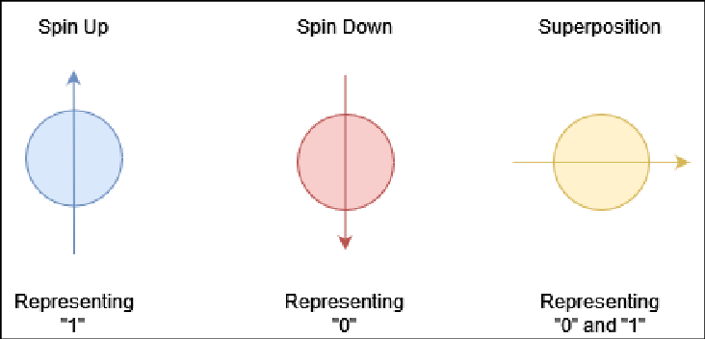
Figure 1: Superposition

4.2 Entanglement

The Entanglement is a quantum effect that two or more qubits systems are correlated so that the state of one qubit directly influences the condition of one, irrespective of the physical separation between them. This tangled state hybrid can’t be characterised as a mere human invention qubit states (Preskill, 1998). Entangled State: One of them is:
|\Phi^+\rangle = \frac{1}{\sqrt 2}( |00\rangle + |11\rangle)
In this Shor Algorithm entanglement plays a role in the modular exponentiation step. An entangled state is generated by the algorithm between the control register (encoding the inputs xxx) and the target register (where the values of the function f(x) = axmod Nf(x) = a^x \mod N are to be stored). This entanglement implies that all values of functions are encoded in state of the system at once, maintaining the periodic structure of functions. This structure is then used by the Quantum Fourier Transform (QFT) to effectively estimate the period of the function which is key to the factoring capability of the algorithm NNN (Nielsen & Chuang, 2010).
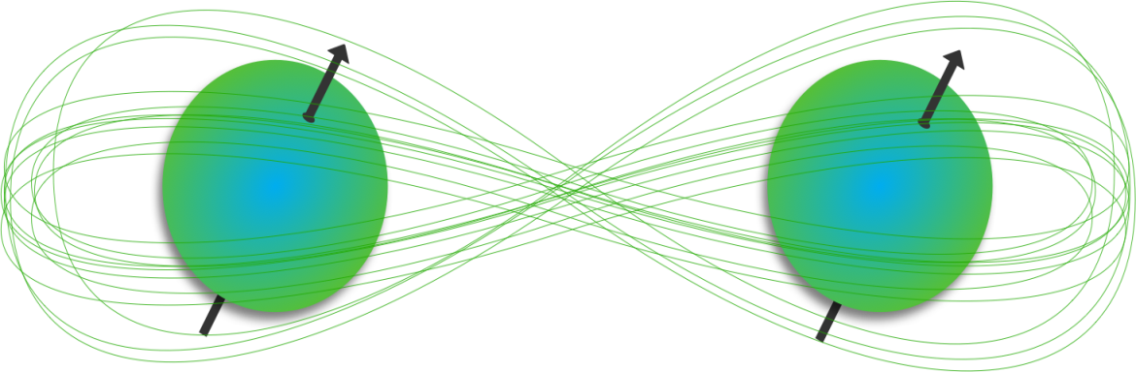
Figure 2: Entanglement

4.3 Quantum Gates
Quantum gates are the fundamental operations that manipulate qubit states in a quantum computer. Unlike classical logic gates, which deterministically flip bits between 0 and 1, quantum gates operate on superpositions and must be unitary.
Key gates used in Shor’s Algorithm include:
- Hadamard Gate (H): Converts basis states into superpositions:
H∣0⟩=12(∣0⟩+∣1⟩)H|0\rangle = \frac{1}{\sqrt{2}} (|0\rangle + |1\rangle)H∣0⟩=2​1​(∣0⟩+∣1⟩)
This gate is used at the start of the algorithm to generate a balanced superposition of all the possible values of input.
Controlled-U Gates: Apply modular exponentiation conditionally based on the control qubit’s state. These gates create entanglement between the control and target registers.
- Quantum Fourier Transform (QFT): It is a quantum analog of discrete Fourier transform, applied to extract periodicity from the input state of quantum.
Precise application of these gates is essential. Any timing error, decoherence, or gate inaccuracy can destroy quantum interference patterns, leading to incorrect outputs. Shor’s Algorithm, in particular, requires tight control over a large number of such gates, especially during the QFT stage (Yanofsky & Mannucci, 2008; Gidney & Ekerå, 2021).
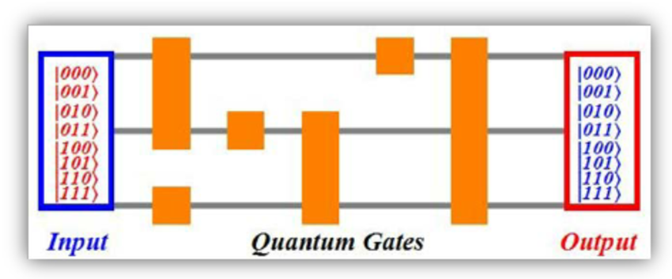
Figure 3: Quantum Gates

4.4 Qubits vs Classical Bits

As the classical computing, the message is described by means of bits, having one of two specific states 0 or 1. On the contrary, quantum computing incorporates qubits that have the capacity to be in a superposition of 0 and 1. The state of a qubit can be denoted as: |\psi\rangle = \alpha|0\rangle + \beta|1\rangle= α∣0⟩+β∣1\rangle with \alpha\alpha and \beta\beta complex amplitudes where the norm of \alpha\alpha and \beta\beta is equal to one, i.e. ∣alpha|^2 + ∣beta|^2 = 1. In addition, qubits can be entangled, which correlations cannot be achieved with classical systems. This allows quantum computers a huge representational advantage: an nnn-qubit register can represent 2n2^n2n possible classical states simultaneously, so quantum computers can simultaneously perform computations over exponentially many states (Nielsen & Chuang, 2010). As a simple example, 300 qubits can in theory encode a larger number of states than there are atoms in the universe, something which cannot be done with classical memory. This is the ability behind the fact that algorithms such as Shor’s run exponentially faster.
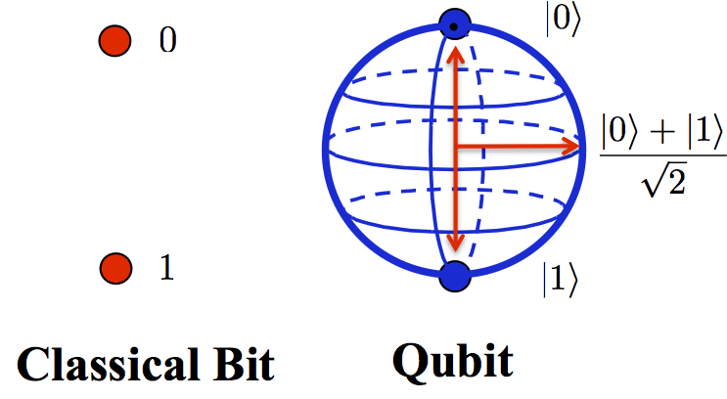
Figure 4: Qubit vs Classical Bits

Property | Classical Bit | Qubit
State | 0 or 1 | Superposition of 0 and 1: ( \alpha
Storage Capacity | Stores one of two possible states | Can represent 2n2^n states with nn qubits
Operations | Logic gates (AND, OR, NOT) | Unitary gates (Hadamard, Pauli, CNOT, etc.)
Entanglement | Not possible | Possible: qubit states can be entangled across systems
Measurement | Deterministic (value is known before read) | Probabilistic (collapses to 0 or 1 based on amplitudes)
Error Sensitivity | Low (well-established classical systems) | High (sensitive to noise and decoherence)
Parallelism | None | Intrinsic via superposition and entanglement
Figure 5: Classical Bit vs Quit

4.4.1 Importance of Qubit Manipulation in Shor’s Algorithm
The effectiveness of Shor’s Algorithm critically depends on accurate qubit manipulation throughout the quantum circuit. Initially, the algorithm generates a equal superposition of all integers xxx usings Hadamard gates. Then, through controlled modular power , it entangles this register with function outputs, forming a quantum state of the form:
1Q∑x=0Q−1∣x⟩∣axmod N⟩\frac{1}{\sqrt{Q}} \sum_{x=0}^{Q-1} |x\rangle |a^x \mod N\rangleQ​1​x=0∑Q−1​∣x⟩∣axmodN⟩
where QQQ is a power of 2 greater than N2N^2N2. This entangled state encodes all values of the function simultaneously.
Next, the Quantum Fourier Transform (QFT) is applied to the control register. This operation amplifies the probabilities of measuring values that reveal the time rrr of the function f(x)f(x)f(x). Once rrr is measured, classical post-processing uses number-theoretic techniques like continued fraction expansion and GCD computations to find non-trivial factors of NNN.
If any qubit manipulation during this process is inaccurate—due to gate errors, quantum decoherence, or crosstalk—the required interference patterns will not form, and the period rrr will not be extracted correctly (Gidney & Ekerå, 2021). Hence, coherent, high-fidelity qubit manipulation is indispensable for the successful execution of Shor’s Algorithm (Preskill, 1998).
If qubit manipulation is faulty—due to decoherence, noise, or gate errors—the interference fails to produce the correct period, and the algorithm breaks down. Thus, precise and coherent manipulation of qubits is not only important but essential to the correct execution of Shor’s Algorithm and all meaningful quantum computations.

Shor’s Algorithm

Purpose of Shor’s Algorithm

The aim of Shor’s Algorithm is to have integers with the help of a quantum computer effectively. This is the problem of finding the non-trivial prime factors of a composite number NNN. Although this is easily seen to be trivial when the integers are small, factoring very large numbers (e.g., 2048-bit integers) is a classically hard computational problem (Shor, 1994). Its relation to the RSA encryption is that the security of the RSA algorithm keys solely depends on how hard it is to factor such large integers. Both public and private RSA keys are constructed using the multiplication of two huge prime numbers. factoring this product with an efficient algorithm such as Shor factoring algorithm would allow extracting the private key given the public one and this makes the system insecure. The effectiveness of Shor Algorithm, therefore, poses a major threat to RSA as well as other cryptographic systems using public-key cryptography (Mosca, 2018).

5.2 Mathematical Basis
The most fundamental basis of Shor Algorithm is that of reducing integer factorization to a period finding problem. In more detail, with an integer NNN to be factored, and a randomly selected integer aaa, with gcd(a,N)=1, the algorithm sets the function:
f(x)=axmodN
This is a periodic function and Shor algorithm is aimed at determining the period rrr of this function, the least positive integer satisfying: aar≡1modN Such a value rrr is called the order of aaa modulo NNN. Having rrr period found, one can apply the following identity to the algorithm to find non-trivial factors of NNN:
gcd(ar/2±1,N)
This is a probabilistic step: in a sense, by varying aaa, the method will succeed in many values of aaa, and will fail in others, requiring one to restart the procedure.
Quantum Fourier Transform (QFT)
The important quantum subroutine that enables the efficient finding of the period rrr is Quantum Fourier Transform (QFT). It is the quantum analog of the classical Discrete Fourier Transform (DFT), and acts on a quantum register in superposition. The QFT on an nnn-qubit system is one determined by the following transformation:
|x⟩ → (1 / sqrt(2^n )) 2^n- 1 e (2piixk / 2^n )|k⟩
The modular exponentiation is applied and then the QFT is used to find information about the period as interference patterns in the probability amplitudes (Nielsen & Chuang, 2010). Figure 5 shows the quantum and classical phases of Shor Algorithm in sequential order, thus providing a clear picture of the steps involved in the Algorithm.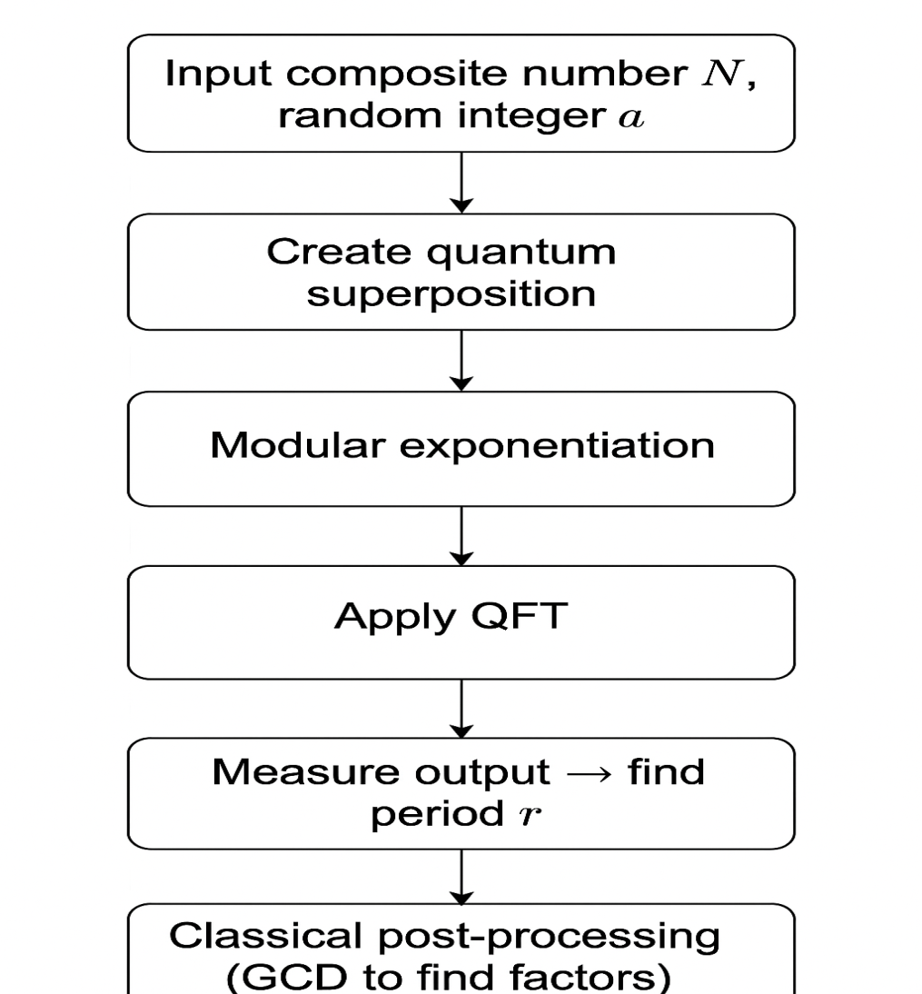
Figure 6: Flowchart of Shor’s Algorithm

5.3 Advantage Over Classical Algorithms

Time Complexity
Shor’s Algorithm runs in polynomial time, specifically:
O((log⁡N)3)O((\log N)^3)O((logN)3)
This is a significant improvement over classical factoring algorithms such as the General Number Field Sieve (GNFS), which has a sub-exponential time complexity of:
$O(e^\{(1.923 + o(1)) (\backslash log N)^\{1/3\} (\backslash log \backslash log N)^\{2/3\}\})$
While GNFS is the fastest known classical algorithm for factoring, it becomes infeasible for very large integers. In contrast, Shor’s Algorithm demonstrates that quantum computers can efficiently solve problems that are classically intractable, illustrating a core concept of quantum advantage (Shor, 1994; Lenstra & Lenstra, 1993).

Limitations of Classical Methods
Classical methods suffer from:
- Exponential or sub-exponential growth in computation time
- No known polynomial-time algorithm for factoring
- Resource constraints: large RAM and CPU cycles
- Inability to exploit periodicity efficiently
Shor’s quantum method overcomes this by leveraging superposition, entanglement, and interference to perform computations across an exponentially large space in parallel (Preskill, 1998).

Applications and Technologies
The applications and technologies used in Shor’s Algorithm are as follows:

6.1 Real-World Application

The capability of Shor algorithm to crack RSA encryption that is relied upon to secure digital communication systems across the world is one of the greatest practical uses of the algorithm in the real world. RSA is depend upon the computational complexity of factoring the product of two large prime numbers. By factoring such numbers in poly-time, Shor Algorithm makes RSA insecure when performed on quantum computer of quantum size large enough (Shor, 1994).
In a practical use-case scenario, consider secure banking communications. Online banking websites use SSL/TLS encryption, which often employs RSA for secure key exchange. If an adversary had access to a scalable quantum computer running Shor’s Algorithm, they could intercept the public key, factor the RSA modulus, and derive the private key. This would allow them to decrypt financial transactions, impersonate account holders, and access confidential data—undermining digital trust infrastructures globally (Mosca, 2018).
The implications go beyond finance: secure email, VPNs, and even encrypted military communications are vulnerable. Shor’s Algorithm thus motivates urgent global action toward quantum-safe cryptography, such as lattice-based encryption methods being standardized by NIST (Chen et al., 2016).

6.2 Current Quantum Computing Platforms
Quantum computers capable of running Shor’s Algorithm at scale are not yet available, but significant progress is being made across various quantum hardware platforms. Each has strengths and limitations, and each is being explored to implement complex algorithms like Shor’s.

Superconducting Qubits (IBM, Google)
Superconducting qubits are implemented using Josephson junctions cooled to near absolute zero. Companies like IBM and Google use these qubits in their quantum processors. They offer fast gate speeds and scalability using planar fabrication, making them suitable for near-term quantum experiments. In 2019, Google’s Sycamore processor achieved quantum supremacy in a benchmark task (Arute et al., 2019), and IBM has demonstrated Shor’s Algorithm on small-scale versions (factoring 15 and 21).

Trapped Ions (IonQ, Honeywell)
Trapped-ion systems encode qubits in the electronic states of ions held in electromagnetic traps. Companies like IonQ and Honeywell have built high-fidelity quantum computers based on this approach. Trapped ions are known for their exceptional coherence times and high-fidelity gates, making them suitable for implementing error-sensitive algorithms like Shor’s (Monz et al., 2016).

Topological Qubits (Microsoft)
Topological qubits are a more experimental approach, being developed by Microsoft’s Quantum division. These qubits rely on non-Abelian anyons to encode information in a topologically protected state. If realized, topological qubits could offer intrinsic error resistance, drastically reducing the overhead for fault-tolerant quantum computation (Nayak et al., 2008). However, no large-scale working system has yet been demonstrated.
Platform | Qubits | Technology | Pros | Limitations
IBM Quantum | 100+ | Superconducting | Widely accessible, real devices | Noise, decoherence
IonQ | ~30 | Trapped Ion | Long coherence time | Slower gate speeds
Google Sycamore | 53 | Superconducting | Achieved quantum supremacy | Limited public access
Rigetti | 80+ | Superconducting | Hybrid cloud models | Lower fidelity than IBM

Figure 7: Comparison of Quantum Hardware Platforms and Their Architectural Trade-offs
Among the compared platforms, IonQ stands out for coherence, IBM offers accessibility, and Google has demonstrated quantum supremacy, though not for public algorithms. Each platform presents trade-offs between scalability, gate speed, and fidelity.

6.3 Challenges and Limitations
Despite its theoretical power, implementing Shor’s Algorithm in practice faces several challenges due to the limitations of current quantum hardware.
Quantum Error Correction
Bad sounds, gate errors and the loss of coherence are very sensitive to quantum systems. Quantum error correction (QEC) plays a critical role in the maintenance of quantum information during long computation. The surface codes, the most popular QEC model, swhich enormously increases hardware demands (Fowler et al., 2012).

Coherence Time

The time during which a qubit can preserve its quantum state is called coherence time. The coherence time of most existing systems is on the scale of microseconds to milliseconds. To run Shor’s Algorithm on large integers, quantum states would have to stay coherent for significantly longer periods, which is not possible without significant error correction at the current time (Preskill, 2018).

Scalability
Implementing Shor’s Algorithm for real-world RSA key sizes (e.g., 2048-bit) would require millions of qubits, with high-fidelity gates and low error rates. No current platform offers this level of scale. Additionally, managing control hardware, cooling, and connectivity becomes exponentially more complex as systems grow (Gidney & Ekerå, 2021).

Future Outlook

Shor’s Algorithm has reshaped the long-term trajectory of both quantum computing and cryptographic security. While it remains mostly theoretical due to current hardware limitations, it has already catalyzed significant changes in how governments, researchers, and industries approach information security, hardware development, and algorithm design.

7.1 Future Developments

Fault-Tolerant Quantum Computers
The Shor’s Algorithm remains definitive benchmark for capabilities of quantum computing. However, practical implementation is currently limited by hardware instability, short coherence times, and gate errors. To run Shor’s Algorithm on RSA-sized inputs (e.g., 2048-bit), quantum computers will require millions of physical qubits, managed through fault-tolerant architectures and quantum error correction methods such as surface codes (Fowler et al., 2012).
Researchers continue to develop scalable systems capable of sustaining long computations without decoherence. These fault-tolerant quantum computers are the key to transforming Shor’s Algorithm from a theoretical breakthrough into a tool with real-world cryptographic impact (Preskill, 2018).
Post-Quantum Cryptography
The looming a threat was posed by Shor’s Algorithm to RSA and similar public-key cryptosystems has accelerated global initiatives in post-quantum cryptography (PQC). The National Institute of Standards and Technology (NIST) is leading efforts to standardize new algorithms resistant to quantum attacks, such as lattice-based and code-based schemes (Chen et al., 2016). Even though large-scale quantum computers are not yet available, the mere existence of Shor’s Algorithm necessitates proactive cryptographic transition.

Quantum-Classical Hybrid Models
While fully universal quantum computers are still years away, hybrid quantum-classical models offer an intermediate path. In these architectures, classical systems handle control and decision-making while quantum processors solve specific subproblems. Though Shor’s Algorithm is inherently quantum, similar modular breakdowns are being explored in quantum factorization circuits and error-mitigation techniques. These hybrid models represent a strategic bridge toward full-scale quantum deployment (Bharti et al., 2022).

7.2 Long-Term Industry Applications

Cybersecurity
Shor’s Algorithm has already transformed the cybersecurity landscape. It has proven that RSA, DSA, and ECC are no longer future-proof, prompting industries to prepare for a cryptographic transition. Financial institutions, defense organizations, and governments are adopting PQC to future-proof their data (Mosca, 2018). Shor’s Algorithm directly motivates the deployment of quantum-safe cryptographic infrastructure.

Drug Discovery and Materials Science
Quantum simulation is another promising domain, but the motivation and investment in quantum hardware largely stems from Shor’s Algorithm and its implications. The need for quantum processors that can run Shor’s Algorithm has spurred advancements in hardware that will also benefit quantum chemistry simulations, accelerating drug discovery and molecular modeling (Cao et al., 2019). Thus, the infrastructure being developed in response to Shor’s Algorithm indirectly fuels broader scientific breakthroughs..

Supply Chain Optimization
Although Shor’s Algorithm itself is not used in optimization, its role as a performance benchmark for quantum hardware has pushed forward the capabilities required for algorithms like QAOA and quantum annealing. Companies like IBM and Google build processors with Shor's circuit depth in mind, which also makes them suitable for running logistics optimization, portfolio balancing, and resource scheduling problems — all key in supply chain optimization (Orús et al., 2019).

7.3 Future Trends and Ethical Implications in Quantum Computing
As quantum computing steadily advances from theoretical models to functional prototypes and commercial applications, its potential to revolutionize existing systems—particularly in cryptography—becomes increasingly evident. Algorithms such as Shor’s demonstrate the power of quantum systems to solve problems previously considered intractable. However, alongside these advancements come critical future trends and ethical implications that researchers, policymakers, and society must urgently address.

Post-Quantum Cryptography (PQC)

Shor’s Algorithm enables the effective factorization of huge integers and solving of discrete logarithm issues—core challenges that underlie the security of widely used cryptographic systems like RSA, DSA, and Elliptic Curve Cryptography (ECC). When quantum computers reach a sufficient number of qubits and gate fidelity, these systems will become vulnerable to attack, potentially jeopardizing the secrecy and integrity of global digital communications.
To counter this threat, the field of post-quantum cryptography has emerged. PQC focuses on developing new cryptographic algorithms that are secure against both classical and quantum adversaries. Unlike traditional public-key systems, PQC relies on hard problems of mathematics that are not easily solvable even by Quantum Computers. The strategies can be popular:
• Lattice cryptography (e.g. NTRU, Kyber)
• Hash-based cryptography (e.g. SPHINCS+)
• Code-based cryptography (e.g. McEliece)
• multivariate polynomial schemes
The National Institute of Standards and Technology (NIST) has been in the forefront in standardization of post-quantum cryptographic algorithms. By 2024, NIST has chosen finalists to be implemented in future, including CRYSTALS-Kyber and CRYSTALS-Dilithium.

Ethical and Societal Implications
Quantum computing’s capabilities also raise complex ethical concerns. While the technology promises breakthroughs in fields like drug discovery, logistics, and materials science, its disruptive potential must be carefully managed.

1. National Security
Quantum computers could undermine state-level cryptographic systems, leading to:
- Espionage threats
- Interference in defense communication
- Disruption of election integrity
Without a robust transition to quantum-safe encryption, nation-states may experience critical vulnerabilities in their cybersecurity frameworks.

2. Economic Disruption
Quantum computing may create global inequality in technological capabilities:
- Countries and corporations with early quantum advantage may dominate emerging industries.
- Traditional tech economies may face obsolescence if unable to adapt quickly.
- Job markets may shift dramatically, requiring reskilling in quantum literacy and cryptographic engineering.

3. Privacy Concerns
Quantum decryption of historical data could violate past agreements of confidentiality. Medical records, financial transactions, and personal communications—assumed secure—could be retrospectively exposed if “harvest-now, decrypt-later” strategies are used.
Ethical Insight: A proactive ethical framework must address not only how quantum technology is used, but also how it is governed, who has access to it, and how power is distributed globally.

The Global Quantum Race
As quantum computing's strategic importance becomes clear, nations and corporations are competing to lead in the domain—driven by the promise of economic gain, scientific prestige, and national defense.
- The United States has allocated over $1.2 billion through the National Quantum Initiative Act, with agencies like DARPA, NIST, and NSF leading development.
- China has invested heavily in quantum networks and photonic quantum computing, achieving milestones such as quantum satellite communication.
- The European Union launched the Quantum Flagship program, dedicating over €1 billion to quantum research over 10 years.
- Tech giants—including IBM, Google, Microsoft, Amazon, and Alibaba—are building quantum processors, quantum cloud services, and quantum SDKs to enable software development.
Global Responsibility: As the race accelerates, international governance and standards—similar to nuclear non-proliferation agreements—may be needed to ensure ethical use and shared benefits.

7.4 Conclusion: The Need for Responsible Innovation
Quantum computing presents a transformative opportunity to advance science, industry, and global problem-solving. Algorithms such as Shor’s illustrate both the computational power and the disruptive potential of quantum technologies. However, realizing the full benefits of quantum computing without creating new social, economic, or geopolitical risks requires intentional and responsible innovation.
To ensure that quantum technologies contribute positively to society, stakeholders—including researchers, governments, industries, and educators—must collaborate across disciplines and sectors. This involves:
- Investing in quantum-safe infrastructure to protect digital communications and critical systems from future quantum threats;
- Promoting ethical education and regulatory frameworks to guide the development and deployment of quantum technologies with respect to fairness, security, and accountability;
- Encouraging global cooperation and open innovation, enabling inclusive access and preventing monopolization or misuse of quantum capabilities.
By embedding ethical foresight and inclusivity into the development of quantum systems, the global community can shape a future where quantum computing enhances—not undermines—human progress, equity, and trust.
Personal Reflection: This report deepened my appreciation for the intricate balance between theoretical quantum computation and its practical limitations. Understanding Shor’s Algorithm highlighted not only the disruptive power of quantum algorithms, but also the ethical foresight needed as we move toward a quantum future.

Summary of the Findings
Shor’s Algorithm represents one of the most profound theoretical breakthroughs in quantum computing. It proves that integer factorization, a problem considered classically intractable for large numbers, can be solved in polynomial time on a quantum computer. This breakthrough has direct consequences for modern cryptography, especially RSA encryption, which underpins much of today’s secure digital communication.
At its core, The Shor’s Algorithm leverages properties of quantum such as superposition, entanglement, and interference to perform period finding using the Quantum Fourier Transform (QFT). This approach demonstrates exponential improvement over the best-known classical factoring algorithm, showcasing the true computational power of quantum systems.
Although full-scale implementation is currently constrained by technological limitations—such as short coherence times, high error rates, and the need for fault-tolerant architectures—rapid advancements in quantum hardware platforms (e.g., superconducting qubits, trapped ions) are steadily closing this gap. Companies like IBM, Google, IonQ, and Microsoft are building the foundational systems necessary for scaling Shor’s Algorithm and other quantum workloads.
The algorithm’s existence has already driven major shifts in cybersecurity strategy. Governments and industries are preparing for a post-quantum era, adopting quantum-resistant encryption methods in anticipation of future threats. Additionally, the quantum computing ecosystem is expanding to include hybrid models, optimization algorithms, and scientific simulations, which benefit from the same hardware innovations motivated by Shor’s Algorithm.
In conclusion, Shor’s Algorithm is more than a mathematical innovation; it is a catalyst that has accelerated progress in quantum computing, post-quantum cryptography, and high-performance computing architectures. It symbolizes both the quantum disruptive potential of technologies and the urgency with which we must adapt to a rapidly approaching computational future.

References
- Shor, P. W. (1994). Algorithms for quantum computation: Discrete logarithms and factoring. In Proceedings of the 35th Annual Symposium on Foundations of Computer Science (pp. 124–134). IEEE. https://doi.org/10.1109/SFCS.1994.365700
- Mosca, M. (2018). Cybersecurity in an era with quantum computers: Will we be ready? IEEE Security & Privacy, 16(5), 38–41. https://doi.org/10.1109/MSP.2018.3761723
- Nielsen, M. A., & Chuang, I. L. (2010). Quantum computation and quantum information (10th anniversary ed.). Cambridge University Press.
- Yanofsky, N. S., & Mannucci, M. A. (2008). Quantum computing for computer scientists. Cambridge University Press.
- Preskill, J. (1998). Quantum information and computation. California Institute of Technology. http://theory.caltech.edu/~preskill/ph229/
- Gidney, C., & Ekerå, M. (2021). How to factor 2048-bit RSA integers in 8 hours using 20 million noisy qubits. Quantum, 5, 433. https://doi.org/10.22331/q-2021-04-15-433
- Lenstra, A. K., & Lenstra, H. W. (Eds.). (1993). The development of the number field sieve. Springer-Verlag.
- Chen, L., et al. (2016). Report on Post-Quantum Cryptography. NISTIR 8105. National Institute of Standards and Technology. https://doi.org/10.6028/NIST.IR.8105
- Arute, F., Arya, K., Babbush, R., Bacon, D., Bardin, J. C., Barends, R., ... & Neven, H. (2019). Quantum supremacy using a programmable superconducting processor. Nature, 574(7779), 505–510. https://doi.org/10.1038/s41586-019-1666-5
- Monz, T., Nigg, D., Martinez, E., Brandl, M. F., Schindler, P., Rines, R., ... & Blatt, R. (2016). Realization of a scalable Shor algorithm. Science, 351(6277), 1068–1070. https://doi.org/10.1126/science.aad9480
- Nayak, C., Simon, S. H., Stern, A., Freedman, M., & Das Sarma, S. (2008). Non-Abelian anyons and topological quantum computation. Reviews of Modern Physics, 80(3), 1083–1159. https://doi.org/10.1103/RevModPhys.80.1083
- Fowler, A. G., Mariantoni, M., Martinis, J. M., & Cleland, A. N. (2012). Surface codes: Towards practical large-scale quantum computation. Physical Review A, 86(3), 032324. https://doi.org/10.1103/PhysRevA.86.032324
- Cao, Y., Romero, J., Olson, J. P., Degroote, M., Johnson, P. D., Kieferová, M., ... & Aspuru-Guzik, A. (2019). Quantum chemistry in the age of quantum computing. Chemical Reviews, 119(19), 10856–10915. https://doi.org/10.1021/acs.chemrev.8b00803
- Orús, R., Mugel, S., & Lizaso, E. (2019). Quantum computing for finance: Overview and prospects. Reviews in Physics, 4, 100028. https://doi.org/10.1016/j.revip.2019.100028
- Bharti, K., Cervera-Lierta, A., Kyaw, T. H., Haug, T., Alperin-Lea, S., Anand, A., ... & Aspuru-Guzik, A. (2022). Noisy intermediate-scale quantum algorithms. Reviews of Modern Physics, 94(1), 015004. https://doi.org/10.1103/RevModPhys.94.015004

