

Faculty of Computing and Informatics (FCI)
Multimedia University
Cyberjaya

TSN 2201
Computer Network Assignment
Semester 2, 2019/2020

Submitted To - Mr.Ng Keng Hoong
Tutorial Section: TT02

Student Name | Student ID
Lou Jia Yu | 1161104266
Perivitta Rajendran | 1171101579

Network Design and Description

Network design for the Ministry of Primary Industries with a total number of 220 employees and 47.46.70.0/23 will be assigned as it’s the major IP address.

Network Performance

Divison | Number of Employees | Location
Account | 36 | Kajang
Information Management | 17 | Kuching
Human Resource | 18 | Putrajaya
Administration & Finance Management | 45 | Kota Kinabalu
Innovation Promotion | 15 | Kota Bahru
Strategic Planning and International | 14 | Putrajaya
Legal Unit | 10 | Kota Kinabalu
Corporate Communication Unit | 65 | Kuala Lumpur

VLSM Subnetting

Subnet Name | Needed Size | Allocated Size | Network Address | Mask | Subnet Mask | Assignable Range | Broadcast
Corporate Communication Unit | 65 | 126 | 45.46.70.0 | /25 | 255.255.255.128 | 45.46.70.1 - 45.46.70.126 | 45.46.70.127
Administration & Finance Management | 45 | 62 | 45.46.70.128 | /26 | 255.255.255.192 | 45.46.70.129 - 45.46.70.190 | 45.46.70.191
Account | 36 | 62 | 45.46.70.192 | /26 | 255.255.255.192 | 45.46.70.193 - 45.46.70.254 | 45.46.70.255
Human Resource | 18 | 30 | 45.46.71.0 | /27 | 255.255.255.224 | 45.46.71.1 - 45.46.71.30 | 45.46.71.31
Information Management | 17 | 30 | 45.46.71.32 | /27 | 255.255.255.224 | 45.46.71.33 - 45.46.71.62 | 45.46.71.63
Innovation Promotion | 15 | 30 | 45.46.71.64 | /27 | 255.255.255.224 | 45.46.71.65 - 45.46.71.94 | 45.46.71.95
Strategic Planning and International | 14 | 14 | 45.46.71.96 | /28 | 255.255.255.240 | 45.46.71.97 - 45.46.71.110 | 45.46.71.111
Legal Unit | 10 | 14 | 45.46.71.112 | /28 | 255.255.255.240 | 45.46.71.113 - 45.46.71.126 | 45.46.71.127
Server | 8 | 14 | 45.46.71.128 | /28 | 255.255.255.240 | 45.46.71.129 - 45.46.71.142 | 45.46.71.143
Putrajaya-Kajang | 2 | 2 | 45.46.71.144 | /30 | 255.255.255.252 | 45.46.71.145 - 45.46.71.146 | 45.46.71.147
Kajang-Kota Bahru | 2 | 2 | 45.46.71.148 | /30 | 255.255.255.252 | 45.46.71.149 - 45.46.71.150 | 45.46.71.151
Kota Bahru-Kota Kinabalu | 2 | 2 | 45.46.71.152 | /30 | 255.255.255.252 | 45.46.71.153 - 45.46.71.154 | 45.46.71.155
Kota Kinabalu-Kuching | 2 | 2 | 45.46.71.156 | /30 | 255.255.255.252 | 45.46.71.157 - 45.46.71.158 | 45.46.71.159
Putrajaya-Kuala Lumpur | 2 | 2 | 45.46.71.160 | /30 | 255.255.255.252 | 45.46.71.161 - 45.46.71.162 | 45.46.71.163

Design Justification

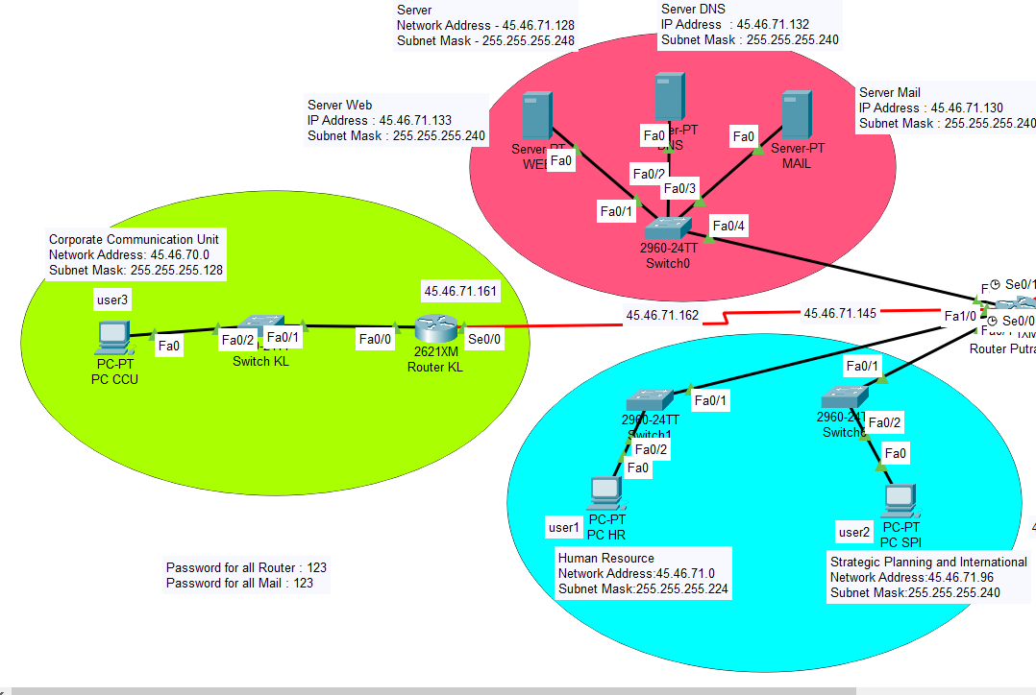

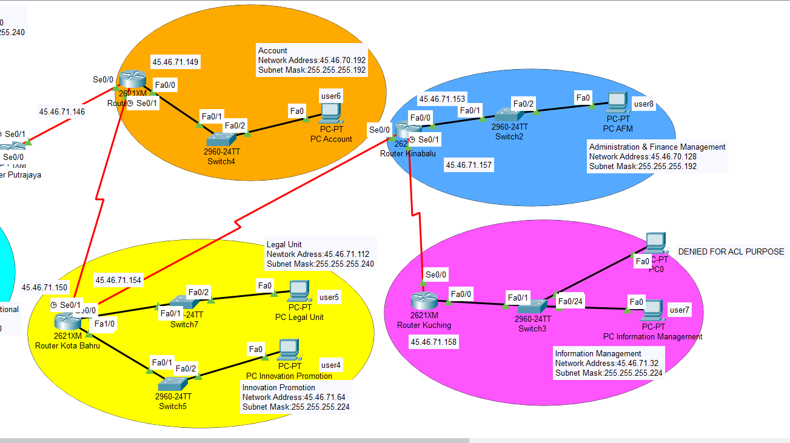

IP Address for PCs and Servers

No | Description | IP Address | Default Gateway | Email Address
1 | PC-HR | 45.46.71.2 | 45.46.71.1 | user1@mpi.com.my
2 | PC-SPI | 45.46.71.98 | 45.46.71.97 | user2@mpi.com.my
3 | PC-CCU | 45.46.70.2 | 45.46.70.1 | user3@mpi.com.my
4 | PC-IP | 45.46.71.66 | 45.46.71.65 | user4@mpi.com.my
5 | PC-LU | 45.46.71.114 | 45.46.71.113 | user5@mpi.com.my
6 | PC-IM | 45.46.70.194 | 45.46.70.193 | user6@mpi.com.my
7 | PC-AFM | 45.46.71.34 | 45.46.71.33 | user7@mpi.com.my
8 | PC-ACL | 45.46.71.35 | 45.46.71.33 | -
8 | DNS-Server | 45.46.71.133 | 45.46.71.129 | www.ministry.com
9 | Web-Server | 45.46.71.132 | 45.46.71.129 | www.mpi.co
10 | Email-Server | 45.46.71.130 | 45.46.71.129 | mpi.com.my

IP Address for Routers

No | Description | Fast Ethernet/Serial Ethernet | IP Address | Cable Type
1 | Putrajaya | Fa0/0 | 45.46.71.129 | Copper-Straight-Through
1 | Putrajaya | Fa0/1 | 45.46.71.1 | Copper-Straight-Through
1 | Putrajaya | Se0/0 | 45.46.71.162 | Copper-Straight-Through
1 | Putrajaya | Se0/1 | 45.46.71.145 | Serial DTE
1 | Putrajaya | Fa1/0 | 45.46.71.97 | Serial DTE
2 | Kuala Lumpur | Fa0/0 | 45.46.70.1 | Copper-Straight-Through
2 | Kuala Lumpur | Se0/0 | 45.46.71.161 | Serial DTE
3 | Kajang | Fa0/0 | 45.46.70.193 | Copper-Straight-Through
3 | Kajang | Se0/0 | 45.46.71.146 | Serial DTE
3 | Kajang | Se0/1 | 45.46.71.149
4 | Kota Bahru | Fa0/0 | 45.46.71.65 | Copper-Straight-Through
4 | Kota Bahru | Fa1/0 | 45.46.71.113 | Copper-Straight-Through
4 | Kota Bahru | Se0/0 | 45.46.71.150 | Serial DTE
4 | Kota Bahru | Se0/1 | 45.46.71.154 | Serial DTE
5 | Kinabalu | Fa0/0 | 45.46.70.129 | Copper-Straight-Through
5 | Kinabalu | Se0/0 | 45.46.71.153 | Serial DTE
5 | Kinabalu | Se0/1 | 45.46.71.157 | Serial DTE
6 | Kuching | Fa0/0 | 45.46.71.33 | Copper-Straight-Through
6 | Kuching | Se0/0 | 45.46.71.158 | Serial DTE

Network Performance

- Routing Information Protocol (RIP)
  - RIP protocol only has a limitation of 15 hops maximum to avoid “count to infinity” problem, which will limit the expansion of the network in the future.

- Purpose of Servers
  - DNS: The Domain Name System consists of domain names that can be accessible to all Users. Servers are used to connect all the Internet Protocol (IP) addresses with the DNS.

  - Email: Servers are more reliable and highly secured to email within a network. Which means the results will be retrieved in split-seconds, once the email is transferred from one subnetwork to another. There will not be any internet slowdown or network disruptions during the transferring process.

  - Web servers: A Web server is a program that allows users to access information within the internet. Having a server provides better security and protection of information from prying eyes.

- Pros and cons of implementing 3 different servers
  - For a better backup system,having three servers allows better data recovery in case of a virus or malware which might cause, if any one of the servers to be affected, having multiple servers causes the data to be stored in multiple locations.

  - Fast browsing.For example, having three servers will divide the tasks among them by loading in three ways during downloads as a result faster internet speed is gained.

  - High Cost, for example, if there are many servers in a design protocol then the price of servers will be high. Based on our design, having multiple servers can also be beneficial where it will be highly secured, and that is why 3 servers were implemented.

- VLANs
  - The Ministry of Primary Industries is not using any VLANs because VLANs have high risks of virus issues because one infected system may spread a virus through the whole logical network. Additional routers are needed to control the loadout.

- Wide Area Network (WAN)
  - WAN has the ability to cover large geographical areas. The network is more centralized as a result of updates, files and data can be transferred instantly. One of the key advantages is high bandwidth which distributed workload and decreases travel charges.

Network Security (Password)

We have added passwords for all the routers and web browsers as well. The password that we have set for the routers is 123. We have also decided to add password so that it could enhance the ministry department’s security.

