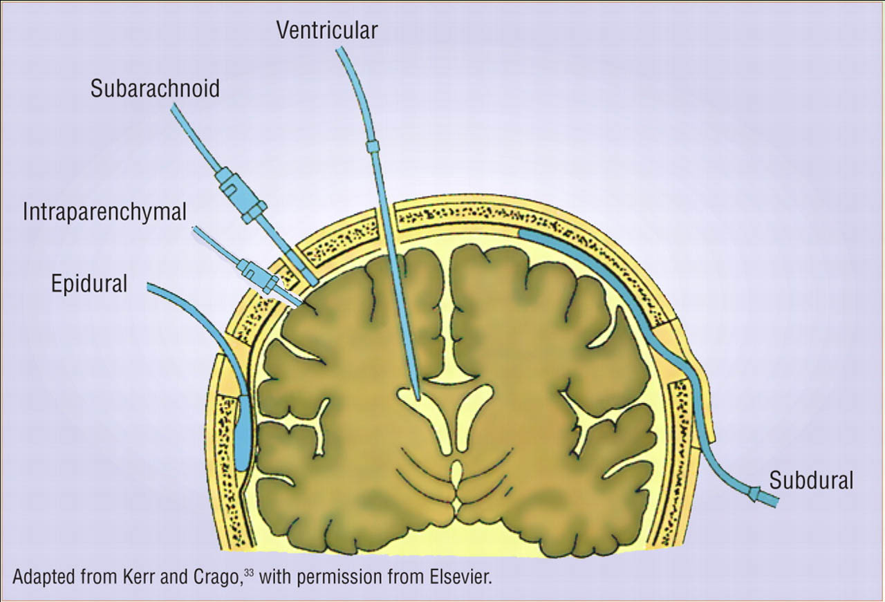

<http://crashingpatient.com/trauma/system/severe-traumatic-brain-injury.htm/>