**Spectroscopic Pathology Pictorial Documentation**

Feb 2023

## Purpose

The purpose of this document is to provide insight into the desired procedure to collect skin data using a spectroscopic probe. Images are provided to describe each step.

## Setup

The physical setup can be seen below. The stage moves in the x and y using manual fine control knobs. The stand moves in the z using manual knobs. The probe is placed in the stand and the sample is placed on the stage.

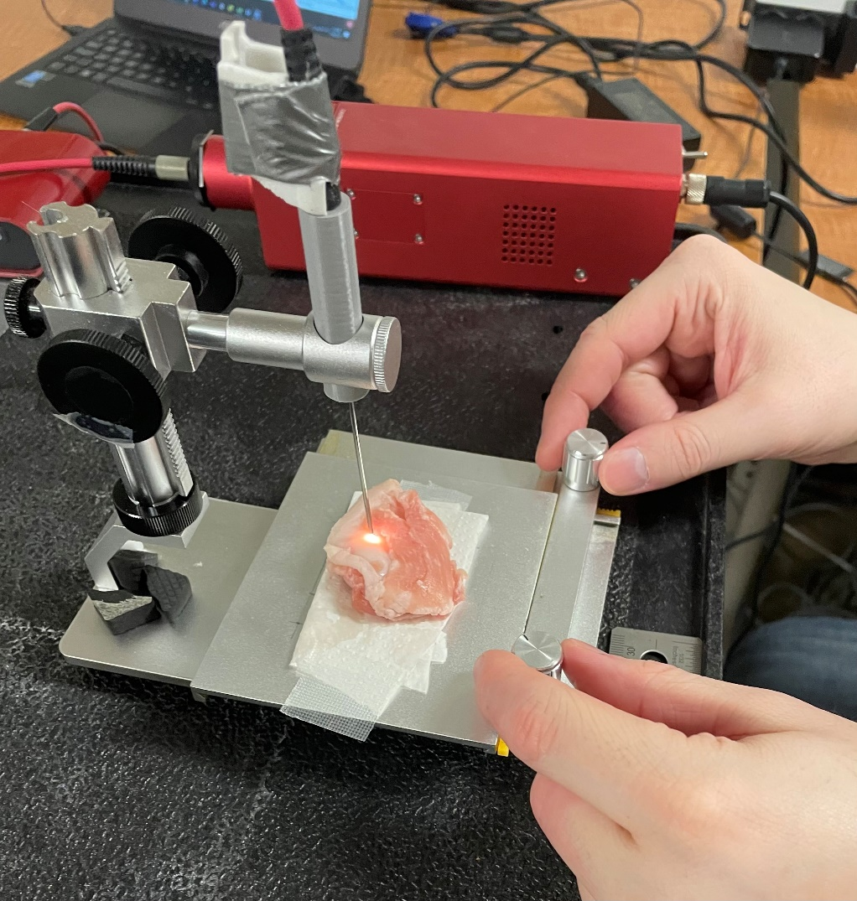

Probe

Stage

Stand

## Procedure

1. Tissue paper is placed in the centre of the stage

1. The skin specimen is placed atop the tissue paper in the centre of the stage

1. Optical imaging (photography) of the specimen. Please ensure the specimen and any measurement references are fully visible.

1. Position the region of interest (ROI) under the probe using the two knobs on the stage. The laser should directly illuminate the ROI.

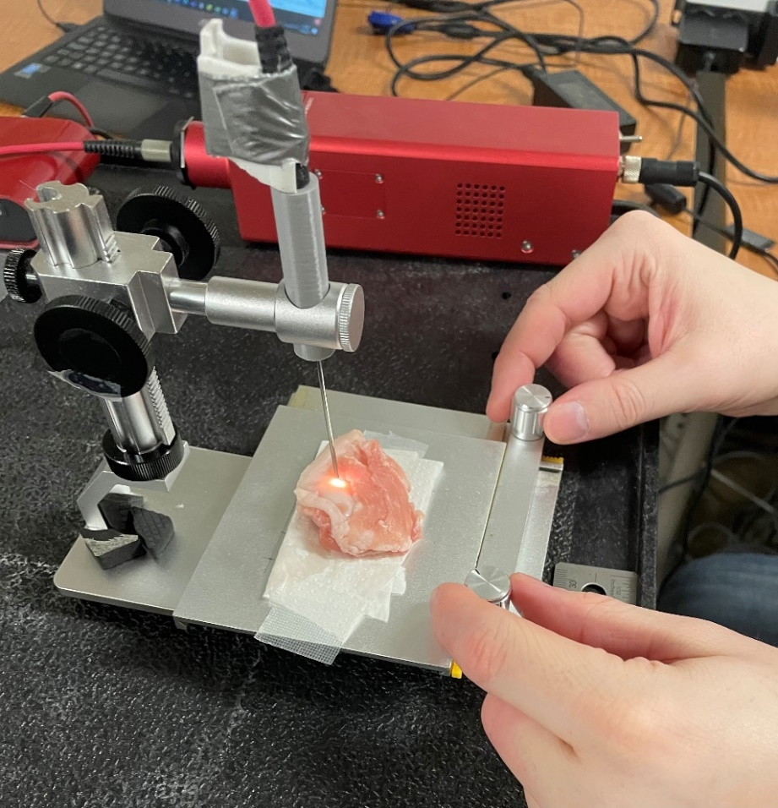

1. Once in position.
   1. Lower the probe until it is within 5mm of the tissue
      1. Closer = smaller collection area = cleaner readings.
      2. Closer = signal
      3. The probe should not touch the tissue surface.
   2. Tell the computer operator the tissue type. (Cancer, healthy)
   3. The operator will request the probe be lowered or raised to achieve

optimal signal strength.

1. Once confirmed the operator will record the region of interest for 1 second
   1. *Repeat steps 4-6 for all regions of interest*.

We will repeat steps 1 – 6 for each tissue sample.