**Anggota Kelompok**: Perkedel Technologies

* Joel Robert Justiawan, 2101629672

Final project proposal

**Game**: The Quest of Fidgets, The First Research prototype

**Genre**: Puzzle

The Quest of Fidgets is a game of puzzle, where player solve objective on each level by figuring it themselves. Each level will show some actions they can do; however, they have to solve the level by themselves. Inspired from Spil Games’s Trollface Quest. The Quest of Fidgets involves more ways of actions rather than just relying on some usual actions such as mouse click on the earlier game.

**Inspiration source**:

* Trollface Quest – Spil Games. Core game mechanics
* Wario Ware – Nintendo. Action based puzzle solving, known to had been releasing games with many unique ways of controlling
* Fidget Spinner – various. This spinning thing is the philosophy of this merchandise, to make user relax and experience something new.

The Quest of Fidgets, also known as Fidget Quest, let the players play in an unusual way. Games these days often rely by sit on gaming, mostly. This is not good for health, because it makes the player seldom to move their body. This creates a polemic of contradiction between digital games and real-life games. The new, Fidget Quest games benefits unique ability of each controller the level required in order to solve, such as: touchscreen, motion sensors, pressure sensor, etc.

In this project, we will realize (make and show/expose) our first research prototype after several months of researching to design this game. This game does not represent actual quality on the real release. We will use any tool we can use to try convincing gamers that digital gaming is not always bad, and good for health, if it is used for good. After some prototypes, we will find a new home (better programming tools) which is reliable, zero fees, zero hell, for us to develop the real games, all alive (forever). Spoiler alert for post-prototype release: Likely we will program this merchandise under pure C++, because Unity, Unreal are expensive. As of now of finding a home (programming tool), none of the programming tool fulfills our requirement above. We hate proprietarism, we hate fees, and we hate hell. Spoiler alert for prototype era release: Java has been offered by our lecturers.

Levels we would like to realize:

* Fidget spinner bomb. In this level, you will use your Fidget Con, Joy-Con, VR-con, 2 Smartphones, or anything you can think of as long as it forms hand, as your VR-hand. You will hold a fidget spinner on right hand, and a rod on left hand. As you start to spin your spinner, you will hear a trap music that is charging. When the trap music heard’s like it is going to explode (bass drop), throw the spinner ahead as soon as possible. You can have 3 extra charges, but be careful, if you reached 4th charge, your spinner will explode on your hand and mess everything up; level failed. If you have enough charge at maximum 3rd charge, your explosion will be powerful, the boxes ahead of you collapse; level complete. If not enough, the fidget spinner will be failed and fall to ground, ruining the fun; level failed. Also remember, your spin charge must be in rhythm with the trap music. If you off sync, the spinner will jam and explode; level failed.
* Destroy the not-real god in statue. As its names, you must destroy the statue that is being used as worship target. That act is seriously bad. But, anyone who tried to depart from doing so, will be punished. You will need VR-hand capable controller to form hand. Pretend to worship by lean down 3 times then act like you are going to destroy the statue. Do not worry, at this moment, nobody will know that you are doing it because that moment is when they lose focus than worshipping. E.g. act like launching Rocket Propelled Grenade to the statue, firing machine gun to the statue until explode, draw a strike of a samurai sword, etc. Just to name few. Proper way and success of doing so, results of the statue destroyed in each respective way the player act; level complete. If you strike your act too soon, you will be detained and punished; level failed. If you worshipped more than 3 times, that mean you declared yourself to away from the real God; level failed.
* Just to name few. More to come in real release sometimes later.

Start Screen for the first time:

When you started the game for the first time, you’ll be greeted with a fidget spinner on the center in a black background. What should you do, is to make the spinner spins. Because it is your first time, we will give you an idea for how it would look like later. Therefore, the instruction of command is shown in visual. Simply follow the image to go. The image will be different for every controller type.

Basically, what you do is to imagine your hand holding a steering wheel. Then, off your right hand and make key turning gesture like you would like to ignite the engine. The fidget spinner will spin, and the engine sound starts. After that, back your hand like you are holding a steering wheel again. Next, off your left hand and do the lever gesture like you would like to change transmission to ‘D’. Then, do hitting acceleration pedal gesture to run the fidget spinner to the right and open the welcome curtain.

If you start the game again after quitting, you will still see the fidget spinner. Simply touch the fidget spinner to start the game.

You can play this welcome first time minigame again on extras.

Character:

* Fidget Cube. Main protagonist of this merchandise. He is a robot cube with general robot face consists of dual camera, scent receptor, OLED display mouth, and stereo speakers beside the mouth. On the side, he has hands, stereo microphones. This cute little thing is the one you carry along your adventure.
* Other characters that comes from every DLC. Even you can import from the other games such as Hexagon Army/Engine (The Yellow Raincoat Group)

Music, Sound, Images, and stuffs:

We will generally use our favorite royalty free music. We appreciate if in case of luck that the musician gave us permission for using their royalty full music, however we will not often to use it unless we love it so much.

The sound will be designed out of freesound.org for this prototype. Later, we will design them ourselves to ensure immersive high-quality experience. Sometimes, we will be relying on some proprietary sounds that permanently match the content, so we will not have to make one. The drawback is that this cause some content will be censored on proprietary platforms such as Windows, Mac, Android, etc. and only shows on gratis and open source platform such as Linux. We do not want to deal with legal Higga Bigga!

We may sometimes make special audio for it. Primarily, we make sure it is purely MIDI based.

All and all, we will create and compose the content, and you can also create your own. This feature will be realized only on real release, not this prototype.

Features:

* Various ways to control
* Loads various memes such as sounds, image, and more
* Hilarious level results
* Boring level results
* 2D or 3D? Whatever!
* Crossover! Multiplayer across different devices, different software, throughout the internet! Spoiler alert: Fidget Quest X Hexagon Army! VR Hexagon, and Conventional Fidget playing together
* What is it?
* Create your own (real release)
* More DLC! Gratis only if you are Linux user.
* Exclusive reward for Linux user: All save data and DLC are saved in $HOME directory! Do anything you can there!
* Proprietary platform user: All save data and DLC are saved in program files. Lose OS, lose save and DLC. No cloud saves allowed. Even if you attempted to manual download DLC and place them in %appdata%, the game will ignore it.
* **NO Digital Restrictions (Rights) Management AT ALL!!!** It’s all yours.
* Just to name few

Disclaimer:

This plan may change overtime without any notice or may be noticed.

License:

Source code: GitHub, some rights reserved

* Coding, GNU GPL v3
* Arts, CC4.0-BY-SA

Binary:

* Open source platform (Linux), Gratis. **All DLCs are also gratis!!! FULL VERSION 1001%!!!**
* Proprietary platforms (Windows, Mac, Steam), Expensive, also extra charge on DLC. Ads everywhere.
* Semi-proprietary platforms (Android), Gratis but with limitation, DLC is expensive, ads everywhere. *Spoiler alert! Highlight these texts above and below, and color it black to view it.*

*Please use Linux to avoid all these hells.*

Spoiler alert: soon, Windows will be the worst OS ever. Likely we will drop support to that OS. If you are still using such OS, please move over to more Gratis and Open Source OS such as Linux. Also, all Jahat edition of Perkedel PC will be no longer using Windows 10 Pro if that happened. It will start to pre-install with Ubuntu Linux just like Baik edition of Perkedel PC with some tuning such as dark hue of evilness.

**PROMO** for research prototype testing participants:

You can try our games for Gratis and full version no matter your platform is. Open Source as well, so you see how we do this. Quick! Download now before the slot run out!

Attachments: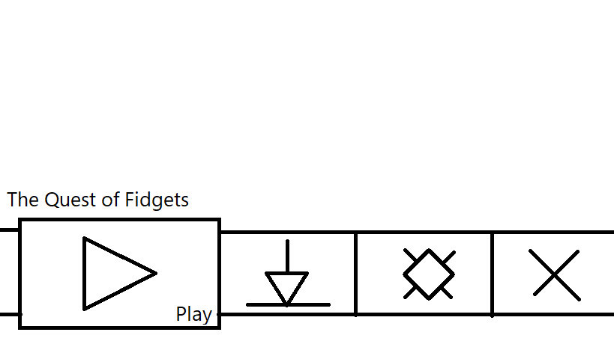

Main menu: Play, Download DLC, Setting, Quit

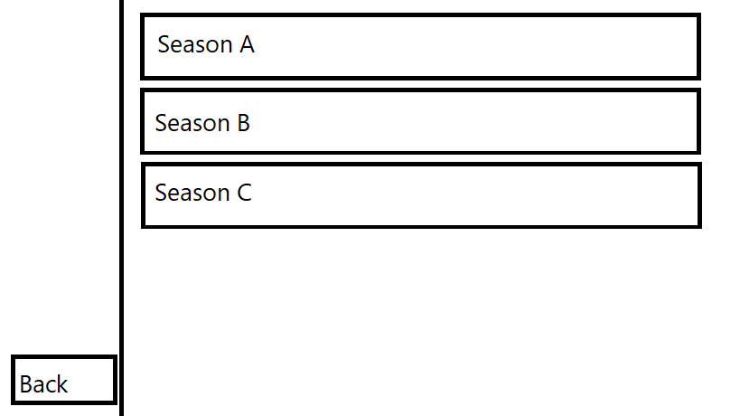

Season select: Select the story DLC.

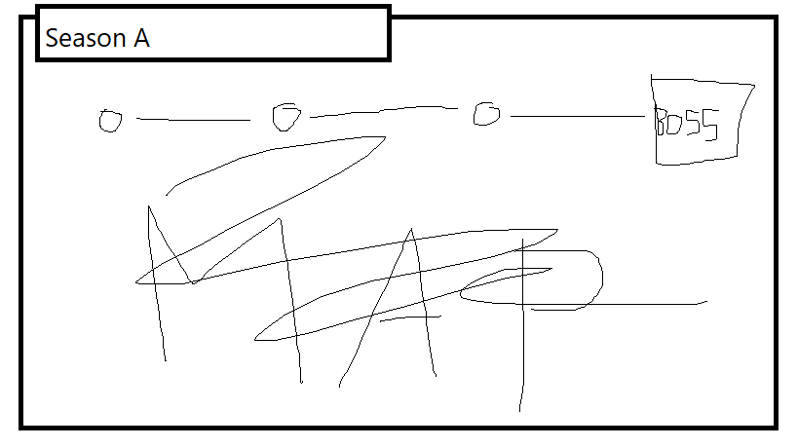

Level select: Usually in forms of maps, but sometimes in traditional forms of menu select.

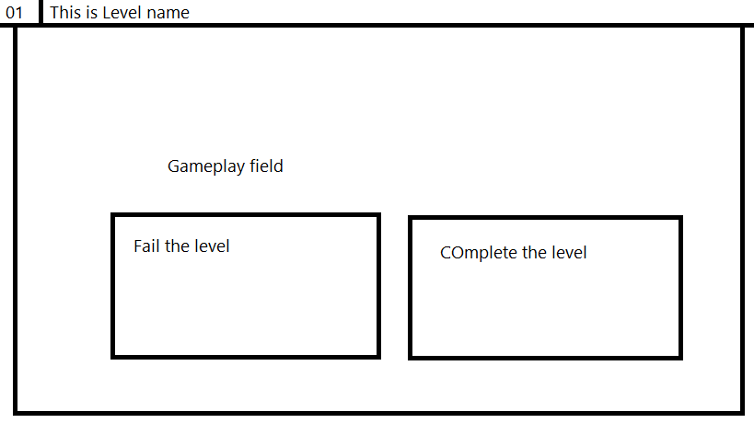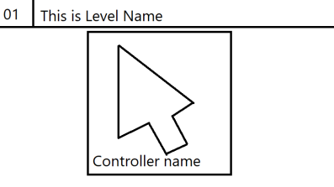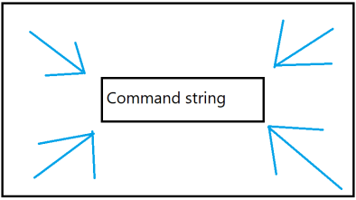

Gameplay sequence: Doable Actions, Objective, Gameplay field with interactions

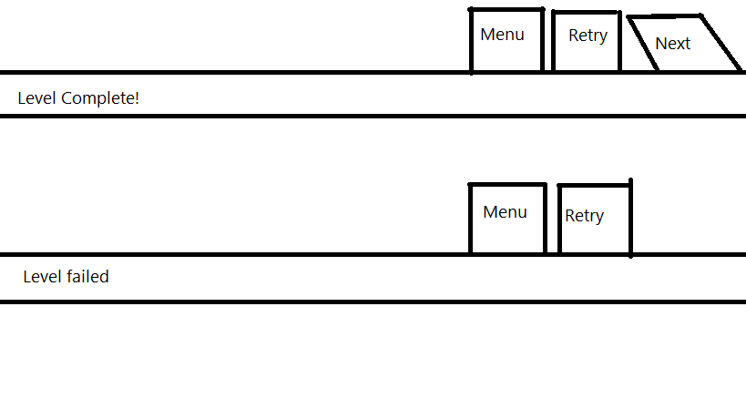

Statements: Above = Level Complete; Below = Level Failed.

Please send this proposal to: [yudjaja@binus.edu](mailto:yudjaja@binus.edu)

Subject: OOGP_GDD_LC04_<Group name>

“LC04” is the class for this subject.

More attachments: Old files since PKM-GT but rejected

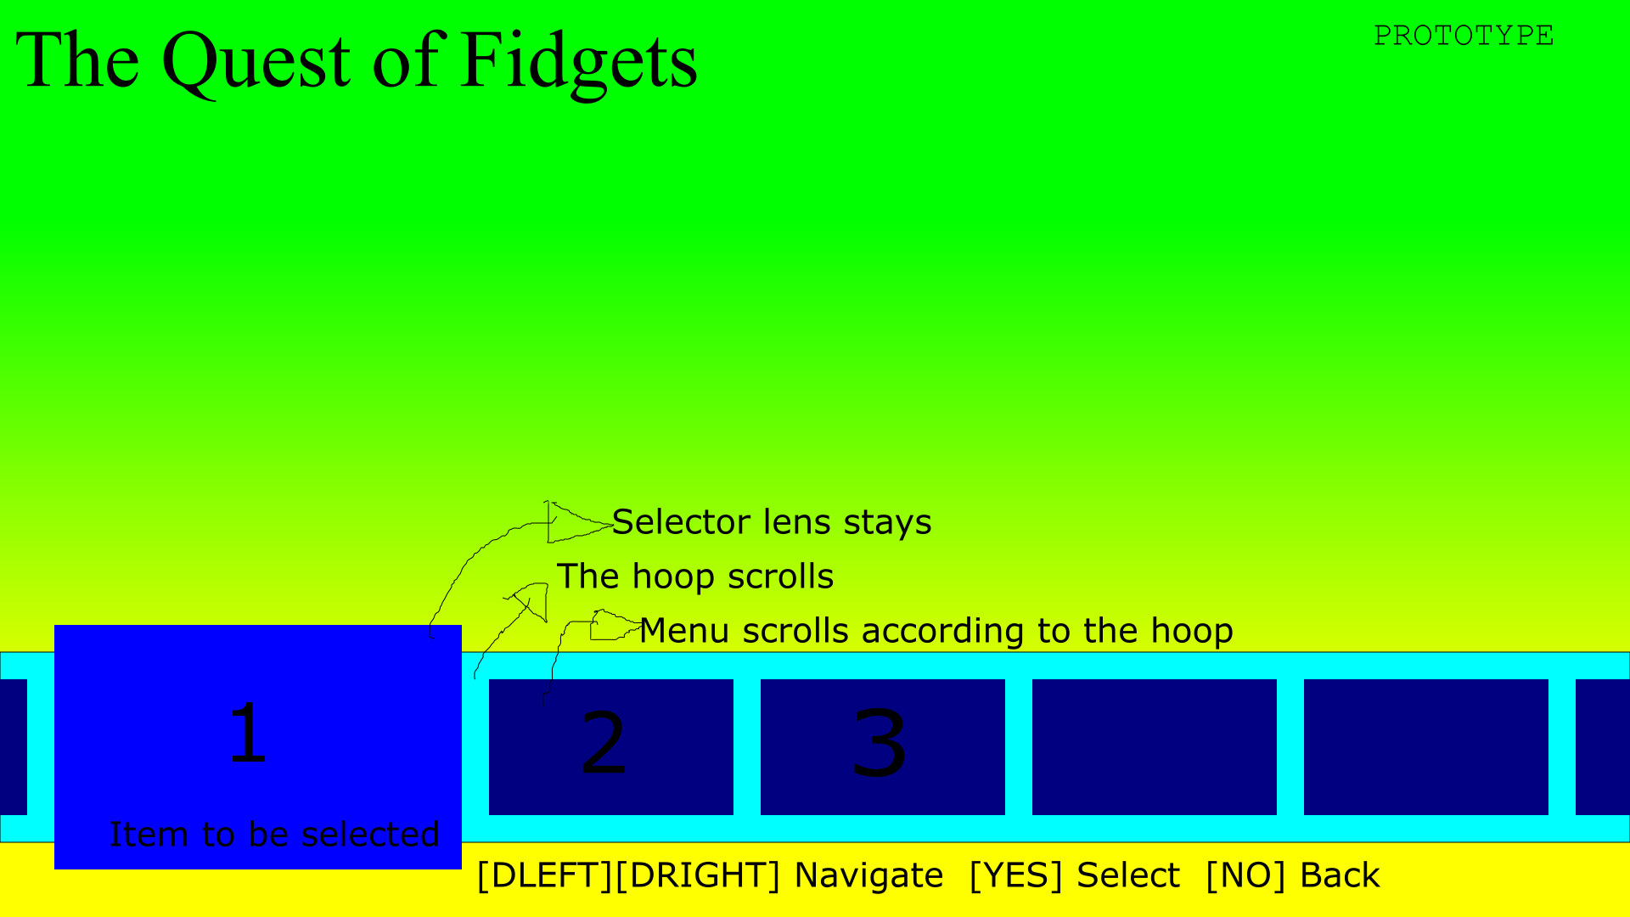

Sebuah gambar berisi objek

Deskripsi dihasilkan dengan keyakinan tinggi

