JOELwindows7

Hello Twitch. I have problem with my Twitch account

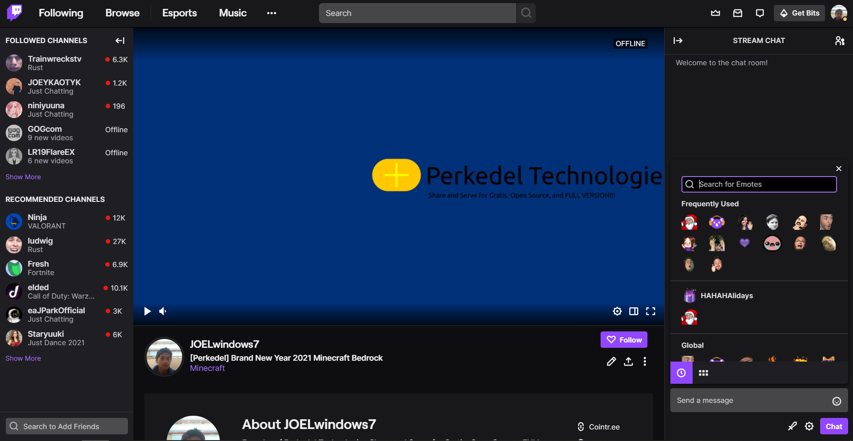

At glance it looks okay. But pay attention to emote I had. Where is my 2fa reward emote? Where is SirPride, SirPrise, whatever..

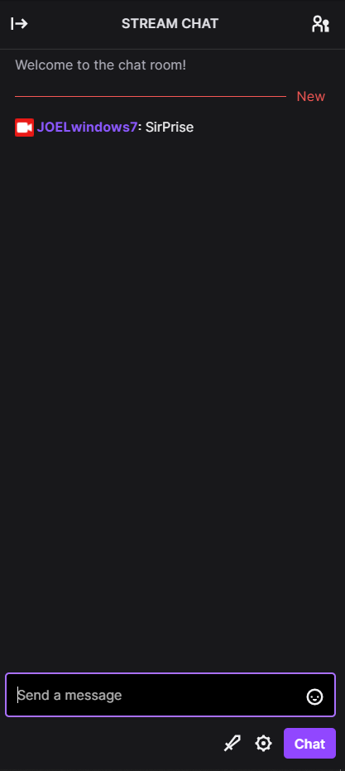 Yeah, it’s gone!

So, Couple weeks ago, my phone with 2fa broke. I panik. I bought new phone. Re log in Twitch. I got Authy fortunately, so I log in the Authy.

But instead I disabled 2fa because panik that I cannot log in. I didn’t know until the time I read the article that Authy cloud backup my 2fa tokens, I shouldn’t even have to turn off 2fa, because the auth (particularly twitch) transfers to a new phone with Authy. So then I turned 2fa on again.

If I disable 2fa the emote will missing. Then if turned on again I should get the 2fa emote back, right? Nope, it didn’t happened.

So I make another account to see if the new account can gets the 2fa reward emote today. I enabled the 2fa of that brand new account. And surprise, it got one.

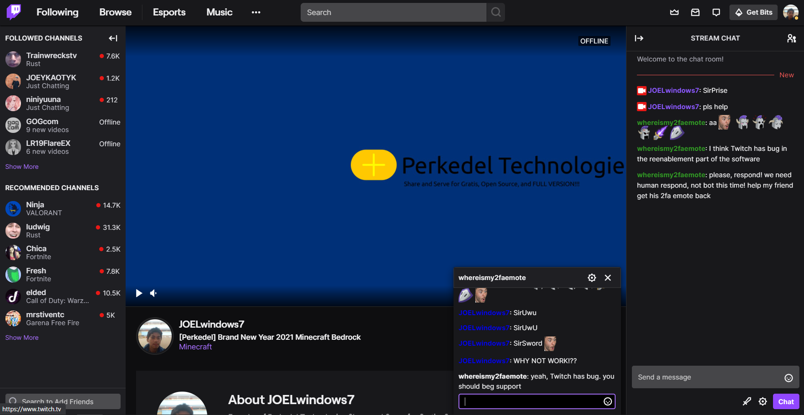

While me and anyone who had disabled and reenabled 2fa do not.

Please fix my account, get my 2fa emote back, I have enabled 2fa right now, but still not have those emote here.