Roland SoundCanvas Re-Preserved, by Community! (for real this time)

Meta
- Monitor the https://theusualsuspects.io/
- Expect & Await Public Release of 88emu, the Roland SoundCanvas SCVA community represervation
- Currently closed beta. Insider access available through $20 donation
- If released indeed, publish below content to Change.org Yamaha Genos Soundfont!
- Else cancel

Content
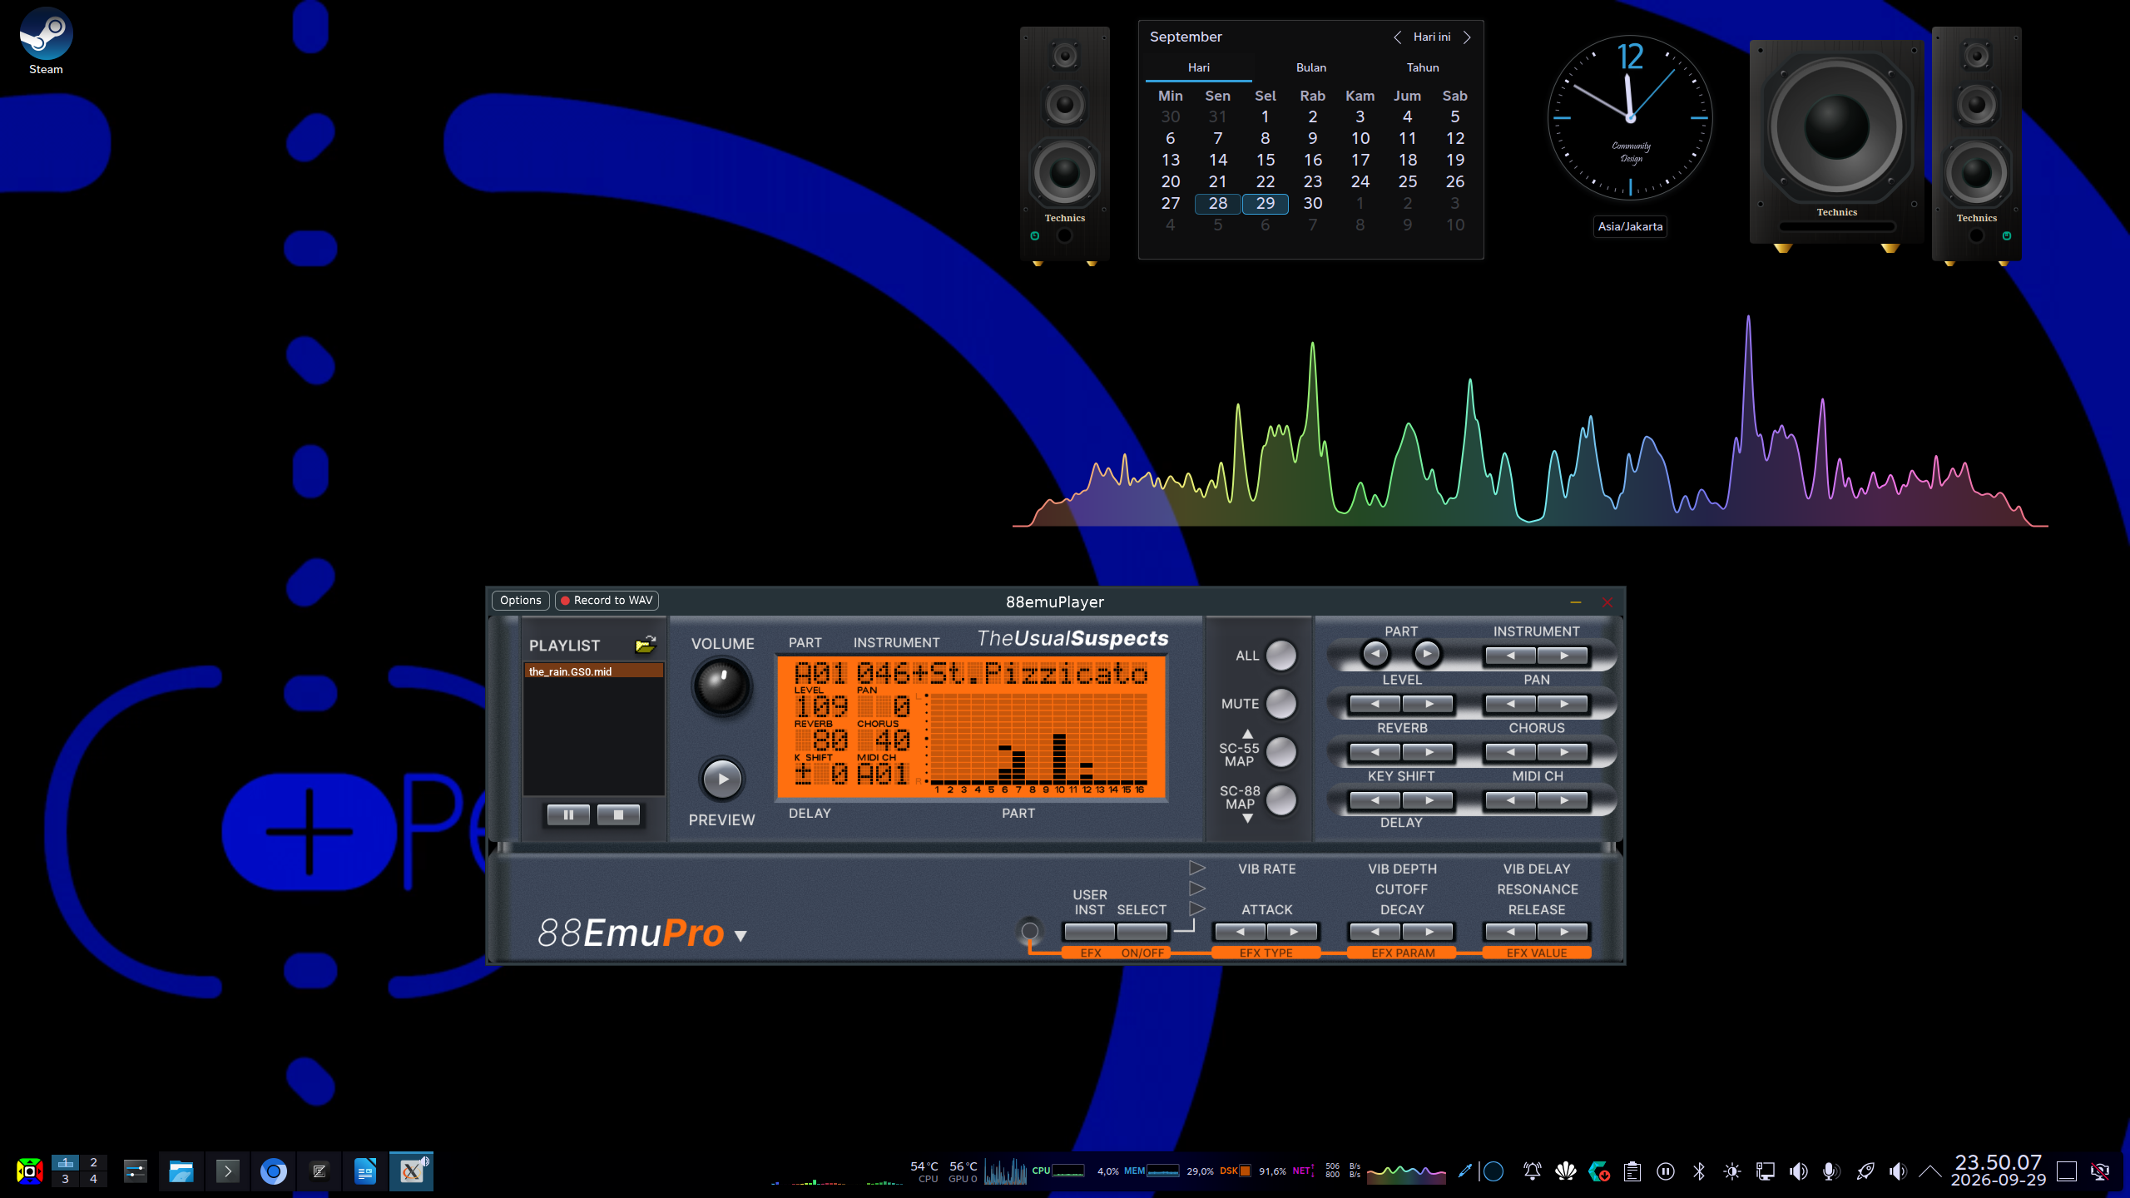
Greetings gamers, Again!! New news for MIDI! And special.
Last time we tried Andre Louis’ Combined Preservation of Yamaha VSTi series, the S-YXG100PVL Hybrid & S-YXG2006LE Hybrid. Man! At last! We can now enjoy all the cool stuffs Yamaha did back then, all the way here in today’s age. Despite it had to be a VST2, coz believe it or not (no trademark), them too have been so, VST2, and bridging it for sake of CLAP & VST3 I think would just be.. complicated. Idk, I might ask again.
Speaking of, I’ve already made few Issues over each of respective repositories, right for bug reports, and feature requests. E.g., I asked Andre if he could program a working GUI for its Combination Hub, coz look at it!, it was just plopping whatever Yamaha had, which was S-YXG50 one. Oh boy, he worked fast! He immediately put it on right away & so I promptly updated it. Dang!! isn’t that looked cool now? Of course not perfect, remember he’s one person, so c’mon, have the GUI on this Hub, all by his own hand, in the age where people think they know coding but lies, it’s a grace trully, I’ve been asking way too much! Especially the followup comment I did after he did it, and the Guitar Tab XF Chord like in MidRadio. He still got more ways to do. Tho still, thank you so much, Andre! Cool and good Extremely duper juber awesome iyey!!!
Btw, these VSTi’s should now work for your Steam devices! Deck, Machine, any Linux with Wine the staging, the latest possible you had! Enjoy.
Once again, giant shoutout to Andre Louis, you’re Awesome div by zero = Infinity!! yeah!
Next up! Octavia has been updated again to restore support of little bit of outdated Browser (and especially LTS versions, for Enterprise and Thorium for some reason) that lacked latest & greatest web standard which Octavia do requires before. Right at since this commit and up, I think.., Octavia now detects the web standard supports automatically & seamlessly. No more Missing Feature error. You can now go back to your own main Browser if you so desire, and resume enjoying the cool visualization of those Octavia displays. Woohoo!
Before we continue, lemme remind you why we’re here.
The financial gatekeeping (even by accident) is utterly bs. In particular, Yamaha should’ve reopened up more affordable access to the most powerful MIDI tools they got, just like before. We have creatives & the potential all across the world, from varying backgrounds at varying capacity. Right now, only splinter few MIDI file sharers who put up download link across the world. The rest were unable to have such power like them. Right MU2000, PSR, Tyros, Genos, or its competitors like SoundCanvas series. All these takes purchases at a huge and with great risk, especially to those old stuffs, where these hardwares requires huge maintenance, and dust. So, why not have it all in just softwares like we’re doing here?
We have all the standards known. But the newer puzzle piece are still far there, only on Genos. Please, please, please, share this petition to all of your friends, sign, and let Yamaha hear this. We need Genos CLAP! Bring back the glory of the S-YXG that contains the most powerful and rich sounds of the MIDI, 5000 times better than all OS built-in synths combined. We cannot just blindly compose with the manual, reference & voice list alone in a hope that it matches Genos 2 well, it just won’t work, we need that Genos to make sure that it matches! By hearing the result, of course! Duh..
Additionally, we are being faced with a large scale shenanigans. While we can filter out those people who think they know about music making, Those who are aware otherwise, like us, are left out blank without a viable choice as great as Yamaha Genos series. For context, lemme pull up a Service that’s much cheaper than Genos, e.g. Machine-S. The Free plan is a good choice to test things out. And to upgrade, Machine-S starts at around 130 Pts./month. And so on, at around the price. Much cheaper than single time purchase of Yamaha Genos 2 at around 6500 Pts. If you ask about the high risk of low survivability, indeed, from social and reputational factors, down to the quality factor. But of course, if a defunct has to happen, chances are, there are more competitors alike and even higher quality at a much cheaper cost. This is bad. Not only making slops much easier & cheaper than ever, those machines only says whatever most people would use, Audio only. Never is MIDI. Well, of course, there are, but again, slop is slop, and slop is uncool.
To be considered artistic, one must understand how it all worked, built, and detailed. All the time, in every nooks and crannies of the art. Imitation, is one form of flattery, shall be done right, like painting on a weasel with reference object ahead, and that’s how it’s done. Not by outsourcing somebody else, or worse, a mechanical device that high chance could only do so much no matter how much has one evolved. MIDI, is art. So MIDI, works if made by soul, even if it’s knocking off someone’s style (provided you do not cause some copyright infringement or what like discrediting, but that’s beyond this article).
So please, share this up. Yamaha must hear this. You, Yamaha. Are you in the game (Yes CLAP VSTi, MIDI making by soul available with full Genos skills), or out of the game? (No CLAP VSTi, no pls! I don’t want to go to AI slop MIDI generator with random untested and sketchy Genos trained data, yuck!!!)
Moving on, Let’s talk about Roland SoundCanvas VA. It’s been a year or two, since this SoundCanvas VA unfortunately had to be discontinued. Yeah. Lemme tell you, I have yet received single report that any customer that bought it this, experience malfunction, lemme know if you are, and here’s the big deal about this shenanigan. This is what I’ve been doing dealing with it this:
- You wanted to Roland SoundCanvas VA. Cool, let’s load it.
- Oh wait, it requires that you authenticate legitimacy. Sparsdat big no no. Okay, I forgot my Roland Cloud. Start Roland Cloud!
- Log-in! It’s been a while! Okay done.
- Make sure everything okay, restart the Host if needed.
- There.
Simple, right? Well, time’s ticking and it’s going to be no more! For those who are late to buy, 💥 GAME OVER 💀. Find some sparsdat then. But that eventually would also gonna apply to legits like me! Trust me, DRM equals time bomb!! We all despise Digital Restriction Managements.
- This requires that you got Internet. Lost auth, internet dedd? 💥 GAME OVER 💀.
- No, Some VST-Hosts do not open Internet Access to the VST, why would?. That’s why you can’t just plop in your email & password to it, coz it just wants internet, to DRM! 💥 GAME OVER 💀.
- You obviously would have hard time going to SteamOS, or pretty much any Linux, coz you really need that DRMings of the Windows, so, 💥 GAME OVER 💀.
- I bid all of my Happily Forever After, that in certain long time, DRM auth server gone. That happen, BOOM!!, 💥 GAME OVER 💀. Even to legits!!
- What do we do now?! 💥 GAME OVER 💀.
- Simply doing SF2 & with GeneralUser won’t cut it! Hey listen, Soundfont IS NOT, Roland GS! Soundfont particularly only got MSB, where all of the synths on the markets here, had got LSBs too! 💥 GAME OVER 💀.
- Also, the SoundFont e, I have yet to find single implementation about it rn, or importantly the SFe file about it. This SFe was promised to also have LSB as well, and yep, where are the application? Lemme know. 💥 GAME OVER 💀.
- Everyone’s having nostalgia! Why don’t you just update it to remove the DRM bruh!? 💥 GAME OVER 💀.
💥 GAME OVER 💀
💥 GAME OVER 💀
💥 GAME OVER 💀
💥 GAME OVER 💀 | 💥 GAME OVER 💀 | 💥 GAME OVER 💀 | 💥 GAME OVER 💀 | 💥 GAME OVER 💀 | 💥 GAME OVER 💀 | 💥 GAME OVER 💀 | 💥 GAME OVER 💀 | 💥 GAME OVER 💀 | 💥 GAME OVER 💀 | 💥 GAME OVER 💀 | 💥 GAME OVER 💀 | 💥 GAME OVER 💀 | 💥 GAME OVER 💀 | 💥 GAME OVER 💀 | 💥 GAME OVER 💀 |
.
.
💥 GAME OVER 💀
.
.
.
Ugh, if only.. there is a way.
Fine. Let’s take a look at the alts. Guys! Help find me alts I can load it in!
- Nuked SC-55 CLAP Plugin from johnnovak. Forked from jcmoyer which is fork of original nukeykt.
That’s it? Huh. Oh cool, Roland SC-55 MAME now in CLAP form! Thankfully, with Falcosoft Soundfont MidiPlayer since v6.6, in 64-bit, it now includes converter to VST2 right inside folder VST of the program folder. Just plop that dll converter next to the CLAP file, rename the dll same as that CLAP file, load the dll up, setup the ROM (link in the repo readme), et voila!!
And? Where’s the rest? Where’s the newer one like SC-88, Pro, and finally 8850? Where?
.
Oh no. We’re stuck.
.
.
Wait, There’s something new there!
https://theusualsuspects.io/downloads/88emuplayer
No way!!! This is it! At last!!! It has been released! Finally, the New, 88emu from The Usual Suspect, has been released. We can now re-enjoy the nostalgia of Roland SoundCanvas VSTi series all the way up.
- Selectable Device Emulation of Different Roland SoundCanvas series. From CM32, SC-55, SC-88 and its Pro, all the way up to 88XX like 8820, 8850, and so on.
- Emulates entire firmware files MAMEly, NOT by Soundfont fakery!
- Available in plugin formats: VST3, CLAP, LV2, AU, VST2 via FST (Plugin formats Coming Soon), & Standalone!!!
- NO DRM!!!!!!! IYEAAAAAAAHH!!!! Plug & Play*!
- Emulates Bitmap SysEx both Text & Image! Even got SC-8850 (Full screen bitmap) covered as well. Believe it or not (no trademark), the official discontinued SCVA does not emulate it. Bruh, you’re cringe, Roland! You screwed that up, had all the cools in your hand before but then dunked ‘em in a toilet & then flushed ‘em. But thankfully, now we had it here, yey!!
- Open Source! Here Source Code: https://github.com/dsp56300/gearmulator yeah!
There you go. So, here’s how you set ‘em up
- *Prep your ROMs! We apologize neither us could help you, I f88888 wish, gamers!.. But alas, until the copyright gone apocalypse, no longer the litigation possible (& hopefully just that), you’re gonna have to find those yourself. Use Search Engine, & Be smart! The ROM files are supposedly a bunch of .bin files, packed inside a .zip package, & nothing else, never .exe or whatever bs it is. When you started this 88emu plugin or player, you should see the Missing ROM files pop-up window & when you switched synth to ROM files that are missing. There, you can see what file you should have. No need to match filenames & sizes actually (tho you can), 88emu will immediately match the files based on MD5 hash! So go crazy, download everything you know you can, plop ‘em into your ~/.local/The Usual Suspects/88EmuPlayer/roms (Linux), My Documents\The Usual Suspects\88emuPlayer\roms (Windows), or shown Data directory for any other. And, it’s okay if the ROMs are subfoldered, it can search & match them too! Just, drop everything there! I promise, if the copyright is one day litterally collapse, cross my heart, I’d definitely put the Download links all I got here. One day. One day. Btw, you can also add SCVA core dll too, inside the roms folder to maybe enhance 8850 mode.
- And your MIDI files. What? How’d you supposed to enjoy nostalgia without those GS MIDI files? I hope you do have and still have those all. If not, go back to previous update around this Petition, and join DTM-Hub on Telegram (sorry again, no Telegram allowed, afraid break policy). There, on MIDI channel you should find all you can try over there.
- Get the 88emu running! The 88emu has MIDI player built-in to quickly play the MIDI files out. You can also use your own MIDI player instead and have the 88emu as the plugin (as of writing, no plugin format available yet, coming soon, stay tuned!). Plop those MIDI in, make sure those ROM files are in check, & you’re good to go!
- Unsure which to pick? I prefer SC-8850! But remember, many of your nostalgia MIDI files are mostly designed to be played in SC-55, & SC-88Pro. Unless you wanna be authentic, go with the latest, SC-8850. Also, if your MIDI file contains commands that can switch the mapping mode into legacy SoundCanvas (especially one like SysEx Reset to `SC88`) that’d be nice!
- More instruction can be found at its README file.
Wow! At last guys, this is exciting! Even tho it had to be back at MAME again coz yes it’s heavy, But hey!! It’s more accurate than Soundfont method like Roland officially did (Allegedly, how does the SCVA worked again?). Who cares at this point, Roland’s faulty here, they goned it!. Now the Legacy Roland SoundCanvas Collection is Back! Sort of, the ROM once again can’t be included for legal reason here on Earth.
Now, onto the various fun & not so fun fact!
- You can Press the VOLUME rotary encoder to preview currently selected instrument at the currently selected channel! (Bruh, did you even read the manual or saw one of the Robbi985 YouTube videos?) Since SC-88 (not on VL) you can preview how’s the patch sounded like. Well, since we don’t know how to do that rotary encoder press thingy in this emulation, 88emu added extra PREVIEW button underneath that you can press and hold to achieve the same.
- Speaking of PREVIEW, did you know on SC-8820 (right?) & 8850, The Preview is more beautiful rather than just singular key A. That’s right, try to scroll on different instrument patches on your SC-8850 or 20, different instrument category gets different solo mini song in it! Go, have that, try it! Press & hold. Yeah, Yamaha is soo late for that, only since the expensive model of Tyros-1 I think, did had it, lol! Any legacy expensive PSR a-time as SC-8850 & 20, does have sophisticated interface with Preview patch feature? Lemme know in the comments bellow. Or maybe mention me on that DTM-Hub? Idk.
- The Bitmap format has limited compatibility between SC-88XX and 88 Legacy! MIDI files that has SC-88 Bitmap plays at SC-8850 & 20, but not vice versa. Checkout Fake SC-8850 display. Go ahead, play the SC-88 demo MIDI file supplied and compare with real and Octavia Fake SC-8850.
- But hey, at least now we got Bitmap & Text SysEx back again, unlike official discontinued Roland SCVA.. yeah? Because again we’re litterally just emulating the whole hardwares as a software now.
- Additionally, they also included VU meter effects found on Monopoly, Supplex, and Moonlight Picnic, and maybe few idk. That too, removed on SC-8850 & 20!! bruh.. No, wait, VU meter effect only available on SC-55?!?!??!? (mkII?) Oargh.. seriously??!...
That is all for today. Thank God it’s not entirely gone, some sort. We get to reexperience the nostalgia once again, and this time more accurate than ever before. Giant shoutout once again to The Usual Suspect, nukeykt, MAME, johnnovak, jcmoyer, mckuhei, DTM Hub, etc., & everyone else doing there! You guys, Cool and good Awesome div by zero = infinity!!!
I do really hope somebody put the Yamaha ones backed up as well like the 88emu. All those PSRs, Tyros & Genos, not just MU-2000EX and QYs. Who knows!
By JOELwindows7
Perkedel Technologies
CC4.0-BY-SA

