<OES Project Functional Specification Document>
Author: <Perkins.Li>
Last Updated: 2017-07-13

Document History
Date | Author | Summary of Change | Note
17年7月13日 | Perkins.Li | Write use case login mock up UI | None
17年7月14日 | Perkins.Li | Write five use case and one detail mock up UI | None
17年7月15日 | Perkins.Li | Review functional requirements | None
<Table of Contents>

Overview 5
Use Case Diagrams 5
Use Case Scenarios 9
UC001 <login> 9
UC002 <create user> 14
UC003 <edit user> 18
UC004 <delete user> 19
UC005 <view users list> 20
UC006<edit user profile> 21
UC007<logout> 22
UC008<create question> 23
UC009<edit question> 23
UC010<delete question> 23
UC011<view question list> 23
UC012<preview test result details page> 23
UC013<auto submit exam > 24
UC014<review all finished exam> 24
UC015<search the exam> 24
UC016<view exam list> 24
UC017<click exam name> 24
UC018<search student> 24
UC019<review statistics information> 25
UC020<finish exams> 25
UC021<submit exams> 25
Non-functional Requirements 25
System Installation Requirements 25
Runtime Requirements 25
I18N and L10N Requirements 25
Documentation Requirements 26
Other Non-functional Requirement 26

Overview
Online Exam System for students can exam in Internet.

Use Case Diagrams

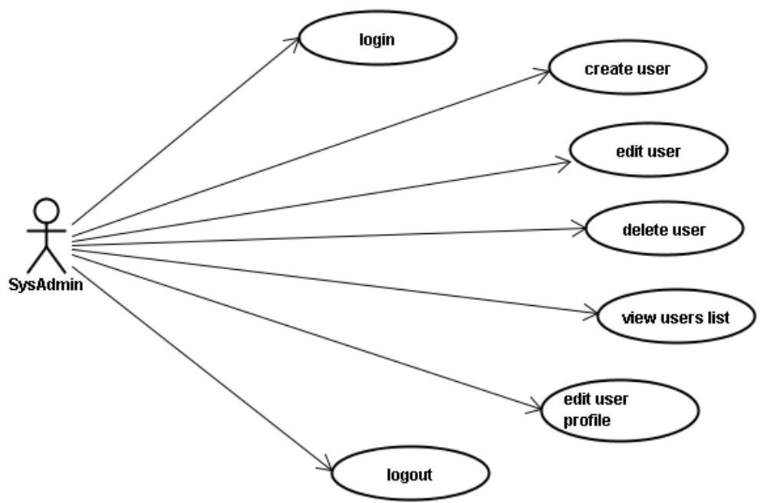
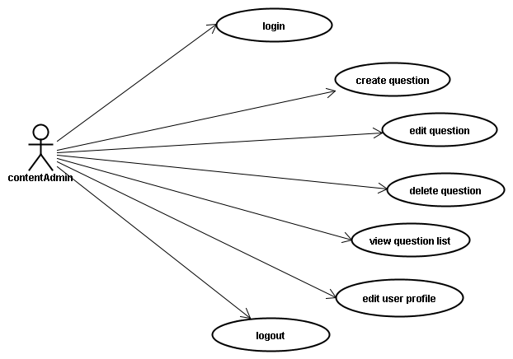

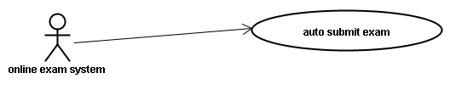
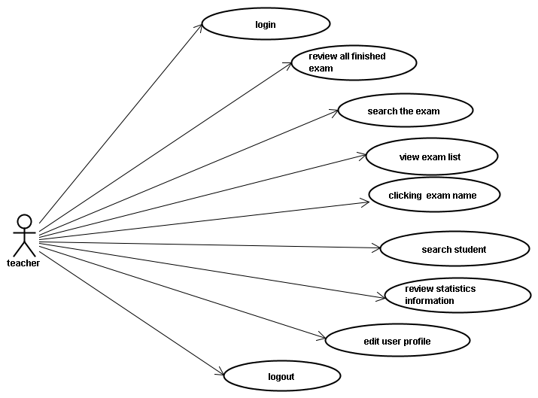

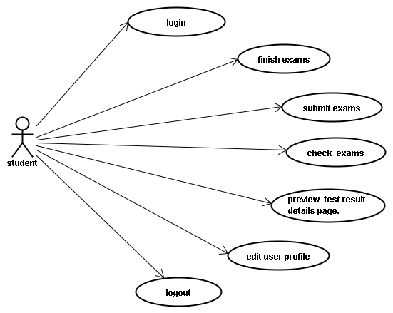

Use case id | Use case name
UC001 | login
UC002 | create user
UC003 | edit user
UC004 | delete user
UC005 | view users list
UC006 | edit user profile
UC007 | logout
UC008 | create question
UC009 | edit question
UC0010 | delete question
UC0011 | view question list
UC0012 | preview test result details page.
UC0013 | auto submit exam
UC0014 | review all finished exam
UC0015 | search the exam
UC0016 | view exam list
UC0017 | clicking exam name
UC0018 | search student
UC0019 | review statistics information
UC0020 | finish exams
UC0021 | submit exams

Use Case Scenarios

UC001 <login>
Brief: user use user name and password login.

Actor: sysAdmin, contentAdmin, student, teacher.

Pre-condition: None.

Mock Up UI:

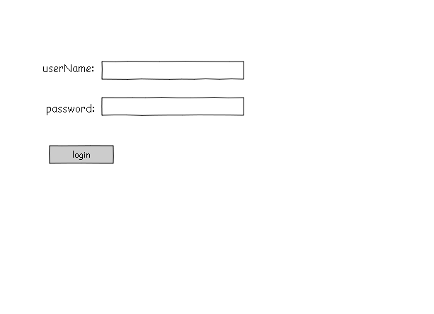
Diagram 1
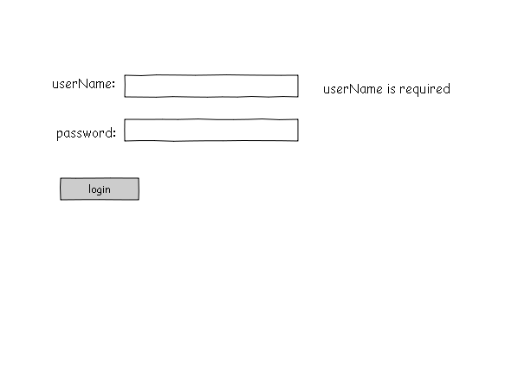
Diagram 2

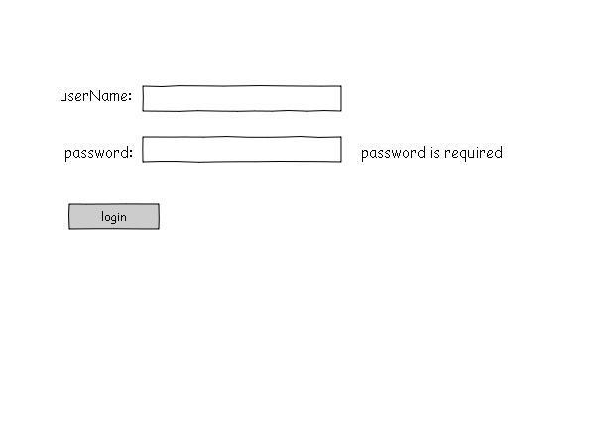
Diagram 3

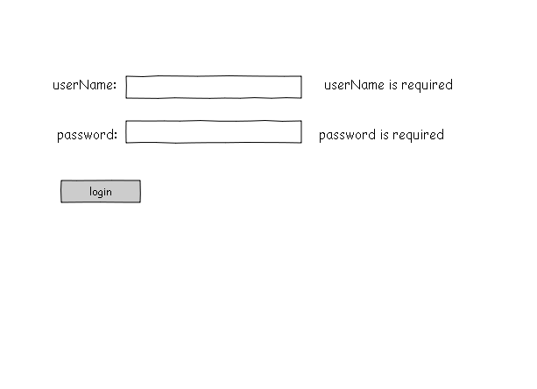
Diagram 4

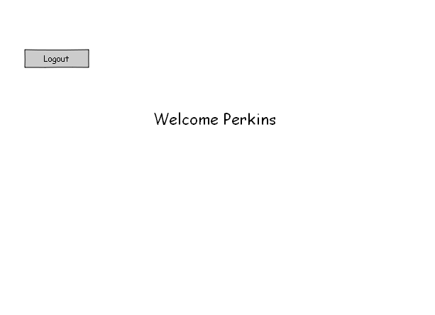
Diagram 5

Diagram 1

General Workflow:

User Operation | System Response
1: User enter system | 2:System opens as shown in Diagram 1
3:User fill the form
3.1:click “login” | 4: System will validate data  4.1: if ok, System will open as shown in Diagram 5  4.2: if user name error,System will shown in Diagram 2  4.3: if password error,System will shown in Diagram 3  4.4: if user name error and password error,System will shown in Diagram 4
Comment:
validate data
user name and password is not null.

UC002 <create user>
Brief: Sysadmin create a new user.

Actor: sysAdmin.

Pre-condition: Already login.

Mock Up UI:

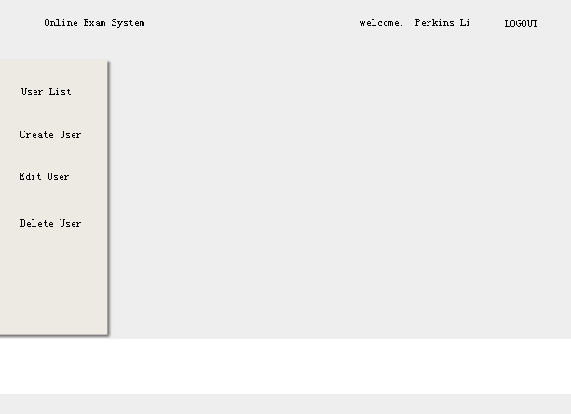
Diagram 6
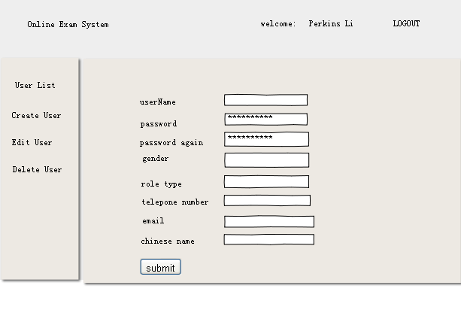

Diagram 7

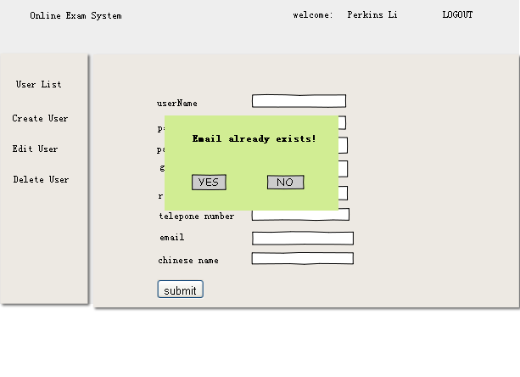

Diagram 8

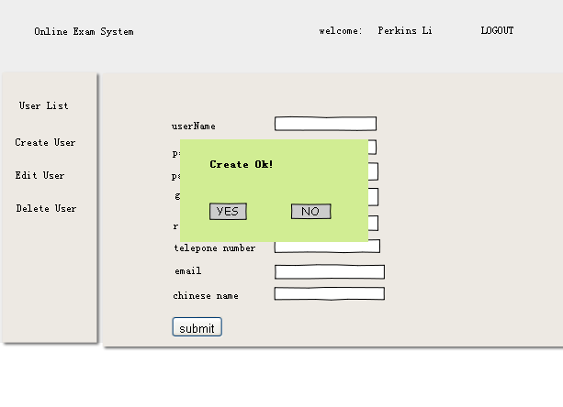
Diagram 9

General Workflow:

User Operation | System Response
1: user click “Create User” in Diagram 6 | 2:System opens as shown in Diagram 7
3:User fill the form
3.1:click “submit” | 4: System will validate data  4.1. if error ,System opens as shown in Diagram 8  4.2 . if ok,System opens as shown in Diagram 9
Comment:
validate data
Email is not have insert

UC003 <edit user>
Brief: user is sysadmin.

Actor: sysAdmin.

Pre-condition: Already login.

Mock Up UI:

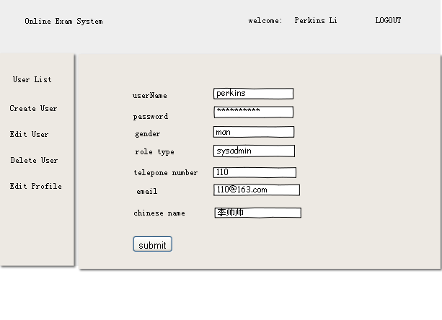
Diagram 10

General Workflow:

User Operation | System Response
1: user click “Edit User” in system main page | 2:System will load Eidt page
3:User change the form
3.1:click “submit” | 4: System willPopup Ok message View
Comment:
validate data
email must be new in the system

UC004 <delete user>
Brief: user delete one user from data

Actor: sysAdmin.

Pre-condition: Already login.

Mock Up UI:
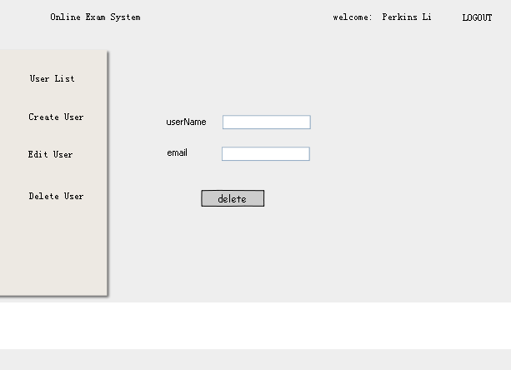
Diagram 11
General Workflow:

User Operation | System Response
1: user click “Delete User” in system main page | 2:System will load Delete page
3:User userName and email the form
3.1:click “delete” | 4: System will validate data  4.1. if error ,System will show a error message view.  4.2 . if ok, System will show a OK message view.
Comment:
validate data
None

UC005 <view users list>
Brief: sysadmin check all users.

Actor: sysAdmin.

Pre-condition: Already login.

Mock Up UI:

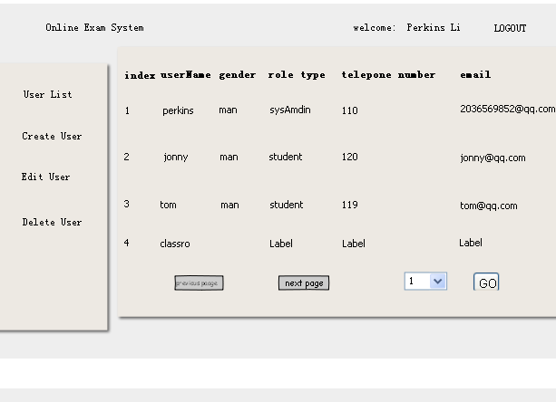
Diagram 12

General Workflow:

User Operation | System Response
1: user click “User List” in system main page | 2:System will check all users
Comment:
validate data
None

UC006<edit user profile>
Brief: users chang or fill himselves information.

Actor: all users.

Pre-condition: Already login.

Mock Up UI:

Diagram 13

General Workflow:

User Operation | System Response
1: user click “Edit Profile” in system main page | 2:System show as Diagram 13
3:user fill form or change information
4:user click “submit” | 5: System will show OK messge
Comment:
validate data
eamil must be new

UC007<logout>
Brief: User exit application .

Actor: all users.

Pre-condition: Already login.

UC008<create question>
Brief: contentadmin create question.

Actor: contentAdmin.

Pre-condition: Already login.

UC009<edit question>
Brief: contentadmin edit question.

Actor: contentAdmin.

Pre-condition: Already login.

UC010<delete question>
Brief: contentadmin delete question.

Actor: contentAdmin.

Pre-condition: Already login.

UC011<view question list>
Brief: contentAdmin check all question.

Actor: contentAdmin.

Pre-condition: Already login.

UC012<preview test result details page>
Brief: student preview test result details page.

Actor: student.

Pre-condition: already login.

UC013<auto submit exam >
Brief: Exam system exam when the exam time end.

Actor: exam system.

Pre-condition: the exam time end.

UC014<review all finished exam>
Brief: teacher review all finished exam.

Actor: teacher.

Pre-condition: already login.

UC015<search the exam>
Brief: teacher search exam.

Actor: teacher.

Pre-condition: already login.

UC016<view exam list>
Brief: teacher find all exams.

Actor: teacher.

Pre-condition: already login.

UC017<click exam name>
Brief: teacher click exam name , review exam detail information.

Actor: teacher.

Pre-condition: already login.

UC018<search student>
Brief: teacher search student.

Actor: teacher.

Pre-condition: already login.

UC019<review statistics information>
Brief: teacher review exam statistics information.

Actor: teacher.

Pre-condition: already login.

UC020<finish exams>
Brief: student finish exam questions.

Actor: student.

Pre-condition: already login.

UC021<submit exams>
Brief: student submit finished exam.

Actor: student.

Pre-condition: already login.

Non-functional Requirements

System Installation Requirements

Runtime Requirements

NFR0001: 125 memeory requirements.
NFR0002: 80 disk space requirement.
NFR0003: tomcat, jvm, server

I18N and L10N Requirements
NFR0004: The System support Chinese and English

Documentation Requirements

NFR0005: Require a user manual, samples, reference manual, quick start guide, online help.

Other Non-functional Requirement
None.

