Parser

Student: Alexandrescu Andrei-Robert, 931/1

Current lab: [Repository Link](https://github.com/PerlMonker303/flcd_lab6)

**Implementation details**

Class Parser is responsible for implementing the LL(1) parser. It contains the first and follow methods that are used to obtain the *first* and *follow* tables. These two methods are implemented in the same way they were specified in the lectures.

The class Parser keeps only the final version of the *first* and *follow* tables. That means, the steps that lead to the final version of *first* and *follow* are not stored because they are not relevant for the problem.

In order to write a cleaner implementation for the *first* and *follow* methods, some methods were added to the Grammar class. These methods are:

* *getIsTerminal*, *getIsNonTerminal*, *getIsEpsilon*, *getIsStartingSymbol*: these are used for checking whether a given symbol belongs to one of the above-mentioned classes
* *getProductionsWithNonTerminalOnRHS*: this method retrieves a vector of productions containing a given symbol in the right-hand side. This method is used in the *follow* algorithm.
* *splitRHSOnNonTerminal*: this method takes a production and a non-terminal (which must belong to the right-handside of the production). It splits the production into two parts, denoted by alpha and gamma. Alpha is the sequence of symbols before the non-terminal and gamma is the sequence after.

The set operations (union, concatenation of length one) were implented in the Helper class.

The class diagram becomes:

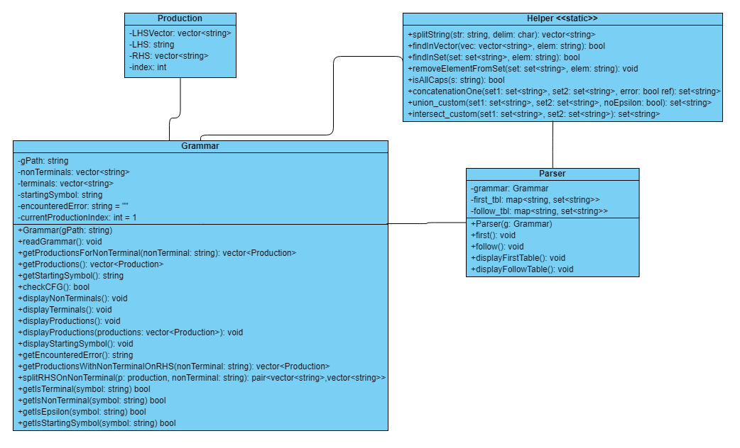

**Experiments:**

*Example 1 (g1.in)*

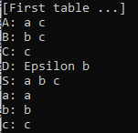S A B C D

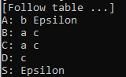a b c

5

S -> a A b | B A

A -> a A | c A | c

B -> D C

D -> Epsilon | b

C -> c

S

|  |  |  |  |  |
| --- | --- | --- | --- | --- |
|  | F0 | F1 | F2 | F3=F2 |
| S | a | a | a, b, c |  |
| A | a, c | a, c | a, c |  |
| B | ∅ | b, c | b, c |  |
| C | c | c | c |  |
| D | ε, b | ε, b | ε, b |  |

First table:

Follow table:

|  |  |  |  |  |
| --- | --- | --- | --- | --- |
|  | L0 | L1 | L2 | L3=L2 |
| S | ε | ε | ε |  |
| A | ∅ | b, ε | b, ε |  |
| B | ∅ | a, c | a, c |  |
| C | ∅ | ∅ | a, c |  |
| D | ∅ | c | c |  |

*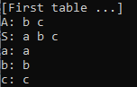Example 2 (g2.in)*

S A

a b c

2

S -> A a | a

A -> b A | c

S

First table:

|  |  |  |  |
| --- | --- | --- | --- |
|  | F0 | F1 | F2=F1 |
| S | a | a, b, c |  |
| A | b, c | b, c |  |

Follow table:

|  |  |  |  |
| --- | --- | --- | --- |
|  | L0 | L1 | L2=L1 |
| S | ε | ε |  |
| A | ∅ | a |  |

*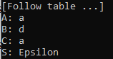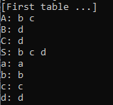Example 3 (g3.in)*

S A B C

a b c d

4

S -> A a | B B

A -> b A | c

B -> C a

C -> d

S

First table:

|  |  |  |  |  |
| --- | --- | --- | --- | --- |
|  | F0 | F1 | F2 | F3=F2 |
| S | ∅ | b, c | b, c, d |  |
| A | b, c | b, c | b, c |  |
| B | ∅ | d | d |  |
| C | d | d | d |  |

Follow table:

|  |  |  |  |
| --- | --- | --- | --- |
|  | L0 | L1 | L2=L1 |
| S | ε | ε |  |
| A | ∅ | a |  |
| B | ∅ | d |  |
| C | ∅ | a |  |

*Example 4 (g4.in)*

S B C

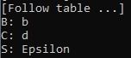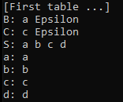a b c d

3

S -> B b | C d

B -> a B | Epsilon

C -> c C | Epsilon

S

First table:

|  |  |  |  |
| --- | --- | --- | --- |
|  | F0 | F1 | F2=F1 |
| S | ∅ | a, b, c, d |  |
| B | a, ε | a, ε |  |
| C | c, ε | c, ε |  |

Follow table:

|  |  |  |  |
| --- | --- | --- | --- |
|  | L0 | L1 | L2=L1 |
| S | ε | ε |  |
| B | ∅ | b |  |
| C | ∅ | d |  |