**Repositorio**

**Pitch**

Link Youtube:

<https://youtu.be/2HqS89dpLyA>

<https://www.youtube.com/watch?v=2HqS89dpLyA>

**Base de datos**

Link OneDrive: <https://1drv.ms/u/s!Ao1T3zmgoBDlixcMOmZzvA72Qw5a?e=D3fcWr>

**Custom Vision**

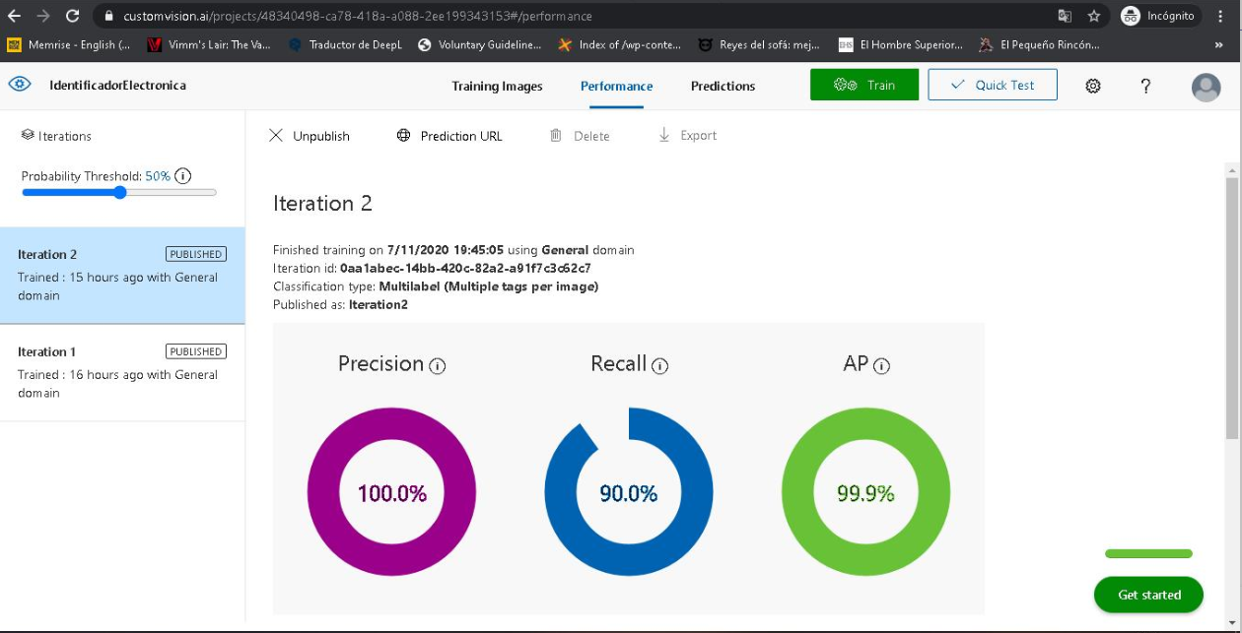

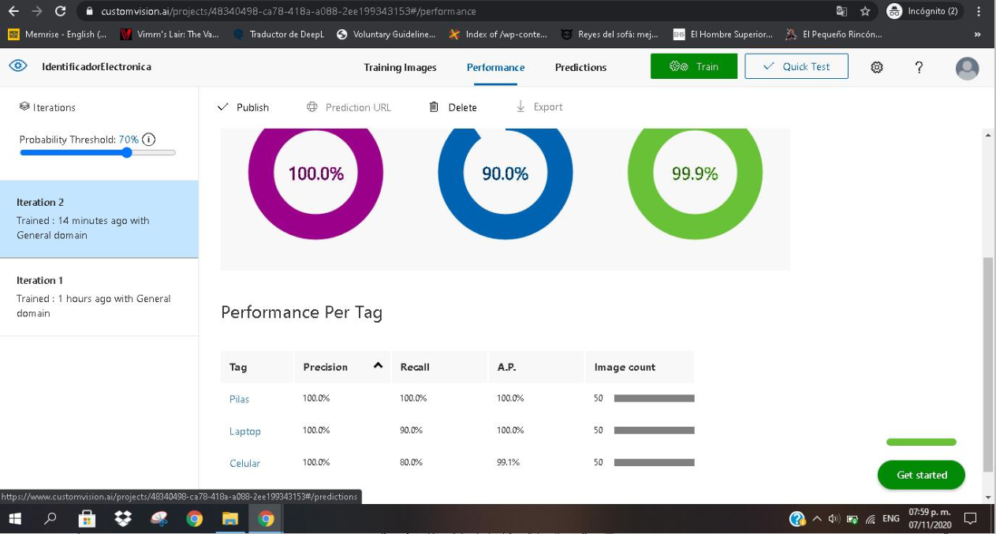

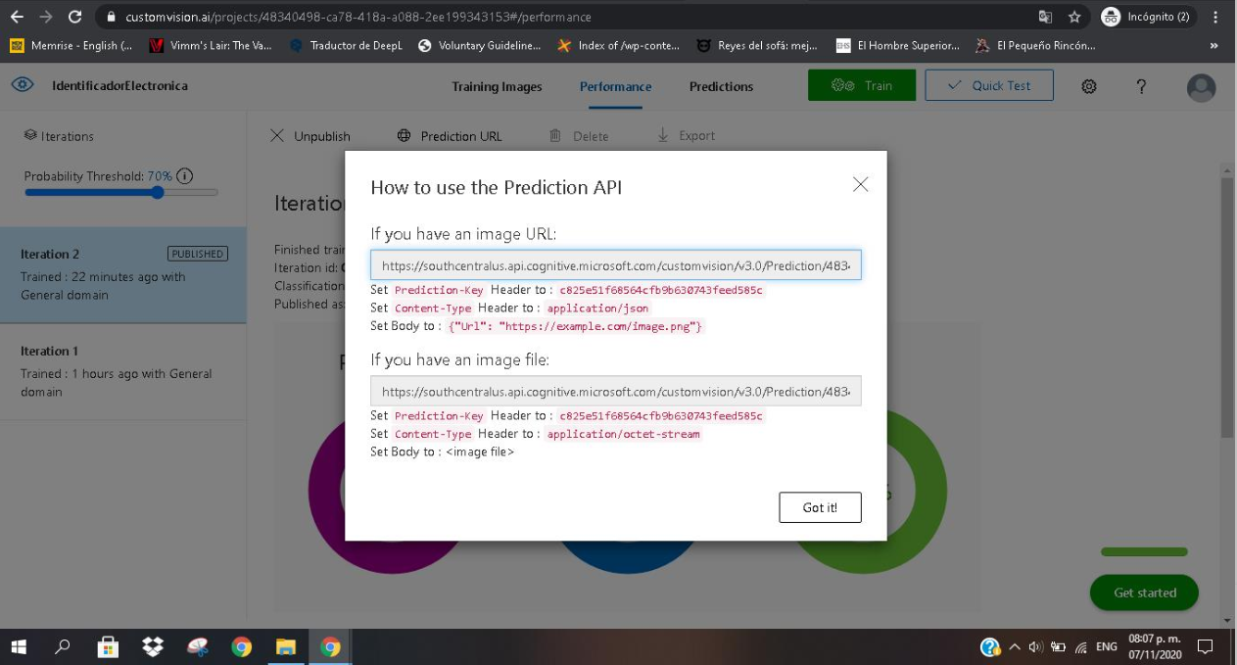<https://southcentralus.api.cognitive.microsoft.com/customvision/v3.0/Prediction/48340498-ca78-418a-a088-2ee199343153/classify/iterations/Iteration2/url>

<https://southcentralus.api.cognitive.microsoft.com/customvision/v3.0/Prediction/48340498-ca78-418a-a088-2ee199343153/classify/iterations/Iteration2/image>

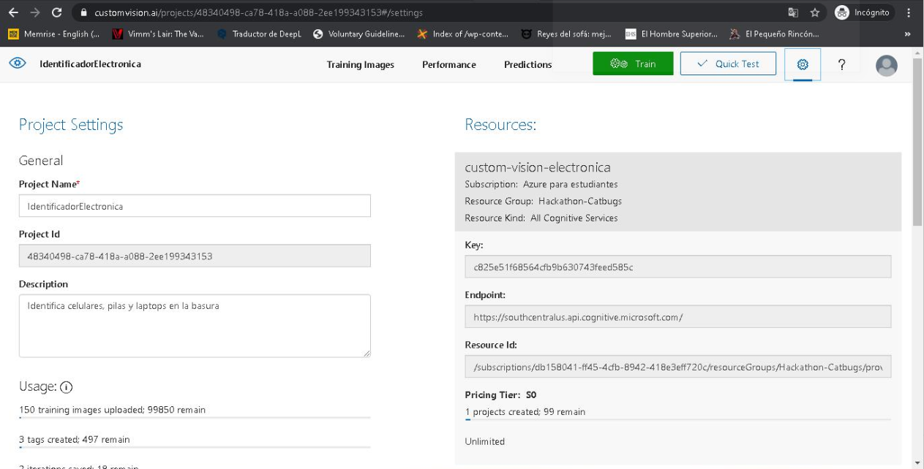

c825e51f68564cfb9b630743feed585c

48340498-ca78-418a-a088-2ee199343153

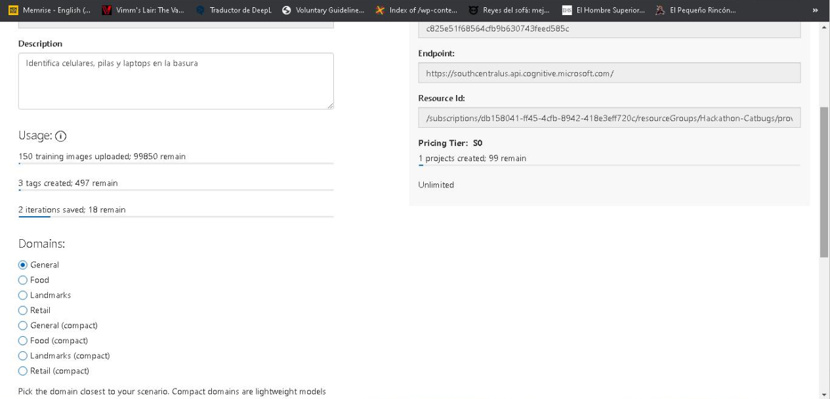

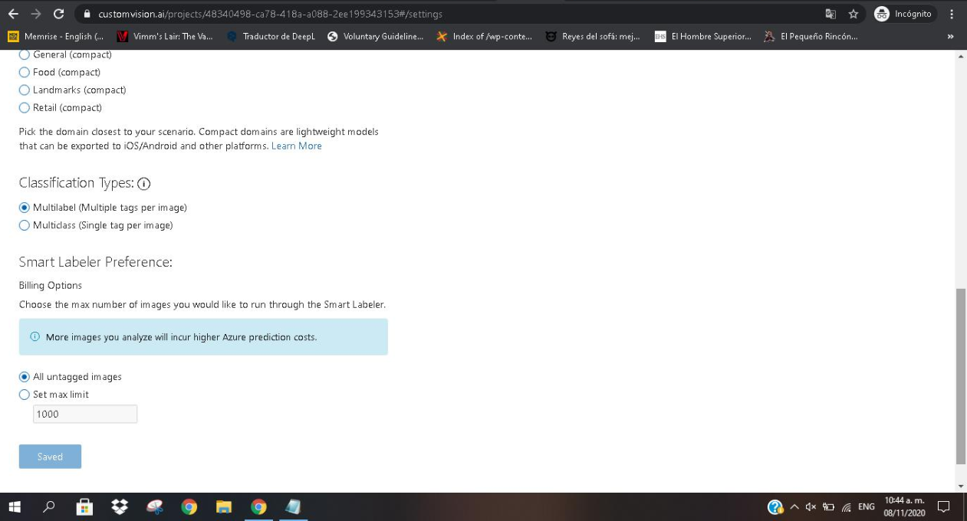

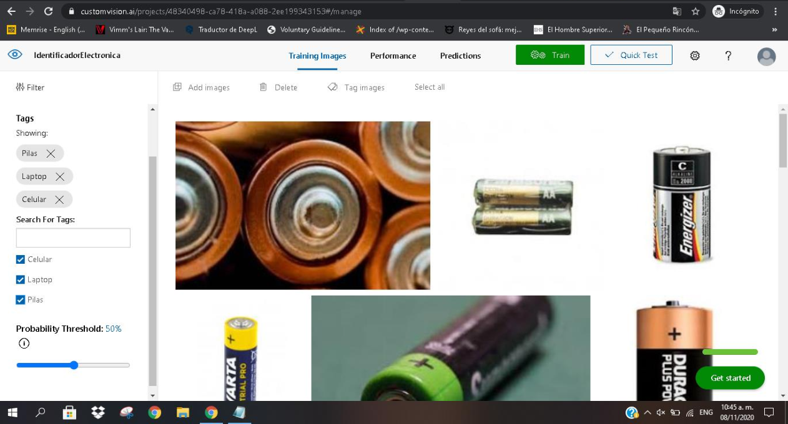

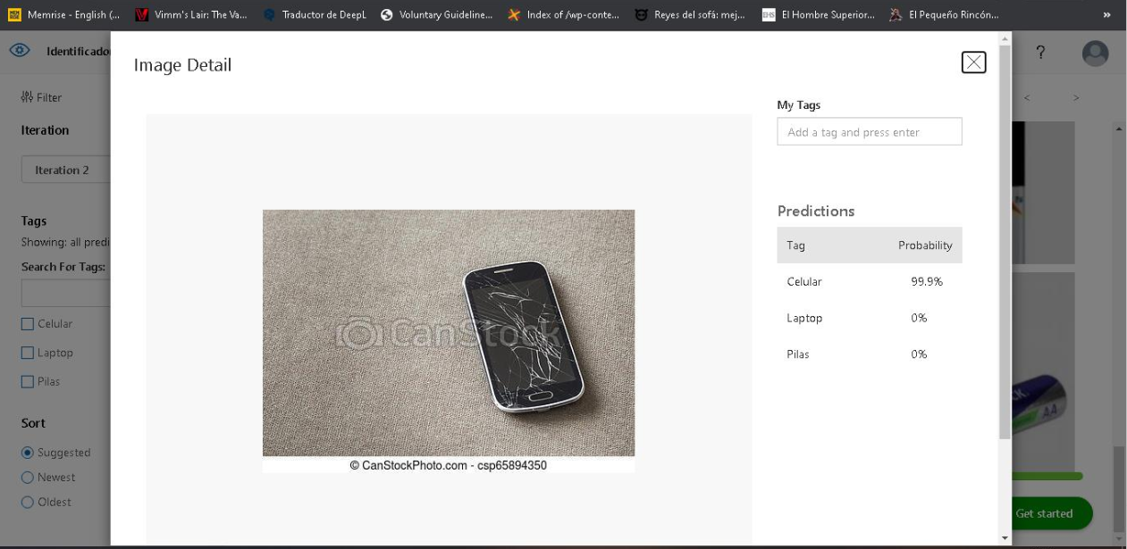

**Powerapp**

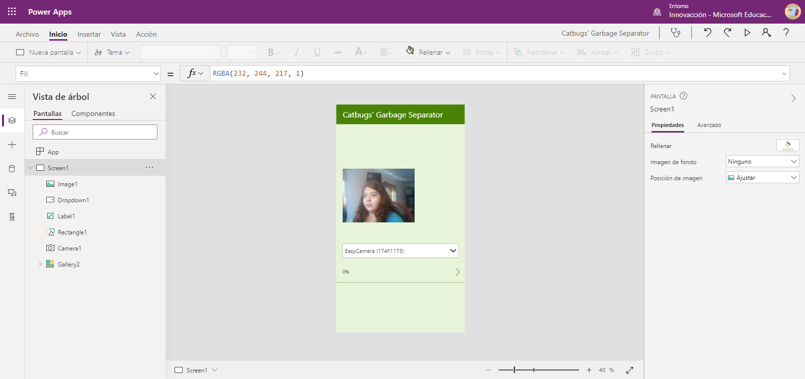

**Demo/prototipo funcional**

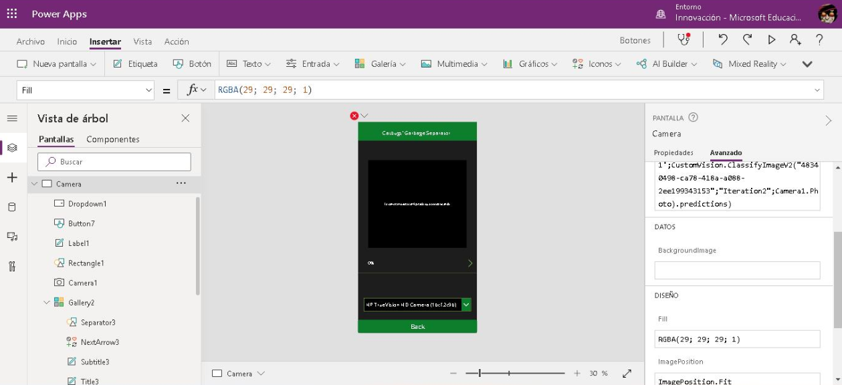

**Capturas de pantalla desde un celular**

