Ping pc1

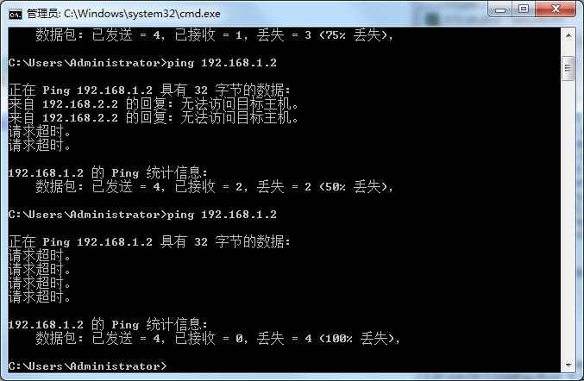

Show ip route

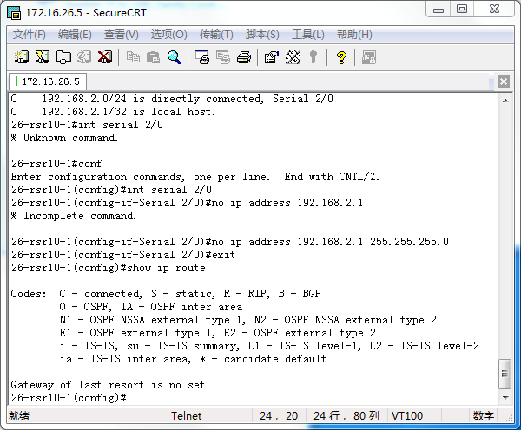

R1 basic configure

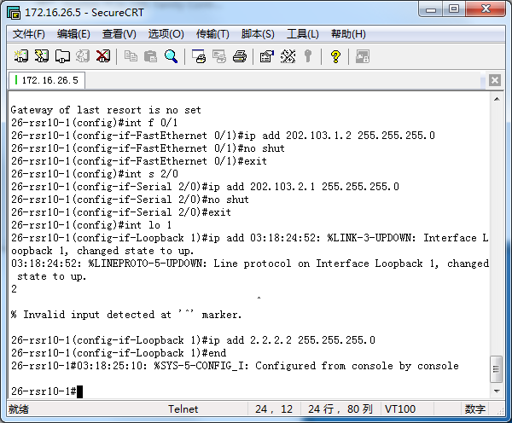

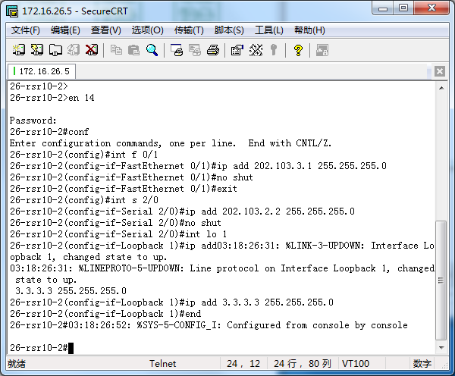

-----------ROUTER 2---------------------------------------------------------------------------------------------

Debug

.1 -> 224.0.0.5), len = 48, cksum = 0xf290

03:18:32:27: %7: -----------------------------------------------------

03:18:32:27: %7: Header

03:18:32:27: %7: Version 2

03:18:32:27: %7: Type 1 (Hello)

03:18:32:27: %7: Packet Len 48

03:18:32:27: %7: Router ID 2.2.2.2

03:18:32:27: %7: Area ID 0.0.0.0

03:18:32:27: %7: Checksum 0xf290

03:18:32:27: %7: AuType 0

03:18:32:27: %7: Hello

03:18:32:27: %7: NetworkMask 255.255.255.0

03:18:32:27: %7: HelloInterval 10

03:18:32:27: %7: Options 0x2 (*|-|-|-|-|-|E|-)

03:18:32:27: %7: RtrPriority 1

03:18:32:27: %7: RtrDeadInterval 40

03:18:32:27: %7: DRouter 0.0.0.0

03:18:32:27: %7: BDRouter 0.0.0.0

03:18:32:27: %7: # Neighbors 1

03:18:32:27: %7: Neighbor 3.3.3.3

03:18:32:27: %7: -----------------------------------------------------

03:18:32:27: %7: NFSM[2.2.2.2-Serial 2/0]: Full (HelloReceived)

03:18:32:27: %7: NFSM[2.2.2.2-Serial 2/0]: nfsm_ignore called

03:18:32:27: %7: NFSM[2.2.2.2-Serial 2/0]: Full (2-WayReceived)

03:18:32:28: %7: NFSM[2.2.2.2-Serial 2/0]: LS update timer expire

03:18:32:28: %7: SPF[0.0.0.0]: SPF calculation (1st STAGE)

03:18:32:28: %7: SPF[0.0.0.0]: Vertex[3.3.3.3] Router(root)

03:18:32:28: %7: SPF[0.0.0.0]: Link #0 (3.3.3.3): Stub Network

03:18:32:28: %7: SPF[0.0.0.0]: Link #1 (2.2.2.2): Point-to-Point

03:18:32:28: %7: SPF[0.0.0.0]: Calculate nexthop for (2.2.2.2)

03:18:32:28: %7: SPF[0.0.0.0]: Link #2 (202.103.2.0): Stub Network

03:18:32:28: %7: SPF[0.0.0.0]: Vertex[2.2.2.2] Router

03:18:32:28: %7: SPF[0.0.0.0]: Link #0 (2.2.2.2): Stub Network

03:18:32:28: %7: SPF[0.0.0.0]: Link #1 (3.3.3.3): Point-to-Point

03:18:32:28: %7: SPF[0.0.0.0]: LSA[Type1:0.0.0.0:Type1:3.3.3.3:(self)] is already in SPF tree

03:18:32:28: %7: SPF[0.0.0.0]: Link #2 (202.103.2.0): Stub Network

03:18:32:28: %7: SPF[0.0.0.0]: SPF calculation (2nd STAGE)

03:18:32:28: %7: SPF[0.0.0.0]: Calculating stub network for (2.2.2.2)

03:18:32:28: %7: RT[Install:0.0.0.0]: 2.2.2.2/32, cost(50) stub network

03:18:32:28: %7: RT[Install:0.0.0.0]: 202.103.2.0/24, cost(100) stub network

03:18:32:28: %7: SPF[0.0.0.0]: Calculation finished (0.000000 sec)

03:18:32:28: %7: SEND[LS-Upd]: 1 LSAs to destination 224.0.0.5

03:18:32:28: %7: LSA[0.0.0.2:Type3:2.2.2.2:(self)]: Install summary-LSA

03:18:32:28: %7: LSA[0.0.0.2:Type3:2.2.2.2:(self)]: LSA refresh scheduled at LS age 2372

03:18:32:28: %7: LSA[0.0.0.2:Type3:2.2.2.2:(self)]: Flooding via interface[FastEthernet 0/1:202.103.3.1]

03:18:32:28: %7: LSA[0.0.0.2:Type3:2.2.2.2:(self)]: summary-LSA(0x25bb440) originated

03:18:32:28: %7: NSM[Route]: add OSPF route [2.2.2.2/32-202.103.2.1] to vrf default

03:18:32:28: %7: [ospfd] --> [NSM] -----------start

03:18:32:28: %7: NSM IPv4 route add

03:18:32:28: %7: Flags: 1

03:18:32:28: %7: Route: 2.2.2.2/32

03:18:32:28: %7: Type: 6

03:18:32:28: %7: process_id: 3

03:18:32:28: %7: Metric: 50

03:18:32:28: %7: Distance: 110

03:18:32:28: %7: Sub_type: 0

03:18:32:28: %7: Nexthop: 202.103.2.1 ifindex 3

03:18:32:28: %7: [ospfd] --> [NSM] -----------end

03:18:32:28: %7: Route[IA:0.0.0.0]: IA prefix calculation timer expire

03:18:32:28: %7: Route[IA:0.0.0.0:N]: Calculate incremental summary for 202.103.1.0

03:18:32:28: %7: LSA[0.0.0.2:Type3:202.103.1.0:(self)]: Install summary-LSA

03:18:32:28: %7: LSA[0.0.0.2:Type3:202.103.1.0:(self)]: LSA refresh scheduled at LS age 1492

03:18:32:28: %7: LSA[0.0.0.2:Type3:202.103.1.0:(self)]: Flooding via interface[FastEthernet 0/1:202.103.3.1]

03:18:32:28: %7: LSA[0.0.0.2:Type3:202.103.1.0:(self)]: summary-LSA(0x25bb1a0) originated

03:18:32:28: %7: NSM[Route]: add OSPF route [202.103.1.0/24-202.103.2.1] to vrf default

03:18:32:28: %7: [ospfd] --> [NSM] -----------start

03:18:32:28: %7: NSM IPv4 route add

03:18:32:28: %7: Flags: 1

03:18:32:28: %7: Route: 202.103.1.0/24

03:18:32:28: %7: Type: 6

03:18:32:28: %7: process_id: 3

03:18:32:28: %7: Metric: 51

03:18:32:28: %7: Distance: 110

03:18:32:28: %7: Sub_type: 1

03:18:32:28: %7: Nexthop: 202.103.2.1 ifindex 3

03:18:32:28: %7: [ospfd] --> [NSM] -----------end

03:18:32:28: %7: Route[IA:0.0.0.0]: Calculation completed [0.000000 sec]

03:18:32:28: %7: Route[IA:0.0.0.0]: IA router route calculation timer expire

03:18:32:28: %7: Route[IA:0.0.0.0]: Calculation completed [0.000000 sec]

03:18:32:28: %7: SEND[LS-Upd]: To 224.0.0.5 via Serial 2/0:202.103.2.2, length 88

03:18:32:28: %7: -----------------------------------------------------

03:18:32:28: %7: Header

03:18:32:28: %7: Version 2

03:18:32:28: %7: Type 4 (Link State Update)

03:18:32:28: %7: Packet Len 88

03:18:32:28: %7: Router ID 3.3.3.3

03:18:32:28: %7: Area ID 0.0.0.0

03:18:32:28: %7: Checksum 0xdab2

03:18:32:28: %7: AuType 0

03:18:32:28: %7: Link State Update

03:18:32:28: %7: # LSAs 1

03:18:32:28: %7: LSA Header

03:18:32:28: %7: LS age 7

03:18:32:28: %7: Options 0x2

03:18:32:28: %7: LS type 1 (router-LSA)

03:18:32:28: %7: Link State ID 3.3.3.3

03:18:32:28: %7: Advertising Router 3.3.3.3

03:18:32:28: %7: LS sequence number 0x80000005

03:18:32:28: %7: LS checksum 0xe450

03:18:32:28: %7: length 60

03:18:32:28: %7: Router-LSA

03:18:32:28: %7: flags -|-|B

03:18:32:28: %7: # links 3

03:18:32:28: %7: Link ID 3.3.3.3

03:18:32:28: %7: Link Data 255.255.255.255

03:18:32:28: %7: Type 3, #TOS 0, metric 0

03:18:32:28: %7: Link ID 2.2.2.2

03:18:32:28: %7: Link Data 202.103.2.2

03:18:32:28: %7: Type 1, #TOS 0, metric 50

03:18:32:28: %7: Link ID 202.103.2.0

03:18:32:28: %7: Link Data 255.255.255.0

03:18:32:28: %7: Type 3, #TOS 0, metric 50

03:18:32:28: %7: -----------------------------------------------------

03:18:32:29: %7: Route[ASE]: ASE calculation starts

03:18:32:29: %7: Route[ASE]: ASE calculation completed [0.000000 sec]

03:18:32:29: %7: RECV[LS-Ack]: From 2.2.2.2 via Serial 2/0:202.103.2.2 (202.103.2.1 -> 224.0.0.5), len = 44, cksum = 0x8724

03:18:32:29: %7: -----------------------------------------------------

03:18:32:29: %7: Header

03:18:32:29: %7: Version 2

03:18:32:29: %7: Type 5 (Link State Acknowledgment)

03:18:32:29: %7: Packet Len 44

03:18:32:29: %7: Router ID 2.2.2.2

03:18:32:29: %7: Area ID 0.0.0.0

03:18:32:29: %7: Checksum 0x8724

03:18:32:29: %7: AuType 0

03:18:32:29: %7: Link State Acknowledgment

03:18:32:29: %7: # LSA Headers 1

03:18:32:29: %7: LSA Header

03:18:32:29: %7: LS age 7

03:18:32:29: %7: Options 0x2

03:18:32:29: %7: LS type 1 (router-LSA)

03:18:32:29: %7: Link State ID 3.3.3.3

03:18:32:29: %7: Advertising Router 3.3.3.3

03:18:32:29: %7: LS sequence number 0x80000005

03:18:32:29: %7: LS checksum 0xe450

03:18:32:29: %7: length 60

03:18:32:29: %7: -----------------------------------------------------

03:18:32:29: %7: LSA[MaxAge]: Maxage walker finished (0.000000 sec)

03:18:32:31: %7: IFSM[Serial 2/0:202.103.2.2]: Hello timer expire

03:18:32:31: %7: SEND[Hello]: To 224.0.0.5 via Serial 2/0:202.103.2.2, length 48

03:18:32:31: %7: -----------------------------------------------------

03:18:32:31: %7: Header

03:18:32:31: %7: Version 2

03:18:32:31: %7: Type 1 (Hello)

03:18:32:31: %7: Packet Len 48

03:18:32:31: %7: Router ID 3.3.3.3

03:18:32:31: %7: Area ID 0.0.0.0

03:18:32:31: %7: Checksum 0xf290

03:18:32:31: %7: AuType 0

03:18:32:31: %7: Hello

03:18:32:31: %7: NetworkMask 255.255.255.0

03:18:32:31: %7: HelloInterval 10

03:18:32:31: %7: Options 0x2 (*|-|-|-|-|-|E|-)

03:18:32:31: %7: RtrPriority 1

03:18:32:31: %7: RtrDeadInterval 40

03:18:32:31: %7: DRouter 0.0.0.0

03:18:32:31: %7: BDRouter 0.0.0.0

03:18:32:31: %7: # Neighbors 1

03:18:32:31: %7: Neighbor 2.2.2.2

03:18:32:31: %7: -----------------------------------------------------

03:18:32:32: %7: NFSM[2.2.2.2-Serial 2/0]: Full (HelloReceived)

03:18:32:35: %7: LSA[MaxAge]: Maxage walker finished (0.000000 sec)

03:18:32:35: %7: IFSM[FastEthernet 0/1:202.103.3.1]: Hello timer expire

03:18:32:35: %7: SEND[Hello]: To 224.0.0.5 via FastEthernet 0/1:202.103.3.1, length 44

03:18:32:35: %7: -----------------------------------------------------

03:18:32:35: %7: Header

03:18:32:35: %7: Version 2

03:18:32:35: %7: Type 1 (Hello)

03:18:32:35: %7: Packet Len 44

03:18:32:35: %7: Router ID 3.3.3.3

03:18:32:35: %7: Area ID 0.0.0.2

03:18:32:35: %7: Checksum 0x292e

03:18:32:35: %7: AuType 0

03:18:32:35: %7: Hello

03:18:32:35: %7: NetworkMask 255.255.255.0

03:18:32:35: %7: HelloInterval 10

03:18:32:35: %7: Options 0x2 (*|-|-|-|-|-|E|-)

03:18:32:35: %7: RtrPriority 1

03:18:32:35: %7: RtrDeadInterval 40

03:18:32:35: %7: DRouter 202.103.3.1

03:18:32:35: %7: BDRouter 0.0.0.0

03:18:32:35: %7: # Neighbors 0

03:18:32:35: %7: -----------------------------------------------------

03:18:32:38: %7: RECV[Hello]: From 2.2.2.2 via Serial 2/0:202.103.2.2 (202.103.2.1 -> 224.0.0.5), len = 48, cksum = 0xf290

03:18:32:38: %7: -----------------------------------------------------

03:18:32:38: %7: Header

03:18:32:38: %7: Version 2

03:18:32:38: %7: Type 1 (Hello)

03:18:32:38: %7: Packet Len 48

03:18:32:38: %7: Router ID 2.2.2.2

03:18:32:38: %7: Area ID 0.0.0.0

03:18:32:38: %7: Checksum 0xf290

03:18:32:38: %7: AuType 0

03:18:32:38: %7: Hello

03:18:32:38: %7: NetworkMask 255.255.255.0

03:18:32:38: %7: HelloInterval 10

03:18:32:38: %7: Options 0x2 (*|-|-|-|-|-|E|-)

03:18:32:38: %7: RtrPriority 1

03:18:32:38: %7: RtrDeadInterval 40

03:18:32:38: %7: DRouter 0.0.0.0

03:18:32:38: %7: BDRouter 0.0.0.0

03:18:32:38: %7: # Neighbors 1

03:18:32:38: %7: Neighbor 3.3.3.3

03:18:32:38: %7: -----------------------------------------------------

03:18:32:38: %7: NFSM[2.2.2.2-Serial 2/0]: Full (HelloReceived)

03:18:32:38: %7: NFSM[2.2.2.2-Serial 2/0]: nfsm_ignore called

03:18:32:38: %7: NFSM[2.2.2.2-Serial 2/0]: Full (2-WayReceived)

03:18:32:39: %7: LSA[MaxAge]: Maxage walker finished (0.000000 sec)

03:18:32:40: %7: IFSM[Serial 2/0:202.103.2.2]: Hello timer expire

03:18:32:40: %7: SEND[Hello]: To 224.0.0.5 via Serial 2/0:202.103.2.2, length 48

03:18:32:40: %7: -----------------------------------------------------

03:18:32:40: %7: Header

03:18:32:40: %7: Version 2

03:18:32:40: %7: Type 1 (Hello)

03:18:32:40: %7: Packet Len 48

03:18:32:40: %7: Router ID 3.3.3.3

03:18:32:40: %7: Area ID 0.0.0.0

03:18:32:40: %7: Checksum 0xf290

03:18:32:40: %7: AuType 0

03:18:32:40: %7: Hello

03:18:32:40: %7: NetworkMask 255.255.255.0

03:18:32:40: %7: HelloInterval 10

03:18:32:40: %7: Options 0x2 (*|-|-|-|-|-|E|-)

03:18:32:40: %7: RtrPriority 1

03:18:32:40: %7: RtrDeadInterval 40

03:18:32:40: %7: DRouter 0.0.0.0

03:18:32:40: %7: BDRouter 0.0.0.0

03:18:32:40: %7: # Neighbors 1

03:18:32:40: %7: Neighbor 2.2.2.2

03:18:32:40: %7: -----------------------------------------------------

03:18:32:45: %7: LSA[MaxAge]: Maxage walker finished (0.000000 sec)

03:18:32:45: %7: IFSM[FastEthernet 0/1:202.103.3.1]: Hello timer expire

03:18:32:45: %7: SEND[Hello]: To 224.0.0.5 via FastEthernet 0/1:202.103.3.1, length 44

03:18:32:45: %7: -----------------------------------------------------

03:18:32:45: %7: Header

03:18:32:45: %7: Version 2

03:18:32:45: %7: Type 1 (Hello)

03:18:32:45: %7: Packet Len 44

03:18:32:45: %7: Router ID 3.3.3.3

03:18:32:45: %7: Area ID 0.0.0.2

03:18:32:45: %7: Checksum 0x292e

03:18:32:45: %7: AuType 0

03:18:32:45: %7: Hello

03:18:32:45: %7: NetworkMask 255.255.255.0

03:18:32:45: %7: HelloInterval 10

03:18:32:45: %7: Options 0x2 (*|-|-|-|-|-|E|-)

03:18:32:45: %7: RtrPriority 1

03:18:32:45: %7: RtrDeadInterval 40

03:18:32:45: %7: DRouter 202.103.3.1

03:18:32:45: %7: BDRouter 0.0.0.0

03:18:32:45: %7: # Neighbors 0

03:18:32:45: %7: -----------------------------------------------------

03:18:32:48: %7: RECV[Hello]: From 2.2.2.2 via Serial 2/0:202.103.2.2 (202.103.2.1 -> 224.0.0.5), len = 48, cksum = 0xf290

03:18:32:48: %7: -----------------------------------------------------

03:18:32:48: %7: Header

03:18:32:48: %7: Version 2

03:18:32:48: %7: Type 1 (Hello)

03:18:32:48: %7: Packet Len 48

03:18:32:48: %7: Router ID 2.2.2.2

03:18:32:48: %7: Area ID 0.0.0.0

03:18:32:48: %7: Checksum 0xf290

03:18:32:48: %7: AuType 0

03:18:32:48: %7: Hello

03:18:32:48: %7: NetworkMask 255.255.255.0

03:18:32:48: %7: HelloInterval 10

03:18:32:48: %7: Options 0x2 (*|-|-|-|-|-|E|-)

03:18:32:48: %7: RtrPriority 1

03:18:32:48: %7: RtrDeadInterval 40

03:18:32:48: %7: DRouter 0.0.0.0

03:18:32:48: %7: BDRouter 0.0.0.0

03:18:32:48: %7: # Neighbors 1

03:18:32:48: %7: Neighbor 3.3.3.3

03:18:32:48: %7: -----------------------------------------------------

03:18:32:48: %7: NFSM[2.2.2.2-Serial 2/0]: Full (HelloReceived)

03:18:32:48: %7: NFSM[2.2.2.2-Serial 2/0]: nfsm_ignore called

03:18:32:48: %7: NFSM[2.2.2.2-Serial 2/0]: Full (2-WayReceived)

03:18:32:49: %7: LSA[MaxAge]: Maxage walker finished (0.000000 sec)

03:18:32:51: %7: IFSM[Serial 2/0:202.103.2.2]: Hello timer expire

03:18:32:51: %7: SEND[Hello]: To 224.0.0.5 via Serial 2/0:202.103.2.2, length 48

03:18:32:51: %7: -----------------------------------------------------

03:18:32:51: %7: Header

03:18:32:51: %7: Version 2

03:18:32:51: %7: Type 1 (Hello)

03:18:32:51: %7: Packet Len 48

03:18:32:51: %7: Router ID 3.3.3.3

03:18:32:51: %7: Area ID 0.0.0.0

03:18:32:51: %7: Checksum 0xf290

03:18:32:51: %7: AuType 0

03:18:32:51: %7: Hello

03:18:32:51: %7: NetworkMask 255.255.255.0

03:18:32:51: %7: HelloInterval 10

03:18:32:51: %7: Options 0x2 (*|-|-|-|-|-|E|-)

03:18:32:51: %7: RtrPriority 1

03:18:32:51: %7: RtrDeadInterval 40

03:18:32:51: %7: DRouter 0.0.0.0

03:18:32:51: %7: BDRouter 0.0.0.0

03:18:32:51: %7: # Neighbors 1

03:18:32:51: %7: Neighbor 2.2.2.2

03:18:32:51: %7: -----------------------------------------------------

03:18:32:54: %7: IFSM[FastEthernet 0/1:202.103.3.1]: Hello timer expire

03:18:32:54: %7: SEND[Hello]: To 224.0.0.5 via FastEthernet 0/1:202.103.3.1, length 44

03:18:32:54: %7: -----------------------------------------------------

03:18:32:54: %7: Header

03:18:32:54: %7: Version 2

03:18:32:54: %7: Type 1 (Hello)

03:18:32:54: %7: Packet Len 44

03:18:32:54: %7: Router ID 3.3.3.3

03:18:32:54: %7: Area ID 0.0.0.2

03:18:32:54: %7: Checksum 0x292e

03:18:32:54: %7: AuType 0

03:18:32:54: %7: Hello

03:18:32:54: %7: NetworkMask 255.255.255.0

03:18:32:54: %7: HelloInterval 10

03:18:32:54: %7: Options 0x2 (*|-|-|-|-|-|E|-)

03:18:32:54: %7: RtrPriority 1

03:18:32:54: %7: RtrDeadInterval 40

03:18:32:54: %7: DRouter 202.103.3.1

03:18:32:54: %7: BDRouter 0.0.0.0

03:18:32:54: %7: # Neighbors 0

03:18:32:54: %7: -----------------------------------------------------

03:18:32:55: %7: LSA[MaxAge]: Maxage walker finished (0.000000 sec)

03:18:32:58: %7: RECV[Hello]: From 2.2.2.2 via Serial 2/0:202.103.2.2 (202.103.2.1 -> 224.0.0.5), len = 48, cksum = 0xf290

03:18:32:58: %7: -----------------------------------------------------

03:18:32:58: %7: Header

03:18:32:58: %7: Version 2

03:18:32:58: %7: Type 1 (Hello)

03:18:32:58: %7: Packet Len 48

03:18:32:58: %7: Router ID 2.2.2.2

03:18:32:58: %7: Area ID 0.0.0.0

03:18:32:58: %7: Checksum 0xf290

03:18:32:58: %7: AuType 0

03:18:32:58: %7: Hello

03:18:32:58: %7: NetworkMask 255.255.255.0

03:18:32:58: %7: HelloInterval 10

03:18:32:58: %7: Options 0x2 (*|-|-|-|-|-|E|-)

03:18:32:58: %7: RtrPriority 1

03:18:32:58: %7: RtrDeadInterval 40

03:18:32:58: %7: DRouter 0.0.0.0

03:18:32:58: %7: BDRouter 0.0.0.0

03:18:32:58: %7: # Neighbors 1

03:18:32:58: %7: Neighbor 3.3.3.3

03:18:32:58: %7: -----------------------------------------------------

03:18:32:58: %7: NFSM[2.2.2.2-Serial 2/0]: Full (HelloReceived)

03:18:32:58: %7: NFSM[2.2.2.2-Serial 2/0]: nfsm_ignore called

03:18:32:58: %7: NFSM[2.2.2.2-Serial 2/0]: Full (2-WayReceived)

03:18:32:59: %7: LSA[MaxAge]: Maxage walker finished (0.000000 sec)

03:18:33:01: %7: IFSM[Serial 2/0:202.103.2.2]: Hello timer expire

03:18:33:01: %7: SEND[Hello]: To 224.0.0.5 via Serial 2/0:202.103.2.2, length 48

03:18:33:01: %7: -----------------------------------------------------

03:18:33:01: %7: Header

03:18:33:01: %7: Version 2

03:18:33:01: %7: Type 1 (Hello)

03:18:33:01: %7: Packet Len 48

03:18:33:01: %7: Router ID 3.3.3.3

03:18:33:01: %7: Area ID 0.0.0.0

03:18:33:01: %7: Checksum 0xf290

03:18:33:01: %7: AuType 0

03:18:33:01: %7: Hello

03:18:33:01: %7: NetworkMask 255.255.255.0

03:18:33:01: %7: HelloInterval 10

03:18:33:01: %7: Options 0x2 (*|-|-|-|-|-|E|-)

03:18:33:01: %7: RtrPriority 1

03:18:33:01: %7: RtrDeadInterval 40

03:18:33:01: %7: DRouter 0.0.0.0

03:18:33:01: %7: BDRouter 0.0.0.0

03:18:33:01: %7: # Neighbors 1

03:18:33:01: %7: Neighbor 2.2.2.2

03:18:33:01: %7: -----------------------------------------------------

03:18:33:02: %7: NFSM[2.2.2.2-Serial 2/0]: DD packet free timer expire

03:18:33:05: %7: IFSM[FastEthernet 0/1:202.103.3.1]: Hello timer expire

03:18:33:05: %7: SEND[Hello]: To 224.0.0.5 via FastEthernet 0/1:202.103.3.1, length 44

03:18:33:05: %7: -----------------------------------------------------

03:18:33:05: %7: Header

03:18:33:05: %7: Version 2

03:18:33:05: %7: Type 1 (Hello)

03:18:33:05: %7: Packet Len 44

03:18:33:05: %7: Router ID 3.3.3.3

03:18:33:05: %7: Area ID 0.0.0.2

03:18:33:05: %7: Checksum 0x292e

03:18:33:05: %7: AuType 0

03:18:33:05: %7: Hello

03:18:33:05: %7: NetworkMask 255.255.255.0

03:18:33:05: %7: HelloInterval 10

03:18:33:05: %7: Options 0x2 (*|-|-|-|-|-|E|-)

03:18:33:05: %7: RtrPriority 1

03:18:33:05: %7: RtrDeadInterval 40

03:18:33:05: %7: DRouter 202.103.3.1

03:18:33:05: %7: BDRouter 0.0.0.0

03:18:33:05: %7: # Neighbors 0

03:18:33:05: %7: -----------------------------------------------------

03:18:33:05: %7: LSA[MaxAge]: Maxage walker finished (0.000000 sec)

n

% Incomplete command.

26-rsr10-2#

26-rsr10-2#

26-rsr10-2#

26-rsr10-2#

26-rsr10-2#

26-rsr10-2#

26-rsr10-2#

26-rsr10-2#

26-rsr10-2#

26-rsr10-2#03:18:33:08: %7: RECV[Hello]: From 2.2.2.2 via Serial 2/0:202.103.2.2 (202.103.2.1 -> 224.0.0.5), len = 48, cksum = 0xf290

03:18:33:08: %7: -----------------------------------------------------

03:18:33:08: %7: Header

03:18:33:08: %7: Version 2

03:18:33:08: %7: Type 1 (Hello)

03:18:33:08: %7: Packet Len 48

03:18:33:08: %7: Router ID 2.2.2.2

03:18:33:08: %7: Area ID 0.0.0.0

03:18:33:08: %7: Checksum 0xf290

03:18:33:08: %7: AuType 0

03:18:33:08: %7: Hello

03:18:33:08: %7: NetworkMask 255.255.255.0

03:18:33:08: %7: HelloInterval 10

03:18:33:08: %7: Options 0x2 (*|-|-|-|-|-|E|-)

03:18:33:08: %7: RtrPriority 1

03:18:33:08: %7: RtrDeadInterval 40

03:18:33:08: %7: DRouter 0.0.0.0

03:18:33:08: %7: BDRouter 0.0.0.0

03:18:33:08: %7: # Neighbors 1

03:18:33:08: %7: Neighbor 3.3.3.3

03:18:33:08: %7: -----------------------------------------------------

03:18:33:08: %7: NFSM[2.2.2.2-Serial 2/0]: Full (HelloReceived)

03:18:33:08: %7: NFSM[2.2.2.2-Serial 2/0]: nfsm_ignore called

03:18:33:08: %7: NFSM[2.2.2.2-Serial 2/0]: Full (2-WayReceived)

26-rsr10-2#

26-rsr10-2#

26-rsr10-2#

26-rsr10-2#03:18:33:09: %7: LSA[MaxAge]: Maxage walker finished (0.000000 sec)

26-rsr10-2#03:18:33:10: %7: IFSM[Serial 2/0:202.103.2.2]: Hello timer expire

03:18:33:10: %7: SEND[Hello]: To 224.0.0.5 via Serial 2/0:202.103.2.2, length 48

03:18:33:10: %7: -----------------------------------------------------

03:18:33:10: %7: Header

03:18:33:10: %7: Version 2

03:18:33:10: %7: Type 1 (Hello)

03:18:33:10: %7: Packet Len 48

03:18:33:10: %7: Router ID 3.3.3.3

03:18:33:10: %7: Area ID 0.0.0.0

03:18:33:10: %7: Checksum 0xf290

03:18:33:10: %7: AuType 0

03:18:33:10: %7: Hello

03:18:33:10: %7: NetworkMask 255.255.255.0

03:18:33:10: %7: HelloInterval 10

03:18:33:10: %7: Options 0x2 (*|-|-|-|-|-|E|-)

03:18:33:10: %7: RtrPriority 1

03:18:33:10: %7: RtrDeadInterval 40

03:18:33:10: %7: DRouter 0.0.0.0

03:18:33:10: %7: BDRouter 0.0.0.0

03:18:33:10: %7: # Neighbors 1

03:18:33:10: %7: Neighbor 2.2.2.2

03:18:33:10: %7: -----------------------------------------------------

26-rsr10-2#

26-rsr10-2#

26-rsr10-2#

26-rsr10-2#

26-rsr10-2#

26-rsr10-2#

26-rsr10-2#

26-rsr10-2#

26-rsr10-2#

26-rsr10-2#

26-rsr10-2#

26-rsr10-2#

26-rsr10-2#

26-rsr10-2#

26-rsr10-2#

26-rsr10-2#

26-rsr10-2#

26-rsr10-2#

26-rsr10-2#

26-rsr10-2#

26-rsr10-2#

26-rsr10-2#

26-rsr10-2#

26-rsr10-2#03:18:33:15: %7: LSA[MaxAge]: Maxage walker finished (0.000000 sec)

03:18:33:15: %7: IFSM[FastEthernet 0/1:202.103.3.1]: Hello timer expire

03:18:33:15: %7: SEND[Hello]: To 224.0.0.5 via FastEthernet 0/1:202.103.3.1, length 44

03:18:33:15: %7: -----------------------------------------------------

03:18:33:15: %7: Header

03:18:33:15: %7: Version 2

03:18:33:15: %7: Type 1 (Hello)

03:18:33:15: %7: Packet Len 44

03:18:33:15: %7: Router ID 3.3.3.3

03:18:33:15: %7: Area ID 0.0.0.2

03:18:33:15: %7: Checksum 0x292e

03:18:33:15: %7: AuType 0

03:18:33:15: %7: Hello

03:18:33:15: %7: NetworkMask 255.255.255.0

03:18:33:15: %7: HelloInterval 10

03:18:33:15: %7: Options 0x2 (*|-|-|-|-|-|E|-)

03:18:33:15: %7: RtrPriority 1

03:18:33:15: %7: RtrDeadInterval 40

03:18:33:15: %7: DRouter 202.103.3.1

03:18:33:15: %7: BDRouter 0.0.0.0

03:18:33:15: %7: # Neighbors 0

03:18:33:15: %7: -----------------------------------------------------

no debug all

26-rsr10-2#

-------------------------- -------------------------------------------------------------------------------------

Ping

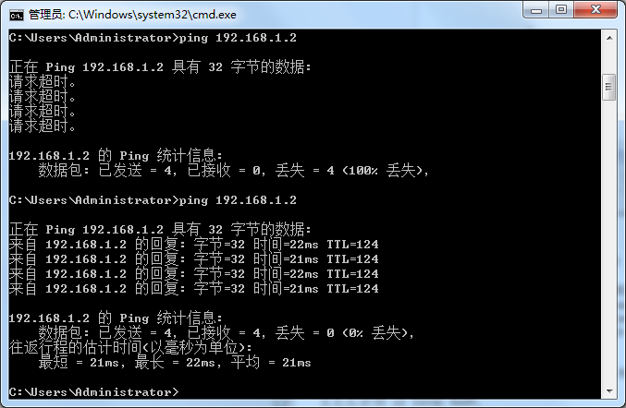

TRACEROUTE PC1

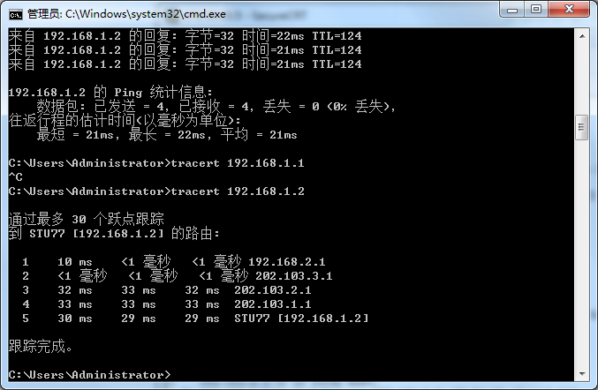

SHOW IP ROUTE 2

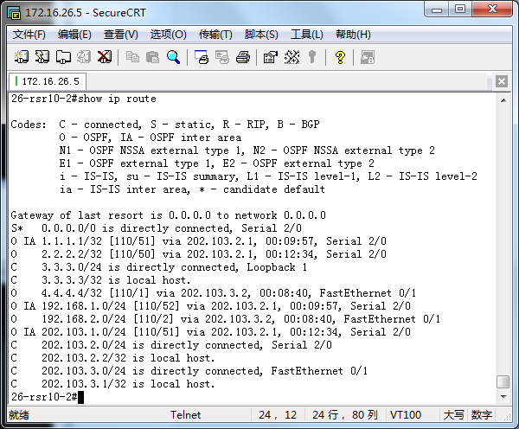

SHOW IP ROUTE 1

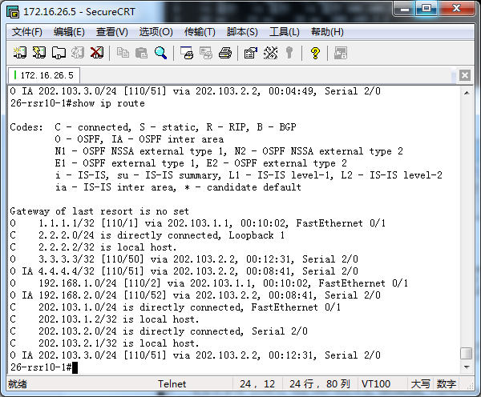

DEBUG R1

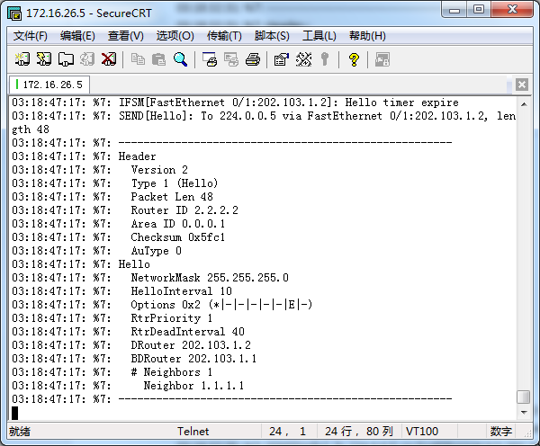

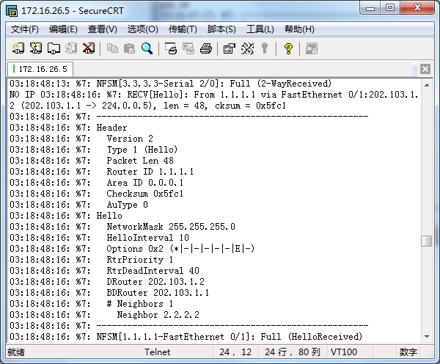

--------------------------DEBUG ROUTE 1 INFO--------------------------------------------------------------------------03:18:47:39: %7: Neighbor 3.3.3.3

03:18:47:39: %7: -----------------------------------------------------

03:18:47:43: %7: RECV[Hello]: From 3.3.3.3 via Serial 2/0:202.103.2.1 (202.103.2.2 -> 224.0.0.5), len = 48, cksum = 0xf290

03:18:47:43: %7: -----------------------------------------------------

03:18:47:43: %7: Header

03:18:47:43: %7: Version 2

03:18:47:43: %7: Type 1 (Hello)

03:18:47:43: %7: Packet Len 48

03:18:47:43: %7: Router ID 3.3.3.3

03:18:47:43: %7: Area ID 0.0.0.0

03:18:47:43: %7: Checksum 0xf290

03:18:47:43: %7: AuType 0

03:18:47:43: %7: Hello

03:18:47:43: %7: NetworkMask 255.255.255.0

03:18:47:43: %7: HelloInterval 10

03:18:47:43: %7: Options 0x2 (*|-|-|-|-|-|E|-)

03:18:47:43: %7: RtrPriority 1

03:18:47:43: %7: RtrDeadInterval 40

03:18:47:43: %7: DRouter 0.0.0.0

03:18:47:43: %7: BDRouter 0.0.0.0

03:18:47:43: %7: # Neighbors 1

03:18:47:43: %7: Neighbor 2.2.2.2

03:18:47:43: %7: -----------------------------------------------------

03:18:47:43: %7: NFSM[3.3.3.3-Serial 2/0]: Full (HelloReceived)

03:18:47:43: %7: NFSM[3.3.3.3-Serial 2/0]: nfsm_ignore called

03:18:47:43: %7: NFSM[3.3.3.3-Serial 2/0]: Full (2-WayReceived)

03:18:47:46: %7: RECV[Hello]: From 1.1.1.1 via FastEthernet 0/1:202.103.1.2 (202.103.1.1 -> 224.0.0.5), len = 48, cksum = 0x5fc1

03:18:47:46: %7: -----------------------------------------------------

03:18:47:46: %7: Header

03:18:47:46: %7: Version 2

03:18:47:46: %7: Type 1 (Hello)

03:18:47:46: %7: Packet Len 48

03:18:47:46: %7: Router ID 1.1.1.1

03:18:47:46: %7: Area ID 0.0.0.1

03:18:47:46: %7: Checksum 0x5fc1

03:18:47:46: %7: AuType 0

03:18:47:46: %7: Hello

03:18:47:46: %7: NetworkMask 255.255.255.0

03:18:47:46: %7: HelloInterval 10

03:18:47:46: %7: Options 0x2 (*|-|-|-|-|-|E|-)

03:18:47:46: %7: RtrPriority 1

03:18:47:46: %7: RtrDeadInterval 40

03:18:47:46: %7: DRouter 202.103.1.2

03:18:47:46: %7: BDRouter 202.103.1.1

03:18:47:46: %7: # Neighbors 1

03:18:47:46: %7: Neighbor 2.2.2.2

03:18:47:46: %7: -----------------------------------------------------

03:18:47:46: %7: NFSM[1.1.1.1-FastEthernet 0/1]: Full (HelloReceived)

03:18:47:46: %7: NFSM[1.1.1.1-FastEthernet 0/1]: nfsm_ignore called

03:18:47:46: %7: NFSM[1.1.1.1-FastEthernet 0/1]: Full (2-WayReceived)

03:18:47:46: %7: LSA[MaxAge]: Maxage walker finished (0.000000 sec)

03:18:47:46: %7: LSA[MaxAge]: Maxage walker finished (0.000000 sec)

03:18:47:47: %7: IFSM[FastEthernet 0/1:202.103.1.2]: Hello timer expire

03:18:47:47: %7: SEND[Hello]: To 224.0.0.5 via FastEthernet 0/1:202.103.1.2, length 48

03:18:47:47: %7: -----------------------------------------------------

03:18:47:47: %7: Header

03:18:47:47: %7: Version 2

03:18:47:47: %7: Type 1 (Hello)

03:18:47:47: %7: Packet Len 48

03:18:47:47: %7: Router ID 2.2.2.2

03:18:47:47: %7: Area ID 0.0.0.1

03:18:47:47: %7: Checksum 0x5fc1

03:18:47:47: %7: AuType 0

03:18:47:47: %7: Hello

03:18:47:47: %7: NetworkMask 255.255.255.0

03:18:47:47: %7: HelloInterval 10

03:18:47:47: %7: Options 0x2 (*|-|-|-|-|-|E|-)

03:18:47:47: %7: RtrPriority 1

03:18:47:47: %7: RtrDeadInterval 40

03:18:47:47: %7: DRouter 202.103.1.2

03:18:47:47: %7: BDRouter 202.103.1.1

03:18:47:47: %7: # Neighbors 1

03:18:47:47: %7: Neighbor 1.1.1.1

03:18:47:47: %7: -----------------------------------------------------

03:18:47:50: %7: IFSM[Serial 2/0:202.103.2.1]: Hello timer expire

03:18:47:50: %7: SEND[Hello]: To 224.0.0.5 via Serial 2/0:202.103.2.1, length 48

03:18:47:50: %7: -----------------------------------------------------

03:18:47:50: %7: Header

03:18:47:50: %7: Version 2

03:18:47:50: %7: Type 1 (Hello)

03:18:47:50: %7: Packet Len 48

03:18:47:50: %7: Router ID 2.2.2.2

03:18:47:50: %7: Area ID 0.0.0.0

03:18:47:50: %7: Checksum 0xf290

03:18:47:50: %7: AuType 0

03:18:47:50: %7: Hello

03:18:47:50: %7: NetworkMask 255.255.255.0

03:18:47:50: %7: HelloInterval 10

03:18:47:50: %7: Options 0x2 (*|-|-|-|-|-|E|-)

03:18:47:50: %7: RtrPriority 1

03:18:47:50: %7: RtrDeadInterval 40

03:18:47:50: %7: DRouter 0.0.0.0

03:18:47:50: %7: BDRouter 0.0.0.0

03:18:47:50: %7: # Neighbors 1

03:18:47:50: %7: Neighbor 3.3.3.3

03:18:47:50: %7: -----------------------------------------------------

03:18:47:53: %7: RECV[Hello]: From 3.3.3.3 via Serial 2/0:202.103.2.1 (202.103.2.2 -> 224.0.0.5), len = 48, cksum = 0xf290

03:18:47:53: %7: -----------------------------------------------------

03:18:47:53: %7: Header

03:18:47:53: %7: Version 2

03:18:47:53: %7: Type 1 (Hello)

03:18:47:53: %7: Packet Len 48

03:18:47:53: %7: Router ID 3.3.3.3

03:18:47:53: %7: Area ID 0.0.0.0

03:18:47:53: %7: Checksum 0xf290

03:18:47:53: %7: AuType 0

03:18:47:53: %7: Hello

03:18:47:53: %7: NetworkMask 255.255.255.0

03:18:47:53: %7: HelloInterval 10

03:18:47:53: %7: Options 0x2 (*|-|-|-|-|-|E|-)

03:18:47:53: %7: RtrPriority 1

03:18:47:53: %7: RtrDeadInterval 40

03:18:47:53: %7: DRouter 0.0.0.0

03:18:47:53: %7: BDRouter 0.0.0.0

03:18:47:53: %7: # Neighbors 1

03:18:47:53: %7: Neighbor 2.2.2.2

03:18:47:53: %7: -----------------------------------------------------

03:18:47:53: %7: NFSM[3.3.3.3-Serial 2/0]: Full (HelloReceived)

03:18:47:53: %7: NFSM[3.3.3.3-Serial 2/0]: nfsm_ignore called

03:18:47:53: %7: NFSM[3.3.3.3-Serial 2/0]: Full (2-WayReceived)

03:18:47:55: %7: RECV[Hello]: From 1.1.1.1 via FastEthernet 0/1:202.103.1.2 (202.103.1.1 -> 224.0.0.5), len = 48, cksum = 0x5fc1

03:18:47:55: %7: -----------------------------------------------------

03:18:47:55: %7: Header

03:18:47:55: %7: Version 2

03:18:47:55: %7: Type 1 (Hello)

03:18:47:55: %7: Packet Len 48

03:18:47:55: %7: Router ID 1.1.1.1

03:18:47:55: %7: Area ID 0.0.0.1

03:18:47:55: %7: Checksum 0x5fc1

03:18:47:55: %7: AuType 0

03:18:47:55: %7: Hello

03:18:47:55: %7: NetworkMask 255.255.255.0

03:18:47:55: %7: HelloInterval 10

03:18:47:55: %7: Options 0x2 (*|-|-|-|-|-|E|-)

03:18:47:55: %7: RtrPriority 1

03:18:47:55: %7: RtrDeadInterval 40

03:18:47:55: %7: DRouter 202.103.1.2

03:18:47:55: %7: BDRouter 202.103.1.1

03:18:47:55: %7: # Neighbors 1

03:18:47:55: %7: Neighbor 2.2.2.2

03:18:47:55: %7: -----------------------------------------------------

03:18:47:55: %7: NFSM[1.1.1.1-FastEthernet 0/1]: Full (HelloReceived)

03:18:47:55: %7: NFSM[1.1.1.1-FastEthernet 0/1]: nfsm_ignore called

03:18:47:55: %7: NFSM[1.1.1.1-FastEthernet 0/1]: Full (2-WayReceived)

03:18:47:56: %7: LSA[MaxAge]: Maxage walker finished (0.000000 sec)

03:18:47:56: %7: LSA[MaxAge]: Maxage walker finished (0.000000 sec)

03:18:47:56: %7: IFSM[FastEthernet 0/1:202.103.1.2]: Hello timer expire

03:18:47:56: %7: SEND[Hello]: To 224.0.0.5 via FastEthernet 0/1:202.103.1.2, length 48

03:18:47:56: %7: -----------------------------------------------------

03:18:47:56: %7: Header

03:18:47:56: %7: Version 2

03:18:47:56: %7: Type 1 (Hello)

03:18:47:56: %7: Packet Len 48

03:18:47:56: %7: Router ID 2.2.2.2

03:18:47:56: %7: Area ID 0.0.0.1

03:18:47:56: %7: Checksum 0x5fc1

03:18:47:56: %7: AuType 0

03:18:47:56: %7: Hello

03:18:47:56: %7: NetworkMask 255.255.255.0

03:18:47:56: %7: HelloInterval 10

03:18:47:56: %7: Options 0x2 (*|-|-|-|-|-|E|-)

03:18:47:56: %7: RtrPriority 1

03:18:47:56: %7: RtrDeadInterval 40

03:18:47:56: %7: DRouter 202.103.1.2

03:18:47:56: %7: BDRouter 202.103.1.1

03:18:47:56: %7: # Neighbors 1

03:18:47:56: %7: Neighbor 1.1.1.1

03:18:47:56: %7: -----------------------------------------------------

03:18:48:00: %7: IFSM[Serial 2/0:202.103.2.1]: Hello timer expire

03:18:48:00: %7: SEND[Hello]: To 224.0.0.5 via Serial 2/0:202.103.2.1, length 48

03:18:48:00: %7: -----------------------------------------------------

03:18:48:00: %7: Header

03:18:48:00: %7: Version 2

03:18:48:00: %7: Type 1 (Hello)

03:18:48:00: %7: Packet Len 48

03:18:48:00: %7: Router ID 2.2.2.2

03:18:48:00: %7: Area ID 0.0.0.0

03:18:48:00: %7: Checksum 0xf290

03:18:48:00: %7: AuType 0

03:18:48:00: %7: Hello

03:18:48:00: %7: NetworkMask 255.255.255.0

03:18:48:00: %7: HelloInterval 10

03:18:48:00: %7: Options 0x2 (*|-|-|-|-|-|E|-)

03:18:48:00: %7: RtrPriority 1

03:18:48:00: %7: RtrDeadInterval 40

03:18:48:00: %7: DRouter 0.0.0.0

03:18:48:00: %7: BDRouter 0.0.0.0

03:18:48:00: %7: # Neighbors 1

03:18:48:00: %7: Neighbor 3.3.3.3

03:18:48:00: %7: -----------------------------------------------------

03:18:48:02: %7: RECV[Hello]: From 3.3.3.3 via Serial 2/0:202.103.2.1 (202.103.2.2 -> 224.0.0.5), len = 48, cksum = 0xf290

03:18:48:02: %7: -----------------------------------------------------

03:18:48:02: %7: Header

03:18:48:02: %7: Version 2

03:18:48:02: %7: Type 1 (Hello)

03:18:48:02: %7: Packet Len 48

03:18:48:02: %7: Router ID 3.3.3.3

03:18:48:02: %7: Area ID 0.0.0.0

03:18:48:02: %7: Checksum 0xf290

03:18:48:02: %7: AuType 0

03:18:48:02: %7: Hello

03:18:48:02: %7: NetworkMask 255.255.255.0

03:18:48:02: %7: HelloInterval 10

03:18:48:02: %7: Options 0x2 (*|-|-|-|-|-|E|-)

03:18:48:02: %7: RtrPriority 1

03:18:48:02: %7: RtrDeadInterval 40

03:18:48:02: %7: DRouter 0.0.0.0

03:18:48:02: %7: BDRouter 0.0.0.0

03:18:48:02: %7: # Neighbors 1

03:18:48:02: %7: Neighbor 2.2.2.2

03:18:48:02: %7: -----------------------------------------------------

03:18:48:02: %7: NFSM[3.3.3.3-Serial 2/0]: Full (HelloReceived)

03:18:48:02: %7: NFSM[3.3.3.3-Serial 2/0]: nfsm_ignore called

03:18:48:02: %7: NFSM[3.3.3.3-Serial 2/0]: Full (2-WayReceived)

03:18:48:06: %7: RECV[Hello]: From 1.1.1.1 via FastEthernet 0/1:202.103.1.2 (202.103.1.1 -> 224.0.0.5), len = 48, cksum = 0x5fc1

03:18:48:06: %7: -----------------------------------------------------

03:18:48:06: %7: Header

03:18:48:06: %7: Version 2

03:18:48:06: %7: Type 1 (Hello)

03:18:48:06: %7: Packet Len 48

03:18:48:06: %7: Router ID 1.1.1.1

03:18:48:06: %7: Area ID 0.0.0.1

03:18:48:06: %7: Checksum 0x5fc1

03:18:48:06: %7: AuType 0

03:18:48:06: %7: Hello

03:18:48:06: %7: NetworkMask 255.255.255.0

03:18:48:06: %7: HelloInterval 10

03:18:48:06: %7: Options 0x2 (*|-|-|-|-|-|E|-)

03:18:48:06: %7: RtrPriority 1

03:18:48:06: %7: RtrDeadInterval 40

03:18:48:06: %7: DRouter 202.103.1.2

03:18:48:06: %7: BDRouter 202.103.1.1

03:18:48:06: %7: # Neighbors 1

03:18:48:06: %7: Neighbor 2.2.2.2

03:18:48:06: %7: -----------------------------------------------------

03:18:48:06: %7: NFSM[1.1.1.1-FastEthernet 0/1]: Full (HelloReceived)

03:18:48:06: %7: NFSM[1.1.1.1-FastEthernet 0/1]: nfsm_ignore called

03:18:48:06: %7: NFSM[1.1.1.1-FastEthernet 0/1]: Full (2-WayReceived)

03:18:48:06: %7: LSA[MaxAge]: Maxage walker finished (0.000000 sec)

03:18:48:06: %7: LSA[MaxAge]: Maxage walker finished (0.000000 sec)

03:18:48:07: %7: IFSM[FastEthernet 0/1:202.103.1.2]: Hello timer expire

03:18:48:07: %7: SEND[Hello]: To 224.0.0.5 via FastEthernet 0/1:202.103.1.2, length 48

03:18:48:07: %7: -----------------------------------------------------

03:18:48:07: %7: Header

03:18:48:07: %7: Version 2

03:18:48:07: %7: Type 1 (Hello)

03:18:48:07: %7: Packet Len 48

03:18:48:07: %7: Router ID 2.2.2.2

03:18:48:07: %7: Area ID 0.0.0.1

03:18:48:07: %7: Checksum 0x5fc1

03:18:48:07: %7: AuType 0

03:18:48:07: %7: Hello

03:18:48:07: %7: NetworkMask 255.255.255.0

03:18:48:07: %7: HelloInterval 10

03:18:48:07: %7: Options 0x2 (*|-|-|-|-|-|E|-)

03:18:48:07: %7: RtrPriority 1

03:18:48:07: %7: RtrDeadInterval 40

03:18:48:07: %7: DRouter 202.103.1.2

03:18:48:07: %7: BDRouter 202.103.1.1

03:18:48:07: %7: # Neighbors 1

03:18:48:07: %7: Neighbor 1.1.1.1

03:18:48:07: %7: -----------------------------------------------------

03:18:48:09: %7: IFSM[Serial 2/0:202.103.2.1]: Hello timer expire

03:18:48:09: %7: SEND[Hello]: To 224.0.0.5 via Serial 2/0:202.103.2.1, length 48

03:18:48:09: %7: -----------------------------------------------------

03:18:48:09: %7: Header

03:18:48:09: %7: Version 2

03:18:48:09: %7: Type 1 (Hello)

03:18:48:09: %7: Packet Len 48

03:18:48:09: %7: Router ID 2.2.2.2

03:18:48:09: %7: Area ID 0.0.0.0

03:18:48:09: %7: Checksum 0xf290

03:18:48:09: %7: AuType 0

03:18:48:09: %7: Hello

03:18:48:09: %7: NetworkMask 255.255.255.0

03:18:48:09: %7: HelloInterval 10

03:18:48:09: %7: Options 0x2 (*|-|-|-|-|-|E|-)

03:18:48:09: %7: RtrPriority 1

03:18:48:09: %7: RtrDeadInterval 40

03:18:48:09: %7: DRouter 0.0.0.0

03:18:48:09: %7: BDRouter 0.0.0.0

03:18:48:09: %7: # Neighbors 1

03:18:48:09: %7: Neighbor 3.3.3.3

03:18:48:09: %7: -----------------------------------------------------

NO IP 03:18:48:13: %7: RECV[Hello]: From 3.3.3.3 via Serial 2/0:202.103.2.1 (202.103.2.2 -> 224.0.0.5), len = 48, cksum = 0xf290

03:18:48:13: %7: -----------------------------------------------------

03:18:48:13: %7: Header

03:18:48:13: %7: Version 2

03:18:48:13: %7: Type 1 (Hello)

03:18:48:13: %7: Packet Len 48

03:18:48:13: %7: Router ID 3.3.3.3

03:18:48:13: %7: Area ID 0.0.0.0

03:18:48:13: %7: Checksum 0xf290

03:18:48:13: %7: AuType 0

03:18:48:13: %7: Hello

03:18:48:13: %7: NetworkMask 255.255.255.0

03:18:48:13: %7: HelloInterval 10

03:18:48:13: %7: Options 0x2 (*|-|-|-|-|-|E|-)

03:18:48:13: %7: RtrPriority 1

03:18:48:13: %7: RtrDeadInterval 40

03:18:48:13: %7: DRouter 0.0.0.0

03:18:48:13: %7: BDRouter 0.0.0.0

03:18:48:13: %7: # Neighbors 1

03:18:48:13: %7: Neighbor 2.2.2.2

03:18:48:13: %7: -----------------------------------------------------

03:18:48:13: %7: NFSM[3.3.3.3-Serial 2/0]: Full (HelloReceived)

03:18:48:13: %7: NFSM[3.3.3.3-Serial 2/0]: nfsm_ignore called

03:18:48:13: %7: NFSM[3.3.3.3-Serial 2/0]: Full (2-WayReceived)

NO IP 03:18:48:16: %7: RECV[Hello]: From 1.1.1.1 via FastEthernet 0/1:202.103.1.2 (202.103.1.1 -> 224.0.0.5), len = 48, cksum = 0x5fc1

03:18:48:16: %7: -----------------------------------------------------

03:18:48:16: %7: Header

03:18:48:16: %7: Version 2

03:18:48:16: %7: Type 1 (Hello)

03:18:48:16: %7: Packet Len 48

03:18:48:16: %7: Router ID 1.1.1.1

03:18:48:16: %7: Area ID 0.0.0.1

03:18:48:16: %7: Checksum 0x5fc1

03:18:48:16: %7: AuType 0

03:18:48:16: %7: Hello

03:18:48:16: %7: NetworkMask 255.255.255.0

03:18:48:16: %7: HelloInterval 10

03:18:48:16: %7: Options 0x2 (*|-|-|-|-|-|E|-)

03:18:48:16: %7: RtrPriority 1

03:18:48:16: %7: RtrDeadInterval 40

03:18:48:16: %7: DRouter 202.103.1.2

03:18:48:16: %7: BDRouter 202.103.1.1

03:18:48:16: %7: # Neighbors 1

03:18:48:16: %7: Neighbor 2.2.2.2

03:18:48:16: %7: -----------------------------------------------------

03:18:48:16: %7: NFSM[1.1.1.1-FastEthernet 0/1]: Full (HelloReceived)

03:18:48:16: %7: NFSM[1.1.1.1-FastEthernet 0/1]: nfsm_ignore called

03:18:48:16: %7: NFSM[1.1.1.1-FastEthernet 0/1]: Full (2-WayReceived)

03:18:48:16: %7: LSA[MaxAge]: Maxage walker finished (0.000000 sec)

03:18:48:16: %7: LSA[MaxAge]: Maxage walker finished (0.000000 sec)

N03:18:48:17: %7: IFSM[FastEthernet 0/1:202.103.1.2]: Hello timer expire

03:18:48:17: %7: SEND[Hello]: To 224.0.0.5 via FastEthernet 0/1:202.103.1.2, length 48

03:18:48:17: %7: -----------------------------------------------------

03:18:48:17: %7: Header

03:18:48:17: %7: Version 2

03:18:48:17: %7: Type 1 (Hello)

03:18:48:17: %7: Packet Len 48

03:18:48:17: %7: Router ID 2.2.2.2

03:18:48:17: %7: Area ID 0.0.0.1

03:18:48:17: %7: Checksum 0x5fc1

03:18:48:17: %7: AuType 0

03:18:48:17: %7: Hello

03:18:48:17: %7: NetworkMask 255.255.255.0

03:18:48:17: %7: HelloInterval 10

03:18:48:17: %7: Options 0x2 (*|-|-|-|-|-|E|-)

03:18:48:17: %7: RtrPriority 1

03:18:48:17: %7: RtrDeadInterval 40

03:18:48:17: %7: DRouter 202.103.1.2

03:18:48:17: %7: BDRouter 202.103.1.1

03:18:48:17: %7: # Neighbors 1

03:18:48:17: %7: Neighbor 1.1.1.1

03:18:48:17: %7: -----------------------------------------------------

O DEBUG ALL

% Unknown command.

26-rsr10-1#03:18:48:20: %7: IFSM[Serial 2/0:202.103.2.1]: Hello timer expire

03:18:48:20: %7: SEND[Hello]: To 224.0.0.5 via Serial 2/0:202.103.2.1, length 48

03:18:48:20: %7: -----------------------------------------------------

03:18:48:20: %7: Header

03:18:48:20: %7: Version 2

03:18:48:20: %7: Type 1 (Hello)

03:18:48:20: %7: Packet Len 48

03:18:48:20: %7: Router ID 2.2.2.2

03:18:48:20: %7: Area ID 0.0.0.0

03:18:48:20: %7: Checksum 0xf290

03:18:48:20: %7: AuType 0

03:18:48:20: %7: Hello

03:18:48:20: %7: NetworkMask 255.255.255.0

03:18:48:20: %7: HelloInterval 10

03:18:48:20: %7: Options 0x2 (*|-|-|-|-|-|E|-)

03:18:48:20: %7: RtrPriority 1

03:18:48:20: %7: RtrDeadInterval 40

03:18:48:20: %7: DRouter 0.0.0.0

03:18:48:20: %7: BDRouter 0.0.0.0

03:18:48:20: %7: # Neighbors 1

03:18:48:20: %7: Neighbor 3.3.3.3

03:18:48:20: %7: -----------------------------------------------------

03:18:48:23: %7: RECV[Hello]: From 3.3.3.3 via Serial 2/0:202.103.2.1 (202.103.2.2 -> 224.0.0.5), len = 48, cksum = 0xf290

03:18:48:23: %7: -----------------------------------------------------

03:18:48:23: %7: Header

03:18:48:23: %7: Version 2

03:18:48:23: %7: Type 1 (Hello)

03:18:48:23: %7: Packet Len 48

03:18:48:23: %7: Router ID 3.3.3.3

03:18:48:23: %7: Area ID 0.0.0.0

03:18:48:23: %7: Checksum 0xf290

03:18:48:23: %7: AuType 0

03:18:48:23: %7: Hello

03:18:48:23: %7: NetworkMask 255.255.255.0

03:18:48:23: %7: HelloInterval 10

03:18:48:23: %7: Options 0x2 (*|-|-|-|-|-|E|-)

03:18:48:23: %7: RtrPriority 1

03:18:48:23: %7: RtrDeadInterval 40

03:18:48:23: %7: DRouter 0.0.0.0

03:18:48:23: %7: BDRouter 0.0.0.0

03:18:48:23: %7: # Neighbors 1

03:18:48:23: %7: Neighbor 2.2.2.2

03:18:48:23: %7: -----------------------------------------------------

03:18:48:23: %7: NFSM[3.3.3.3-Serial 2/0]: Full (HelloReceived)

03:18:48:23: %7: NFSM[3.3.3.3-Serial 2/0]: nfsm_ignore called

03:18:48:23: %7: NFSM[3.3.3.3-Serial 2/0]: Full (2-WayReceived)

no debug a03:18:48:25: %7: RECV[Hello]: From 1.1.1.1 via FastEthernet 0/1:202.103.1.2 (202.103.1.1 -> 224.0.0.5), len = 48, cksum = 0x5fc1

03:18:48:25: %7: -----------------------------------------------------

03:18:48:25: %7: Header

03:18:48:25: %7: Version 2

03:18:48:25: %7: Type 1 (Hello)

03:18:48:25: %7: Packet Len 48

03:18:48:25: %7: Router ID 1.1.1.1

03:18:48:25: %7: Area ID 0.0.0.1

03:18:48:25: %7: Checksum 0x5fc1

03:18:48:25: %7: AuType 0

03:18:48:25: %7: Hello

03:18:48:25: %7: NetworkMask 255.255.255.0

03:18:48:25: %7: HelloInterval 10

03:18:48:25: %7: Options 0x2 (*|-|-|-|-|-|E|-)

03:18:48:25: %7: RtrPriority 1

03:18:48:25: %7: RtrDeadInterval 40

03:18:48:25: %7: DRouter 202.103.1.2

03:18:48:25: %7: BDRouter 202.103.1.1

03:18:48:25: %7: # Neighbors 1

03:18:48:25: %7: Neighbor 2.2.2.2

03:18:48:25: %7: -----------------------------------------------------

03:18:48:25: %7: NFSM[1.1.1.1-FastEthernet 0/1]: Full (HelloReceived)

03:18:48:25: %7: NFSM[1.1.1.1-FastEthernet 0/1]: nfsm_ignore called

03:18:48:25: %7: NFSM[1.1.1.1-FastEthernet 0/1]: Full (2-WayReceived)

03:18:48:26: %7: LSA[MaxAge]: Maxage walker finished (0.000000 sec)

03:18:48:26: %7: LSA[MaxAge]: Maxage walker finished (0.000000 sec)

03:18:48:26: %7: IFSM[FastEthernet 0/1:202.103.1.2]: Hello timer expire

03:18:48:26: %7: SEND[Hello]: To 224.0.0.5 via FastEthernet 0/1:202.103.1.2, length 48

03:18:48:26: %7: -----------------------------------------------------

03:18:48:26: %7: Header

03:18:48:26: %7: Version 2

03:18:48:26: %7: Type 1 (Hello)

03:18:48:26: %7: Packet Len 48

03:18:48:26: %7: Router ID 2.2.2.2

03:18:48:26: %7: Area ID 0.0.0.1

03:18:48:26: %7: Checksum 0x5fc1

03:18:48:26: %7: AuType 0

03:18:48:26: %7: Hello

03:18:48:26: %7: NetworkMask 255.255.255.0

03:18:48:26: %7: HelloInterval 10

03:18:48:26: %7: Options 0x2 (*|-|-|-|-|-|E|-)

03:18:48:26: %7: RtrPriority 1

03:18:48:26: %7: RtrDeadInterval 40

03:18:48:26: %7: DRouter 202.103.1.2

03:18:48:26: %7: BDRouter 202.103.1.1

03:18:48:26: %7: # Neighbors 1

03:18:48:26: %7: Neighbor 1.1.1.1

03:18:48:26: %7: -----------------------------------------------------

no debug all03:18:48:30: %7: IFSM[Serial 2/0:202.103.2.1]: Hello timer expire

03:18:48:30: %7: SEND[Hello]: To 224.0.0.5 via Serial 2/0:202.103.2.1, length 48

03:18:48:30: %7: -----------------------------------------------------

03:18:48:30: %7: Header

03:18:48:30: %7: Version 2

03:18:48:30: %7: Type 1 (Hello)

03:18:48:30: %7: Packet Len 48

03:18:48:30: %7: Router ID 2.2.2.2

03:18:48:30: %7: Area ID 0.0.0.0

03:18:48:30: %7: Checksum 0xf290

03:18:48:30: %7: AuType 0

03:18:48:30: %7: Hello

03:18:48:30: %7: NetworkMask 255.255.255.0

03:18:48:30: %7: HelloInterval 10

03:18:48:30: %7: Options 0x2 (*|-|-|-|-|-|E|-)

03:18:48:30: %7: RtrPriority 1

03:18:48:30: %7: RtrDeadInterval 40

03:18:48:30: %7: DRouter 0.0.0.0

03:18:48:30: %7: BDRouter 0.0.0.0

03:18:48:30: %7: # Neighbors 1

03:18:48:30: %7: Neighbor 3.3.3.3

03:18:48:30: %7: -----------------------------------------------------

^

% Invalid input detected at '^' marker.

26-rsr10-1#

26-rsr10-1#

26-rsr10-1#

26-rsr10-1#03:18:48:32: %7: RECV[Hello]: From 3.3.3.3 via Serial 2/0:202.103.2.1 (202.103.2.2 -> 224.0.0.5), len = 48, cksum = 0xf290

03:18:48:32: %7: -----------------------------------------------------

03:18:48:32: %7: Header

03:18:48:32: %7: Version 2

03:18:48:32: %7: Type 1 (Hello)

03:18:48:32: %7: Packet Len 48

03:18:48:32: %7: Router ID 3.3.3.3

03:18:48:32: %7: Area ID 0.0.0.0

03:18:48:32: %7: Checksum 0xf290

03:18:48:32: %7: AuType 0

03:18:48:32: %7: Hello

03:18:48:32: %7: NetworkMask 255.255.255.0

03:18:48:32: %7: HelloInterval 10

03:18:48:32: %7: Options 0x2 (*|-|-|-|-|-|E|-)

03:18:48:32: %7: RtrPriority 1

03:18:48:32: %7: RtrDeadInterval 40

03:18:48:32: %7: DRouter 0.0.0.0

03:18:48:32: %7: BDRouter 0.0.0.0

03:18:48:32: %7: # Neighbors 1

03:18:48:32: %7: Neighbor 2.2.2.2

03:18:48:32: %7: -----------------------------------------------------

03:18:48:32: %7: NFSM[3.3.3.3-Serial 2/0]: Full (HelloReceived)

03:18:48:32: %7: NFSM[3.3.3.3-Serial 2/0]: nfsm_ignore called

03:18:48:32: %7: NFSM[3.3.3.3-Serial 2/0]: Full (2-WayReceived)

no debug all

26-rsr10-1#-

