**25.03.25 H/w: p. 113 ex. 14**

**1. The Growing Conflict Between Humans and Nature**

Human progress has reached a stage of intensive exploration of nuclear and solar energy, the World Ocean, and outer space. However, the relationship between humans and their environment has become one of the most pressing issues for many sciences due to its significance for humanity. The contradictions between man and nature have dramatically increased with industrialization and globalization, leading to excessive consumption of resources and pollution.

**2. Types of Environmental Pollution**

Environmental pollution manifests in various forms: air, water, soil, and pollution caused by solid waste, noise, and radiation. Noise pollution is particularly concerning today, as it not only harms physical health but also weakens energy levels and damages mental well-being. Many cities are now too noisy to live comfortably. Transport plays a major role in environmental degradation, with cars consuming vast amounts of air and releasing harmful gases like carbon dioxide, which traps heat in Earth's atmosphere

**3. Water Pollution and Deforestation**

Clean water is essential for life, yet human activities have led to widespread water contamination globally. Protecting our water supply is crucial for survival. Additionally, deforestation—especially the destruction of tropical forests—disrupts ecosystems, kills wildlife, alters climates, and contributes to ecological imbalances. Alarmingly, over 78 million acres of trees are cut down annually, exacerbating these issues.

**4. The Greenhouse Effect and Global Warming**

The greenhouse effect occurs when certain gases trap heat in Earth’s atmosphere, preventing it from escaping into space. While water vapor is the primary greenhouse gas, human activities significantly enhance this effect through emissions of carbon dioxide and other pollutants. This leads to global warming, which could raise Earth's temperature by 3°C over the next 50 years, causing droughts in some regions and floods in others.

**5. Soil Pollution and Agricultural Challenges**

Soil pollution and degradation pose significant threats to agriculture. Issues such as salinity and misuse of chemical fertilizers, pesticides, and herbicides harm soil quality and plant growth. These chemicals must be carefully controlled or minimized to prevent further damage. Sustainable practices are needed to address these challenges effectivel

**6. Restoring Harmony Between Humans and Nature**

Solving environmental problems requires restoring unity between humans and nature. Modern humans increasingly recognize their responsibility toward the planet. As the most powerful species on Earth, humans must protect the welfare of the world and all its inhabitants. Nature conservation is everyone’s concern, and collective action is vital to safeguarding the environment for future generations.

**ex. 17 (write about 60 -70 words).**

Our planet is fragile, and everyone must take responsibility to protect it. Personally, I can contribute by reducing waste and recycling regularly. Using reusable bags, bottles, and containers helps cut down on plastic pollution. Conserving water and energy at home, such as turning off lights and fixing leaks, makes a big difference. I also try to walk or use public transport instead of driving. I support eco-friendly companies and educating others about sustainability like FEFU EcoTeam.

**01.03.25 H/w: p. 125 ex. 6 - do the crossword**

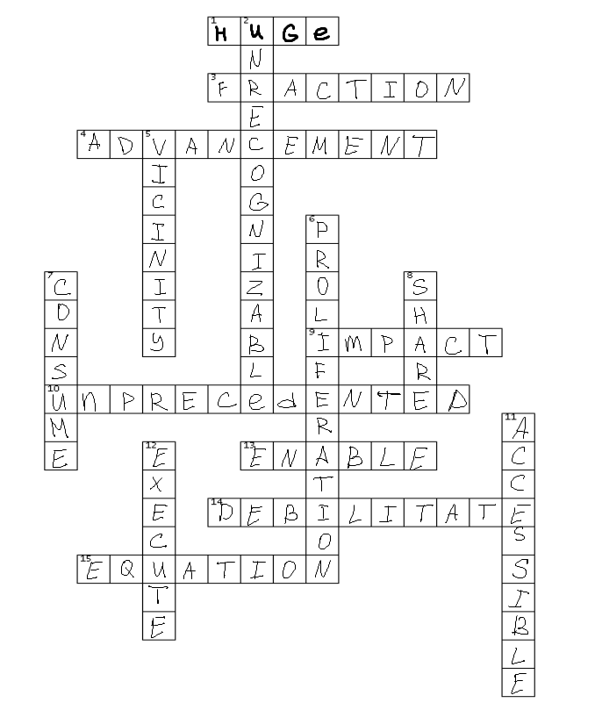**ACROSS**

1. *Huge* – extremely large in size
2. *Fraction* – a numerical value that is a part of a whole
3. *Advancement* – a development or improvement made in a particular field or area
4. *Impact* – powerful effect or influence that something has on a person, thing, or situation
5. *Unprecedented* – never done or known before; extraordinary
6. *Enable* – to give someone the authority, means, or opportunity to do something
7. *Debilitate* – to make someone weak and infirm
8. *Equation* – a mathematical statement that says two things are equal

**DOWN**

1. *Unrecognizable* – not able to be recognized or identified
2. *Vicinity* – the area or region near or surrounding a particular place or object
3. *Proliferation* – rapid increase or growth in numbers
4. *Consume* – to use up or take in something completely or entirely
5. *Share* – to give a portion or part of something
6. *Accessible* – able to be reached, entered, or used
7. *Execute* – to carry out or perform a task or action

**Make up your own 10 sentences with these vocabulary:**

1. She decided to not **share** her notes with the rest of the class.
2. The **advancement** of technology has made our lives much easier than before.
3. Social media has had a huge **impact** on how people communicate today.
4. The pandemic caused an **unprecedented** shift to online learning worldwide.
5. This app will **enable** you to track your daily expenses easily.
6. A poor diet can **debilitate** your immune system over time.
7. There are several great restaurants in the **vicinity** of the city center.
8. We should try to **consume** less plastic to protect the environment.
9. Public transportation should be **accessible** to everyone, including people with disabilities.
10. It is important to **execute** tasks carefully to avoid mistakes.

**08.04.25**

**H/w: p. 131-132 Text H-J - Choose the correct heading for each passage and write out 2-3 sentences from every passage**

***A6. Improved & Advanced Communication***

1. The continuous developments in technology have improved modern communication methods.
2. These electronic and digital communication tools have helped us eradicate time and distance to make communication more comfortable, effective, and better.
3. Modern technology also helps users connect with multiple people on online audio or video calls using video conferencing.

***B3. Advanced Business and Marketing***

1. Modern technology benefits customers by making it easy for them to buy products or services online.
2. Companies can sell their products and services to customers living on opposite ends of the globe, and transactions are made quickly in real-time.
3. Business tech solutions like CRM-enabled POS systems, telematics, productivity tracking software, accounting solutions, and mobile payments have made various business operations and processes accessible and efficient by minimizing the possibility of errors.

***C9. Better Housing and Lifestyle***

1. Thanks to smart home devices and gadgets, the latest technology has made our life organized, easier, and safer.
2. The smart home tech industry has made thousands of smart home gadgets that are automatic and controllable via mobile apps.
3. We can turn the lights on, open the door, keep an eye on the main gate, and even make coffee using our smartphones.

***D4. High-tech Traveling & Transportation Facilities***

1. Modern technology used in the transportation sector has made it easier for people to travel long distances, conveniently and comfortably.
2. Moreover, technologies like GPS trackers for car and fleet tracking solutions have made it easier to keep the vehicles secure and keep track of traveling efficiently.
3. Driverless vehicles are on their way to eliminate the need for drivers for traveling and transportation.

***E10. Distance Education and Modern Learning***

1. Technology has changed education in many ways.
2. Students can watch informative videos on YouTube to enhance their knowledge in a specific subject or field of life.
3. These virtual educational institutes allow students to earn degrees from the comfort of their homes. Students can communicate with their teachers and educators in real-time by using the latest communication methods to learn more effectively.

***F8. Easy Accessibility to Healthcare Facility***

1. We have seen the impact of technology on our lives, especially in the healthcare sector.
2. The invention of the latest medications has also made it possible to treat illnesses like heart disease, cancer, etc.
3. Modern health or fitness tracking devices have changed the way we take care of ourselves.
4. Technology today also allows us to consult a doctor and share his medical history online.

***G5. Online Shopping and Secured Bill Payment***

1. Online shopping is becoming more famous in recent years, all thanks to technology in everyday life.
2. It has made it quite convenient for people with busy schedules to shop and have all necessary things delivered to their doorstep.
3. The most significant impact of technology is it allows the customer to pay money online, saving him the hassle of carrying cash or entering a pin.

***H1. Easy Accessibility to Information***

1. But with the use of technology in daily life, we can search for anything on the internet without even leaving our spot.
2. Modern technology has changed the way we learn, date, dine, or converse online.
3. One such example is Google Maps. These advanced services have made it possible to find new places, see the direction of unfamiliar paths with the best route, see satellite images, etc.

***I2. Instant Connection using social media***

1. Social media handles are another significant advancement and example of the impact of technology on our lives.
2. People access services like Facebook, Instagram, WhatsApp, Snapchat, Twitter, TikTok, etc., to have an insight into others’ lives, be it someone we know from the neighbors or a celebrity.
3. Social media has also impacted the business world and provided them a platform for marketing their brand and product.
4. The urge to stay connected and updated with what’s happening worldwide has made us more dependent or addicted to these platforms.

***J7. Flexibility in Work Life***

1. Technology has helped us stay connected to the office and work while staying at home.
2. For example, an employee doesn’t have to commute from home to the office, gets more flexible working hours, chooses where to work, etc.
3. Some productivity apps and software help in time management, organization, goal focus, and keeping track of employees’ activity.

**p. 133 ex. 1**

1. **Consume** less power

2. **Perform** tasks

3. **Fraction** of a second

4. **Advancements** in technology

5. To have a significant **impact**

6. **Unprecedented** levels of precision and efficiency

7. A complex **system**

8. **Share** information

9. **Convenient** online shopping

10. **Digital** world

**p. 133-134 ex.2. Change the synonyms with the words from the Active Vocabulary.**

1. **Advancements** (Growth) in technology enable connectivity on a global scale.

2. The impact of social media has been **significant** (enormous) in shaping modern society.

3. Computers have enabled access to vast amounts of information, making it more **accessible** (available) than ever before.

4. Technological **advancements** (progress) have revolutionized the way we communicate and share information.

5. The ability to **execute** (to perform) tasks quickly and efficiently has been enhanced by technological innovations.

6. **Unprecedented** (Extraordinary) opportunities for learning and growth are available through online education.

7. The lack of access to modern technology can **debilitate** (weaken) in their pursuit of educational and career opportunities.

8. Technology has had a huge **impact** (influence) on various industries, from healthcare to agriculture.

9. The accessibility of smartphones and laptops **has enabled** (has allowed) people to stay connected wherever they go.

10. Distributing data securely has become **essential/vital** (crucial) in the digital age.