假定你是李华， 准备参加学校组织的**远足活动**。请给你校国际部学生 Jack 写封邮件，邀请他参加， 内容包括：

1．活动安排；2．活动意义；3．邀请参加。

注意：

1．写作词数应为 80 左右；

2．请在答题卡的相应位置作答。

Dear Jack,

How is everything going?

____________________________________________________________________________________________

Yours,

Li Hua

1. 开头：寒暄+写信目的
2. 活动安排：集合、出发时间、地点；到达目的之后的活动、返程时间。
3. 活动意义：锻炼放松身心，具体形式（呼吸新鲜空气、观景、散心、娱乐活动等），更好投入到接下来的紧张繁忙的学习生活中；
4. 结尾：敬候佳音、期待回复

Dear Jack,（参考范文）

How is everything going? The decision has been made by our school to organize the students to **go hiking** on Saturday this weekend.

All the participants **are required to** gather at the school gate at seven o’clock and then take the school buses to the foot of the Nanshan Mountain. The hiking **is scheduled to** start at eight o’clock. We will sing songs along the way and play recreational games at the mountain top. After the picnic, we will return around four in the afternoon. The trip is about 10 kilometers, which can be **physically and mentally** **beneficial**. **A good sight of the view** and sincere communication can also be the rewards.

Would you like to join us? If so, I’m looking forward to your earliest reply.

Yours,

Li Hua

Dear Jack,

How is everything going? **Thrilled and eager, I am writing to** invite you to join me in a **long-anticipated** hike **organized** **by** our school on Saturday this weekend.

**技巧**：活用复合形容词: (**adv-pp.** **副词-过去分词** heavily-guarded, well-prepared, **dimly-lighted**灯光昏暗的)

**To arrive on time/ punctually,** all the participants **are required to** **gather** at the school gate at seven o’clock and then take the school buses to the foot of the Nanshan Mountain. Along the way, we may **amuse ourselves with** melodious songs or entertaining/recreational games. **Scheduled to kick/set off** at 8:00, the trip will take us **approximately/some** 4 hours and we **are expected to** arrive in the afternoon after **relishing/enjoying** a **plentiful and hearty/ scrumptious/tasty/yummy/luscious** lunch at the top of the mountain. **Through this activity**, I **have a firm belief that** you will **get refreshed** by the **fragrance of the** **charming** flowers and oxygen-filled air and **captivating/appealing view** and **get relaxed both physically and mentally**, **leaving behind** all the worries temporarily.

**Should you be interested in** it, just **drop me a line** and you are welcome to join us．

Yours,

Li Hua

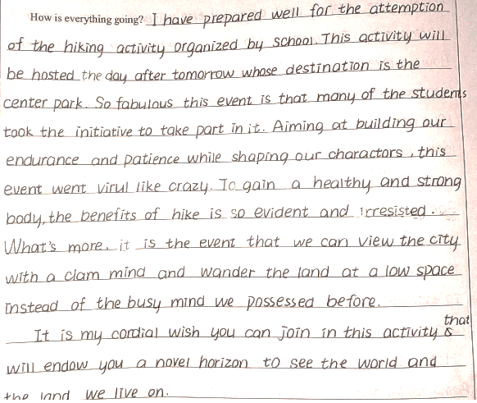 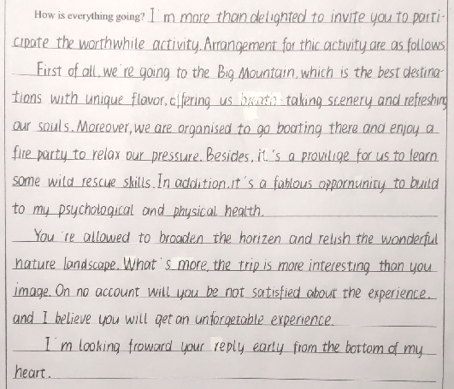

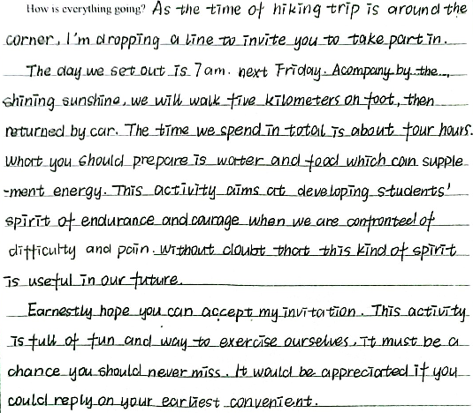

字迹模仿范本

