Issue Tracker CLI - Architecture & Documentation

# 1. Introduction

The Issue Tracker CLI is a Spring Boot based command-line application designed to manage issues stored in Google Sheets. It leverages the layered architecture pattern to separate concerns across different layers (Application, Service, Domain, Persistence, Infrastructure). The project is containerized using Docker for easy distribution and execution.

# 2. Architecture Overview

The system is organized into multiple layers:  
- Application Layer: Entrypoint and CLI handling.  
- Service Layer: Core business logic.  
- Domain Layer: Core domain entities.  
- Persistence Layer: Repository abstraction and implementations.  
- Infrastructure Layer: Integration with Google Sheets API.

# 3. Data Flow

1. The user executes a CLI command (e.g., create, update, list).  
2. The Application Layer (`IssueTrackerApplication`) delegates the command to the Service Layer (`IssueService`).  
3. The Service Layer processes business logic and interacts with the Persistence Layer.  
4. The Persistence Layer (`IssueRepository`, `GoogleSheetsIssueRepository`) uses the Infrastructure Layer (`GoogleSheetsFacade`) to communicate with Google Sheets API.  
5. Results are returned to the CLI and displayed to the user.

# 4. Architecture Diagram

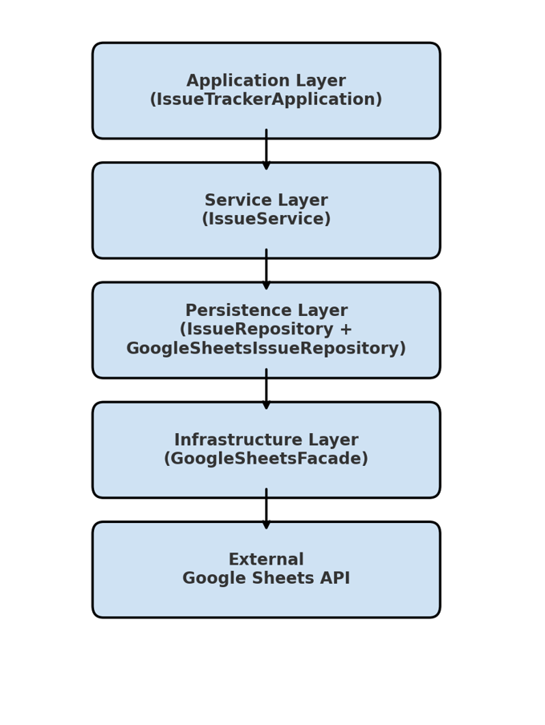

# 5. Configuration

- `application.properties`: Holds application-wide properties like spreadsheet ID.  
- `.env`: Stores environment variables for local development.  
- `credentials.json`: Google service account credentials for accessing Sheets API.  
- `Dockerfile`: Defines how to build and run the app in a container.

# 6. Testing

The project includes two types of tests:  
- Unit Tests: Validate business logic in `IssueService` without external dependencies.  
- Functional Tests: Boot the Spring context and run CLI commands, using mocked `GoogleSheetsFacade` to avoid real API calls.

# 7. Deployment

The application is packaged with Maven and distributed via Docker. The `Dockerfile` builds a lightweight image containing the CLI app, allowing execution in isolated environments.