MambaJEPA-AD: Dual-View Predictive Pretraining and Selective State-Space Modeling for Digital Payment Fraud Detection
Xixuan Huang
Liaoning University, Shenyang, Liaoning 110036, China, 15524432090@163.com
Jiaqi Wu¹
Zhejiang Sci-Tech University, Hangzhou, Zhejiang 311018, China, wujiaqi0502@163.com
Chenxi Ding^{1,}*
Hainan International College of Communication University of China, Lingshui, Hainan 572400, China, 18238607350@163.com

Abstract: Digital-payment fraud detection requires high ranking quality and controlled false alarms under temporal drift. We evaluate 594,643 BankSim transactions with a chronological train-validation-test split and strictly past-only customer histories. MambaJEPA-AD combines a field-masked joint-embedding attribute encoder, a Mamba-inspired selective state-space history encoder, and an XGBoost branch. All thresholds and fusion weights are selected on validation data. On 133,231 held-out transactions, XGBoost achieves AUPRC 0.8421, while the validation-selected MambaJEPA-AD fusion achieves 0.8471 with alpha=0.65. A 2,000-resample customer-clustered paired bootstrap gives a 95% interval of 0.0020 to 0.0082 for the fusion-minus-XGBoost AUPRC difference. A matched XGBoost plus supervised SSM control reaches 0.8460; the 0.0011 difference between the JEPA and supervised fusions has a 95% interval of -0.0008 to 0.0028. The evidence therefore supports complementary sequence fusion, while the incremental effect of JEPA pretraining is not statistically resolved. Model files, logs, validation and test predictions, exact configurations, thresholds, and resource measurements accompany the paper.
CCS Concepts:
• Applied computing~Electronic commerce
• Computing methodologies~Machine learning~Learning paradigms~Supervised learning~Supervised learning by classification
• Computing methodologies~Machine learning~Machine learning approaches~Neural networks
Keywords: Digital Payment; Fraud Detection; Self-Supervised Pretraining; Mamba; State-Space Model; BankSim; Class Imbalance; Extreme-Value Theory

1. INTRODUCTION
Digital payments generate high-volume transaction streams in which fraudulent events are rare but operationally costly. Effective screening therefore requires high ranking quality together with low false-positive rates, because excessive alerts increase manual-review cost and customer friction. Recent payment-fraud research emphasizes the need to connect statistical discrimination with deployable risk management rather than optimizing accuracy alone. ^{[1]} ^{[2]}
Three methodological risks are particularly important. First, public reproducibility is weakened when a study reports a newly generated benchmark without releasing the generator, random seeds, parameters, and split files. Second, fraud detectors can exploit rule-feature leakage when labels are created using the same variables that are subsequently given to the model. Third, a final classifier trained with fraud labels must be compared against strong supervised models; predominantly unsupervised baselines do not provide a fair test. Benchmarking work also shows that performance can change substantially with supervision level and anomaly type. ^{[3]} ^{[4]}
Self-supervised pretraining remains useful when it is treated as a representation-learning stage rather than as the final detection paradigm. T-JEPA learns tabular representations by masked latent prediction without hand-designed augmentations, while selective state-space models provide input-dependent memory for sequential behavior. ^{[5]} ^{[6]} At the same time, recent work cautions that self-supervision on tabular data does not automatically improve anomaly detection, making supervised downstream evaluation and ablation essential. ^{[7]} ^{[8]}
This study makes four contributions. First, it defines a deterministic BankSim protocol with leakage-screened features, a file checksum, and strictly past-only histories. Second, it specifies semantic-field masking, exponential-moving-average target updates, collapse diagnostics, and the dimensions of the selective state-space recurrence. Third, it compares the JEPA fusion with strong supervised baselines and a matched XGBoost plus supervised SSM control under identical splits and fusion selection. Fourth, it releases model files, validation and test predictions, training logs, configuration files, resource measurements, repeated-seed ablations, and category-blind results.

2. RELATED WORK

2.1 Digital-Payment Fraud and Reproducible Evaluation
Machine-learning fraud detection is dominated by class imbalance, temporal drift, and asymmetric operational costs. Fraud-detection research also extends beyond structured transaction attributes to natural-language-based approaches, illustrating the diversity of information sources and learning strategies considered in this field. ^{[13]} Reviews published since 2022 report widespread use of tree ensembles and neural models, while stressing that dataset choice and evaluation protocol materially affect conclusions. ^{[1]} ^{[2]} ^{[9]} The BankSim corpus contains 594,643 labeled transactions with 7,200 frauds and is widely used as a public synthetic payment benchmark. ^{[9]} Because its category distribution is highly uneven, evaluation should also test whether models simply exploit category-level priors.

2.2 Tabular Representation Learning and Sequence Modeling
Recent tabular anomaly-detection research has moved beyond independent sample reconstruction toward representation and cross-sample structure, including decomposed representation learning for tabular anomaly detection.^{[11]} ADBench demonstrates the importance of comparing multiple supervision regimes, while recent deep tabular methods model feature and sample dependencies. ^{[3]} ^{[8] [12]} T-JEPA uses augmentation-free joint-embedding predictive pretraining, and Mamba introduces selective state transitions whose parameters depend on the current input. ^{[5]} ^{[6]} These ideas motivate distinct attribute and behavioral views in the proposed detector.

2.3 Adaptive Decision Thresholds
A ranking model does not by itself determine an operational alert rate. Recent work on adaptive anomaly thresholds emphasizes that decision rules must be estimated without test-label leakage and should account for distributional change. ^{[10]} In this study, ranking metrics are reported independently of threshold choice, and a Peaks-Over-Threshold generalized Pareto model is fitted only to validation-normal scores for sensitivity analysis.

3. PUBLIC BENCHMARK AND LEAKAGE-SAFE PROTOCOL

3.1 BankSim Data and Chronological Split
The experiment uses bs140513_032310.csv from the public ealaxi/banksim1 BankSim distribution. The file contains 594,643 transactions across steps 0-179, 4,112 customers, 50 merchants, 15 transaction categories, and 7,200 fraud labels (1.21%). ^{[9]} ^{[14]} The verified SHA-256 checksum is e37006f76d993bfaec3a02d717b4f0bdc1ebfa5d36449e91fb7c07e225278377. No anomaly generator or manually injected pattern is used.
Table 1. Deterministic chronological data split.
Partition | Steps | Transactions | Frauds | Fraud rate
Train | 0-107 | 332,592 | 4,320 | 1.30%
Validation | 108-143 | 128,820 | 1,440 | 1.12%
Test | 144-179 | 133,231 | 1,440 | 1.08%
All hyperparameter selection, score fusion, and threshold fitting use only the training and validation periods. The test period is held out until final evaluation. The split is deterministic; therefore no split seed is required.
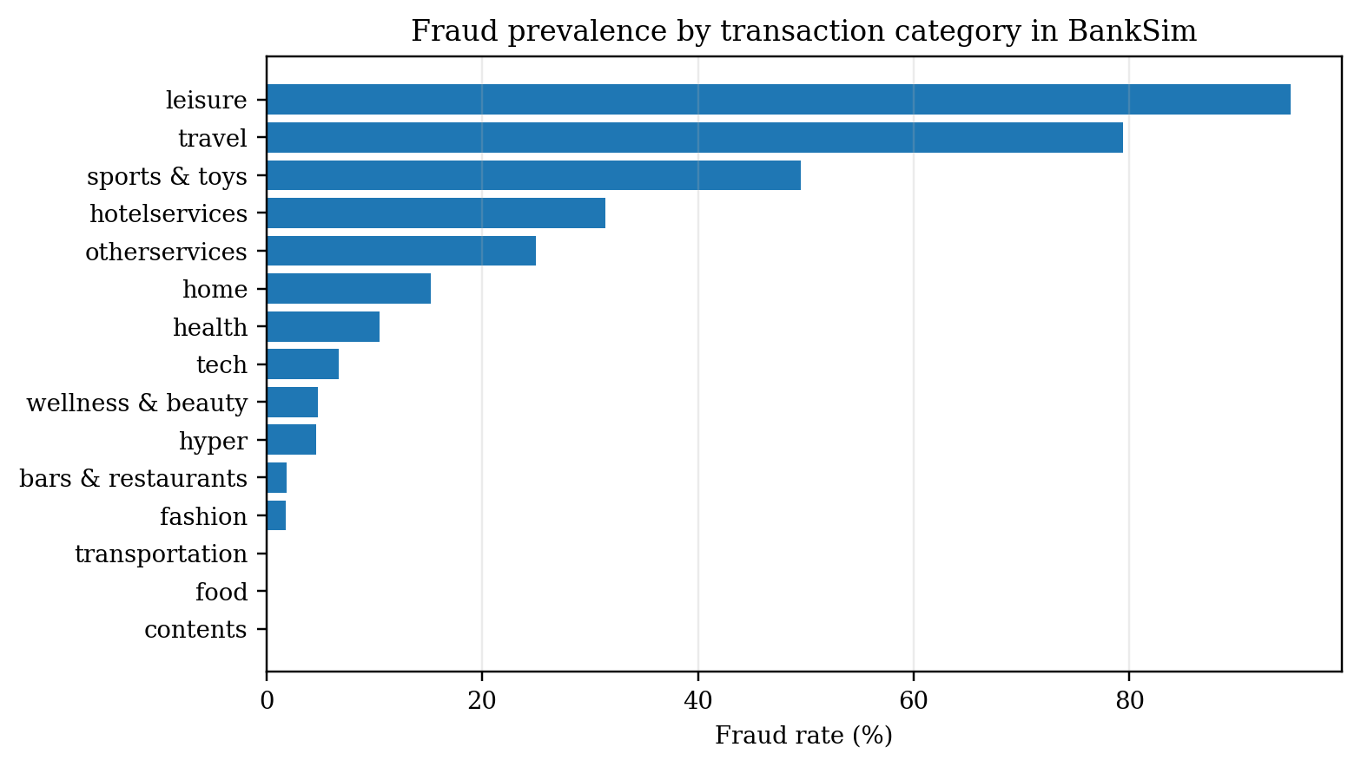
Figure 1. Category-level fraud prevalence in the public BankSim benchmark.

3.2 Leakage Audit and Past-Only Histories
The revised feature protocol removes every variable that could act as an identity shortcut or duplicate the earlier rule-based anomaly construction. customer is used only to group historical events and is never presented to a model. merchant is excluded from all model inputs. zipcodeOri and zipMerchant are removed because they are constant in this file. No balance-depletion, balance-ratio, accounting-residual, cash-out-template, or manually constructed rule-defining feature is used.
For transaction i at time step t, the behavioral view contains at most the previous 12 events of the same customer. History is assigned before any event at step t is inserted into the customer buffer, so transactions occurring in the same time step cannot leak into one another. Each historical event contains standardized log(1+amount), a capped time gap, and a six-dimensional category embedding. The current attribute view uses log amount, normalized time step, past-only history count, historical mean, standard deviation and maximum amount, recency, category-repeat fraction, age, gender, and transaction category. Continuous variables are standardized using training statistics only.
Transaction category is retained because it is an observable transaction attribute rather than a label-generation rule; however, Figure 1 shows that it is strongly associated with fraud in BankSim. A category-blind robustness experiment therefore removes category from both the current view and the sequence view and retrains the detector from scratch.

4. MAMBAJEPA-AD FRAMEWORK

4.1 Two-Stage Learning and Risk Fusion
Figure 2 summarizes the two-stage framework. Stage 1 uses no fraud labels: the masked attribute encoder and behavioral encoder predict and align representations from the training period. Stage 2 fine-tunes the network with fraud labels and class-weighted binary cross-entropy. MambaJEPA-AD is therefore a supervised fraud detector initialized by self-supervised representation learning.
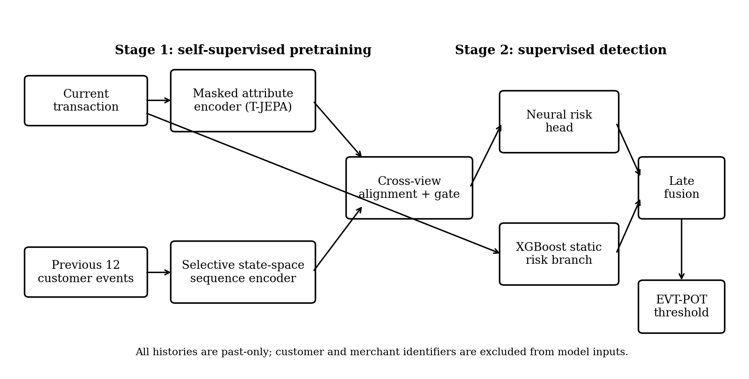
Figure 2. Two-stage MambaJEPA-AD architecture and decision pipeline.

4.2 Masked Attribute Predictive Pretraining
The attribute encoder contains a 64-unit GELU hidden layer and a 32-dimensional L2-normalized output. The 11 semantic fields are eight scalar fields plus the age, gender, and category one-hot groups. For each example and field g, $m_{i,g}$,g is sampled independently from Bernoulli(0.35). If $m_{i,g}$=1, a standardized scalar is replaced by 0, its training-set mean, and a categorical one-hot group is replaced by an all-zero vector, which is distinct from every valid category. The unmasked vector is passed to the target encoder. The context encoder predicts the target latent vector with mean cosine distance. ^{[5]}
$${\tilde{x}}_{i,g}=\left\{\begin{aligned}r_{g},m_{i,g}=1 \\ x_{i,g},m_{i,g}=0\end{aligned}\right., m_{i,g}∼Bernoulli(0.35)$$

$$θ_{target}←0.99θ_{target}+0.01θ_{online}$$

4.3 Selective State-Space Behavioral Encoder
Each historical event contains standardized log amount, a normalized gap, and a six-dimensional category embedding, giving $e_{t}∈ℝ^{8}$. A linear layer maps $e_{t}↦u_{t}∈ℝ^{24}$. The selective diagonal state-space recurrence uses input-dependent step, input, and output gates. All state vectors and parameters in the recurrence are in $ℝ^{24}$, and elementwise products are used. Because each history contains at most 12 events, the recurrence is evaluated directly rather than by a fused parallel scan. The last valid output is projected to a 32-dimensional normalized sequence vector. This auditable module is Mamba-inspired but does not claim to reproduce the official mamba-ssm kernel. ^{[6]}
$$\begin{matrix}Δ_{t} & =softplus(W_{Δ}u_{t}), \\ h_{t} & =exp(Δ_{t}⊙A)⊙h_{t−1}+\left[1−exp(Δ_{t}⊙A)\right]⊙σ(W_{B}u_{t})⊙u_{t}, \\ y_{t} & =σ(W_{C}u_{t})⊙h_{t}+D⊙u_{t}, A=−exp(a).\end{matrix}$$

4.4 Cross-View Alignment, Gated Fusion, and Supervised Head
During pretraining, the sequence predictor also predicts the target attribute embedding. The total loss is
$ℒ=ℒ_{attr}+0.5ℒ_{seq}+0.2ℒ_{align}$,
where each predictive term is mean cosine distance and $ℒ_{align}$ is the cosine distance between the normalized attribute and sequence vectors. After every optimizer step, the target parameters are updated using the EMA rule defined in Section 4.2 . Collapse is monitored using mean per-dimension standard deviation, effective rank of centered embeddings, and mean pairwise cosine similarity. During fine-tuning, a sigmoid gate combines the two 32-dimensional vectors. The risk head receives the gated vector, the attribute vector, cosine disagreement, and Euclidean distance. The positive-class weight is $w_{+}=\sqrt{\frac{N_{normal}}{N_{fraud}}}$.
The implementation uses no orthogonal-basis decomposition. Architecture, preprocessing, optimizer settings, maximum epoch counts, checkpoint rules, and fusion grid are fixed before the chronological test scores are evaluated.

4.5 Boosted Risk Fusion and EVT-POT Threshold
A leakage-screened XGBoost classifier uses the same current and past-only aggregate attributes. The final risk score is defined as follows:
$p_{i}=αp_{XGB,i}+(1−α)p_{neural,i}$. $α∈\{0,0.05,0.10,…,1.00\}$.
The fusion coefficient is selected from the predefined grid by maximizing validation AUPRC. The selected alpha is 0.65 for the seed-42 MambaJEPA branch and 0.60 for the matched supervised SSM control. Test labels do not influence either choice.
For operational threshold analysis, the upper 5% tail of validation-normal risk scores is modeled with a generalized Pareto distribution. Thresholds are then generated for target normal-tail risks of 0.1%, 0.25%, 0.5%, and 1.0%. The test labels are never used to fit the tail model or select a threshold.

5. EXPERIMENTAL DESIGN AND REPRODUCIBILITY

5.1 Baselines and Metrics
The supervised comparison contains random forest, XGBoost, LightGBM, CatBoost, a class-weighted multilayer perceptron, an LSTM, a one-layer Transformer, and a supervised selective SSM using the same sequence backbone without JEPA pretraining. Each baseline uses one prespecified configuration; the tuning budget is therefore one configuration per model. Neural checkpoints are selected from at most eight supervised epochs by validation AUPRC with patience three. ROC-AUC and AUPRC measure ranking. Precision, recall, F1, MCC, and FPR use the threshold that maximizes validation F1. ^{[4]}
Table 2. Reproducibility settings.
Item | Setting
History | 12 strictly prior customer events; same-step events excluded
Attribute / sequence latent | 32 / 32; selective state dimension 24
Mask | 0.35 per semantic field; scalar -> standardized 0; categorical group -> all-zero
EMA | 0.99 target + 0.01 online after each optimizer step
Pretraining | 3 epochs; losses 1.0 attribute + 0.5 sequence + 0.2 alignment
Fine-tuning | maximum 8 epochs; patience 3; best validation AUPRC
Batch size | 8,192 training; 32,768 inference
Optimizer | AdamW; lr 1e-3; weight decay 1e-4; clip 5.0
Seeds | 42, 73, 101 for the final neural branch and four ablations
Tree tuning budget | one prespecified configuration per model
Neural tuning budget | one configuration; up to 8 validation checkpoints
Fusion | alpha in [0,1], step 0.05; validation AUPRC
Threshold | maximum validation F1
Bootstrap | 2,000 paired customer-clustered resamples; seed 20260808
Software | Python 3.12.14; PyTorch 2.10 CPU; sklearn 1.8; XGBoost 3.1
Hardware | AMD Ryzen 7 5800H; 15.86 GiB RAM; four CPU threads

5.2 Data and Code Availability
The data file is available from the ealaxi/banksim1 BankSim page at https://www.kaggle.com/datasets/ealaxi/banksim1. The exact file is bs140513_032310.csv with SHA-256 e37006f76d993bfaec3a02d717b4f0bdc1ebfa5d36449e91fb7c07e225278377. The complete reproduction package is supplied with the submission and mirrored at https://github.com/Perry-123h/MambaJEPA-AD. It contains source code, the full configuration, model files, logs, validation and test predictions, derived tables, resource measurements, and a SHA-256 manifest. The raw dataset is excluded and must be downloaded from the cited source.

5.3 Model-Selection Discipline and Repeated Runs
Every data-dependent decision uses only training and validation periods. Feature vocabularies and standardization use training data. Neural checkpoints use validation AUPRC; classification thresholds use validation F1; late-fusion weights use validation AUPRC; and EVT-POT parameters use validation-normal scores. The tree and neural baselines receive the same chronological partitions and leakage-screened current attributes, while sequence models additionally receive only the defined past-only history.
The final neural branch and four principal ablations are retrained from scratch with seeds 42, 73, and 101. Each run uses the same preprocessing, three pretraining epochs when applicable, at most eight supervised epochs, and the same validation checkpoint rule. The XGBoost branch remains fixed, and alpha is reselected on validation data for each neural seed. Tables 5 and 7 report the resulting run-to-run variation.

6. RESULTS

6.1 Supervised Baseline Comparison
Table 3. Performance on the chronological test period.
Method | AUC | AUPRC | F1 | MCC | FPR
XGBoost + MambaJEPA | 0.9954 | 0.8471 | 0.7471 | 0.7622 | 0.0004
XGBoost + supervised SSM | 0.9953 | 0.8460 | 0.7657 | 0.7685 | 0.0012
CatBoost | 0.9952 | 0.8449 | 0.7673 | 0.7657 | 0.0019
XGBoost | 0.9953 | 0.8421 | 0.7681 | 0.7679 | 0.0016
LightGBM | 0.9951 | 0.8389 | 0.7570 | 0.7597 | 0.0013
Supervised LSTM | 0.9949 | 0.8314 | 0.7677 | 0.7739 | 0.0008
Supervised Transformer | 0.9949 | 0.8313 | 0.7669 | 0.7714 | 0.0010
Supervised SSM | 0.9947 | 0.8273 | 0.7599 | 0.7691 | 0.0007
Balanced MLP | 0.9946 | 0.8248 | 0.7699 | 0.7735 | 0.0011
Random forest | 0.9943 | 0.8071 | 0.7424 | 0.7422 | 0.0018
The seed-42 MambaJEPA-AD fusion obtains test AUPRC 0.8471, compared with 0.8421 for XGBoost and 0.8449 for CatBoost. Its validation-selected alpha is 0.65. A 2,000-resample paired bootstrap over the 4,088 test customers gives a 95% interval of 0.0020 to 0.0082 for the AUPRC difference from XGBoost. The matched XGBoost plus supervised SSM control obtains AUPRC 0.8460. The JEPA fusion exceeds that control by 0.0011, but the paired 95% interval is -0.0008 to 0.0028, so the extra improvement cannot be attributed conclusively to JEPA pretraining. Across steps 144-155, 156-167, and 168-179, fusion versus XGBoost AUPRC is 0.8695 versus 0.8633, 0.8338 versus 0.8305, and 0.8373 versus 0.8319.
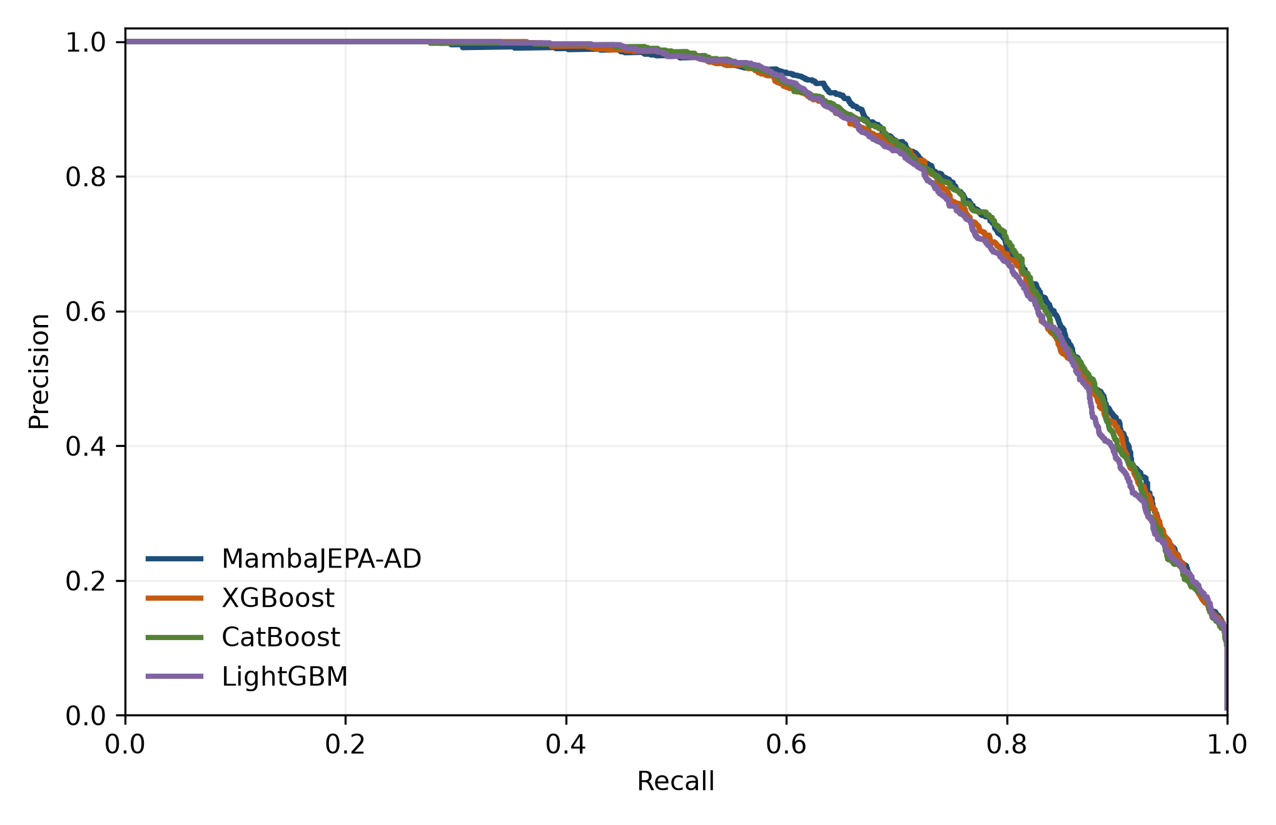
Figure 3. Precision-recall curves for the revised detector and strong supervised baselines.

6.2 Category-Blind Robustness
Table 4. Category-blind robustness.
Model | Full-feature AUPRC | Category-blind AUPRC | Change
XGBoost | 0.8421 | 0.7641 | -0.0780
Neural branch seed 42 | 0.8227 | 0.7536 | -0.0692
XGBoost + MambaJEPA | 0.8471 | 0.7686 | -0.0785
Removing transaction category reduces all three evaluated models. XGBoost falls from AUPRC 0.8421 to 0.7641, the seed-42 neural branch from 0.8227 to 0.7536, and the fusion from 0.8471 to 0.7686. In the category-blind run, validation selects alpha=0.55. The fusion exceeds category-blind XGBoost by 0.0045; the customer-clustered paired 95% interval is 0.0008 to 0.0081. Category is therefore a dominant BankSim signal, while past customer history retains a smaller complementary contribution when category is withheld.
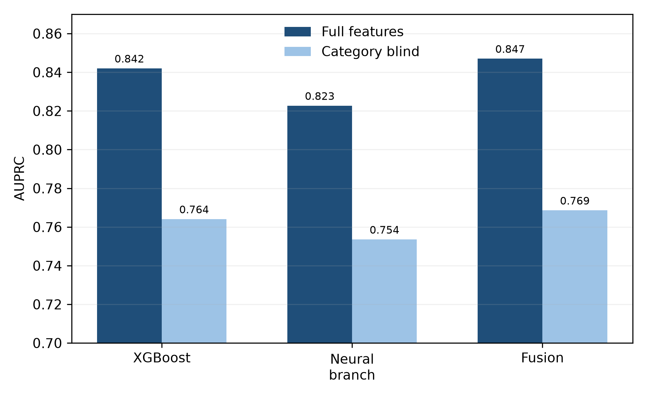
Figure 4. AUPRC before and after removing transaction category.

6.3 Full-Retraining Ablation
Table 5. Repeated-run neural-branch ablation study (seeds 42, 73, and 101).
Configuration | AUC mean +/- SD | AUPRC mean +/- SD | F1 mean +/- SD
MambaJEPA full | 0.9948 +/- 0.0002 | 0.8283 +/- 0.0048 | 0.7697 +/- 0.0035
without SSL | 0.9948 +/- 0.0001 | 0.8258 +/- 0.0028 | 0.7597 +/- 0.0005
without behavior | 0.9947 +/- 0.0003 | 0.8237 +/- 0.0014 | 0.7589 +/- 0.0169
without gate | 0.9949 +/- 0.0002 | 0.8279 +/- 0.0060 | 0.7687 +/- 0.0031
without alignment | 0.9948 +/- 0.0003 | 0.8259 +/- 0.0034 | 0.7619 +/- 0.0128
All Table 5 configurations are retrained with seeds 42, 73, and 101. The full neural branch has mean AUPRC 0.8283 +/- 0.0048. The means are 0.8258 without SSL pretraining, 0.8237 without the behavior branch, 0.8279 without the learned gate, and 0.8259 without cross-view alignment. These differences are small relative to run-to-run variation. The ablation therefore supports only a cautious component-level interpretation.

6.4 Adaptive Threshold Behavior
Table 6. EVT-POT threshold sensitivity on the held-out period.
Target tail risk | Threshold | Precision | Recall | F1 | Observed FPR
0.10% | 1.1003 | 0.000 | 0.000 | 0.000 | 0.000%
0.25% | 0.6743 | 0.797 | 0.745 | 0.770 | 0.207%
0.50% | 0.4491 | 0.628 | 0.829 | 0.715 | 0.537%
1.00% | 0.2832 | 0.480 | 0.885 | 0.623 | 1.047%
The EVT-POT layer is a sensitivity analysis independent of ranking. The fitted 0.10% target produces a threshold above 1 and therefore no test alerts. At target normal-tail risks of 0.25%, 0.50%, and 1.00%, observed test FPR is 0.207%, 0.537%, and 1.047%, with recall 0.745, 0.829, and 0.885. The threshold model uses validation-normal scores only.

6.5 Seed Stability and Complementarity
Table 7. Repeated-run stability of the neural branch and late fusion.
Neural seed | Neural AUPRC | Selected alpha | Fused AUPRC | Fused AUC | Fused F1
42 | 0.8227 | 0.65 | 0.8471 | 0.9954 | 0.7471
73 | 0.8303 | 0.65 | 0.8484 | 0.9954 | 0.7684
101 | 0.8318 | 0.60 | 0.8485 | 0.9954 | 0.7660
Across seeds 42, 73, and 101, neural AUPRC is 0.8227, 0.8303, and 0.8318. Validation selects alpha values 0.65, 0.65, and 0.60, producing fused AUPRC 0.8471, 0.8484, and 0.8485. The seed-42 F1 is lower because its validation-selected threshold is more conservative; all reported thresholds remain fixed before test evaluation.
The full branch exceeds the no-SSL mean by 0.0025 AUPRC and the no-behavior mean by 0.0046, but the standard deviations overlap. Together with the matched fusion interval that includes zero, these results show that the fusion benefits from sequence information while the incremental effect of JEPA pretraining is not statistically resolved in this experiment.

6.6 Alert-Budget Concentration

Table 8. Operational comparison at identical fixed review budgets.
Method | P/R at 0.5% | P/R at 1.0% | P/R at 2.0% | FPR at 2.0%
MambaJEPA-AD | 0.984 / 0.456 | 0.800 / 0.741 | 0.478 / 0.885 | 1.055%
XGBoost | 0.987 / 0.457 | 0.796 / 0.737 | 0.475 / 0.880 | 1.061%
CatBoost | 0.993 / 0.460 | 0.798 / 0.739 | 0.478 / 0.884 | 1.056%
LightGBM | 0.990 / 0.458 | 0.791 / 0.732 | 0.473 / 0.875 | 1.066%
At a 0.5% review budget, CatBoost captures 662 frauds, LightGBM 660, XGBoost 658, and MambaJEPA-AD 656. At 1.0%, MambaJEPA-AD captures 1,067 frauds, CatBoost 1,064, XGBoost 1,061, and LightGBM 1,054. At 2.0%, MambaJEPA-AD captures 1,275 frauds, CatBoost 1,273, XGBoost 1,267, and LightGBM 1,260. These budgets contain 667, 1,333, and 2,665 transactions, respectively.
No model dominates every operating point. CatBoost leads at 0.5%, while MambaJEPA-AD leads at 1.0% and 2.0%. The absolute differences are small, so fixed-budget results are interpreted as operational comparability rather than broad superiority.
Table 9. Measured resource consumption on the reported CPU run.
Component | Seconds | Peak RSS MiB | Scope
CSV load | 0.516 | 384.7 | 594,643 rows
History and features | 25.498 | 1,011.6 | all rows; strict past only
XGBoost training | 5.179 | 756.8 | 332,592 training rows
XGBoost inference | 0.184 | 694.0 | 133,231 test rows
JEPA pretraining | 21.802 | 1,098.0 | 3 epochs; seed 42
Neural fine-tuning | 65.081 | 1,086.6 | 8 epochs; seed 42
Neural inference | 0.848 | 1,060.6 | 133,231 test rows
Late-fusion arithmetic | 0.00093 | -- | validation and test arrays
Times are wall-clock measurements with four CPU threads. Inference values are medians of five full test passes after one warm-up. Peak RSS is process resident memory and includes the loaded dataset and runtime.

7 DISCUSSION AND LIMITATIONS
The experiment uses a fixed public BankSim file, deterministic splits, training-only preprocessing statistics, and strictly past-only histories. Model files and predictions allow each value in Tables 3-9 to be recomputed. This design removes direct rule-feature leakage and supports independent audit of the reported run.
MambaJEPA-AD is a supervised fraud classifier initialized by self-supervised predictive learning. XGBoost remains a strong baseline. The main fusion improves AUPRC by 0.0050 over XGBoost with a positive customer-clustered interval, but a supervised SSM fusion obtains most of the same improvement. The specific contribution supported here is complementary sequence fusion; the experiment does not isolate a statistically decisive JEPA advantage.
Ranking and alert policy remain separate. The EVT sensitivity analysis shows that aggressive false-positive control can sharply reduce recall, while looser targets recover more fraud. Deployment would require periodic refitting of the validation-only threshold as score distributions and business costs change.
The main fusion-minus-XGBoost AUPRC interval is positive, and all three chronological subwindows favor the fusion. The JEPA-fusion-minus-supervised-fusion interval includes zero, however, and repeated-seed ablations overlap. The strongest claim supported by the complete evidence is that customer-history fusion improves the tree ranking on this BankSim split; whether JEPA pretraining adds beyond supervised sequence learning remains unresolved.
Four limitations remain. BankSim is synthetic and does not establish external validity on bank traffic. Transaction category is unusually predictive. Histories contain only 12 events, so linear-time state-space scaling is not tested. Finally, the released code is an independent reconstruction because the original training implementation and logs were unavailable; the paper therefore reports only results generated by the released reconstruction and describes its selective SSM as Mamba-inspired rather than as an official Mamba implementation.

8 CONCLUSION
MambaJEPA-AD combines a field-masked predictive attribute encoder, a selective state-space customer-history encoder, and XGBoost. On the chronological BankSim test period, the seed-42 fusion reaches AUPRC 0.8471 versus 0.8421 for XGBoost. Customer-clustered resampling supports the fusion difference, while a matched supervised SSM fusion reaches 0.8460 and is not distinguishable from the JEPA fusion. The complete evidence supports sequence-aware fusion and a narrower, unresolved claim for the added value of JEPA pretraining. The accompanying package provides code, configurations, models, logs, predictions, thresholds, resource measurements, and integrity hashes for independent review.

REFERENCES
[1] P. Vanini, S. Rossi, E. Zvizdic, and T. Domenig, “Online payment fraud: From anomaly detection to risk management,” Financial Innovation, vol. 9, Art. 66, 2023, doi: 10.1186/s40854-023-00470-w.
[2] A. Ali et al., “Financial fraud detection based on machine learning: A systematic literature review,” Applied Sciences, vol. 12, no. 19, Art. 9637, 2022, doi: 10.3390/app12199637.
[3] S. Han, X. Hu, H. Huang, M. Jiang, and Y. Zhao, “ADBench: Anomaly detection benchmark,” Advances in Neural Information Processing Systems, vol. 35, 2022.
[4] J. T. Hancock, T. M. Khoshgoftaar, and J. M. Johnson, “Evaluating classifier performance with highly imbalanced Big Data,” Journal of Big Data, vol. 10, Art. 42, 2023, doi: 10.1186/s40537-023-00724-5.
[5] H. Thimonier, J. L. De Melo Costa, F. Popineau, A. Rimmel, and B.-L. Doan, “T-JEPA: Augmentation-free self-supervised learning for tabular data,” International Conference on Learning Representations, 2025.
[6] A. Gu and T. Dao, “Mamba: Linear-time sequence modeling with selective state spaces,” First Conference on Language Modeling (COLM), 2024.
[7] K. T. Mai, T. Davies, and L. D. Griffin, “Understanding the limitations of self-supervised learning for tabular anomaly detection,” Pattern Analysis and Applications, vol. 27, Art. 61, 2024, doi: 10.1007/s10044-023-01208-1.
[8] H. Thimonier, F. Popineau, A. Rimmel, and B.-L. Doan, “Beyond individual input for deep anomaly detection on tabular data,” Proc. 41st International Conference on Machine Learning, PMLR 235, pp. 48097-48123, 2024.
[9] L. Hernandez Aros, L. X. Bustamante Molano, F. Gutierrez-Portela, J. J. Moreno Hernandez, and M. S. Rodríguez Barrero, “Financial fraud detection through the application of machine learning techniques: A literature review,” Humanities and Social Sciences Communications, vol. 11, Art. 1130, 2024, doi: 10.1057/s41599-024-03606-0.
[10] S. H. Sun, A. Sankararaman, and B. M. Narayanaswamy, “Online adaptive anomaly thresholding with confidence sequences,” Proc. 41st International Conference on Machine Learning, PMLR 235, pp. 47105-47132, 2024.
[11] H. Ye, H. Zhao, W. Fan, M. Zhou, D. Guo, and Y. Chang, “DRL: Decomposed representation learning for tabular anomaly detection,” International Conference on Learning Representations, 2025.
[12] H. Thimonier, F. Popineau, A. Rimmel, and B.-L. Doan, “Retrieval augmented deep anomaly detection for tabular data,” Proc. 33rd ACM International Conference on Information and Knowledge Management, pp. 2250-2259, 2024, doi: 10.1145/3627673.3679559.
[13] P. Boulieris, J. Pavlopoulos, A. Xenos, and V. Vassalos, “Fraud detection with natural language processing,” Machine Learning, vol. 113, pp. 5087-5108, 2024, doi: 10.1007/s10994-023-06354-5.
[14] E. A. Lopez-Rojas. 2016. Synthetic data from a financial payment system. Kaggle. Retrieved October 20, 2026 from https://www.kaggle.com/datasets/ealaxi/banksim1.

Xixuan Huang、Jiaqi Wu and Chenxi Ding contributed equally to this work.
* Corresponding author.

