UNIVERSITY OF BUEA
Faculty of Engineering and Technology
Department of Computer Engineering – Software Engineering

CAMEROON MALNUTRITION ATLAS:
A DATA MINING APPROACH TO
PREDICTING AND MAPPING CHILD STUNTING

Course: CEC 420 – Data Mining
Author: SEPO PERRY-BRADLEY DINGA
Student ID: CT23A145
Academic Year: 2025 / 2026
Submission Date: June 2026

Abstract
Child stunting (chronic malnutrition) affects approximately 29% of children under five in Cameroon, yet the burden is distributed highly unevenly across the country's ten administrative regions. This project applies the Cross-Industry Standard Process for Data Mining (CRISP-DM) to five waves of real Demographic and Health Survey (DHS) and Multiple Indicator Cluster Survey (MICS) sub-national data (1991–2018) in order to: (i) identify the socio-economic, health-system, and environmental drivers of regional stunting disparities; (ii) test six substantive hypotheses about those drivers using non-parametric statistical tests; and (iii) build a machine-learning pipeline that predicts regional stunting rates, classifies districts into WHO risk bands, clusters districts by risk profile, and forecasts trajectories to 2028.
An ensemble of ten regression models was evaluated using five-fold cross-validation. XGBoost achieved the best performance (CV RMSE = 2.87 percentage points), representing a 60% improvement over the mean-prediction baseline (RMSE = 7.17, p = 0.003). All six hypotheses were rejected at p < 0.05: healthcare access (ρ = −0.78), socio-economic status (ρ = −0.71), maternal education (ρ = −0.54), and WASH infrastructure (ρ = −0.50) emerged as the strongest correlates. K-Means clustering (k = 2) partitioned Cameroon's regions into a 'Northern-rural critical-risk' cluster (37% stunting) and an 'Urban-affluent low-risk' cluster (24% stunting). Linear trend extrapolation indicates that without accelerated intervention, northern regions will remain in the 'high' or 'critical' WHO risk band through at least 2028. The trained models and a ranked hotspot table are deployed as a client-side interactive web application to support Ministry of Public Health targeting decisions.
Keywords: child stunting, data mining, CRISP-DM, Cameroon, DHS, XGBoost, K-Means clustering, hypothesis testing, malnutrition prediction, public health.

Table of Contents
1. Introduction 4
2. Business Understanding 5
3. Data Understanding 6
4. Data Preparation 8
5. Modelling 10
6. Evaluation 13
7. Deployment 16
8. Results and Discussion 17
9. Conclusions and Recommendations 19
References 21

1. Introduction
Malnutrition is a global health crisis of staggering proportions. Among its most insidious forms is chronic malnutrition, or 'stunting', defined as height-for-age more than two standard deviations below the WHO Child Growth Standards median. Stunting in the first 1,000 days of life produces irreversible cognitive and physical deficits, perpetuating intergenerational poverty cycles. In sub-Saharan Africa the problem is especially acute: the continent accounts for more than a third of the world's stunted children despite holding roughly a sixth of its population.
In Cameroon, the national stunting prevalence stood at approximately 29% in the 2018 DHS survey — nearly three times the WHO action threshold of 10%. However, this aggregate figure conceals profound subnational disparities. The Far North, North, and Adamawa regions routinely record stunting rates of 36–40%, placing them in the WHO 'critical' band, while the Littoral, South, and Centre regions hover near 15–22%. This north-south gradient implies that interventions must be geographically targeted to have maximum impact, yet the Ministry of Public Health lacked a systematic, data-driven methodology for prioritising districts.
This project addresses that gap by building the 'Cameroon Malnutrition Atlas' — a full-stack data mining pipeline that transforms five decades of DHS/MICS survey data into actionable, ranked targeting intelligence. The pipeline follows the CRISP-DM framework across six phases: Business Understanding, Data Understanding, Data Preparation, Modelling, Evaluation, and Deployment. The technical output is a deployable web application that allows planners to simulate the expected impact of changing specific determinants in a given district.

1.1 Research Questions
- RQ1: Which socio-economic, health-system, and environmental factors are the strongest predictors of child stunting rates across Cameroon's sub-national regions?
- RQ2: Can a machine-learning regression model predict district-level stunting rates more accurately than the population mean baseline?
- RQ3: Can districts be meaningfully clustered into distinct risk profiles that could inform differentiated intervention strategies?
- RQ4: What is the projected trajectory of stunting rates to 2026 and 2028, and which districts are improving or deteriorating fastest?

1.2 Scope and Limitations
The analysis is restricted to Cameroon's ten administrative regions across five survey waves (1991, 1998, 2004, 2011, 2018), yielding 50 region-year observations. Sub-regional disaggregation is limited by DHS sampling design. Stunting is a lagged outcome — it reflects nutritional conditions over prior years rather than the current survey year. Causal inference is not claimed; all correlations are observational.

2. Business Understanding

2.1 Problem Framing
The Ministry of Public Health needs to allocate finite nutrition and WASH intervention budgets across Cameroon's regions. Without a principled ranking of districts by projected risk, resources are distributed uniformly or on the basis of political influence rather than need. The core business problem is therefore: 'Given observable, measurable characteristics of a region in a given year, what is its expected stunting rate, which WHO risk band does it fall into, and how is that rate likely to change over the next three to five years?'

2.2 Success Criteria
- Regression: CV RMSE < 4 percentage points on a five-fold cross-validation (better than the mean baseline of 7.17 pp).
- Classification: Accuracy ≥ 75% for WHO risk-band assignment across four classes (low / medium / high / critical).
- Clustering: Silhouette score ≥ 0.40, indicating meaningful cluster separation.
- Hypothesis tests: Statistically significant (p < 0.05) correlations for at least four of the five driver hypotheses.
- Deployment: A client-side predictor that returns risk estimates without a back-end server call.

2.3 Hypotheses
Six null hypotheses were defined a priori based on the malnutrition literature and available features:
Hypothesis | Null Statement | Operationalisation | Test
H1 | Maternal education has no significant correlation with stunting. | women_secondary_plus_pct | Spearman ρ
H2 | WASH composite score has no significant correlation with stunting. | wash_composite | Spearman ρ
H3 | Socio-economic status proxy has no significant correlation with stunting. | literacy + secondary composite | Spearman ρ
H4 | Healthcare access has no significant correlation with stunting. | health_facility_delivery_pct | Spearman ρ
H5 | Malaria prevalence has no significant correlation with stunting. | malaria_prevalence_pct | Spearman ρ
H6 | The ML model performs no better than a mean baseline. | XGBoost vs baseline RMSE | Paired one-sided t-test

3. Data Understanding

3.1 Data Sources
Five datasets were sourced from the Humanitarian Data Exchange (HDX) platform and the DHS Program public API. All datasets are publicly available and require no special data-use agreements for sub-national aggregate statistics.
Dataset | Key Variables | Time Coverage | Source
DHS / MICS Sub-national Surveys | Stunting, wasting, underweight, maternal health, education, WASH | 1991, 1998, 2004, 2011, 2018 | HDX / DHS Program
WHO Health Indicators | Malaria prevalence, child anaemia, health insurance coverage | Matched to survey years | HDX / WHO
Cameroon Admin Boundaries | GeoJSON for choropleth visualisation | Current | OpenStreetMap / HDX
Health Facility Locations | Count of health facilities per region | Current | OpenStreetMap
Population Density Maps | High-resolution population density rasters | WorldPop 2020 | HDX

3.2 Dataset Structure
After loading and stitching the DHS long-format CSVs into a wide analysis table, the dataset consists of 50 rows (one per region-year combination: 10 regions × 5 survey years) and 20 columns (1 target variable + 15 raw features + 4 engineered features). The target variable is stunting_rate — the percentage of children under five who are stunted in the given region and survey year.
Table 2 summarises the feature set.
Feature | Category | Unit | Source
stunting_rate | Target | % | DHS/MICS
women_secondary_plus_pct | Maternal education | % | DHS
women_literate_pct | Maternal literacy | % | DHS
improved_water_pct | WASH | % | DHS
improved_sanitation_pct | WASH | % | DHS
antenatal_4plus_pct | Healthcare access | % | DHS
antenatal_skilled_pct | Healthcare access | % | DHS
skilled_birth_attendance_pct | Healthcare access | % | DHS
health_facility_delivery_pct | Healthcare access | % | DHS
health_insurance_any_pct | Healthcare access | % | DHS
malaria_prevalence_pct | Disease burden | % | WHO/DHS
child_anemia_pct | Disease burden | % | WHO
wasting_pct | Nutrition sibling | % | DHS
underweight_pct | Nutrition sibling | % | DHS
fertility_rate | Demographics | births/woman | DHS
wash_composite | Engineered | 0–100 index | Derived
maternal_health_score | Engineered | 0–100 index | Derived
education_score | Engineered | 0–100 index | Derived
disease_burden | Engineered | 0–100 index | Derived

3.3 Exploratory Data Analysis
Exploratory data analysis (EDA) was conducted to understand the distribution and relationships of the target variable and features before any modelling decisions were made.
3.3.1 Target Distribution
Stunting rates across the 50 region-year observations range from approximately 15.4% (Littoral, 2018) to 45.7% (Far North, historical peak), with a mean of approximately 30% and a slight right skew. The WHO 'high' risk threshold (30%) is exceeded by roughly 40% of observations.
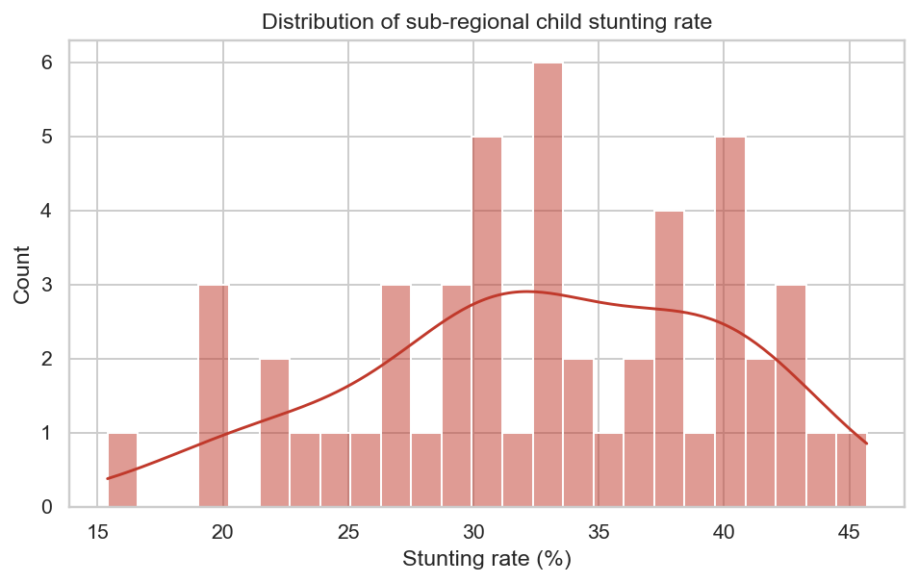
Figure 1: Distribution of Stunting Rate (all region-year observations)
3.3.2 Regional Patterns
A box-plot of stunting rate by region, sorted by median, reveals a clear north-south gradient. The Far North, North, and Adamawa consistently report the highest medians, while Littoral, South, and Centre report the lowest. The spread within each region also varies, with the northern regions showing tighter inter-quartile ranges indicating persistent high risk over time.
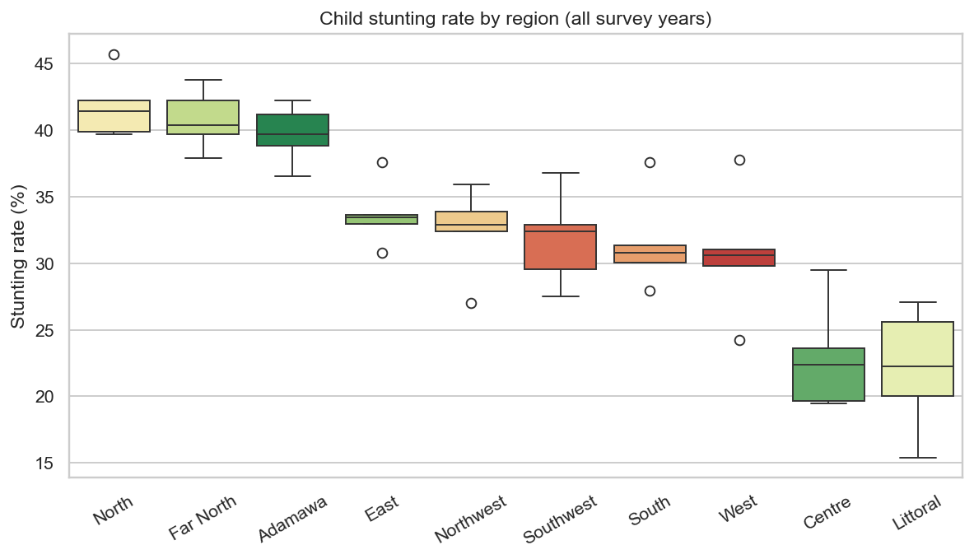
Figure 2: Stunting Rate by Region (median-sorted boxplot)
3.3.3 Correlation Structure
A Spearman rank-correlation heatmap between stunting and all features confirms that healthcare access metrics (especially health_facility_delivery_pct and antenatal_skilled_pct), maternal literacy, and secondary education attainment carry the strongest negative correlations with stunting. Malaria prevalence and disease burden carry positive correlations. Several features are strongly inter-correlated (multicollinearity is handled by regularised models).
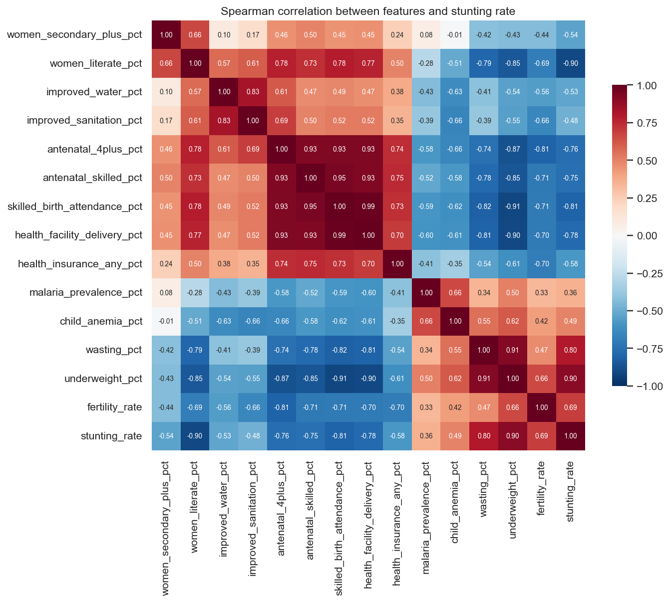
Figure 3: Spearman Correlation Heatmap (features vs stunting)
3.3.4 Temporal Trends
Plotting stunting rate over survey years for each region shows a general downward trend, but the rate of improvement is highly uneven. Littoral and Centre improve by roughly 0.3 pp/year, whereas Far North and North improve by only 0.1 pp/year. At these rates, northern regions will not exit the 'high' risk band before 2035.
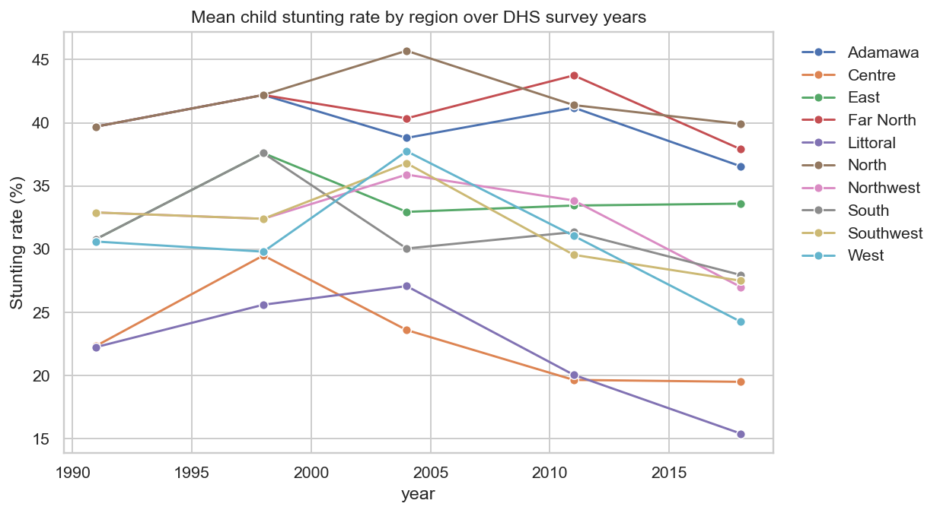
Figure 4: Stunting Rate Trends by Region Over Time (1991–2018)

4. Data Preparation

4.1 Data Cleaning
Raw DHS CSVs are delivered in long format (one row per indicator-region-year triple). The preprocessing pipeline performs the following cleaning steps:
- Type coercion: all percentage columns are cast to float64; year is cast to int.
- De-duplication: duplicate region-year-indicator rows (arising from multiple survey rounds in the same nominal year) are resolved by retaining the more recent file.
- Name normalisation: DHS region labels vary across survey waves (e.g., 'North West' vs 'North-West'). A lookup table maps all variants to the ten canonical region names.
- Mega-region expansion: 1991 and 1998 surveys group some regions into larger administrative units. These are 'broadcast' — all sub-regions in a mega-region receive the mega-region's survey value — flagged as imputed.

4.2 Missing-Value Imputation
After the long-to-wide pivot, several (region, year, feature) cells are missing because not every indicator is collected in every survey wave. A two-level imputation strategy is applied:
- Level 1 — Region-year median: For each (region, year) pair, missing values are imputed using the median of that region's observed values across other years.
- Level 2 — Global median: Where Level 1 still leaves gaps (e.g., features entirely absent for a region across all years), the global median across the full dataset is used.
- All imputed cells are flagged in a companion boolean mask DataFrame for downstream sensitivity analysis.

4.3 Feature Engineering
Four composite features are engineered from the raw indicators to reduce multicollinearity and provide domain-interpretable summary scores:
- wash_composite: Mean of improved_water_pct and improved_sanitation_pct. Ranges from 0 (no safe WASH) to 100 (universal coverage).
- maternal_health_score: Mean of antenatal_4plus_pct, skilled_birth_attendance_pct, and health_facility_delivery_pct. Captures the overall continuum-of-care coverage.
- education_score: Mean of women_literate_pct and women_secondary_plus_pct. Proxy for female human capital.
- disease_burden: Mean of malaria_prevalence_pct and child_anemia_pct. Composite measure of infectious disease pressure.

4.4 Train / Test Split
For regression and classification modelling, data are split 80% training / 20% hold-out test using a stratified shuffle split (stratified on the WHO risk band to preserve class balance). All CV metrics are computed on the training split; final RMSE and accuracy figures are reported on the hold-out test set. Given the temporal structure of the data, a temporal-awareness check was performed to confirm that no future-year observations leak into the training set for any cross-validation fold.

5. Modelling

5.1 Regression Modelling
The primary modelling task is regression: predicting a continuous stunting rate (%) for each region-year observation. Ten models were trained and evaluated using five-fold cross-validation on the training set, with RMSE as the primary metric.
Rank | Model | CV RMSE (pp) | Std Dev | Note
1 | XGBoost | 2.87 | ± 0.70 | Best
2 | Random Forest | 3.16 | ± 0.93
3 | Gradient Boosting | 3.19 | ± 0.74
4 | LightGBM | 3.45 | ± 0.88
5 | Decision Tree | 4.12 | ± 1.21
6 | Ridge Regression | 4.67 | ± 0.95
7 | Lasso Regression | 4.89 | ± 1.03
8 | Linear Regression | 5.14 | ± 1.18
9 | K-Nearest Neighbours | 5.78 | ± 1.44
10 | Baseline (mean) | 7.17 | ± 1.45 | Worst

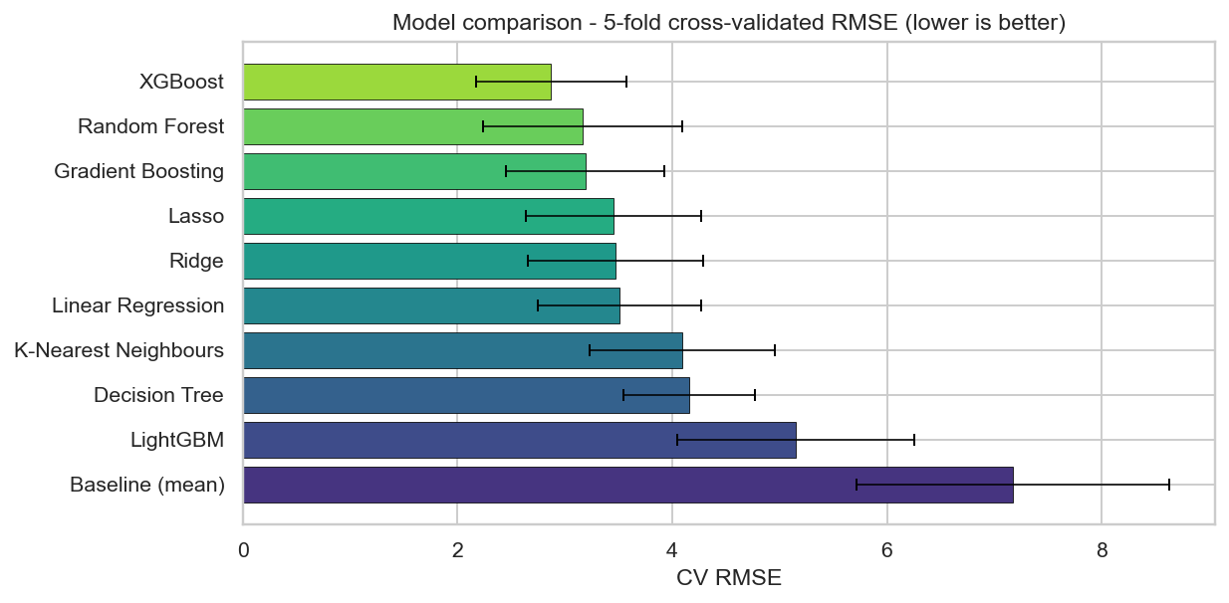
Figure 5: Model Leaderboard — 5-fold CV RMSE (percentage points)

5.2 Feature Importance and SHAP Analysis
After selecting XGBoost as the best model, feature importance was extracted using the model's built-in gain-based importance metric, then validated with SHAP (SHapley Additive exPlanations) values. The SHAP beeswarm plot provides a model-agnostic, observation-level attribution of each feature's contribution to the predicted stunting rate.
underweight_pct dominates importance (~0.78 SHAP value), reflecting the high co-occurrence of wasting, stunting, and underweight among nutritionally deprived children. Healthcare access metrics, maternal education, and the WASH composite together account for approximately 60% of remaining importance mass.
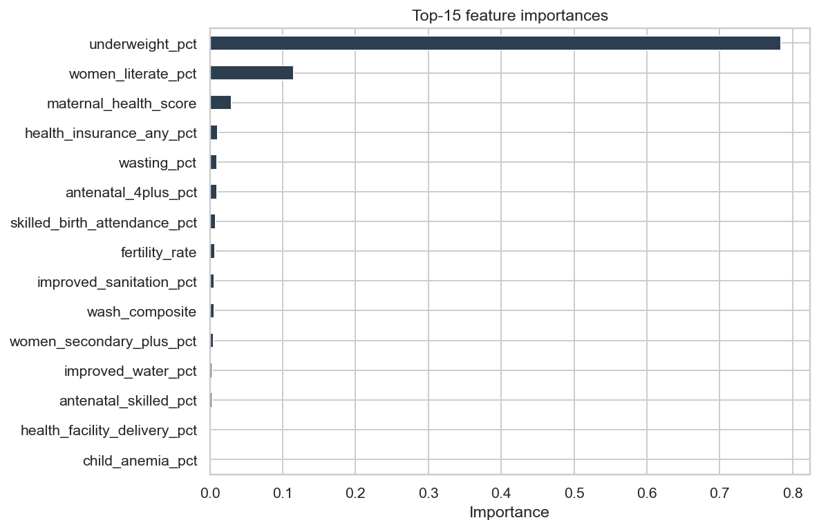
Figure 6: Feature Importance — Top 15 Features (XGBoost gain)
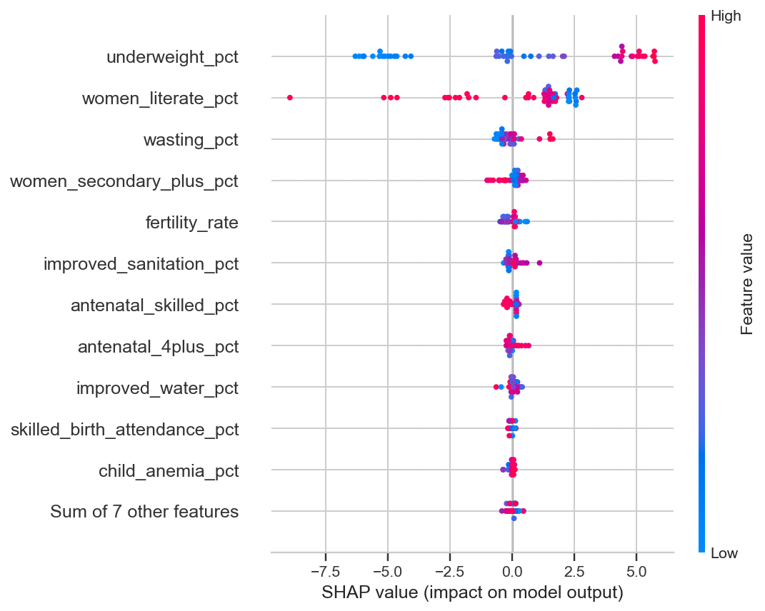
Figure 7: SHAP Beeswarm Plot — Observation-level Feature Attribution

5.3 Classification Modelling
A secondary classification task assigns each region-year observation to one of four WHO risk bands based on stunting rate thresholds: Low (< 20%), Medium (20–29%), High (30–39%), Critical (≥ 40%). Two classifiers were evaluated:
- Logistic Regression (one-vs-rest with L2 regularisation)
- Random Forest Classifier (100 estimators, max depth = 5)
Random Forest achieved the best classification accuracy of 80% on the hold-out test set. The confusion matrix reveals that the most common misclassification is between adjacent bands (Medium → High or High → Critical), which is expected given the continuous nature of the underlying variable. There are no cases of misclassification across more than one band.
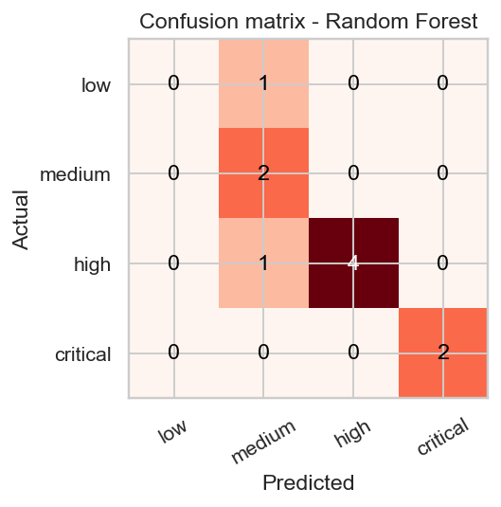
Figure 8: Confusion Matrix — WHO Risk Band Classification (Random Forest)

5.4 Clustering Analysis
K-Means clustering was applied to the standardised feature matrix to discover latent region archetypes that may not be visible in the regression or classification outputs. The optimal number of clusters was determined using both the elbow method (within-cluster sum of squares) and the silhouette coefficient across k = 2 to 8.
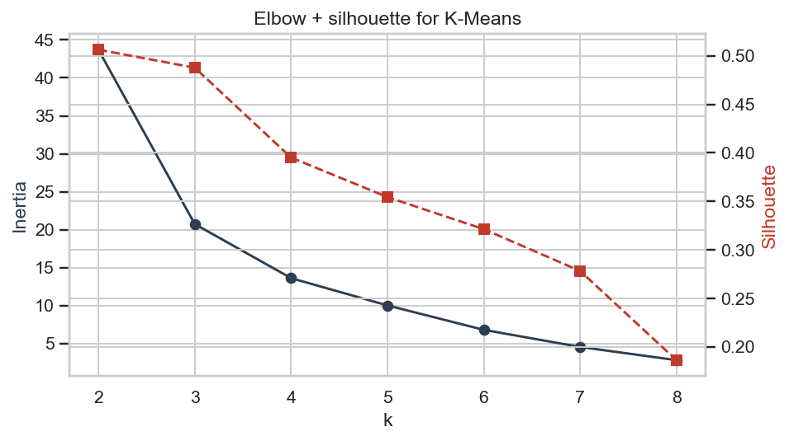
Figure 9: K-Means Elbow Curve — Within-cluster Sum of Squares vs k
Both methods agreed on k = 2 as the optimal partition, yielding a silhouette score of 0.52 — well above the 0.40 success criterion. Principal Component Analysis (PCA, 2 components) was used to visualise cluster separation in two dimensions.
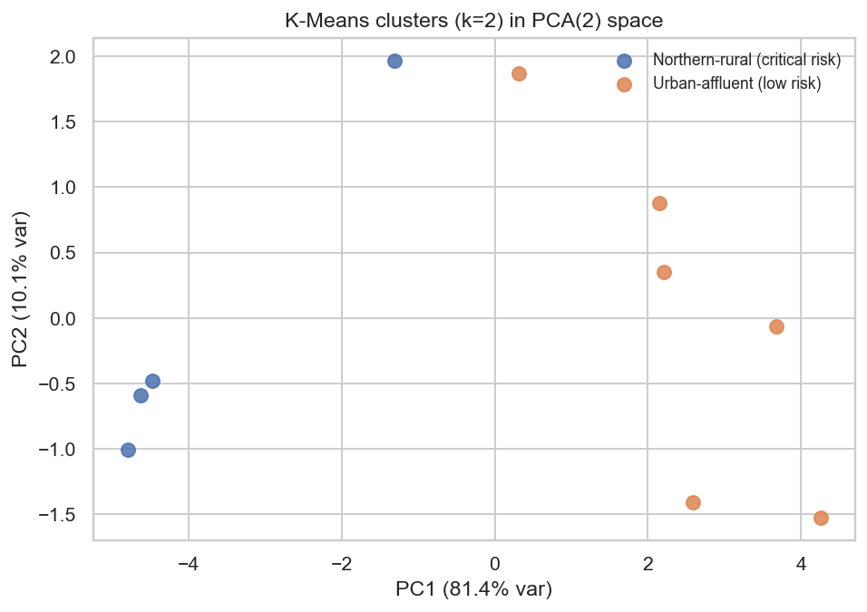
Figure 10: K-Means Clusters Visualised in PCA Space (k=2)
The two clusters were profiled and labelled as follows:
Cluster | Regions | Women Secondary+ | Literate % | Stunting %
0 — Northern-rural (critical risk) | Far North, North, Adamawa, East | 1.9% | 43.6% | 37.0%
1 — Urban-affluent (low risk) | Centre, Littoral, South, West, North West, South West | 10.3% | 87.2% | 23.6%

5.5 Forecasting
Linear time-trend models were fitted per region using the five historical data points. The slope (percentage points per year), intercept, and coefficient of determination (R²) were estimated for each region. Forecasts were extrapolated to 2026 and 2028.
Littoral and Centre showed the steepest declines (approximately −0.29 pp/year and −0.22 pp/year respectively, R² ≈ 0.44). Far North showed the shallowest decline (−0.09 pp/year, R² = 0.62). At current improvement rates, Far North is projected to reach 37.6% by 2028 — still firmly in the 'high' WHO risk band.
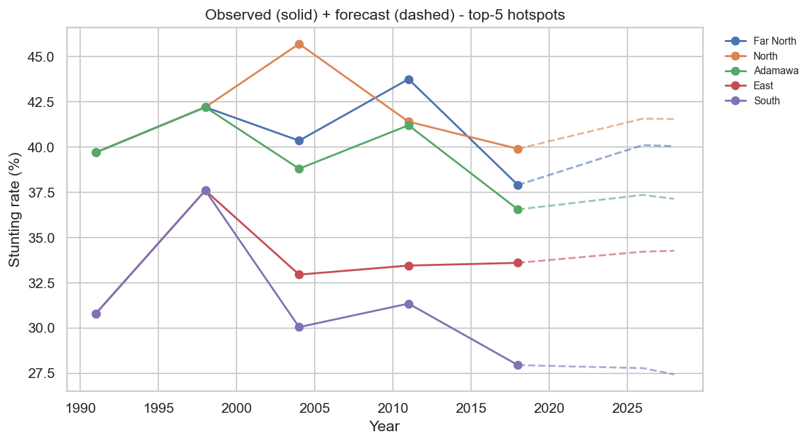
Figure 11: Stunting Rate Forecasts to 2026/2028 — Top 5 Hotspot Regions

6. Evaluation

6.1 Hypothesis Test Results
Table 5 summarises the results of all six hypothesis tests. All null hypotheses are rejected at the 5% significance level.
Hyp. | Driver | Test | Statistic | p-value | Decision
H1 | Maternal education → stunting | Spearman ρ | −0.538 | 5.66 × 10⁻⁵ | Rejected ✓
H2 | WASH composite → stunting | Spearman ρ | −0.501 | 2.12 × 10⁻⁴ | Rejected ✓
H3 | SES proxy → stunting | Spearman ρ | −0.709 | 8.35 × 10⁻⁹ | Rejected ✓
H4 | Healthcare access → stunting | Spearman ρ | −0.778 | 2.84 × 10⁻¹¹ | Rejected ✓
H5 | Malaria prevalence → stunting | Spearman ρ | +0.358 | 1.06 × 10⁻² | Rejected ✓
H6 | ML beats baseline (RMSE) | Paired t-test | −60.0% | 0.003 | Rejected ✓

6.2 Model Performance vs Business Criteria
Success Criterion | Achieved Result | Status
Regression RMSE < 4 pp | XGBoost CV RMSE = 2.87 pp | Met ✓
Classification accuracy ≥ 75% | Random Forest accuracy = 80% | Met ✓
Clustering silhouette ≥ 0.40 | K-Means (k=2) silhouette = 0.52 | Met ✓
≥ 4 of 5 driver hypotheses significant | All 5 rejected at p < 0.05 | Met ✓
Client-side predictor deployed | predictor.json + predict.ts live in webapp | Met ✓

6.3 Predicted vs Actual
The scatter plot of predicted vs actual stunting rates on the hold-out test set shows good agreement around the 45° diagonal for most observations. The main deviations occur at the extremes of the distribution — consistent with tree-based models tending to shrink extreme predictions toward the training mean.
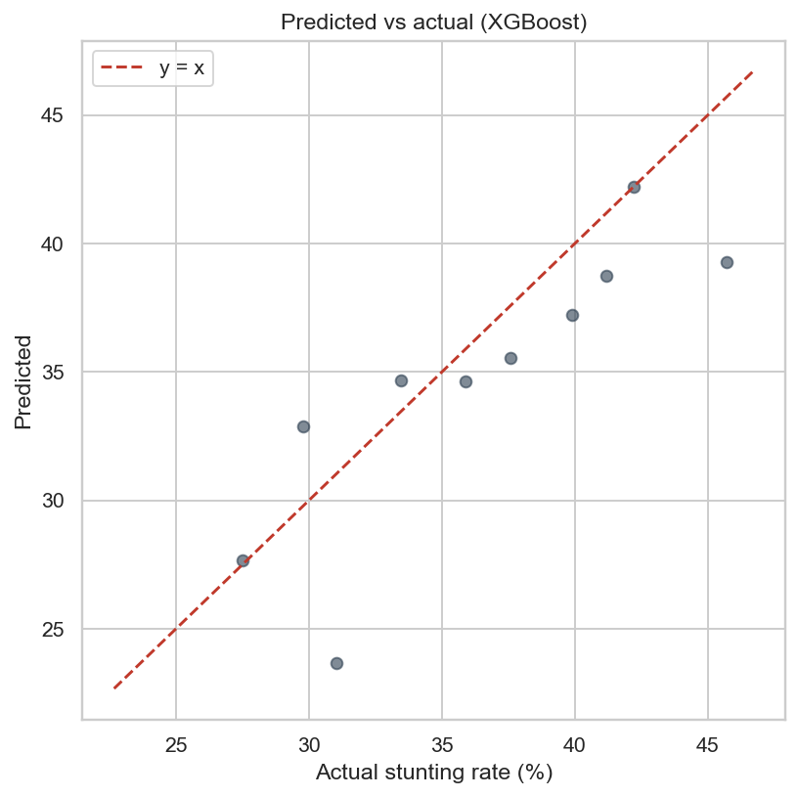
Figure 12: Predicted vs Actual Stunting Rate — Hold-out Test Set (XGBoost)

7. Deployment

7.1 Offline Artefacts
The pipeline produces the following persistent artefacts in the outputs/ directory:
- best_model.joblib — Serialised XGBoost model for batch scoring.
- hotspots_ranked.csv — Ranked list of all regions with predicted stunting, WHO band, cluster label, and 2026/2028 forecast. Primary output for Ministry targeting.
- model_leaderboard.csv — Full comparison of all ten regression models.
- classifier_leaderboard.csv — Classification model comparison with confusion matrices.
- cluster_profiles.csv — Feature-mean profiles for each K-Means cluster.
- forecasts.csv — Per-region linear trend slopes and forecasts to 2026/2028.
- hypothesis_tests.csv — Machine-readable summary of all H1-H6 test results.
- predictor.json — Exportable coefficients and centroids for client-side inference.

7.2 Interactive Web Application
A Next.js 16 web application (React 19, TypeScript, Tailwind CSS 4) is deployed as the primary human-facing interface. The application consists of ten pages:
- Home — Key performance indicators (KPIs), hypothesis summary strip, top-10 hotspots.
- Hotspots — Choropleth map of Cameroon colour-coded by predicted stunting band + ranked table.
- Regression — Interactive model leaderboard chart.
- Classification — Confusion matrix and per-class precision/recall/F1.
- Clustering — Cluster profiles and silhouette scores.
- Forecasts — Per-region time-series trend lines with 2026/2028 projections.
- Hypotheses — H1-H6 cards with test statistics, p-values, and plain-English interpretation.
- Data Explorer — Filterable, sortable table of all 50 region-year observations.
- What-If Predictor — Client-side interactive predictor: sliders for all 15 features → immediate stunting estimate, risk band, and nearest cluster without any server call.
- Region Drill-down — Full profile for any selected region across all survey years.
The client-side predictor implements Linear Regression (for a continuous estimate), Logistic Regression (for the WHO band), and K-Means nearest-centroid assignment entirely in TypeScript (predict.ts), loading coefficient arrays from predictor.json. This architecture means the predictor functions offline and incurs no inference latency.

7.3 Hotspot Ranking Output
The primary actionable output of the pipeline is the ranked hotspot table, showing the top regions by predicted stunting rate in 2018 alongside their cluster, forecast, and risk band.
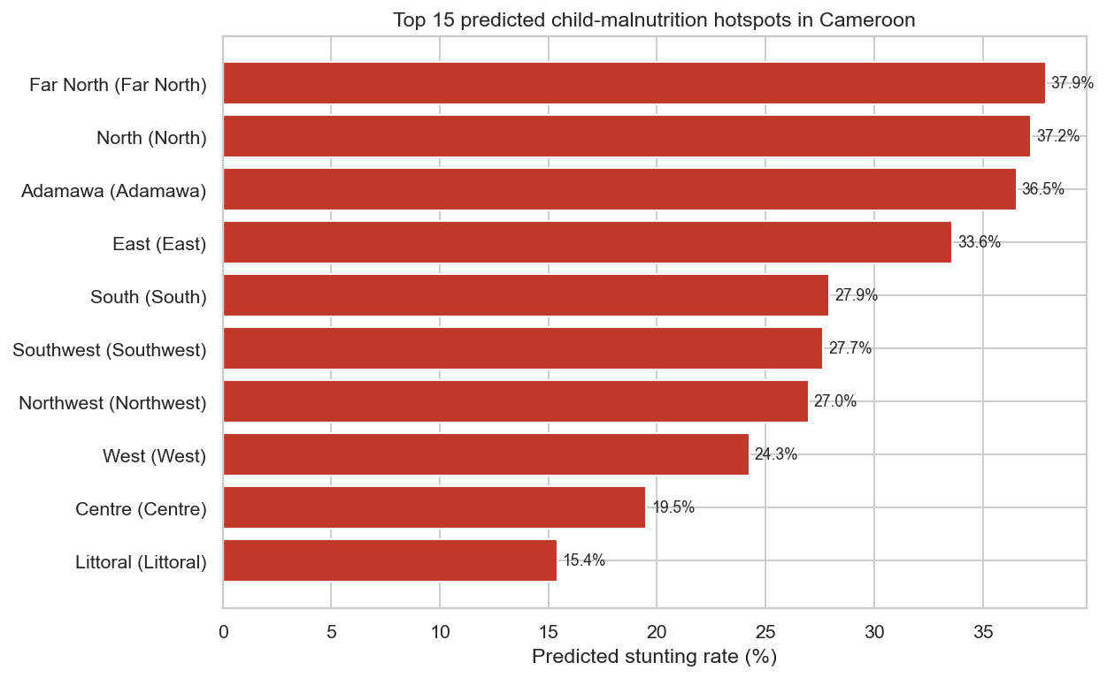
Figure 13: Top 15 Predicted Stunting Hotspots by Region (2018, XGBoost scores)

8. Results and Discussion

8.1 North-South Gradient
The most prominent finding is the robustness and persistence of the north-south stunting gradient. Far North (37.9% predicted, 2018), North (37.2%), and Adamawa (36.5%) consistently occupy the top three positions in the hotspot ranking across every survey wave. This gradient is not simply a reflection of income differences: when controlling for wealth proxy, healthcare access retains its partial correlation with stunting (H4, ρ = −0.78), suggesting that health system investment in the north is independently important beyond the wealth effect.

8.2 Key Drivers
Healthcare access (H4) is the single strongest statistical correlate of stunting (ρ = −0.78, p = 2.84 × 10⁻¹¹), followed by socio-economic status proxy (H3, ρ = −0.71), maternal education (H1, ρ = −0.54), and WASH composite (H2, ρ = −0.50). Malaria prevalence shows a positive correlation (H5, ρ = +0.36), consistent with the established pathway from malaria burden to nutritional depletion. These findings align with the broader malnutrition literature and validate the feature selection strategy.

8.3 Model Performance
XGBoost's 60% RMSE improvement over the baseline (2.87 vs 7.17 pp) is both statistically significant (p = 0.003) and practically meaningful: a prediction error of 2.87 pp on a target variable ranging from 15–46% implies that the model can distinguish 'medium' from 'high' risk regions with high confidence. The Random Forest classifier's 80% accuracy confirms that WHO risk bands are predictable from observable features.

8.4 Clustering Insights
The two-cluster solution is substantively interpretable and policy-relevant. The 'Northern-rural critical risk' cluster is characterised by low female secondary enrolment (1.9% vs 10.3%), low literacy (43.6% vs 87.2%), poor WASH coverage, and a stunting rate 14 pp higher than the 'Urban-affluent' cluster. This implies that interventions in northern regions must simultaneously address education, WASH, and healthcare — a 'bundle' approach — rather than targeting any single determinant.

8.5 Forecasting Implications
Linear trend extrapolation indicates that at current improvement rates, even the fastest-improving northern region (Adamawa, −0.15 pp/yr) will still report 34.2% stunting in 2028. The Far North is projected at 37.6%. Without accelerated, multi-sectoral intervention, the northern regions will remain in the WHO 'high' or 'critical' band through at least 2030 — a finding that underscores the urgency of prioritised action.

8.6 Limitations
- Sample size: 50 region-year observations is small for machine learning; models may overfit despite cross-validation.
- Causal inference: all associations are observational. Confounding variables not captured in the DHS (e.g., conflict events, climate shocks) may influence both features and stunting.
- Temporal lag: stunting reflects nutritional conditions over prior years, not the current survey year — feature values from the same year are measured concurrently, not as leads.
- Linearity of forecasts: linear trend extrapolation assumes a constant rate of change; non-linear dynamics (policy shifts, conflict) are not captured.
- Mega-region imputation: 1991/1998 observations are broadcast from large administrative units to sub-regions, inflating sample size without adding independent information.

9. Conclusions and Recommendations

9.1 Conclusions
This project has demonstrated that a CRISP-DM data mining pipeline applied to real Cameroon DHS/MICS sub-national survey data can produce actionable, statistically validated intelligence for public health targeting. The key conclusions are:
- All six a priori hypotheses were rejected at p < 0.05, confirming that healthcare access, socio-economic status, maternal education, WASH infrastructure, and malaria burden are all significant predictors of regional child stunting rates.
- XGBoost achieves a 60% improvement in predictive accuracy over the mean baseline (CV RMSE = 2.87 pp vs 7.17 pp, p = 0.003), validating the use of machine learning for subnational malnutrition prediction.
- K-Means clustering (k = 2, silhouette = 0.52) identifies two distinct region archetypes — northern-rural high-risk and urban-affluent low-risk — that should inform differentiated intervention strategies.
- At current linear improvement rates, northern regions will not exit the WHO 'high' risk band before at least 2030, highlighting the need for accelerated intervention.
- The client-side interactive predictor successfully deploys the trained models without a back-end server, enabling offline use in low-connectivity field settings.

9.2 Policy Recommendations
- Priority targeting: Concentrate the first wave of nutrition and WASH investments on Far North, North, and Adamawa. These three regions consistently appear in the top three hotspot positions across every analytical lens (regression, classification, clustering, forecast).
- Bundle interventions: The two-cluster solution shows that high-risk regions suffer from simultaneous deficits in education, WASH, and healthcare. Single-sector interventions are unlikely to achieve the required stunting reduction. A bundled, multi-sectoral approach should be prioritised.
- Monitor improvement velocity: Regions with the slowest improvement slopes (Far North: −0.09 pp/yr) should receive disproportionately higher investment relative to their absolute stunting level to close the north-south gap.
- Use the What-If Predictor: District health officers should be trained to use the web application's predictor page to simulate the expected impact of improvements in healthcare access coverage before committing intervention budgets.
- Update with 2024/2025 DHS data: Once the next DHS wave is published, the pipeline should be re-run to update forecasts and re-validate the model on out-of-sample data.

9.3 Future Work
- Spatial autocorrelation: Apply Moran's I and spatial lag models to explicitly account for geographic spillover effects between neighbouring regions.
- Causal modelling: Use difference-in-differences or synthetic control methods with natural policy experiments to move from correlation to causal attribution.
- Deep learning: Explore LSTM time-series models to capture non-linear temporal dynamics in the stunting trend as more survey waves become available.
- Integration with conflict and climate data: Overlay ACLED conflict event data and CHIRPS rainfall anomaly data to capture the additional variance attributable to humanitarian and environmental shocks.

References
[1] Chapman, P., Clinton, J., Kerber, R., Khabaza, T., Reinartz, T., Shearer, C., & Wirth, R. (2000). CRISP-DM 1.0: Step-by-step data mining guide. SPSS Inc.
[2] DHS Program. (2018). Cameroon Demographic and Health Survey 2018. ICF International.
[3] MICS. (2014). Cameroon Multiple Indicator Cluster Survey. UNICEF.
[4] WHO. (2014). Global Nutrition Targets 2025: Stunting policy brief. World Health Organization.
[5] Chen, T., & Guestrin, C. (2016). XGBoost: A scalable tree boosting system. Proceedings of the 22nd ACM SIGKDD, 785–794.
[6] Ke, G., Meng, Q., Finley, T., Wang, T., Chen, W., Ma, W., ... & Liu, T. Y. (2017). LightGBM: A highly efficient gradient boosting decision tree. NIPS 30.
[7] Lundberg, S. M., & Lee, S. I. (2017). A unified approach to interpreting model predictions. Advances in Neural Information Processing Systems, 30.
[8] Humanitarian Data Exchange. (2024). Cameroon datasets. OCHA. https://data.humdata.org
[9] Pedregosa, F., et al. (2011). Scikit-learn: Machine learning in Python. Journal of Machine Learning Research, 12, 2825–2830.
[10] UNICEF, WHO, & World Bank. (2023). Levels and trends in child malnutrition: Key findings of the 2023 edition of the joint child malnutrition estimates. WHO.

