REPUBLIC OF CAMEROON  Peace – Work – Fatherland  UNIVERSITY OF BUEA  COLLEGE OF TECHNOLOGY  DEPARTMENT OF COMPUTER ENGINEERING | RÉPUBLIQUE DU CAMEROUN  Paix – Travail – Patrie  UNIVERSITÉ DE BUEA  COLLÈGE DE TECHNOLOGIE  DÉPARTEMENT DE GÉNIE INFORMATIQUE


DESIGN AND IMPLEMENTATION OF SKILLMAP: A WEB-BASED SKILL-GAP ANALYSIS AND CAREER ROADMAP SYSTEM USING DATA MINING
A Web-Based Skill-Gap Analysis & Career Roadmap System for Junior Developers
A Project Report submitted to the Department of Computer Engineering of the College of Technology of the University of Buea in Fulfilment of the Requirements of the Course CEC 420
PRESENTED BY:
ASHU HENRY ENYO - CT23A022
DEPARTMENT OF COMPUTER ENGINEERING
COURSE CODE: CEC 418
2025/2026 Academic Year
Certification
This is to certify that this project entitled “Design and Implementation of SkillMap: A Web-Based Skill-Gap Analysis and Career Roadmap System Using Data Mining” has been carried out by Ashu Henry Enyo(CT23A022) and submitted to the Department of Computer Engineering of the College of Technology of the University of Buea in partial fulfilment of the requirements of the course CEC 420.
Attestation
I hereby declare that this project, entitled “Design and Implementation of SkillMap: A Web-Based Skill-Gap Analysis and Career Roadmap System Using Data Mining”, is the result of my own original work carried out as part of the course CEC 420. To the best of my knowledge, it contains no material previously published or written by another person except where due acknowledgement and reference have been made.
Abstract
Junior software developers, particularly in emerging African technology ecosystems, frequently struggle to decide which skill to learn next. Career advice is often generic, anecdotal, and disconnected from the real demand expressed in the job market. This project presents the design and implementation of SkillMap, a web-based system that mines real job-market data and transforms it into a personalized, ranked, and evidence-backed skill-gap roadmap. A user enters the technologies they can already work with, and SkillMap returns the highest-impact skills to learn next, each justified with concrete demand and salary evidence.
SkillMap is built as a two-tier web application: a Next.js (TypeScript) mobile-first dashboard and a FastAPI (Python) backend, backed by a relational database (SQLite for development, PostgreSQL for production). The backend implements a complete data pipeline: a source-agnostic ingestion layer pulls job listings from a committed seed corpus and pluggable live feeds; an Extract-Transform-Load (ETL) stage cleans the data, normalizes locations and salaries, and extracts skills using an alias-aware dictionary of over one hundred entries; and a mining engine runs four independent jobs — Apriori association-rule mining, K-Means archetype clustering, a Random-Forest demand classifier, and time-series demand snapshots. A recommendation engine then combines association rules, the closest job archetype, and market demand to rank missing skills and explain each suggestion.
The system was developed following an iterative, Agile methodology and validated through a layered testing strategy. The backend is covered by an automated suite of ninety-two unit and integration tests executed in continuous integration, alongside system-level verification of every functional requirement. All test cases passed, and the non-functional requirements for performance, usability, reliability, portability, and maintainability were satisfied. The results demonstrate that an accessible, low-cost, data-driven career-guidance tool can be built end-to-end using open-source technologies.
Keywords: Skill-gap analysis, Data mining, Association rules, K-Means clustering, Job-market intelligence, Recommendation system, Web application, FastAPI, Next.js.
List of Abbreviations
Abbreviation | Meaning
API | Application Programming Interface
ARM | Association Rule Mining
CI/CD | Continuous Integration / Continuous Delivery
COT | College of Technology
CORS | Cross-Origin Resource Sharing
CSV | Comma-Separated Values
DB | Database
ERD | Entity-Relationship Diagram
ETL | Extract, Transform, Load
FR | Functional Requirement
HTML | HyperText Markup Language
HTTP(S) | HyperText Transfer Protocol (Secure)
JSON | JavaScript Object Notation
ML | Machine Learning
NFR | Non-Functional Requirement
NLP | Natural Language Processing
ORM | Object-Relational Mapping
REST | Representational State Transfer
RF | Random Forest
SQL | Structured Query Language
TC | Test Case
UB | University of Buea
UI / UX | User Interface / User Experience
URL | Uniform Resource Locator
UUID | Universally Unique Identifier
List of Figures
Figure | Title
Figure 4.1 | Home (landing) screen
Figure 4.2 | Skills input screen
Figure 4.3 | Personalized roadmap screen
Figure 4.4 | Skill demand-trend screen
Figure 4.5 | Market overview screen
Figure 4.6 | Continuous-integration pipeline run
List of Tables
Table | Title
Table 1.1 | Definition of key terms
Table 3.1 | Software requirements
Table 3.2 | Functional requirements
Table 3.3 | Non-functional requirements
Table 3.4 | Skill-dictionary categories
Table 3.5 | Principal API endpoints
Table 4.1 | Unit test cases and results
Table 4.2 | Integration test cases and results
Table 4.3 | System test (functional-requirement verification)
Table of Contents
CHAPTER ONE: GENERAL INTRODUCTION 10
1.1 Introduction 10
1.2 Background of the Study 10
1.3 Statement of the Problem 10
1.4 Objectives of the Study 11
1.4.1 General Objective 11
1.4.2 Specific Objectives 11
1.5 Significance of the Study 11
1.6 Scope of the Study 11
1.7 Definition of Key Terms 12
1.8 Organisation of the Study 12
CHAPTER TWO: LITERATURE REVIEW 13
2.1 Introduction 13
2.2 Review of Related Concepts 13
2.2.1 Job-Market Intelligence 13
2.2.2 Data Mining 13
2.2.3 Association-Rule Mining and the Apriori Algorithm 13
2.2.4 Clustering and the K-Means Algorithm 13
2.2.5 Classification and Random Forests 14
2.2.6 Skill Extraction and Text Normalization 14
2.2.7 Web Applications and REST APIs 14
2.3 Review of Existing Systems 14
2.3.1 LinkedIn (Skills & Jobs) 14
2.3.2 Stack Overflow Developer Survey 14
2.3.3 Coursera / Online Learning Platforms 14
2.3.4 Adzuna / Job Aggregators 14
2.4 Proposed Solution 15
CHAPTER THREE: MATERIALS AND METHODS 16
3.1 Introduction 16
3.2 Development Methodology 16
3.3 Methods Used 16
3.3.1 System Analysis 16
3.3.2 Materials (Hardware and Software Requirements) 18
3.4 System Design 18
3.4.1 System Architecture 18
3.4.2 Data Model and Database Design 18
3.4.3 Algorithm Design 19
3.4.4 Skill Dictionary and API Design 19
CHAPTER FOUR: IMPLEMENTATION, RESULTS AND TESTING 21
4.1 Introduction 21
4.2 Implementation 21
4.2.1 Ingestion Layer 21
4.2.2 ETL Pipeline 21
4.2.3 Mining Engine 21
4.2.4 Recommendation Engine 21
4.2.5 REST API 22
4.2.6 Dashboard (Frontend) 22
4.2.7 Automation and Deployment 22
4.3 System Testing 23
4.3.1 Unit Testing 23
4.3.2 Integration Testing 23
4.3.3 System Testing 24
4.3.4 Non-Functional Verification 24
CHAPTER FIVE: CONCLUSIONS AND RECOMMENDATIONS 25
5.1 Conclusions 25
5.2 Limitations 25
5.3 Perspectives for Further Study 25
REFERENCES 26

CHAPTER ONE: GENERAL INTRODUCTION

1.1 Introduction
The modern software industry evolves at a pace that makes continuous learning a professional necessity rather than an option. New languages, frameworks, cloud platforms, and tools emerge constantly, and the value of any given skill rises and falls with market demand. For a junior developer, the central question is rarely “should I keep learning?” but rather “what exactly should I learn next so that my effort translates into employability?”
SkillMap is a web-based system that answers this question with evidence rather than opinion. It collects real job-listing data, analyses it with established data-mining techniques, and produces a personalized, ranked roadmap of the skills a user should acquire next — each recommendation accompanied by a concrete justification drawn from the data, such as how often the skill co-occurs with skills the user already has, how strongly it is in demand, and what salary impact it carries.

1.2 Background of the Study
Career guidance for software developers is traditionally delivered through mentorship, blog posts, “roadmap” infographics, and annual developer surveys. While useful, these sources share three weaknesses: they are generic (the same advice for everyone), they age quickly (a roadmap published a year ago may already be stale), and they are rarely localized to a specific regional job market.
Meanwhile, the raw material for better guidance already exists in abundance: thousands of public job listings describe exactly which skills employers are paying for, where, and how they cluster together. Data-mining techniques such as association-rule mining and clustering are well suited to turning this unstructured, high-volume text into structured, actionable insight. SkillMap was conceived to bridge this gap — to put the analytical power normally reserved for large recruitment platforms into a free, lightweight tool aimed at junior African developers.

1.3 Statement of the Problem
Junior developers lack an objective, data-driven, and personalized way to prioritize what to learn next. Existing resources are generic and quickly outdated; large job platforms that do possess the underlying analytics expose them, if at all, only to recruiters and behind paywalls, and rarely reflect regional demand or local salary realities.
The specific problems this project addresses are:
- Career recommendations are not personalized to an individual’s existing skill set.
- Recommendations are seldom backed by transparent, verifiable evidence.
- Salary expectations are usually presented in foreign currencies with no regional context.
- Insight into how demand for a skill is trending over time is largely inaccessible to learners.

1.4 Objectives of the Study

1.4.1 General Objective
To design and implement a web-based system that mines real job-market data and produces a personalized, ranked, and evidence-backed skill-gap roadmap for junior software developers.

1.4.2 Specific Objectives
- To build a source-agnostic ingestion layer capable of collecting job listings from a committed seed corpus and from pluggable live feeds.
- To implement an ETL pipeline that cleans listings, normalizes locations and salaries, and extracts skills using an alias-aware skill dictionary.
- To mine association rules (Apriori) and job archetypes (K-Means) from the cleaned data, and to classify and track skill demand over time.
- To design a recommendation engine that ranks missing skills and explains each recommendation with concrete evidence.
- To deliver a mobile-first dashboard that presents the roadmap, demand trends, and a market overview.
- To validate the system through unit, integration, and system testing within a continuous-integration workflow.

1.5 Significance of the Study
For learners, SkillMap converts the overwhelming question of “what next?” into a short, prioritized, and justified list, reducing wasted study effort. For the broader ecosystem, it demonstrates that job-market intelligence can be made free, transparent, and locally relevant. Academically, it provides a concrete, end-to-end case study in applying association-rule mining, clustering, and classification to a real text-mining problem, integrated into a production-grade web application with automated testing and deployment.

1.6 Scope of the Study
This project covers the complete design and implementation of the SkillMap platform: data ingestion, ETL, the four mining jobs, the recommendation engine, a six-endpoint REST API, a five-screen dashboard, automated testing, and deployment configuration.
The following are explicitly outside the scope of this first version (V1): user authentication and accounts; any payment functionality; a native mobile application; and the training of large language models. The system instead uses a lightweight, anonymous profile identified by a client-generated identifier, and relies on classical, interpretable data-mining methods.

1.7 Definition of Key Terms
Table 1.1: Definition of key terms
Term | Meaning in this project
Skill | A canonical technology or competency (e.g. Python, React, Docker) matched in text via aliases.
Listing | A single job advertisement ingested from a source and normalized into the internal schema.
Skill-gap | The set of in-demand skills relevant to a user that the user does not yet have.
Association rule | A pattern of the form {A, B} ⇒ C meaning skills A and B tend to co-occur with skill C.
Archetype | A cluster of similar job listings, summarized by its most representative skills.
Demand class | A skill’s classified market status: high-demand, stable, or declining.
Roadmap | The final ranked list of recommended skills returned to the user.

1.8 Organization of the Study
This report is organized into five chapters. Chapter One introduces the project, its problem, objectives, significance, and scope. Chapter Two reviews related concepts and existing systems and presents the proposed solution. Chapter Three describes the materials and methods, including the development methodology, system analysis, and system design. Chapter Four presents the implementation, results, and testing. Chapter Five concludes the work, discusses its limitations, and proposes perspectives for further study.

CHAPTER TWO: LITERATURE REVIEW

2.1 Introduction
This chapter reviews the concepts and technologies underpinning SkillMap and surveys existing systems that address adjacent problems. It then positions the proposed solution relative to those systems.

2.2 Review of Related Concepts

2.2.1 Job-Market Intelligence
Job-market intelligence is the practice of extracting structured, decision-useful insight from labour-market data such as job advertisements. Because listings are written in free-form natural language, deriving insight requires text processing to identify entities (here, skills) followed by statistical analysis of how those entities behave across the corpus.

2.2.2 Data Mining
Data mining is the process of discovering patterns and relationships in large datasets. The three families of techniques used in this project are association-rule mining (finding items that co-occur), clustering (grouping similar records), and classification (assigning records to predefined categories).

2.2.3 Association-Rule Mining and the Apriori Algorithm
Association-rule mining discovers rules of the form {antecedent} ⇒ {consequent}. Each rule is characterized by three measures: support (how frequently the items appear together), confidence (how often the consequent appears when the antecedent does), and lift (how much more likely the consequent is given the antecedent, relative to chance). The Apriori algorithm efficiently mines such rules by exploiting the property that any subset of a frequent itemset is itself frequent. In SkillMap, each listing’s skill set is treated as a transaction, and rules such as {React} ⇒ TypeScript are mined to power evidence-backed recommendations.

2.2.4 Clustering and the K-Means Algorithm
Clustering partitions records into groups whose members are more similar to one another than to members of other groups. K-Means is a widely used centroid-based algorithm that assigns each record to the nearest of k cluster centres and iteratively refines those centres. SkillMap represents each listing as a binary vector over the skill vocabulary, clusters the vectors, and labels each resulting cluster by its most representative skills, producing interpretable “job archetypes”. The number of clusters k is selected automatically using the silhouette score.

2.2.5 Classification and Random Forests
Classification assigns records to discrete categories based on learned patterns. A Random Forest is an ensemble of decision trees whose individual predictions are aggregated, giving robust performance and resistance to over-fitting. SkillMap uses a Random Forest to classify each skill as high-demand, stable, or declining from engineered time-series features (trend, recent count, total count, and average salary).

2.2.6 Skill Extraction and Text Normalization
Extracting skills from descriptions is complicated by aliases (“python3”, “py” → Python) and by tokens that defeat naive word-boundary matching (“C++”, “C#”, “Node.js”). SkillMap addresses this with a curated dictionary of canonical names and aliases and a punctuation-safe matcher that tries the longest aliases first.

2.2.7 Web Applications and REST APIs
A modern web application typically separates a client (the user interface) from a server exposing a REST API over HTTP. This separation allows the interface and the analytical backend to evolve and scale independently, and is the architecture adopted by SkillMap.

2.3 Review of Existing Systems

2.3.1 LinkedIn (Skills & Jobs)
LinkedIn possesses extensive data on skills and demand and offers skill assessments and job recommendations. However, its analytics are oriented toward recruiters and premium subscribers, are not transparent about the evidence behind suggestions, and actively prohibit data scraping.

2.3.2 Stack Overflow Developer Survey
The annual Stack Overflow survey provides authoritative, aggregate insight into popular and well-paid technologies. It is, however, a yearly static snapshot, not personalized to an individual, and not localized to a specific regional market.

2.3.3 Coursera / Online Learning Platforms
Learning platforms recommend courses and sometimes “skill paths”, but their recommendations are optimized to drive course enrolment rather than to reflect independent, market-wide demand, and they rarely expose salary or demand evidence.

2.3.4 Adzuna / Job Aggregators
Aggregators such as Adzuna expose job listings and some salary statistics through public APIs and are an excellent data source. They are not, however, personal skill-roadmap tools: they help a user find a job today, not decide which skill to learn to qualify for better jobs tomorrow.

2.4 Proposed Solution
SkillMap synthesizes the strengths of the systems above while filling their gaps. Like the aggregators, it draws on real listings; like the developer survey, it surfaces demand and salary signal; but unlike all of them, it is personalized to the individual’s current skills, transparent about the evidence behind every recommendation, localized to a chosen region’s salary reality, and free of cost and sign-up.
Concretely, the proposed system ingests listings from compliant sources, extracts skills, mines association rules and archetypes, classifies and tracks demand, and combines these signals in a recommendation engine that ranks and explains the next best skills to learn — all delivered through a mobile-first dashboard.

CHAPTER THREE: MATERIALS AND METHODS

3.1 Introduction
This chapter presents the methodology adopted for the development of SkillMap and the methods used in analyzing and designing the system. It covers the development life cycle, the requirements (functional and non-functional), the hardware and software materials, and the detailed system design including architecture, data model, algorithms, and interface design.

3.2 Development Methodology
An iterative, Agile methodology was adopted. Rather than building the entire system in a single pass, the work was divided into six incremental phases, each producing a working, testable increment. This approach suited a project whose later stages (mining, recommendations) depended on the correctness of earlier ones (ingestion, ETL), and allowed continuous testing throughout.
The six phases were:
- Foundations — repository scaffold, database schema, seed data, and a minimal API and UI skeleton.
- Data pipeline — the ingestion interface, source adapters, and the full ETL with skill extraction.
- Mining engine — Apriori rules, K-Means archetypes, the demand classifier, and trend snapshots.
- API and recommendations — the recommendation engine and six validated REST endpoints.
- Dashboard — the five mobile-first screens with demand-trend charts.
- Automation and deployment — the scheduled refresh job, continuous integration, and deployment configuration.

3.3 Methods Used

3.3.1 System Analysis
System analysis established what the system must do (functional requirements) and the qualities it must exhibit (non-functional requirements), along with the actors that interact with it.
Actors. The system has two actors. The Learner (end user) enters their skills and consumes the roadmap, trends, and market overview. The Scheduler (an automated cron actor) periodically triggers ingestion and mining to keep the data current. No administrator or authenticated user exists in V1.
Functional requirements. The functional requirements are summarized in Table 3.2.
Table 3.2: Functional requirements
ID | Functional requirement
FR1 | The system shall accept a set of current skills and resolve them against the canonical dictionary (alias-aware), flagging unrecognized inputs.
FR2 | The system shall ingest job listings from a committed seed corpus and from pluggable live sources behind a shared adapter interface.
FR3 | The system shall clean listings (strip HTML, normalize whitespace), normalize locations and salaries, and extract skills from text.
FR4 | The system shall mine association rules between skills (support, confidence, lift) using the Apriori algorithm.
FR5 | The system shall cluster listings into job archetypes using K-Means with an automatically selected number of clusters.
FR6 | The system shall classify each skill’s demand (high-demand / stable / declining) and record demand snapshots over time.
FR7 | The system shall return a ranked list of recommended skills, each with a human-readable reason and supporting metrics.
FR8 | The system shall localize salary figures to a user-selected region’s currency, using a regional median where enough data exists.
FR9 | The system shall present a market overview and per-skill demand-trend visualizations through the dashboard.
Non-functional requirements. The non-functional requirements are summarized in Table 3.3.
Table 3.3: Non-functional requirements
Quality | Requirement
Performance | API responses for recommendations and stats shall be returned in well under one second on the seed corpus.
Usability | The dashboard shall be mobile-first, require no sign-up, and present every recommendation with a plain-language reason.
Reliability | A single malformed listing or a single failed source shall not abort an ETL or mining run; the cron shall exit non-zero on failure for monitoring.
Portability | The same code shall run on SQLite (development) and PostgreSQL (production) by changing one configuration value.
Maintainability | The backend shall be fully typed, linted, and covered by an automated test suite executed in continuous integration.
Security & Compliance | No secrets shall be hard-coded; cross-origin access shall be restricted via CORS; data sources shall respect their terms of service.

3.3.2 Materials (Hardware and Software Requirements)
SkillMap was developed and runs on a standard modern personal computer; a dual-core processor, 4 GB of RAM (8 GB recommended when running the mining jobs), and about 1 GB of free disk space are sufficient. An internet connection is required only to fetch live data sources and to deploy. The software stack used is summarized in Table 3.1.
Table 3.1: Software requirements
Category | Technology
Frontend | Next.js 14 (App Router), TypeScript (strict), Tailwind CSS, Chart.js
Backend | Python 3.11+, FastAPI, Pydantic v2, SQLAlchemy 2, Uvicorn
Data mining | scikit-learn, efficient-apriori, pandas, NumPy
Database | SQLite (development), PostgreSQL / Supabase (production)
Tooling & DevOps | Git/GitHub, GitHub Actions, ruff, pytest, Docker (optional), Vercel, Railway/Render

3.4 System Design

3.4.1 System Architecture
SkillMap follows a layered, two-tier client/server architecture. The presentation tier is a Next.js dashboard running in the browser. The application tier is a FastAPI service exposing a REST API; behind it sit the recommendation engine and the offline data pipeline (ingestion, ETL, and mining). The data tier is a relational database accessed through an ORM. A scheduled cron job periodically refreshes the data independently of user traffic.

3.4.2 Data Model and Database Design
The data model is centred on listings and skills, joined by a many-to-many relationship, with the mining outputs (rules, archetypes, and demand snapshots) stored alongside. A lightweight anonymous user profile records a client identifier and the user’s current skills.
The principal tables are: skill (the canonical dictionary, holding each canonical name, its aliases, its category, and the cached demand class, demand score, and average salary); job_listing (the normalized advertisement — source, a unique source identifier, title, description, country, remote flag, posted date, salary range, and currency); and listing_skill (the many-to-many join recording which skills each listing mentions). The mining outputs are held in association_rule (antecedent, consequent, support, confidence, and lift), job_archetype (a cluster label with its centroid skills and a description), and skill_demand_snapshot (per-period demand points by kind, start, and basis). Finally, user_profile stores the anonymous client identifier, the user’s current skills, and a target region.

3.4.3 Algorithm Design
Skill extraction. All canonical names and aliases are compiled into a single regular expression, longest aliases first, using non-alphanumeric look-arounds (instead of word boundaries) so tokens like C++, C#, and Node.js match correctly. The input text is padded so matches at the start or end still anchor.
Association rules (Apriori). Each listing’s extracted skill set forms a transaction. Apriori is run with a minimum support of 0.1 and minimum confidence of 0.4; rules are limited to at most three antecedent skills and a single consequent, and sorted by descending lift then confidence.
Archetype clustering (K-Means). Listings are vectorized as binary skill vectors. K-Means is run for k from 2 to 6, and the value of k maximizing the silhouette score is selected. Each cluster is labelled by its top centroid skills, giving interpretable archetypes such as “Python / AWS / Docker”.
Demand classification. For each skill, four features are engineered from its demand snapshots — the linear-fit trend, the most recent count, the total count, and the average salary. Weak labels (high-demand / declining / stable) are derived from quantile thresholds, a Random Forest is trained on the labelled subset, and accuracy, precision, recall, and F1 are reported via cross-validation. The resulting demand_class and demand_score are cached on each skill.
Recommendation engine. User inputs are resolved to canonical skills. Candidate skills are first drawn from association rules whose antecedent is a subset of the user’s skills; if none fire, the engine falls back to the closest archetype’s centroid skills, and finally to the highest-demand skills overall. Candidates are scored by combining demand with rule strength (confidence × lift), and each is given a human-readable reason. When a region is supplied, salary is localized using a regional median where enough samples exist, otherwise the global figure converted to the local currency.

3.4.4 Skill Dictionary and API Design
The skill dictionary contains over one hundred canonical entries, each with aliases and a category. The categories are summarized in Table 3.4, and the principal API endpoints in Table 3.5.
Table 3.4: Skill-dictionary categories
Category | Examples
Language | Python, JavaScript, TypeScript, Java, Go, SQL
Framework | React, Next.js, Django, FastAPI, Spring Boot, Tailwind CSS
Mobile | React Native, Flutter, Android, iOS
Database | PostgreSQL, MySQL, MongoDB, Redis, Supabase
Cloud | AWS, Google Cloud, Azure, Docker, Kubernetes, CI/CD
Tooling | Git, GitHub, Vite, Jest, Pytest, Playwright
Data | Pandas, NumPy, Spark, Kafka, BigQuery, Power BI
AI | Machine Learning, PyTorch, TensorFlow, LLM, NLP
Soft | Communication, Teamwork, Problem Solving, Agile
Table 3.5: Principal API endpoints
Endpoint | Description
GET /health | Liveness/readiness check used by the platform and CI.
POST /recommendations | Returns the ranked, explained skill roadmap for a given skill set and optional region.
GET /skills, GET /skills/{id}/trend | Lists skills and returns a skill’s demand-trend time series.
GET /archetypes | Returns the mined job archetypes.
GET /stats | Returns market overview statistics (totals, top skills, sources, archetypes).
POST/PUT /profile | Creates or updates the anonymous user profile.

CHAPTER FOUR: IMPLEMENTATION, RESULTS AND TESTING

4.1 Introduction
This chapter describes how the design of Chapter Three was implemented, presents the resulting system, and reports the testing carried out at the unit, integration, and system levels, together with verification of the non-functional requirements.

4.2 Implementation

4.2.1 Ingestion Layer
The ingestion layer is built around a shared adapter interface. Each source implements a single method to fetch listings and is registered in a central registry. Four adapters were implemented: a Seed adapter that reads the committed corpus (so the whole system runs offline), a RemoteOK adapter that calls a public feed with a polite, contact-attributed user agent, and Adzuna and Jooble adapters that activate only when their API keys are configured. A source whose keys are absent is simply skipped, so missing configuration never causes a failure.

4.2.2 ETL Pipeline
For each enabled source the pipeline fetches raw listings and, for each one, strips HTML, normalizes whitespace, resolves the location to a country, converts the salary to a common basis, and extracts skills. Listings are upserted by their (source, source_id) key, and skill links are refreshed idempotently. Crucially, each listing is committed in isolation inside its own try/except block, so a single bad record cannot undo the rest of the run — directly satisfying the reliability requirement.

4.2.3 Mining Engine
The mining engine runs four independent jobs over the cleaned data: Apriori association-rule mining, K-Means archetype clustering, the Random-Forest demand classifier, and per-period demand snapshots in two bases (a reconstructed “posted” series and an append-only “observed” series accumulated at each refresh). Each job replaces its previous output atomically. A typical mined rule is {React} ⇒ TypeScript, with a confidence of about 0.78 and a lift of roughly 2.4×, indicating that listings mentioning React very often also require TypeScript.

4.2.4 Recommendation Engine
The recommendation engine is implemented as a set of pure functions over the post-mining database state. It resolves the user’s skills, gathers rule-based candidates, falls back to archetype and then popular candidates if needed, scores and ranks them, attaches a reason and supporting metrics to each, and — when a region is given — localizes the salary figure. A typical reason reads: “Co-occurs with React in 78% of related listings (lift 2.4×).”

4.2.5 REST API
The FastAPI application wires together six routers (meta/health, profile, recommendations, skills, archetypes, and stats), each validated by Pydantic request and response models. Cross-origin access is restricted to the configured frontend origins via CORS middleware.

4.2.6 Dashboard (Frontend)
The dashboard comprises five mobile-first screens: a landing page with live market figures, a skills-input screen, the personalized roadmap, a per-skill demand-trend view rendered with Chart.js, and a market overview. The interface stores the anonymous profile locally and requires no sign-up. The screens are shown in Figures 4.1–4.5.
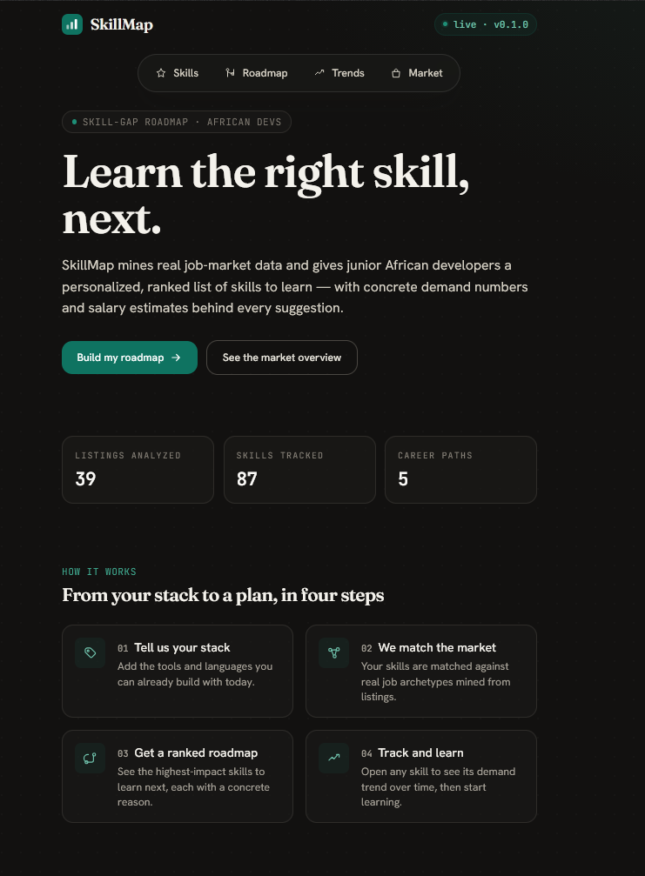
Figure 4.1: Home (landing) screen
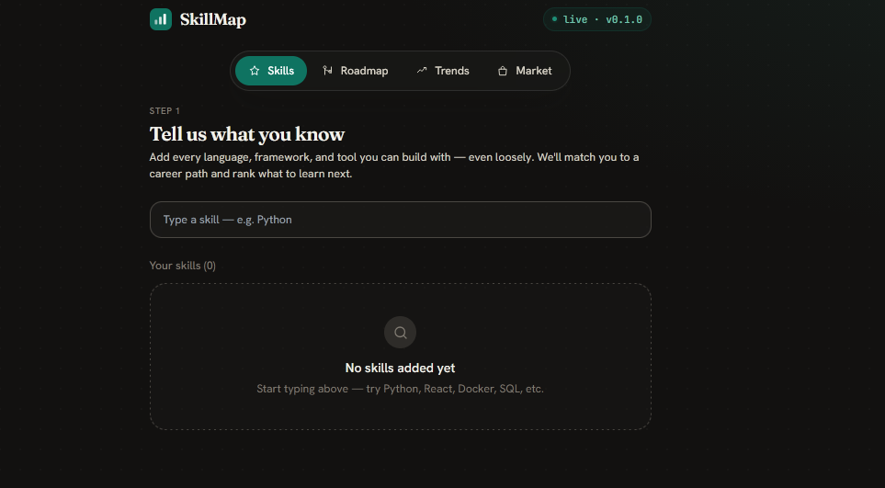
Figure 4.2: Skills input screen
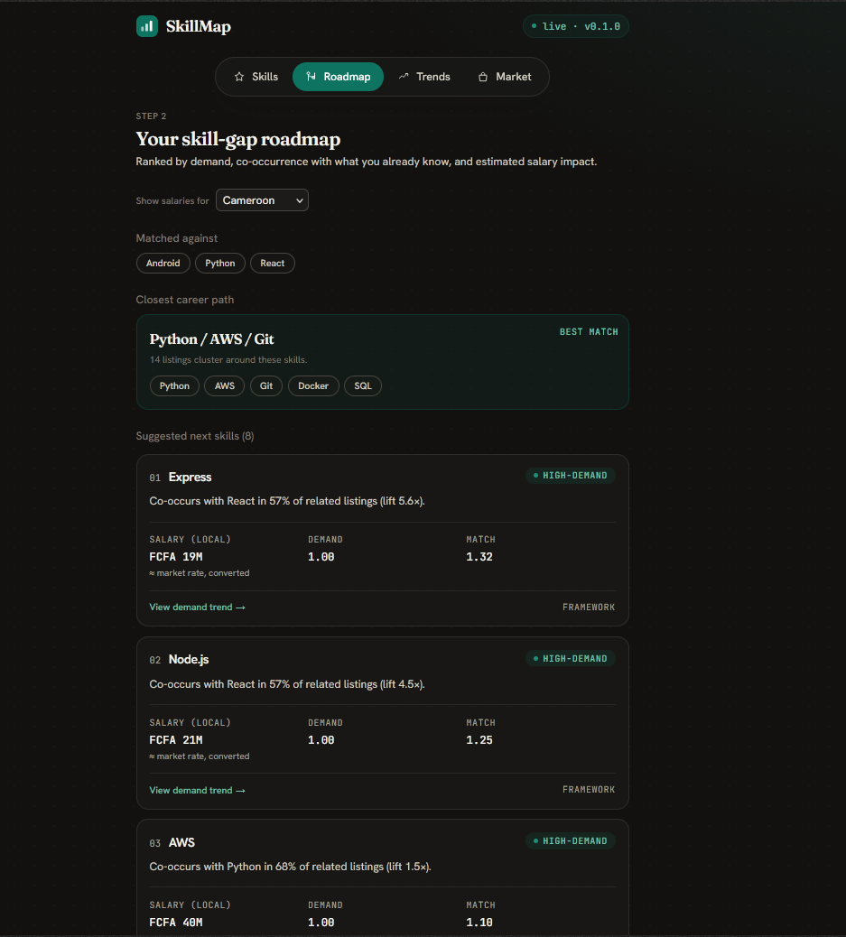
Figure 4.3: Personalized roadmap screen
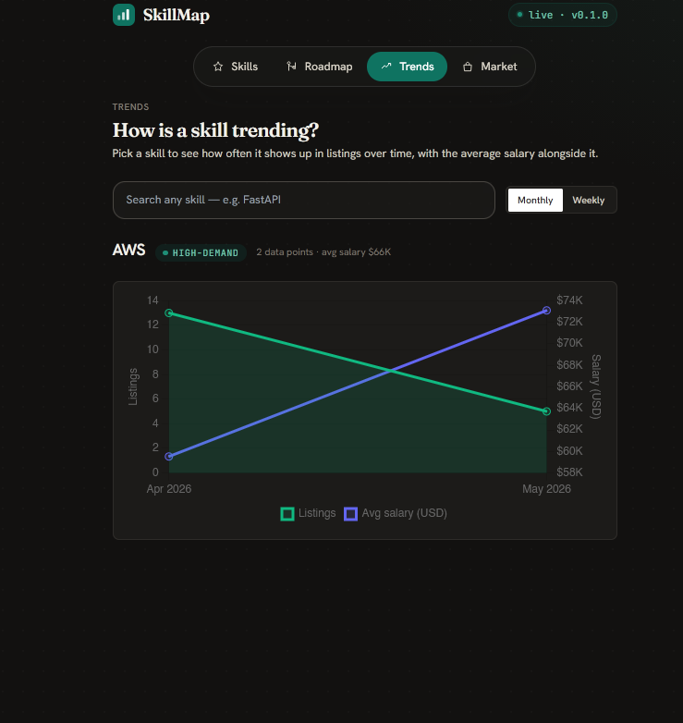
Figure 4.4: Skill demand-trend screen
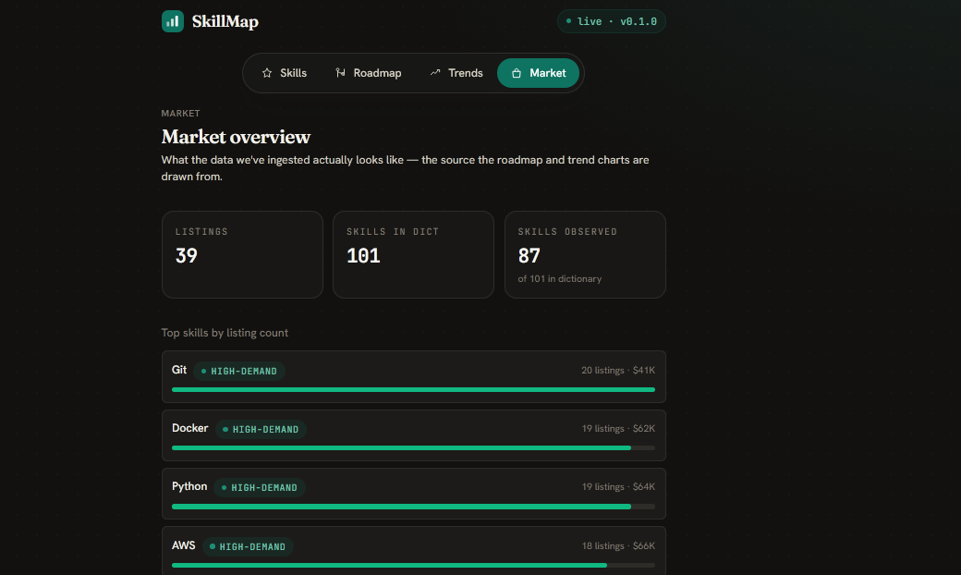
Figure 4.5: Market overview screen

4.2.7 Automation and Deployment
A cron refresh job orchestrates ingestion and mining end-to-end and exits with a non-zero status if any stage fails, so it can be monitored. Continuous integration runs the backend lint and tests and the frontend type-check, lint, and build on every push and pull request. Deployment configuration targets Vercel for the frontend and Railway or Render (with Supabase) for the backend and scheduled refresh.

4.3 System Testing
Testing was carried out at three levels — unit, integration, and system — supported by an automated suite of ninety-two backend tests executed under continuous integration.

4.3.1 Unit Testing
Unit tests verify individual components in isolation. Representative cases and their outcomes are listed in Table 4.1.
Table 4.1: Unit test cases and results
TC# | Test case | Result
TC-01 | Skill extractor matches C++, C#, and Node.js without false boundaries | PASS
TC-02 | Skill extractor resolves aliases (e.g. “py”, “reactjs”) to canonical names | PASS
TC-03 | HTML stripping and whitespace normalization clean a raw description | PASS
TC-04 | Location normalization resolves a country from a free-text location | PASS
TC-05 | Salary normalization converts currencies to a common basis | PASS
TC-06 | Apriori mining returns rules with valid support, confidence, and lift | PASS
TC-07 | K-Means clustering selects k by silhouette and labels archetypes | PASS
TC-08 | Feature engineering computes trend/recent/total/avg-salary correctly | PASS
TC-09 | Demand classifier assigns classes and scores; zero-demand skills stay stable | PASS
TC-10 | Recommendation scoring ranks rule candidates above fallbacks | PASS
TC-11 | Demand snapshots are produced in both posted and observed bases | PASS
TC-12 | Health endpoint reports the service as live | PASS

4.3.2 Integration Testing
Integration tests verify that components work together across module boundaries. The cases and outcomes are listed in Table 4.2.
Table 4.2: Integration test cases and results
IT# | Test case | Result
IT-01 | Seed adapter → ETL persists listings and skill links end-to-end | PASS
IT-02 | Source adapters (RemoteOK, Adzuna, Jooble) parse sample payloads correctly | PASS
IT-03 | Full ETL run isolates a malformed listing without aborting the batch | PASS
IT-04 | Mining run populates rules, archetypes, snapshots, and skill demand fields | PASS
IT-05 | POST /recommendations returns ranked, explained skills for a skill set | PASS
IT-06 | GET /stats and /skills/{id}/trend return consistent data after mining | PASS
IT-07 | Cron refresh runs every stage and exits non-zero when a stage fails | PASS

4.3.3 System Testing
System testing verifies the complete system against the functional requirements of Chapter Three. The verification is summarized in Table 4.3.
Table 4.3: System test (functional-requirement verification)
FR | Verification | Result
FR1 | Entering a stack resolves known skills and flags unknown inputs | PASS
FR2 | Listings are ingested from the seed corpus and configured live sources | PASS
FR3 | Listings are cleaned, normalized, and skills extracted | PASS
FR4 | Association rules are mined with support/confidence/lift | PASS
FR5 | Listings are clustered into labelled job archetypes | PASS
FR6 | Skill demand is classified and snapshots recorded over time | PASS
FR7 | A ranked, explained roadmap is returned to the user | PASS
FR8 | Salary figures are localized to the selected region’s currency | PASS
FR9 | The dashboard presents the market overview and demand trends | PASS

4.3.4 Non-Functional Verification
The non-functional requirements were also confirmed: API responses on the seed corpus return well under one second; the dashboard is mobile-first and requires no sign-up; the ETL and cron tolerate single-record and single-source failures; the same code runs unchanged on SQLite and PostgreSQL; and the backend remains fully typed, linted, and green across its ninety-two tests in continuous integration.

CHAPTER FIVE: CONCLUSIONS AND RECOMMENDATIONS

5.1 Conclusions
This project set out to design and implement a web-based system that turns real job-market data into a personalized, ranked, and evidence-backed skill roadmap for junior developers. All of the stated objectives were achieved: a source-agnostic ingestion layer, a robust ETL pipeline with alias-aware skill extraction, a four-job mining engine (Apriori, K-Means, a Random-Forest classifier, and demand snapshots), an explanatory recommendation engine, a six-endpoint API, and a five-screen mobile-first dashboard were all built, integrated, and tested.
The system passed its unit, integration, and system tests and satisfied its non-functional requirements, demonstrating that an accessible, transparent, low-cost career-guidance tool can be delivered end-to-end using open-source technologies and classical, interpretable data-mining methods.

5.2 Limitations
- The demand classifier is bootstrapped from heuristic (weak) labels because no curated, labelled time series of rising and falling skills was available; its metrics should be read in that light.
- Mining parameters and salary conversions are tuned for the seed corpus and a small set of regions, and would need recalibration at larger scale.
- The first version has no user authentication or persistent accounts, relying on an anonymous, device-local profile.
- Archetype labels are derived automatically from centroid skills and are less crisp than human-curated career names.

5.3 Perspectives for Further Study
- Integrate additional compliant job sources to broaden and localize the corpus.
- Replace the heuristic labels with a curated, labelled benchmark to train and properly evaluate the demand classifier.
- Add optional user accounts to persist roadmaps and track skill progress over time.
- Introduce locale-specific salary medians and human-curated archetype names.
- Explore richer NLP (beyond dictionary matching) for extracting emerging skills not yet in the dictionary.

REFERENCES
Agrawal, R., & Srikant, R. (1994). Fast Algorithms for Mining Association Rules. Proceedings of the 20th International Conference on Very Large Data Bases (VLDB).
Han, J., Kamber, M., & Pei, J. (2011). Data Mining: Concepts and Techniques (3rd ed.). Morgan Kaufmann.
MacQueen, J. (1967). Some Methods for Classification and Analysis of Multivariate Observations. Proceedings of the 5th Berkeley Symposium on Mathematical Statistics and Probability.
Breiman, L. (2001). Random Forests. Machine Learning, 45(1), 5–32.
Rousseeuw, P. J. (1987). Silhouettes: A Graphical Aid to the Interpretation and Validation of Cluster Analysis. Journal of Computational and Applied Mathematics, 20, 53–65.
Pedregosa, F., et al. (2011). Scikit-learn: Machine Learning in Python. Journal of Machine Learning Research, 12, 2825–2830.
Ramírez, S. (2018). FastAPI Documentation. Retrieved from https://fastapi.tiangolo.com
Vercel Inc. (2024). Next.js Documentation. Retrieved from https://nextjs.org/docs
SQLAlchemy Project. (2024). SQLAlchemy 2.0 Documentation. Retrieved from https://docs.sqlalchemy.org
Stack Overflow. (2024). Stack Overflow Annual Developer Survey. Retrieved from https://survey.stackoverflow.co

