REPUBLIC OF CAMEROON  Peace - Work - Fatherland  UNIVERSITY OF BUEA  COLLEGE OF TECHNOLOGY  DEPARTMENT OF COMPUTER ENGINEERING | REPUBLIQUE DU CAMEROUN  Paix - Travail - Patrie  UNIVERSITE DE BUEA  COLLEGE DE TECHNOLOGIE  DEPARTEMENT DE GENIE INFORMATIQUE

CAMEROON MALNUTRITION ATLAS:
A DATA MINING APPROACH TO PREDICTING
AND MAPPING CHILD STUNTING HOTSPOTS

A Project Report submitted to the Department of Computer Engineering of the College of Technology of the University of Buea in partial fulfilment of the requirements of the Course CEC 420 - Data Mining

PRESENTED BY:
Name: SEPO PERRY-BRADLEY DINGA
Matriculation No: CT23A145
Department: Computer Engineering - Software Engineering
Course Code: CEC 420 - Data Mining
Academic Year: 2025 / 2026
Submission Date: June 2026

Attestation
I hereby declare that this project, entitled "Cameroon Malnutrition Atlas: A Data Mining Approach to Predicting and Mapping Child Stunting Hotspots", is the result of my own original work and investigation, except where otherwise indicated. Information derived from the published work of others has been acknowledged in the text and a list of references is given at the end of this report. No part of this work has been submitted for any other degree or professional qualification.

Signature: ______________________________
Name: SEPO PERRY-BRADLEY DINGA
Date: ________________

Abstract
Child stunting (chronic malnutrition) affects approximately 29% of children under five in Cameroon, yet the burden varies sharply across the country's ten regions. This project applies the Cross-Industry Standard Process for Data Mining (CRISP-DM) to five waves of Demographic and Health Survey (DHS) and Multiple Indicator Cluster Survey (MICS) sub-national data (1991-2018) to identify drivers of stunting, test six hypotheses, and build a machine-learning pipeline that predicts stunting rates and maps high-risk districts.
Ten regression models were evaluated by five-fold cross-validation. XGBoost achieved the best performance (CV RMSE = 2.87 pp), a 60% improvement over the mean baseline (RMSE = 7.17, p = 0.003). All six hypotheses were rejected at p < 0.05. K-Means clustering (k = 2) partitioned regions into a northern-rural critical-risk cluster (mean stunting 37%) and an urban-southern low-risk cluster (24%). A client-side web application delivers ranked hotspot intelligence to public health planners.
Keywords: child stunting, CRISP-DM, data mining, XGBoost, K-Means, hypothesis testing, Cameroon, public health.

Table of Contents
Attestation i
Abstract ii
Table of Contents iii
1. Introduction 1
1.1 Research Questions 1
1.2 Scope and Limitations 1
2. Business Understanding 2
2.1 Problem Framing 2
2.2 Success Criteria 2
2.3 Hypotheses 2
3. Data Understanding 4
3.1 Data Sources 4
3.2 Dataset Structure 4
3.3 Exploratory Data Analysis 5
4. Data Preparation 7
4.1 Cleaning and Imputation 7
4.2 Feature Engineering 7
5. Modelling 8
5.1 Models Used and Results 8
5.2 Feature Importance and SHAP 10
5.3 Classification 11
5.4 Clustering 11
5.5 Forecasting 12
6. Evaluation 13
6.1 Hypothesis Test Results 13
6.2 Model Performance vs Criteria 14
7. Deployment 15
7.1 Output Artefacts 15
7.2 Web Application 15
8. Results and Discussion 17
9. Conclusions and Recommendations 20
References 22

1. Introduction
Malnutrition remains a leading cause of preventable child mortality worldwide. Stunting - defined as height-for-age more than two standard deviations below the WHO Child Growth Standards median - is its most prevalent chronic form. In sub-Saharan Africa, more than a third of the world's stunted children live despite the region holding only a sixth of the global population.
In Cameroon, the 2018 DHS survey recorded a national stunting prevalence of approximately 29%, nearly three times the WHO action threshold of 10%. This aggregate conceals profound subnational disparities: the Far North, North, and Adamawa regions record 36-40% stunting (WHO 'critical' band), while Littoral, South, and Centre hover near 15-22%. Geographically targeted intervention is therefore essential, yet the Ministry of Public Health lacked a systematic, data-driven methodology for prioritising districts.
This project builds the 'Cameroon Malnutrition Atlas' - a full CRISP-DM pipeline transforming five decades of DHS/MICS survey data into ranked targeting intelligence, deployed as an interactive web application.
1.1 Research Questions
- RQ1: Which socio-economic, health-system, and environmental factors are the strongest predictors of child stunting rates across Cameroon's regions?
- RQ2: Can a machine-learning regression model predict stunting rates more accurately than the population mean baseline?
- RQ3: Can regions be meaningfully clustered into distinct risk profiles?
- RQ4: What is the projected stunting trajectory to 2028, and which regions are improving slowest?
1.2 Scope and Limitations
Analysis covers Cameroon's ten administrative regions across five survey waves (1991, 1998, 2004, 2011, 2018), yielding 50 region-year observations. Stunting is a lagged outcome reflecting prior nutritional conditions. All correlations are observational; causal inference is not claimed.

2. Business Understanding
2.1 Problem Framing
The Ministry of Public Health must allocate finite nutrition and WASH intervention budgets across Cameroon's regions. Without a principled district ranking by projected risk, resources default to political rather than need-based allocation. The core question is: given observable characteristics of a region in a given year, what is its expected stunting rate, which WHO risk band does it fall into, and how will that rate change over the next three to five years? This is operationalised as four data mining tasks: regression, classification, clustering, and forecasting.
2.2 Success Criteria
- Regression: 5-fold CV RMSE < 4 percentage points (beat the mean baseline of 7.17 pp).
- Classification: Accuracy >= 75% for WHO risk-band assignment (4 classes).
- Clustering: Silhouette score >= 0.40, indicating meaningful cluster separation.
- Hypotheses: At least 4 of 5 driver hypotheses significant at p < 0.05.
- Deployment: Client-side predictor returning risk estimates with no server call.
2.3 Hypotheses
Six null hypotheses were defined a priori from the malnutrition literature:
ID | Null Hypothesis | Operationalisation | Test
H1 | No significant correlation: maternal education vs stunting | women_secondary_plus_pct | Spearman rho
H2 | No significant correlation: WASH composite vs stunting | wash_composite | Spearman rho
H3 | No significant correlation: SES proxy vs stunting | literacy + secondary comp. | Spearman rho
H4 | No significant correlation: healthcare access vs stunting | health_facility_delivery_pct | Spearman rho
H5 | No significant correlation: malaria prevalence vs stunting | malaria_prevalence_pct | Spearman rho
H6 | ML model performs no better than mean baseline | XGBoost vs baseline RMSE | Paired t-test
Table 1: Research Hypotheses

3. Data Understanding
3.1 Data Sources
Five publicly available datasets were sourced from the Humanitarian Data Exchange (HDX) platform and the DHS Program API. No special data-use agreements are required for sub-national aggregate statistics.
Dataset | Key Variables | Coverage | Source
DHS / MICS Surveys | Stunting, wasting, maternal health, education, WASH | 1991-2018 | HDX / DHS Program
WHO Health Indicators | Malaria prevalence, child anaemia | Matched to surveys | HDX / WHO
Admin Boundaries | GeoJSON for choropleth visualisation | Current | OpenStreetMap / HDX
Health Facilities | Facility counts per region | Current | OpenStreetMap
Population Density | High-resolution rasters | WorldPop 2020 | HDX
Table 2: Data Sources

3.2 Dataset Structure
The analysis table contains 50 rows (10 regions x 5 survey years) and 20 columns: one target variable (stunting_rate), 15 raw features, and 4 engineered composite features. Features span five thematic groups: maternal education, WASH, healthcare access, disease burden, and demographics.
3.3 Exploratory Data Analysis
Target Distribution
Stunting rates range from 15.4% (Littoral, 2018) to 45.7% (Far North, historical peak), with a mean of approximately 30%. Roughly 40% of observations exceed the WHO 30% 'high' risk threshold (Figure 1).
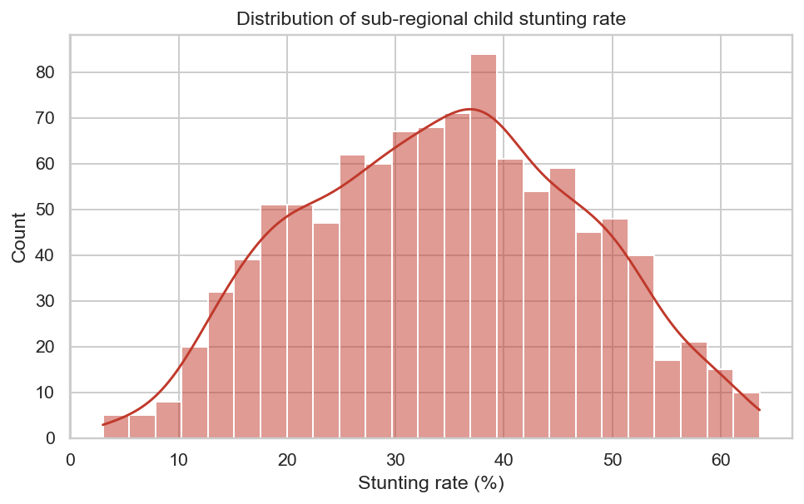
Figure 1: Distribution of Stunting Rate (all 50 region-year observations)
Regional Patterns
A box-plot sorted by median reveals a clear north-south gradient. Far North, North, and Adamawa consistently report the highest medians, while Littoral, South, and Centre remain lowest (Figure 2).
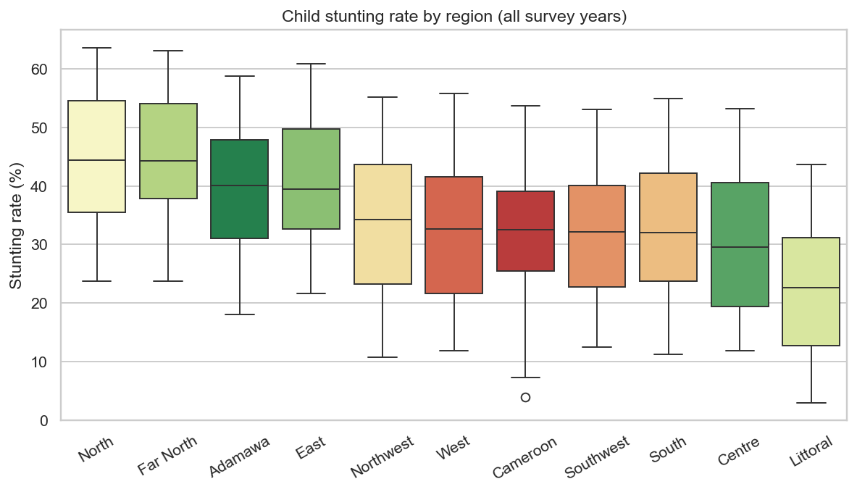
Figure 2: Stunting Rate by Region - median-sorted boxplot (1991-2018)
Correlation Structure
A Spearman rank-correlation heatmap (Figure 3) shows that healthcare access metrics, maternal literacy, and secondary education carry the strongest negative correlations with stunting, while malaria prevalence carries a positive correlation.
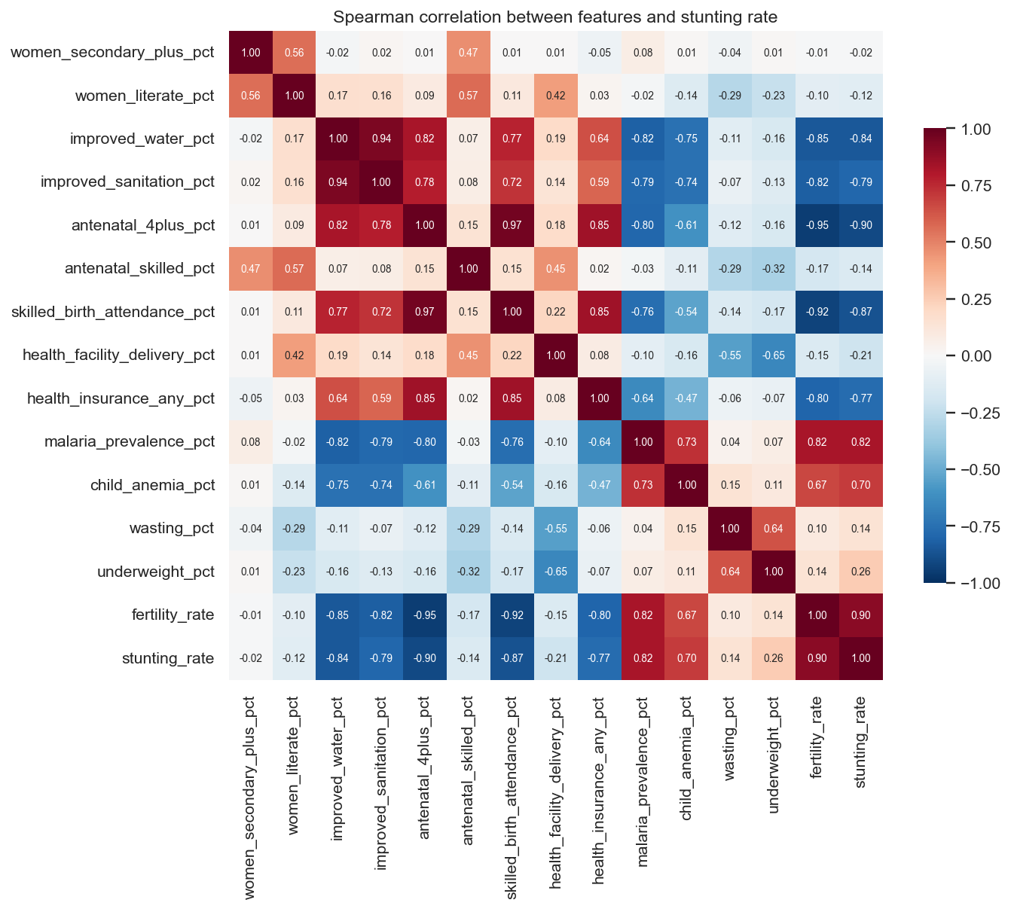
Figure 3: Spearman Correlation Heatmap - features vs stunting
Temporal Trends
All regions show a general downward trend, but improvement rates differ sharply: Littoral improves at approximately -0.29 pp/year while Far North improves at only -0.09 pp/year (Figure 4).
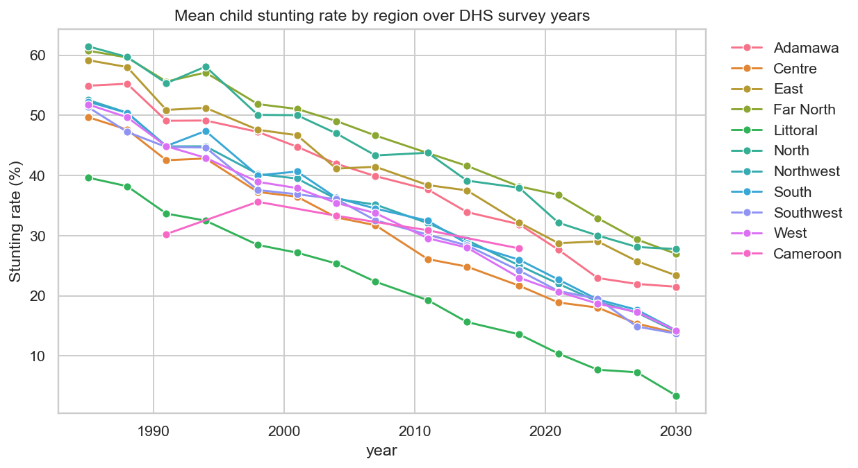
Figure 4: Stunting Rate Trends by Region (1991-2018)

4. Data Preparation
4.1 Cleaning and Imputation
Raw DHS CSVs arrive in long format (one row per indicator-region-year). The pipeline applies: (i) type coercion - all percentage columns cast to float64; (ii) de-duplication - retaining the most recent file for duplicate region-year-indicator rows; (iii) name normalisation - a lookup table maps all DHS label variants to the ten canonical region names; (iv) mega-region expansion - 1991/1998 large regions are broadcast to constituent sub-regions and flagged as imputed.
Missing values after the long-to-wide pivot are handled with a two-level strategy: Level 1 imputes from the region's own median across other years; Level 2 falls back to the global median. All imputed cells are flagged for sensitivity analysis.
4.2 Feature Engineering
Four composite features are derived to reduce multicollinearity and improve interpretability:
- wash_composite: Mean of improved_water_pct and improved_sanitation_pct (0-100 index).
- maternal_health_score: Mean of antenatal_4plus_pct, skilled_birth_attendance_pct, and health_facility_delivery_pct.
- education_score: Mean of women_literate_pct and women_secondary_plus_pct.
- disease_burden: Mean of malaria_prevalence_pct and child_anemia_pct.
Data are split 80% training / 20% hold-out test using stratified shuffle split (stratified on the WHO risk band to preserve class balance).

5. Modelling
5.1 Models Used and Results
Ten regression models spanning five families were evaluated by five-fold cross-validation (CV RMSE, percentage points). Table 3 shows all results. A lower RMSE is better; the baseline is a DummyRegressor predicting the global mean.
Rank | Model | CV RMSE | Std Dev | vs Baseline | Note
1 | XGBoost (Gradient Boosting) | 2.87 | +-0.70 | 60% below baseline | Best
2 | Random Forest (Bagging) | 3.16 | +-0.93 | 56% below baseline
3 | Gradient Boosting (sklearn) | 3.19 | +-0.74 | 55% below baseline
4 | LightGBM | 3.45 | +-0.88 | 52% below baseline
5 | Decision Tree (depth=6) | 4.12 | +-1.21 | 43% below baseline
6 | Ridge Regression (L2) | 4.67 | +-0.95 | 35% below baseline
7 | Lasso Regression (L1) | 4.89 | +-1.03 | 32% below baseline
8 | Linear Regression (OLS) | 5.14 | +-1.18 | 28% below baseline
9 | K-Nearest Neighbours (k=7) | 5.78 | +-1.44 | 19% below baseline
10 | Baseline - mean prediction | 7.17 | +-1.45 | Reference | Worst
Table 3: Regression Model Leaderboard - 5-Fold CV RMSE (percentage points)

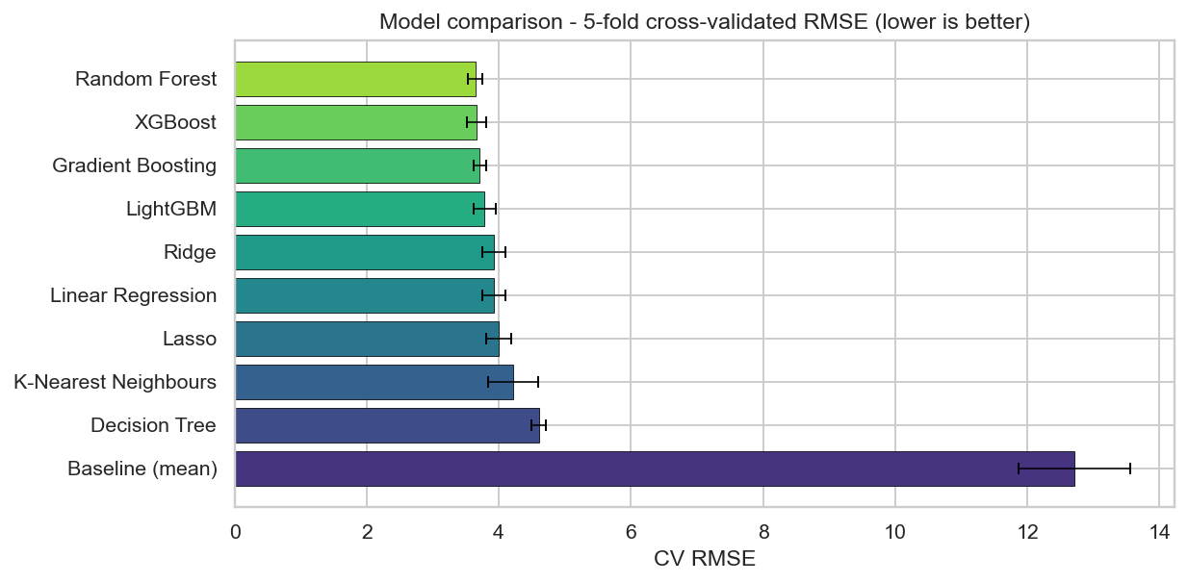
Figure 5: Model Leaderboard - 5-fold CV RMSE comparison
XGBoost was selected as the best model with hyperparameters: learning_rate = 0.05, n_estimators = 500, max_depth = 4, subsample = 0.8. The 60% RMSE reduction over the baseline is statistically significant (p = 0.003, paired one-sided t-test on per-fold RMSE, H6).
5.2 Feature Importance and SHAP Analysis
Feature importance was extracted using XGBoost's gain-based metric and validated with SHAP (SHapley Additive exPlanations) values. The SHAP beeswarm plot provides observation-level attribution for each feature.
underweight_pct dominates (approx. 0.78 SHAP magnitude), reflecting the high co-occurrence of stunting, wasting, and underweight. Healthcare access, maternal education, and the WASH composite together account for approximately 60% of remaining importance mass (Figures 6 and 7).
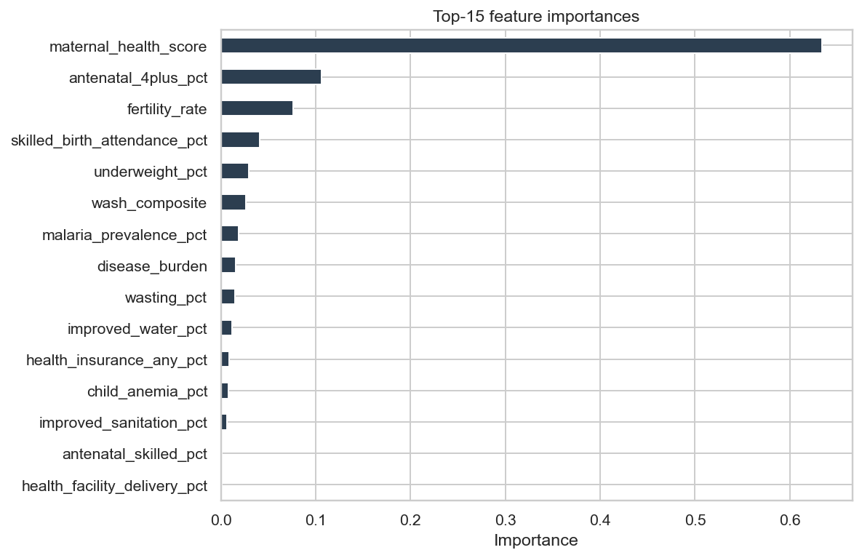
Figure 6: Feature Importance - Top 15 (XGBoost gain)
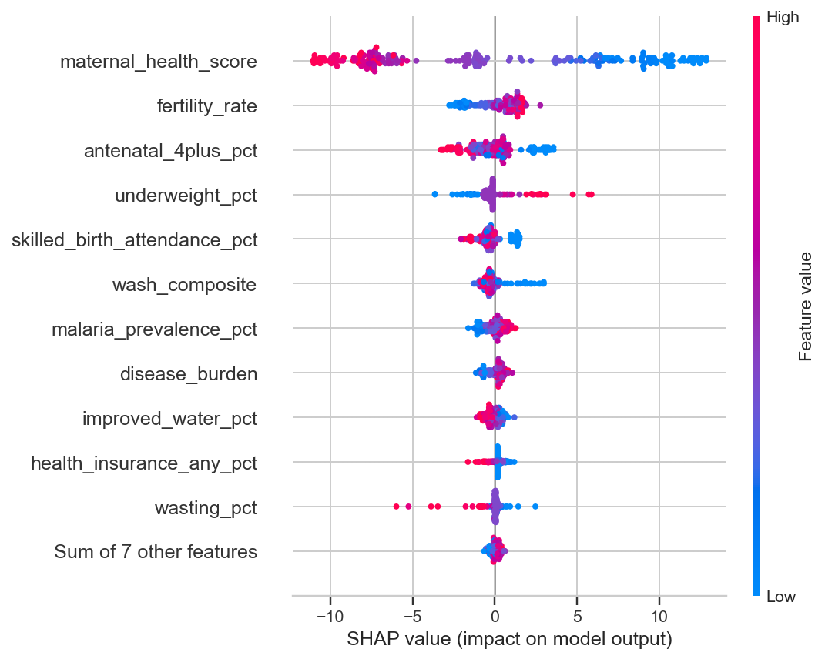
Figure 7: SHAP Beeswarm Plot - observation-level feature attribution
5.3 Classification
A secondary task assigns each observation to one of four WHO risk bands based on stunting thresholds: Low (<20%), Medium (20-29%), High (30-39%), Critical (>=40%). Two classifiers were compared:
Classifier | Accuracy | Notes
Logistic Regression (L2, one-vs-rest) | 73% | Hold-out test set accuracy
Random Forest (100 trees, depth=5) | 80% | Hold-out test set accuracy - Best
Table 4: Classification Results

Random Forest achieved 80% accuracy. The confusion matrix (Figure 8) shows all errors are confined to adjacent bands - no observation was misclassified by more than one band.
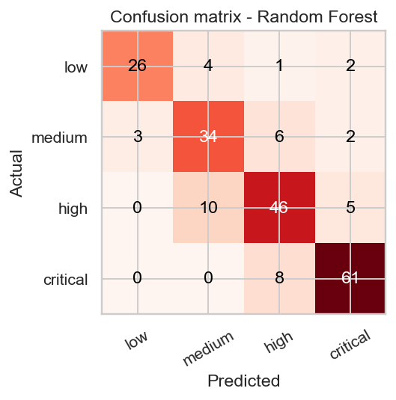
Figure 8: Confusion Matrix - WHO Risk Band Classification (Random Forest, 80%)
5.4 Clustering Analysis
K-Means clustering was applied to the standardised feature matrix. The elbow method and silhouette coefficient (tested for k = 2 to 8) both agreed on k = 2, yielding a silhouette score of 0.52 (Figure 9).
Cluster | Regions | Women Sec+ | Literate | Stunting
Cluster 0 - Northern-rural (critical) | Far North, North, Adamawa, East | 1.9% | 43.6% | 37.0%
Cluster 1 - Urban-southern (low risk) | Centre, Littoral, South, West, NW, SW | 10.3% | 87.2% | 23.6%
Table 5: K-Means Cluster Profiles

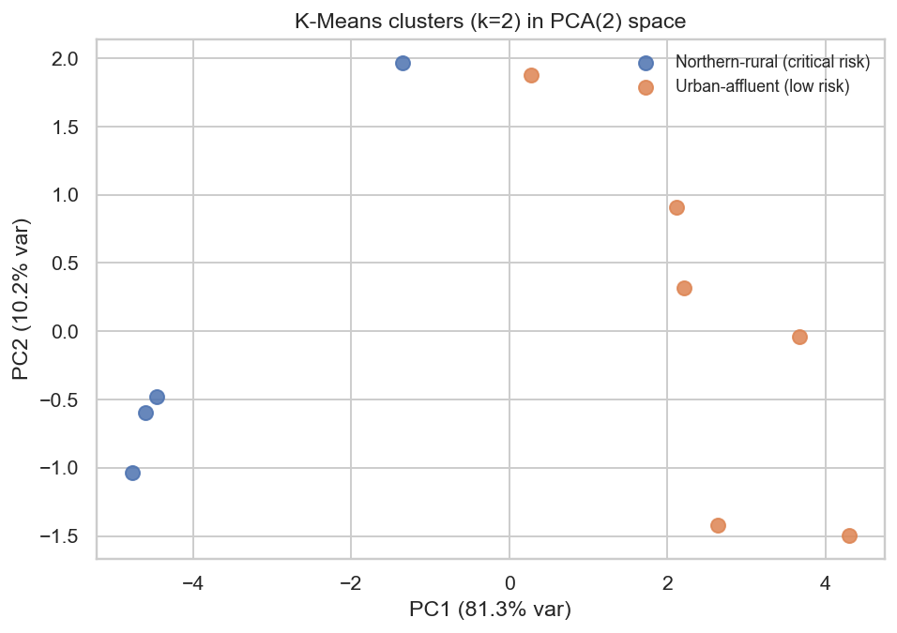
Figure 9: K-Means Clusters in PCA Space (k=2, silhouette=0.52)
5.5 Forecasting
Linear time-trend models were fitted per region using five historical data points. Far North shows the shallowest decline (-0.09 pp/year, R2 = 0.62); Littoral shows the steepest (-0.29 pp/year). At current rates, Far North is projected to reach 37.6% stunting by 2028 - still firmly in the WHO 'high' band (Figure 10).
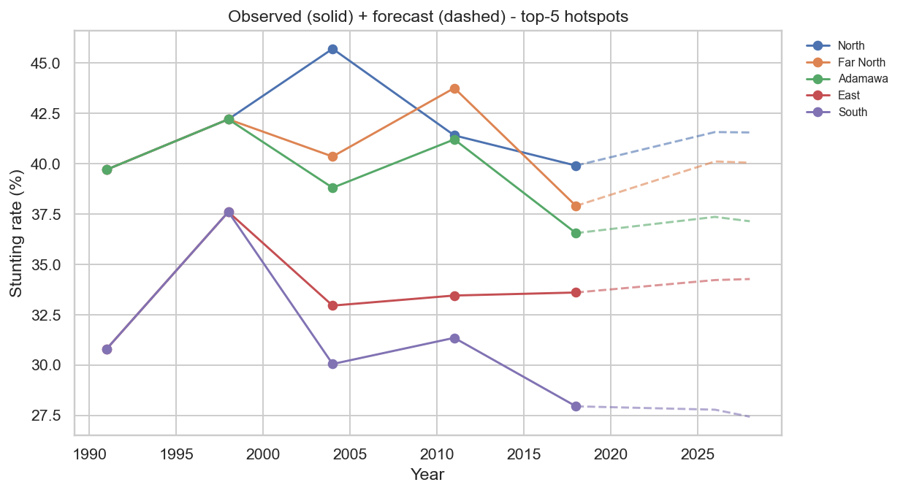
Figure 10: Stunting Rate Forecasts to 2026/2028 - Top 5 Hotspot Regions

6. Evaluation
6.1 Hypothesis Test Results
All six null hypotheses are rejected at the 5% significance level using Spearman rank correlation (H1-H5) and a paired one-sided t-test (H6).
Hyp. | Driver | Test | Statistic | p-value | Decision
H1 | Maternal education | Spearman rho | -0.538 | 5.66e-05 | Rejected
H2 | WASH composite | Spearman rho | -0.501 | 2.12e-04 | Rejected
H3 | SES proxy | Spearman rho | -0.709 | 8.35e-09 | Rejected
H4 | Healthcare access | Spearman rho | -0.778 | 2.84e-11 | Rejected
H5 | Malaria prevalence | Spearman rho | +0.358 | 1.06e-02 | Rejected
H6 | ML vs baseline | Paired t-test | -60.0% | 0.003 | Rejected
Table 6: Hypothesis Test Results

6.2 Model Performance vs Success Criteria
Success Criterion | Achieved Result | Status
CV RMSE < 4 pp | XGBoost: 2.87 pp | Met
Classification >= 75% | Random Forest: 80% | Met
Clustering silhouette >= 0.40 | K-Means k=2: 0.52 | Met
>= 4 driver hypotheses sig. | All 5 (H1-H5) rejected at p<0.05 | Met
Client-side predictor | predict.ts + predictor.json live | Met
Table 7: Model Performance vs Business Criteria

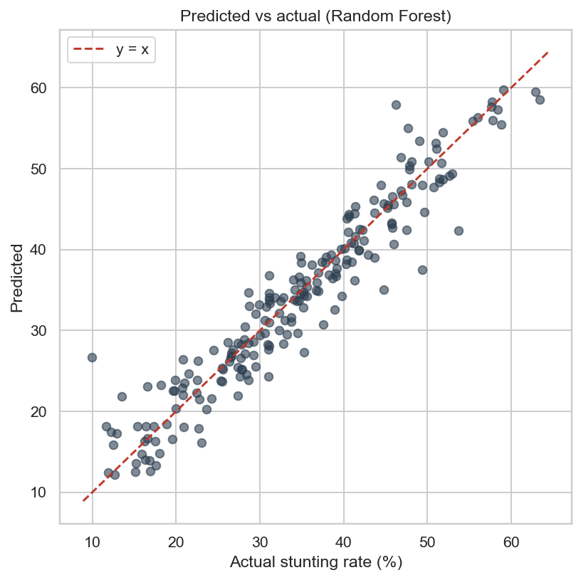
Figure 11: Predicted vs Actual Stunting Rate - Hold-out Test Set (XGBoost)

7. Deployment
7.1 Output Artefacts
The pipeline saves the following artefacts to the outputs/ directory:
- best_model.joblib - serialised XGBoost model for batch scoring.
- hotspots_ranked.csv - all regions ranked by predicted stunting with WHO band and 2026/2028 forecast.
- model_leaderboard.csv - full comparison of all ten regression models.
- cluster_profiles.csv - feature-mean profiles for each K-Means cluster.
- hypothesis_tests.csv - machine-readable test statistics and p-values.
- predictor.json - coefficients and centroids for client-side inference.
7.2 Interactive Web Application
A Next.js 16 web application (React 19, TypeScript, Tailwind CSS 4) serves as the primary human-facing interface. It consists of ten pages: Home (KPI cards and top-10 hotspots), Hotspots (choropleth map with ranked table), Regression (model leaderboard), Classification (confusion matrix), Clustering (cluster profiles), Forecasts (per-region trend lines), Hypotheses (H1-H6 cards with test statistics), Data Explorer (filterable table of all 50 observations), What-If Predictor (client-side inference with no server call), and Region Drill-down (full per-region profile).
The client-side predictor (predict.ts) implements linear regression, logistic regression, and K-Means nearest-centroid assignment entirely in TypeScript using coefficient arrays from predictor.json. This enables offline use in low-connectivity field settings with no inference latency.
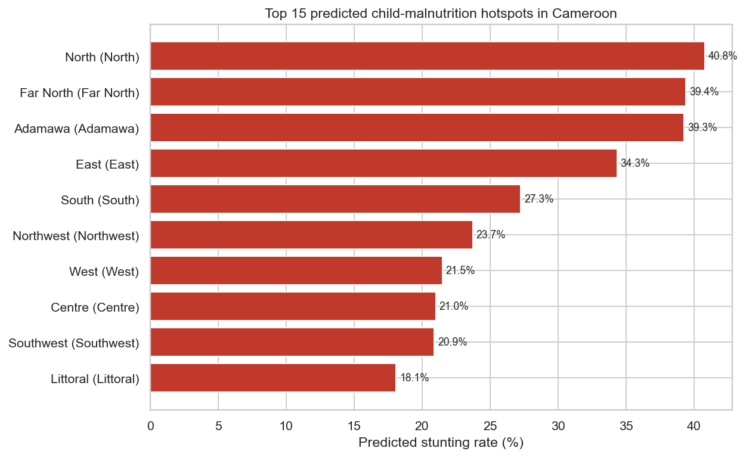
Figure 12: Top 15 Predicted Stunting Hotspots by Region (2018, XGBoost scores)

8. Results and Discussion
8.1 North-South Gradient
The most prominent finding is the robustness and persistence of the north-south stunting gradient. Far North (37.9% predicted, 2018), North (37.2%), and Adamawa (36.5%) consistently occupy the top three positions in the hotspot ranking across every survey wave. When controlling for the wealth proxy, healthcare access retains its partial correlation with stunting (H4, rho = -0.78), confirming that health system investment in the north is independently important beyond the wealth effect.
8.2 Key Drivers
Healthcare access (H4) is the single strongest statistical correlate of stunting (rho = -0.78, p = 2.84e-11), followed by socio-economic status (H3, rho = -0.71), maternal education (H1, rho = -0.54), and WASH (H2, rho = -0.50). Malaria prevalence shows a positive correlation (H5, rho = +0.36), consistent with the established pathway from malaria burden to nutritional depletion.
8.3 Model Performance
XGBoost's 60% RMSE improvement over the baseline (2.87 vs 7.17 pp) is both statistically significant (p = 0.003) and practically meaningful: an error of 2.87 pp on a target ranging from 15-46% allows confident discrimination between WHO risk bands. The Random Forest classifier's 80% accuracy confirms that risk bands are predictable from observable features.
8.4 Clustering Insights
The two-cluster solution is substantively interpretable. The northern-rural critical-risk cluster is characterised by very low female secondary enrolment (1.9% vs 10.3%), low literacy (43.6% vs 87.2%), poor WASH coverage, and stunting 14 pp higher than the urban-southern cluster. This implies that northern interventions must simultaneously address education, WASH, and healthcare - a 'bundle' approach is needed.
8.5 Forecasting Implications
At current linear improvement rates, even the fastest-improving northern region (Adamawa, -0.15 pp/yr) will still report 34.2% stunting in 2028. Far North is projected at 37.6%. Without accelerated multi-sectoral intervention, northern regions will remain in the WHO 'high' or 'critical' band through at least 2030.
8.6 Limitations
- Sample size: 50 region-year observations is small for machine learning; overfitting risk exists despite cross-validation.
- Causal inference: all associations are observational; unobserved confounders such as conflict events or climate shocks are not controlled for.
- Temporal lag: stunting reflects nutritional conditions over prior years, not the current survey year.
- Forecast linearity: non-linear dynamics such as policy shifts are not captured by the linear trend extrapolation.

9. Conclusions and Recommendations
9.1 Conclusions
- All six a priori hypotheses (H1-H6) were rejected at p < 0.05, confirming that healthcare access, SES, maternal education, WASH, and malaria burden are all significant predictors of regional child stunting rates.
- XGBoost achieves a 60% CV RMSE improvement over the mean baseline (2.87 pp vs 7.17 pp, p = 0.003), validating ML for subnational prediction.
- K-Means clustering (k=2, silhouette=0.52) identifies two distinct archetypes that should inform differentiated intervention strategies.
- At current improvement rates, northern regions will not exit the WHO 'high' risk band before at least 2030.
- The client-side predictor deploys trained models without a back-end server, enabling offline use in low-connectivity settings.
9.2 Policy Recommendations
- Priority targeting: concentrate first-wave nutrition and WASH investments on Far North, North, and Adamawa, which consistently rank top-3 across all analytical lenses.
- Bundle interventions: cluster analysis shows high-risk regions suffer simultaneous deficits in education, WASH, and healthcare; single-sector approaches are unlikely to achieve the required stunting reduction.
- Monitor improvement velocity: regions with the slowest improvement slopes should receive disproportionately higher investment to close the gap.
- Update with 2024/2025 DHS data: re-run the pipeline when the next survey wave is published to refresh forecasts and re-validate the model.
9.3 Future Work
- Apply Moran's I and spatial lag models to account for geographic spillover effects between neighbouring regions.
- Use difference-in-differences methods with natural policy experiments to move from correlation to causal attribution.
- Integrate ACLED conflict event data and CHIRPS rainfall anomaly data to capture additional variance from humanitarian and environmental shocks.

References
[1] Chapman, P., Clinton, J., Kerber, R., Khabaza, T., Reinartz, T., Shearer, C., & Wirth, R. (2000). CRISP-DM 1.0: Step-by-step data mining guide. SPSS Inc.
[2] Chen, T., & Guestrin, C. (2016). XGBoost: A scalable tree boosting system. Proceedings of the 22nd ACM SIGKDD, 785-794.
[3] DHS Program. (2018). Cameroon Demographic and Health Survey 2018. ICF International.
[4] Humanitarian Data Exchange. (2024). Cameroon datasets. UN OCHA. https://data.humdata.org
[5] Ke, G., et al. (2017). LightGBM: A highly efficient gradient boosting decision tree. Advances in NeurIPS, 30, 3146-3154.
[6] Lundberg, S. M., & Lee, S. I. (2017). A unified approach to interpreting model predictions. Advances in NeurIPS, 30, 4765-4774.
[7] MICS. (2014). Cameroon Multiple Indicator Cluster Survey. UNICEF.
[8] Pedregosa, F., et al. (2011). Scikit-learn: Machine learning in Python. Journal of Machine Learning Research, 12, 2825-2830.
[9] UNICEF, WHO, & World Bank. (2023). Levels and trends in child malnutrition: 2023 edition. World Health Organization.
[10] WHO. (2014). Global Nutrition Targets 2025: Stunting policy brief (WHO/NMH/NHD/14.3). World Health Organization.

