**EE5101/ME5401 Linear Systems mini-project**

**Multivariable Controller Design for Diesel Engine Air System Control**

**A0260045R MiaoChenxin**

1. Introduction

As the increasing regulatory standards for diesel engine emissions, particularly oxides of nitrogen (NOx) and particulate matter (PM). Compliance with these standards has led to greater complexity in diesel engine systems, with more sensors and actuators to monitor and control emissions. The most common method for reducing emissions is through the active control of inducted air and recirculated exhaust gas (EGR), using actuators like EGR and Variable Geometry Turbochargers (VGTs).

This mini project focuses on modeling and controlling the engine air system as a Multi-Input Multi-Output (MIMO) linear system. The control strategy involves manipulating the flow of gases through the engine to achieve the required reduction in emissions. The project is adapted from a Master's thesis at Iowa State University, where empirical data were collected from the engine air system to tune a linear fourth-order state-space model using MATLAB's System Identification Toolbox. The obtained state-space model includes valve positions for EGR and VGT as inputs and in-cylinder air/fuel ratio (AFR) and intake manifold EGR percentage as outputs.

1. Get parameters

The space state model:

Where:

A =[-8.8487+(a-b)/5 -0.0399 -5.5500+(c+d)/10 3.5846;

-4.5740 2.5010*((d+5)/(c+5)) -4.3662 -1.1183-(a-c)/20;

3.7698 16.1212-c/5 -18.2103+(a+d)/(b+4) 4.4936;

-8.5645-(a-b)/(c+d+2) 8.3742 -4.4331 -7.7181*(c+5)/(b+5)];

B = [0.0564+(b/(10+c)) ,0.0319;0.0165-(c+d-5)/(1000+20*a),-0.02;

4.4939,1.5985*(a+10)/(b+12);-1.4269,0.2730];

C = [-3.2988, -2.1932+(10*c +d)/(100+5*a) ,0.0370 ,-0.0109;

0.2922-(a*b)/500, -2.1506, -0.0104, 0.0163];

Since my student matriculation number is A0260045R, then a = 0, b =0, c = 4, d =5.

1. Pole placement

3.1 Theory

Because of that the overshoot is less than 10%, the 2% settling time is less than 20 seconds, the second order system can be described as:

After calculation, we get and ,then , = 0.4 is selected. The poles of reference model are:

Because of that the system is four-order system, the other two poles are at least 3 to 5 times larger than the computed ones. Therefore, the overall poles are:

To check the controllability of system,

]

and the rank of is 4, which is full rank, meaning that the system is controllable. Since that it’s a MIMO system, the transformation matrix T exists. Then build the matrix , the . Since 2 b1 and 2 b2 are used, therefore d1 =2, d2 = 2. The transformation matrix T is:

Then , ,, which can be obtained by using the desired poles. Finally, we get and .

* 1. Simulation

3.1 Simulink diagram

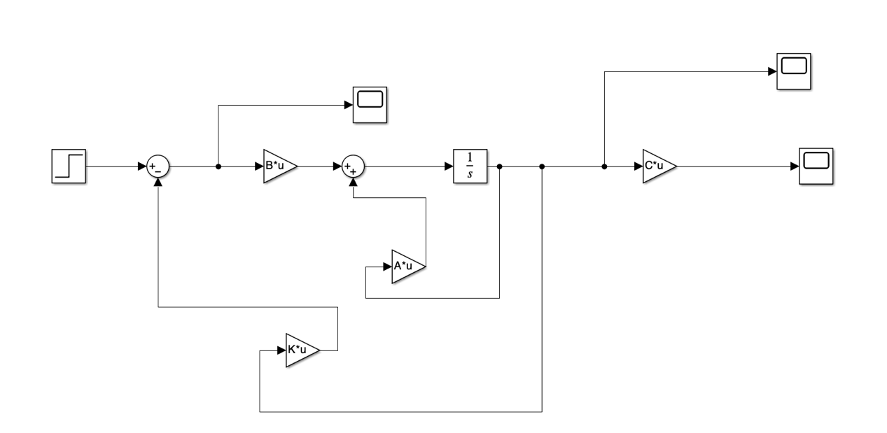

3.2 Analysis

3.2.1

The system has already reached the desired qualification.

Step response:

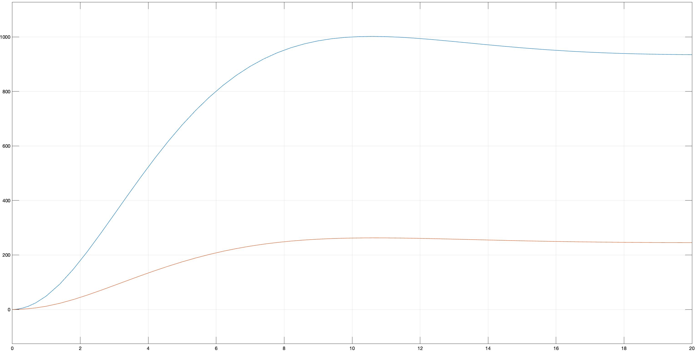

State response:

Control signal:

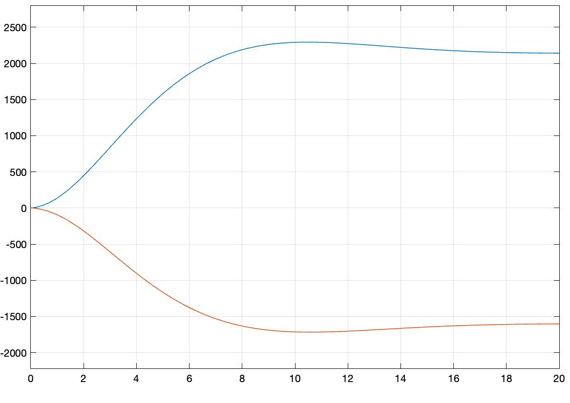

3.2.2

Step response:

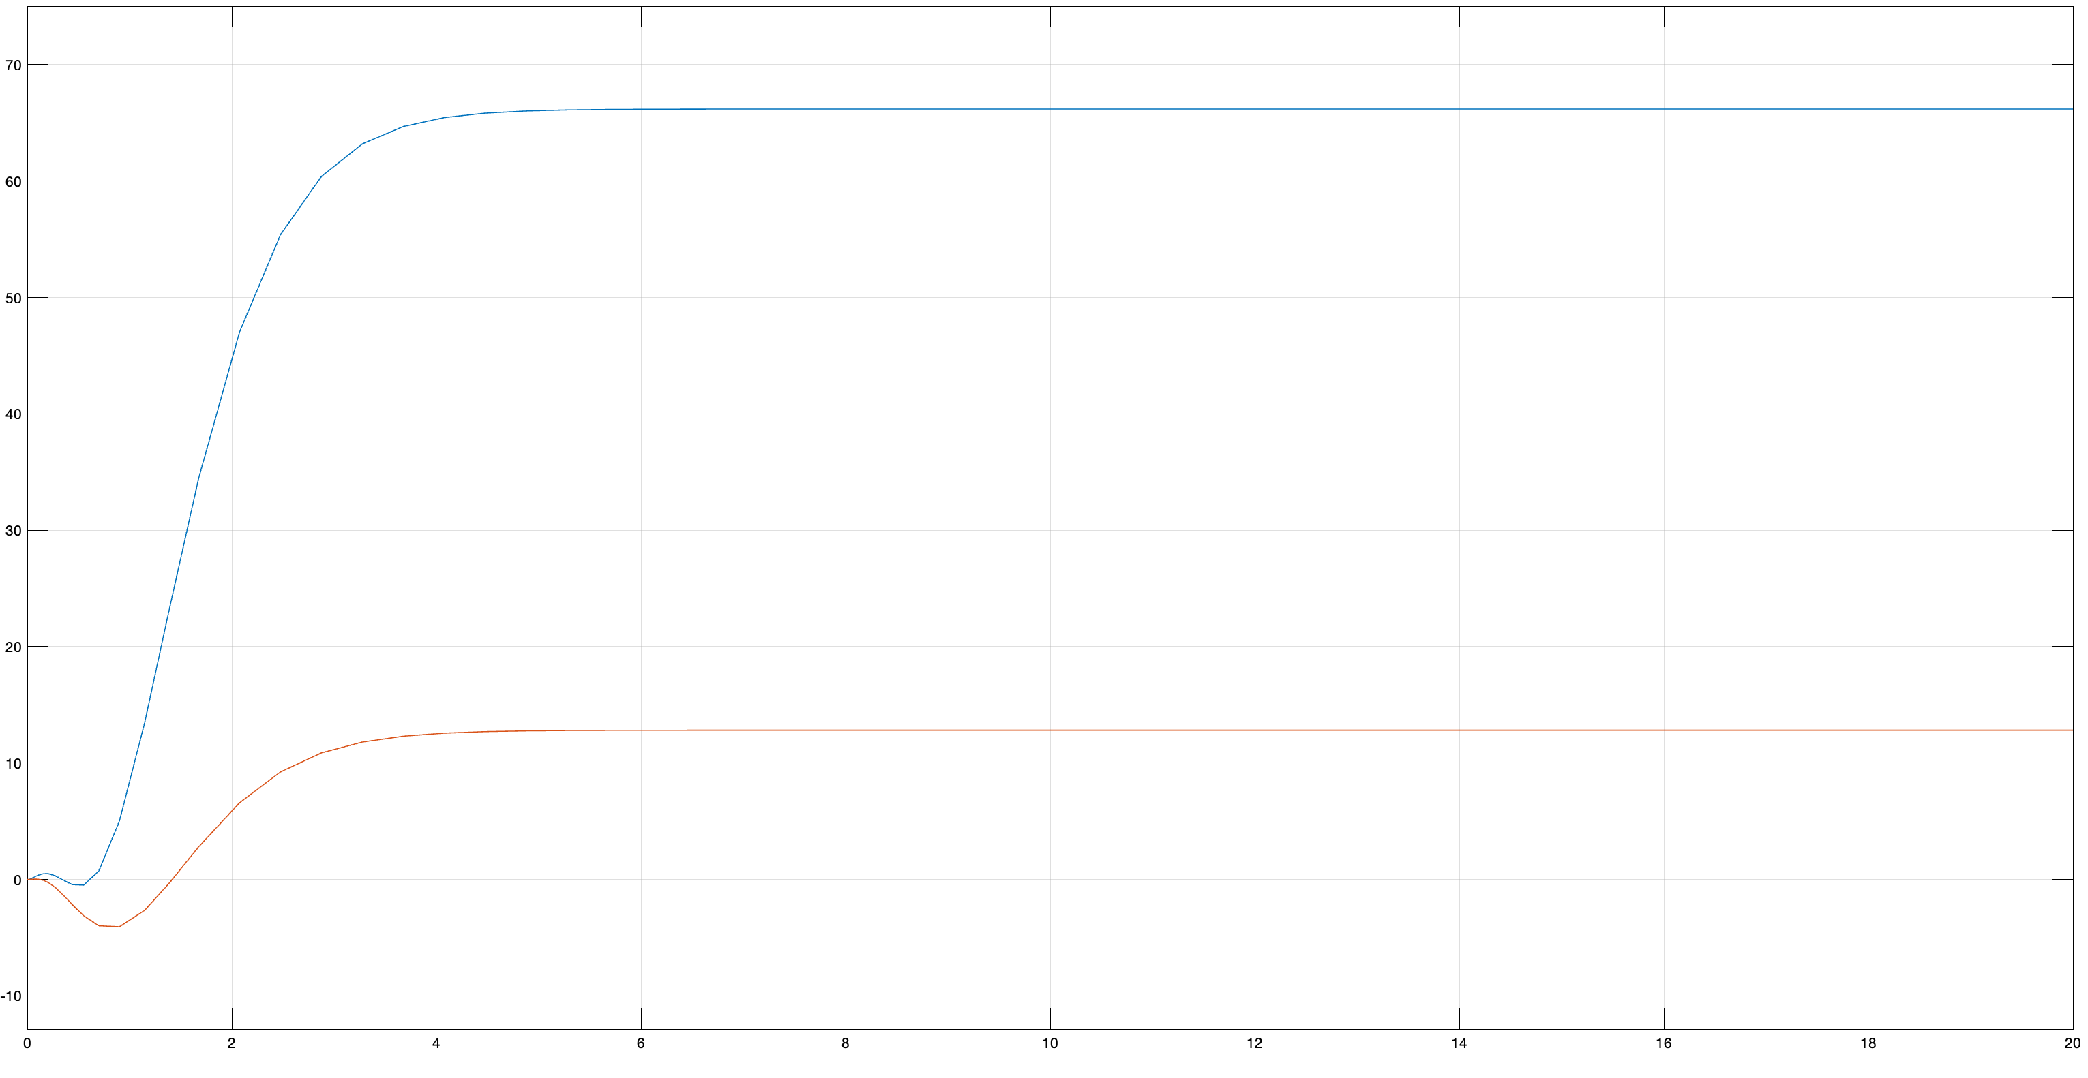

State Response:

Control Signal

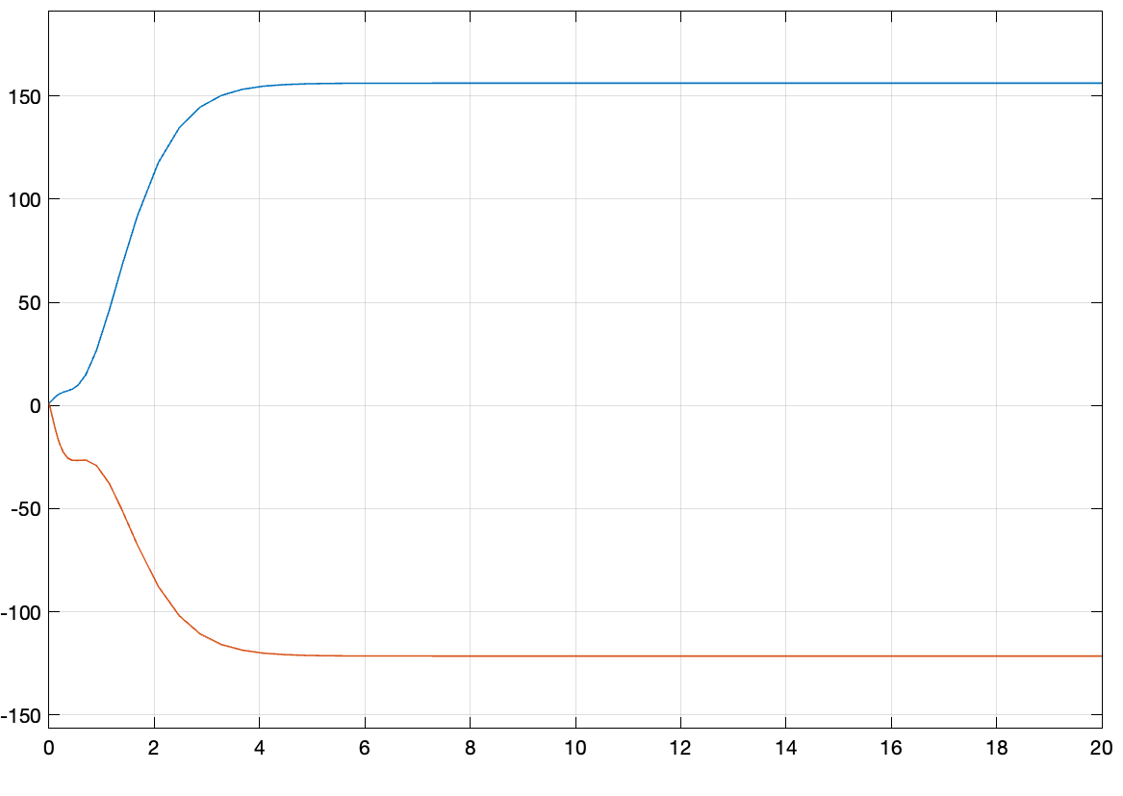Figure Control signal

3.2.3

Step response:

State response:

Control signal:

The poles position can affect the system performance, there are 4 poles:

We only change the first two, when the real part absolute value increase, the system takes less time to stabilize, the settling time is less. When the imaginary part absolute value increase, the system has more vibrations in response.

1. LQR

4.1 Theory

Assume that all four state variables can be measured, a state feedback controller using LQR method can be designed. The matrix Q and R can be set as:

The cost function should be minimized as:

Where: due to optimal control law. P is a positive matrix, and it meets the Algebraic Riccati Equation (ARE) as:

A systematic way to solve this equation is to form the 2n x 2n matrix:

Choose the stable eigenvalue of and the corresponding eigenvector is and P = [] . Finally, .

P =

12.5330 -32.9649 2.0020 4.0296

-32.9649 97.6106 -5.6575 -12.5547

2.0020 -5.6575 1.8938 1.2052

4.0296 -12.5547 1.2052 5.2839

K =

3.5416 -8.1491 6.8329 -2.0532

4.8259 -13.9675 3.0287 3.4276

4.2 Simulation

4.2.1 Simulink design

4.2.2 Analysis

Step response:

Step Response:

瓷砖地上

Step Response:

Step response:

The lower value of R makes the settling time less whereas the higher R value makes it longer to stabilize. The higher value of Q also makes the settling time is shorter, but the influence is not so obvious.

1. State observer

5.1 Theory

A LQR control is still needed and the Q, the matrix Q and R can be set as:

The full order controller is designed, consider an estimator in

=

Where . The LQR method selected parameters are:

By using the pole placement, the new poles are -2,-2,-1,-1, and Wc is calculated again, which is full rank. in observer is calculated using full rank method, and which is the transform of L. The computed L is:

L =

7.7799 -10.9608

3.1122 -1.0637

11.1696 -17.8933

-5.0947 26.2042

* 1. Simulation
     1. Simulink Design

* + 1. Analysis

Output:

瓷砖地上

Observer output:

瓷砖地上

State:

There is no obvious difference on output and observer output in steady state, which means the observer has good performance.

1. Decoupling control

6.1 theory

Decoupling control is to decouple a coupled plant, and it is usually required in practice for easy operations. There are two schemes to decouple a plant: state feedback with the state-space model and output feedback with the transfer function matrix. This is a linear state-space model, so it is convenient to use first scheme, state feedback to decouple this plant.

The transfer function:

In this plant, ,therefore:

K = =

-140.8374 521.8800 -383.3264 117.9665

-30.9467 336.3904 -530.8043 288.7609

6.2 Simulation

6.2.1 Simulink design

6.2.2 Analysis

State:

Output:

Though I tried many times, it still has error and shut down when t>0.28. After trouble shooting, I found out that the number after intergrator goes into infinity, it may be due to the original number and new poles set in . However, though I changed it still causes error, meaning the system is not stable. it may due to the original number is not fit for decoupling control.

1. Controller design

7.1 Simulink design

7.2 Analysis

Output error:

State

Output:

Estimated error:

瓷砖地上

Control Signal:

1. Codes

Q1:

clc

clear all

syms s;

%a0260045r

a = 0;

b = 0;

c = 4;

d = 5;

B = [0.0564+(b/(10+c)) ,0.0319;

0.0165-(c+d-5)/(1000+20*a),-0.02;

4.4939,1.5985*(a+10)/(b+12);

-1.4269,0.2730];

A =[-8.8487+(a-b)/5 -0.0399 -5.5500+(c+d)/10 3.5846;

-4.5740 2.5010*((d+5)/(c+5)) -4.3662 -1.1183-(a-c)/20;

3.7698 16.1212-c/5 -18.2103+(a+d)/(b+4) 4.4936;

-8.5645-(a-b)/(c+d+2) 8.3742 -4.4331 -7.7181*(c+5)/(b+5)];

C = [-3.2988, -2.1932+(10*c +d)/(100+5*a) ,0.0370 ,-0.0109;

0.2922-(a*b)/500, -2.1506, -0.0104, 0.0163];

x0 = [0.5 -0.1 0.3 -0.8]';

s0 = -0.26 + 0.3*i; s1 = -0.26 - 0.3*i; s2 = -4; s3 = -4;

m = (s-s0)*(s-s1)*(s-s2)*(s-s3);

a = expand(m)

wc = [B A*B A*A*B A*A*A*B];

rank(wc)

b1=B(:,1);

b2=B(:,2);

C_1=[b1,A*b1,b2,A*b2];

C_t=inv(C_1);

q1 = C_t(1,:);

q2=C_t(2,:);

q3=C_t(3,:);

q4 = C_t(4,:);

T=[q2;q2*A;q4;q4*A];

Abar=T*A/T;

Bbar=T*B;

Adbar = [0 1 0 0 ;

0 0 1 0;

0 0 0 1;

-8776/625 -9588/625 -26297/1250 -213/25]; % Ad = Abar - Bbar*Kbar

Kbar = pinv(Bbar) * (Abar - Adbar);

K = Kbar *T

Q2

clc

clear all

syms s;

a = 0;

b = 0;

c = 4;

d = 5;

B = [0.0564+(b/(10+c)) ,0.0319;

0.0165-(c+d-5)/(1000+20*a),-0.02;

4.4939,1.5985*(a+10)/(b+12);

-1.4269,0.2730];

A =[-8.8487+(a-b)/5 -0.0399 -5.5500+(c+d)/10 3.5846;

-4.5740 2.5010*((d+5)/(c+5)) -4.3662 -1.1183-(a-c)/20;

3.7698 16.1212-c/5 -18.2103+(a+d)/(b+4) 4.4936;

-8.5645-(a-b)/(c+d+2) 8.3742 -4.4331 -7.7181*(c+5)/(b+5)];

C = [-3.2988, -2.1932+(10*c +d)/(100+5*a) ,0.0370 ,-0.0109;

0.2922-(a*b)/500, -2.1506, -0.0104, 0.0163];

x0 = [0.5 -0.1 0.3 -0.8]';

Q = [10 0 0 0; 0 100 0 0; 0 0 100 0; 0 0 0 100];

R = [10 0 ; 0 10];

Gamma=[A,-B/R*B';-Q,-A'];

[x,y]=eig(Gamma);

y=diag(y);

k=1;

for i=1:length(y)

if(y(i)<0)

v(:,k)=x(1:4,i);

mu(:,k)=x(5:8,i);

k=k+1;

end

end

P=(mu)*pinv(v)

a = inv(R)*B';

K = real(a*P)

Q3

clc

clear all

syms s;

a = 0;

b = 0;

c = 4;

d = 5;

B = [0.0564+(b/(10+c)) ,0.0319;

0.0165-(c+d-5)/(1000+20*a),-0.02;

4.4939,1.5985*(a+10)/(b+12);

-1.4269,0.2730];

A =[-8.8487+(a-b)/5 -0.0399 -5.5500+(c+d)/10 3.5846;

-4.5740 2.5010*((d+5)/(c+5)) -4.3662 -1.1183-(a-c)/20;

3.7698 16.1212-c/5 -18.2103+(a+d)/(b+4) 4.4936;

-8.5645-(a-b)/(c+d+2) 8.3742 -4.4331 -7.7181*(c+5)/(b+5)];

C = [-3.2988, -2.1932+(10*c +d)/(100+5*a) ,0.0370 ,-0.0109;

0.2922-(a*b)/500, -2.1506, -0.0104, 0.0163];

x0 = [0.5 -0.1 0.3 -0.8]';

Q = [10 0 0 0; 0 1000 0 0; 0 0 1000 0; 0 0 0 1000];

R = [1 0 ; 0 1];

Gamma=[A,-B/R*B';-Q,-A'];

[x,y]=eig(Gamma);

y=diag(y);

k=1;

for i=1:length(y)

if(y(i)<0)

v(:,k)=x(1:4,i);

mu(:,k)=x(5:8,i);

k=k+1;

end

end

P=(mu)*pinv(v)

a = inv(R)*B';

K = a*P %lqr

A_= A';

B_ = C';

wc = [B_ A_*B_ A_*A_*B_ A_*A_*A_*B_];

rank(wc) %full rank

b1=B_(:,1);

b2=B_(:,2);

C_1=[b1,A_*b1,b2,A_*b2];

C_t=inv(C_1);

q1 = C_t(1,:);

q2=C_t(2,:);

q3=C_t(3,:);

q4 = C_t(4,:);

T=[q2;q2*A_;q4;q4*A_];

Abar=T*A_/T;

Bbar=T*B_;

s0 = -2; s1 = -2; s2 = -1; s3 = -1;

m = (s-s0)*(s-s1)*(s-s2)*(s-s3);

a = expand(m)

Adbar = [0 1 0 0 ;

0 0 1 0;

0 0 0 1;

-4 -12 -13 -6];

Kbar = pinv(Bbar) * (Abar - Adbar);

K_ = Kbar *T;

L = K_'

Q4

clc

clear all

syms s;

a = 0;

b = 0;

c = 4;

d = 5;

B = [0.0564+(b/(10+c)) ,0.0319;

0.0165-(c+d-5)/(1000+20*a),-0.02;

4.4939,1.5985*(a+10)/(b+12);

-1.4269,0.2730];

A =[-8.8487+(a-b)/5 -0.0399 -5.5500+(c+d)/10 3.5846;

-4.5740 2.5010*((d+5)/(c+5)) -4.3662 -1.1183-(a-c)/20;

3.7698 16.1212-c/5 -18.2103+(a+d)/(b+4) 4.4936;

-8.5645-(a-b)/(c+d+2) 8.3742 -4.4331 -7.7181*(c+5)/(b+5)];

C = [-3.2988, -2.1932+(10*c +d)/(100+5*a) ,0.0370 ,-0.0109;

0.2922-(a*b)/500, -2.1506, -0.0104, 0.0163];

x0 = [0.5 -0.1 0.3 -0.8]';

C1T=C(1,:);

C2T=C(2,:);

q1 = C1T * B % not 0

q2 = C2T * B % not 0

% sigma 1 and sigma 2 both =1

B_ = [C1T*B; C2T*B]

C_ = [C1T;C2T]

I = eye(4)

C_ss = [C1T*(A+10*I);C2T*(A+10*I)]

F = pinv(B_)

K = F*C_ss

Q5

clc

clear all

syms s;

a = 0;

b = 0;

c = 4;

d = 5;

B = [0.0564+(b/(10+c)) ,0.0319;

0.0165-(c+d-5)/(1000+20*a),-0.02;

4.4939,1.5985*(a+10)/(b+12);

-1.4269,0.2730];

A =[-8.8487+(a-b)/5 -0.0399 -5.5500+(c+d)/10 3.5846;

-4.5740 2.5010*((d+5)/(c+5)) -4.3662 -1.1183-(a-c)/20;

3.7698 16.1212-c/5 -18.2103+(a+d)/(b+4) 4.4936;

-8.5645-(a-b)/(c+d+2) 8.3742 -4.4331 -7.7181*(c+5)/(b+5)];

C = [-3.2988, -2.1932+(10*c +d)/(100+5*a) ,0.0370 ,-0.0109;

0.2922-(a*b)/500, -2.1506, -0.0104, 0.0163];

x0 = [0.5 -0.1 0.3 -0.8]';

A_ = [A,zeros(4,2);-C,zeros(2,2)];

B_ = [B;zeros(2,2)];

q =[10 50 50 50 30 10];

Q = diag(q);

r = [0.1 0.1];

R = diag(r);

R_1 = inv(R);

gamma=[A_,-B_*(R_1)*B_';-Q,-A_'];

[x,y]=eig(gamma);

y=diag(y);

k=1;

for i=1:length(y)

if(y(i)<0)

v(:,k)=x(1:6,i);

mu(:,k)=x(7:12,i);

k=k+1;

end

end

v_1 = inv(v);

P = mu/v

K1 = R\B_'*P

k1 = K1(:,1:4);

k2 = K1(:,5:6);

A1 = A - B*k1;

[x_1,y_1] = eig(A1);

s0 = 1;

s1 = 2;

s2 = 3;

s3 = 4;

B_1 = C';

wc = [B_1 A'*B_1 A'*A'*B_1 A'*A'*A'*B_1];

C_ = [wc(1:4,1) wc(1:4,3) wc(1:4,2) wc(1:4,4)];

C_inv = inv(C_);

q_d1_T = C_inv(2,:);

q_d1d2_T = C_inv(4,:);

q_d1_T_A = q_d1_T * A';

q_d1d2_T_A = q_d1d2_T * A';

T = [q_d1_T;q_d1_T_A ;q_d1d2_T;q_d1d2_T_A];

A_ba = T*A'*inv(T);

B_ba = T * B_1;

m = (s-s0)*(s-s1)*(s-s2)*(s-s3);

a = expand(m)

Ad_1 = [0 1 0 0 ;

0 0 1 0;

0 0 0 1;

-24 50 -35 10];

H_ba_1 = B_ba\(A_ba-Ad_1);

H_1 = H_ba_1*T;

H = H_1'