# CS 255 System Design Document Template

## UML Diagrams

### UML Use Case Diagram

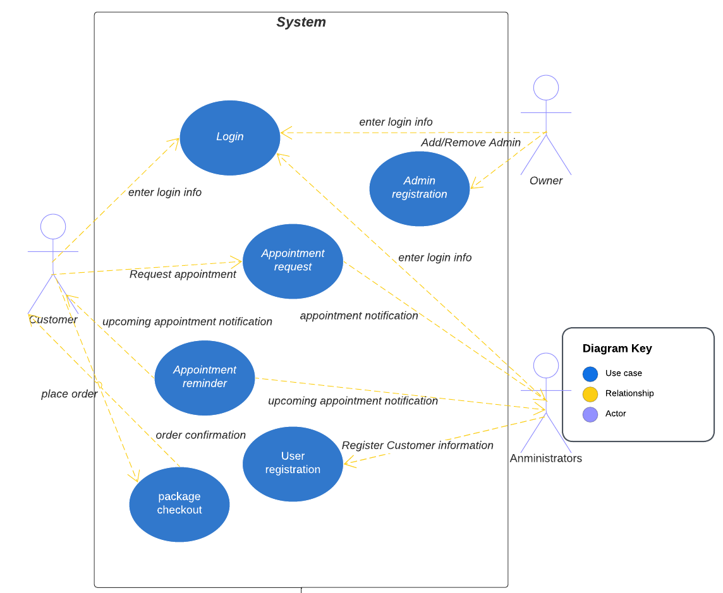

### UML Activity Diagrams

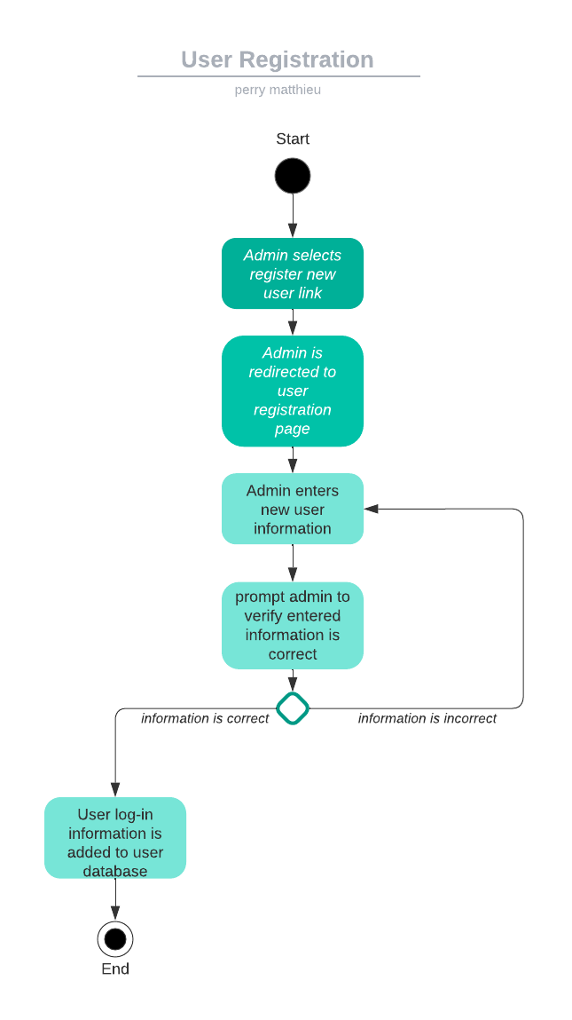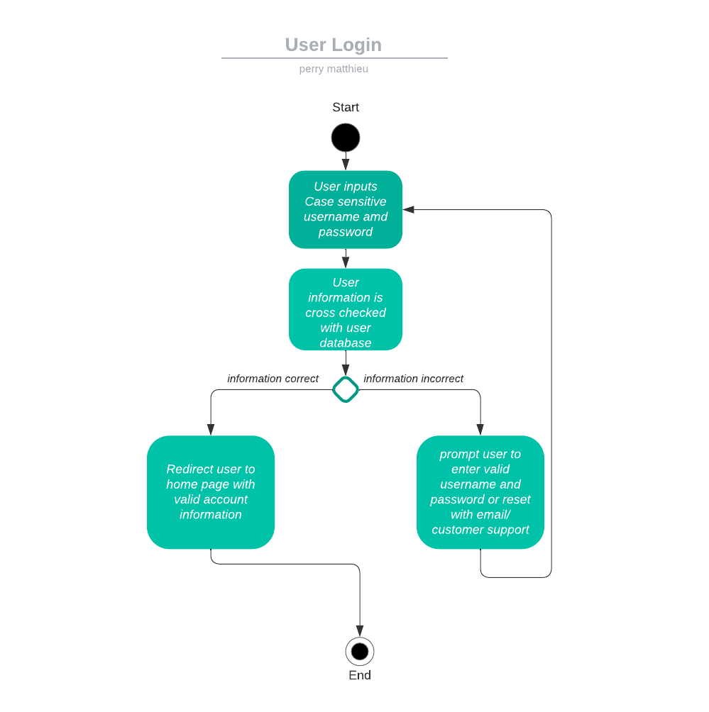

### UML Sequence Diagram

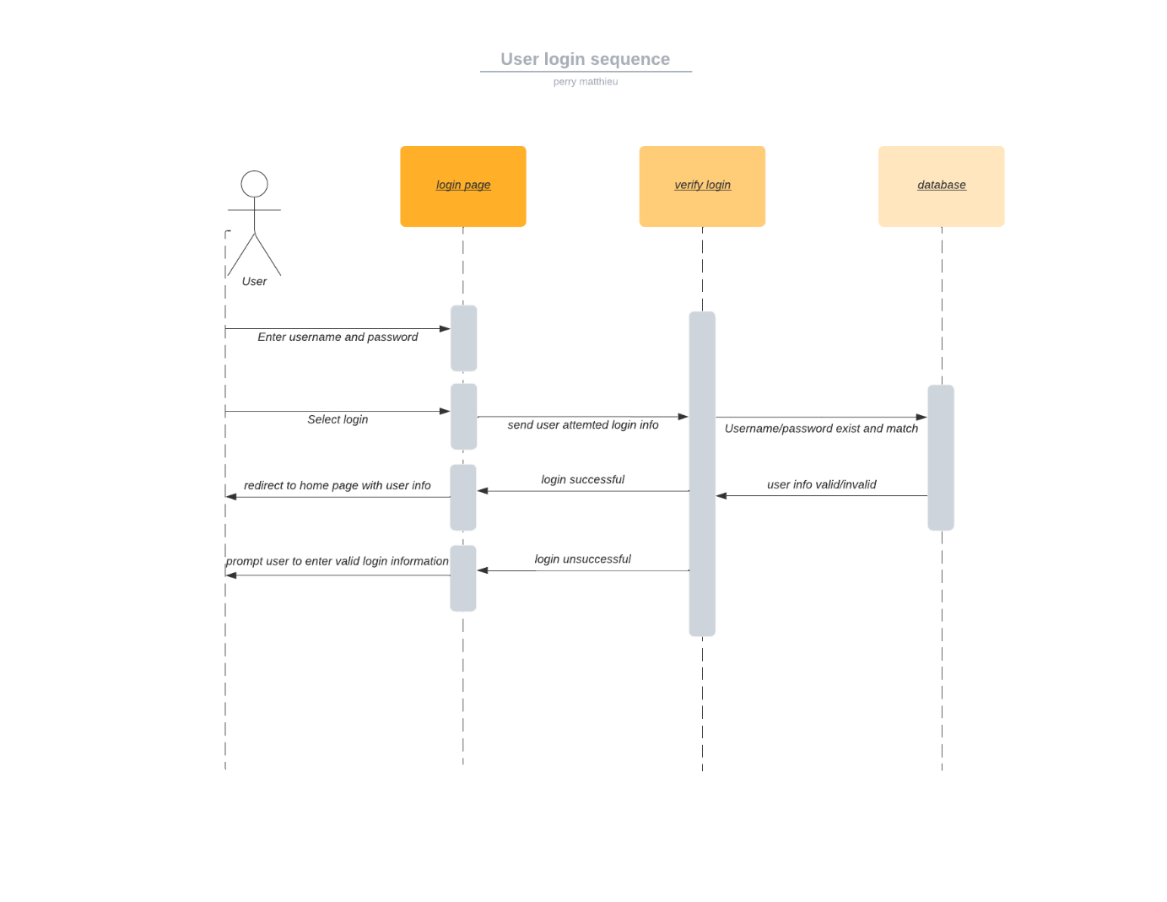

### UML Class Diagram

## Technical Requirements

This system is cloud-based, and therefore storage requirements will be met as needed. The system will be accessible from mobile devices as well as Linux, Mac, and Windows operating systems. Basic IDE such as visual studio will be used for development.