**ARDUINO LED PROJECT**

**MicroServo**

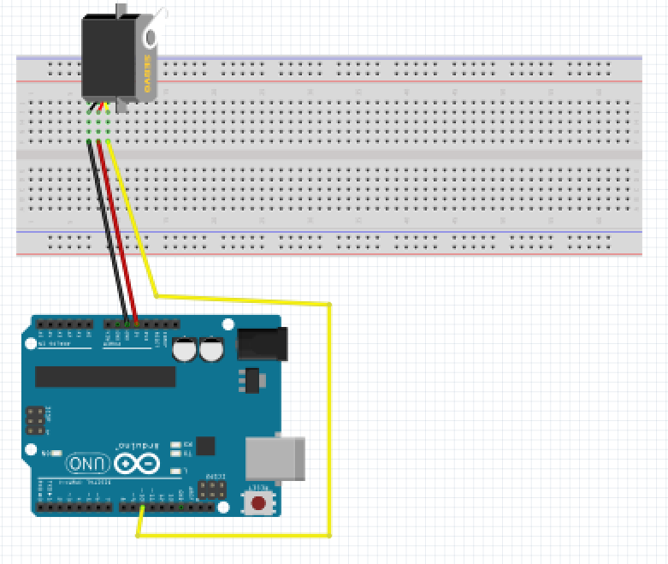

For this project we will need:

* Arduino board.
* MicroServo
* Breadboard.
* 3-pin connector.

Circuit Design:

1. First make sure that the Arduino is powered off (no USB cable plugged to power).
2. Check the servo motor, identify the three pins and respective colors.
3. Using a 3 pin connector,
4. Connect the yellow line to pin 10 of the Arduino. This will be our signal wire
5. Connect the red line to pin 5v of the Arduino.
6. Connect the black line to pin GND of the Arduino. This will be our signal wire.

|  |
| --- |
| #include <Servo.h>  Servo myServo;  int servoPosition=0;  void setup() {  myServo.attach(10); }  /void loop(){  for(servoPosition=0;servoPosition<=180;servoPosition += 1){  myServo.write(servoPosition);  delay(100); //duration for the 180 degree movement  }  for(servoPosition=180;servoPosition>=0;servoPosition -= 1){  myServo.write(servoPosition);  delay(100); //  } |

#include <Servo.h>

Servo myServo;

int servoPosition=0;

For the functionality of the server we need a library.

The library comes with inbuilt commands which control the functionality of the microservo. Instead of writing them from scratch we tell the program to use this library.

We then declare the name we want to use to refer to our servo

We then set the initial position of the servo.

for(servoPosition=0;servoPosition<=180;servoPosition += 1){

This sets a boundary for the range of values we wish to use.

The servo can rotate 180 degrees.

This value will keep changing by 1 to effect changes every cycle.\

myServo.write(servoPosition);

This instructs the microservo to move to the expected position

voidloop(){}

After executing thevoid setup() function, we enter the void loop() and this function is executed continuously and repeatedly, until you Arduino is powered off.