Learn Cmake, Gmock and Gtest
Notes

No arg constructor

- When you define a no arg constructor, when calling it you need to omit the parentheses.

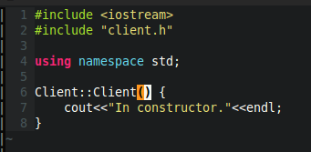

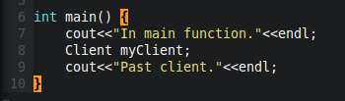

- Explained
  - If in line 8 you had put myClient(); it wouldn't have gone to that no arg constructor defined above. Not sure why.

Build.sh so far

- This is just up to the point where we're compiling the test program (no testing)

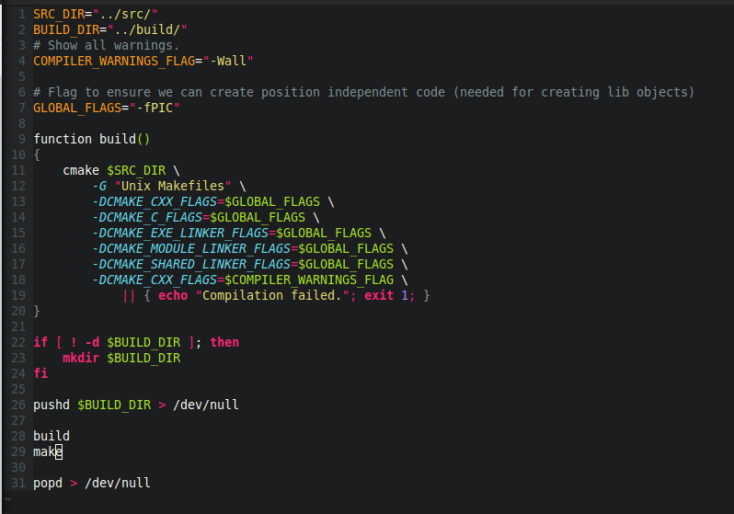
- Explained
  - 4: That warnings flag is just ensures it shows all warnings
  - 6-7: That global flag is used for libs. It ensures the produced code can be relocatable – it was something to that effect. Look into it more if you need to know later.
  - Build
    - We're calling cmake in our source dir.
    - -G specifies the output of our cmake. So in this case we're generating makefiles. It can also generate eclipse CDT appropriate make files.
    - 13-17: For all of CXX, C, EXE Linker, Module Linker and Shared Linker we're passing them that GLOBAL_FLAGS (the one for relocation).
    - 18: Notice how we can make two calls to CMAKE_CXX_FLAGS and it's going to add both, ratehr than overwriting them. So with this one we're just asking top get warnings for our CPP code.
  - 26-31: push into build dir
    - 28: We call build which creates our make files.
    - 29: We then compile

