Configure Intellij

Window placement

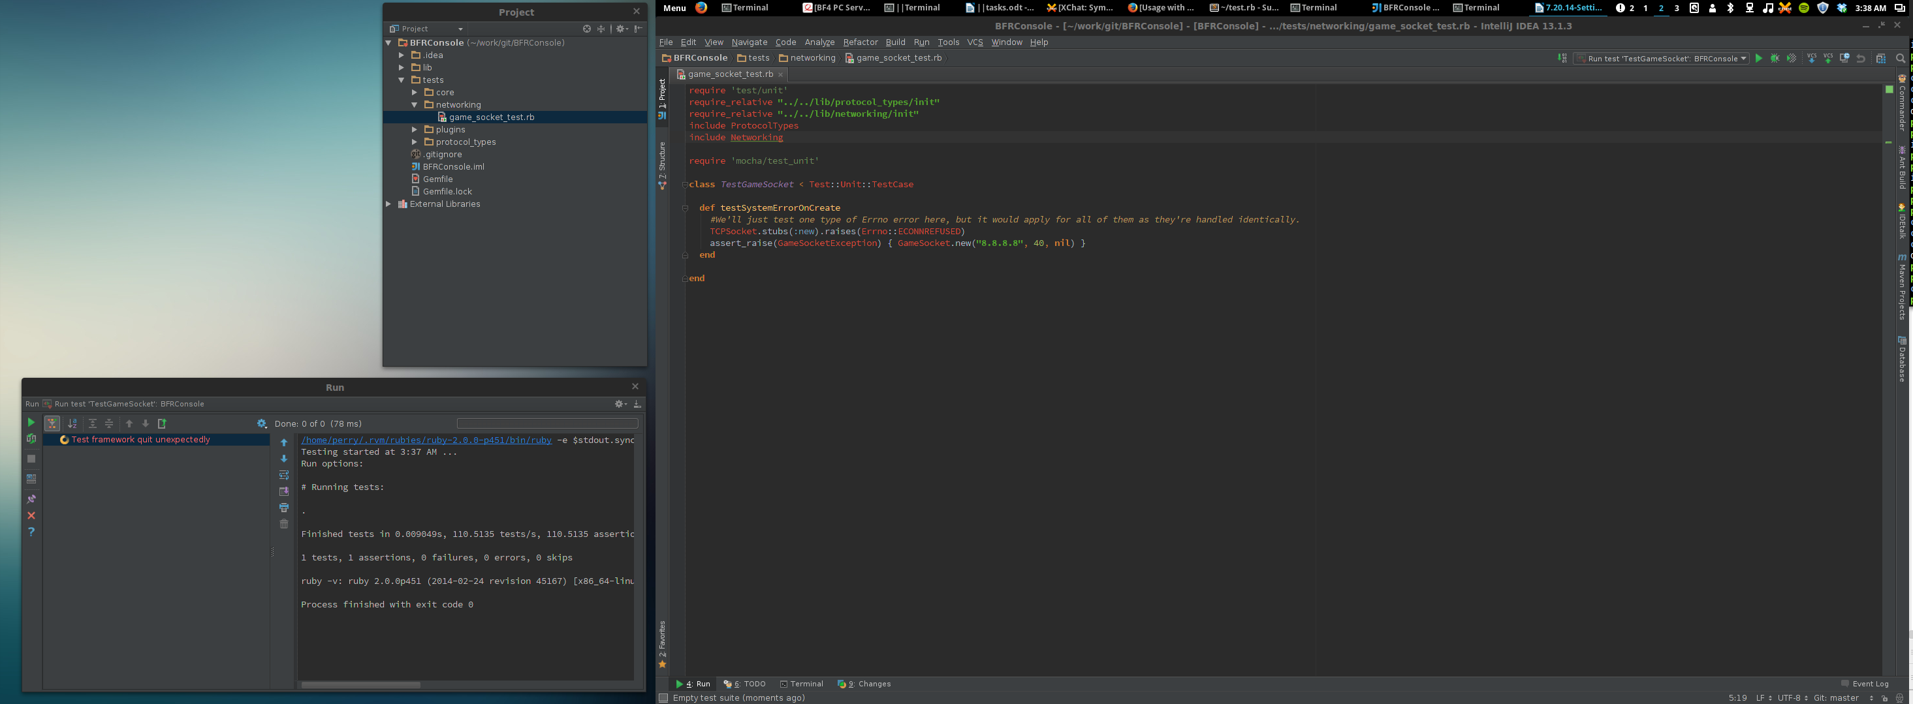

Enable line numbers

File → Settings → IDE Settings → Show linenumbers

Disable syntax highlighting

- This feature gets annoying. Just click the face in the bottom right, press configure inspections and create a new profile called disable which has everything unchecked.

Make it so windows can be closed with ctrl + w

Under settings → keymap → find “Editor Tabs → Close (NOT close active tab) and add ctrl + w as asn option.

