Eclipse Settings

Prevent auto removing static imports

From http://stackoverflow.com/questions/9831047/can-eclipse-the-organize-import-ctrlshifto-commands-handling-of-static-impo

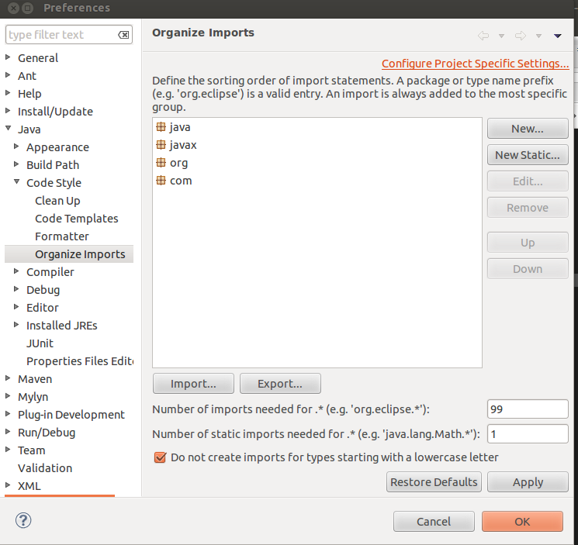

Variable name conventions

Allows you to use e.g. mObjectType with the getter auto being getObjectType() (excludes m) . Can use for m and s for instance and static fields, respectively.

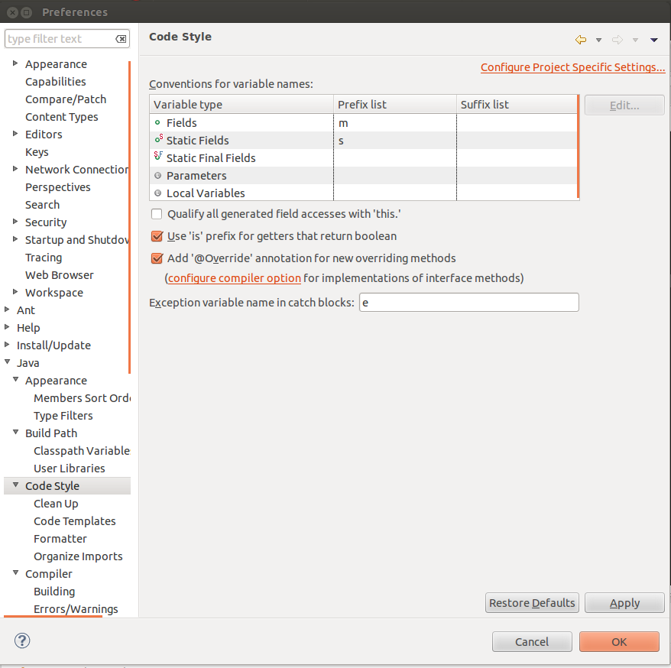
Fix content auto assist color

http://stackoverflow.com/questions/3571850/eclipse-change-popup-text-background-color-when-hovering-the-mouse-on-a-keyword

I set it to green.

WIthout this your content assist font and background will be the same, making it impossible to read.

Add word wrap

http://ahtik.com/blog/projects/eclipse-word-wrap/

Update site is : http://ahtik.com/eclipse-update/

Once installed you can enable/disable it from the right click menu (Word Wrap).

Add git hotykeys

Enable hotkeys

windows > customize perspective -> go into command groups availability and check git.

Set commit hotkey

- ctrl + 3, type keys, press enter.
- This bring sup hotkey box. Search for commit, chang ethe hotkey htere (I use ctrl + g)

