Running a Sample Program on Expanse

CSE 4331/5331 Fall 2025

Instructor: Sharma Chakravarthy

EXPANSE LOG IN and SET UP HADOOP

Now that you know your username, you may directly login to expanse using either of the following methods:

- You need to login to expanse using the following methods:
  - command from your command prompt
ssh <your_username>@login.expanse.sdsc.edu
You will need to set up 2FA for Expanse before ssh-ing into it, as it requires a TOTP authentication code.
  - Using Expanse portal: https://www.sdsc.edu/support/user_guides/expanse.html
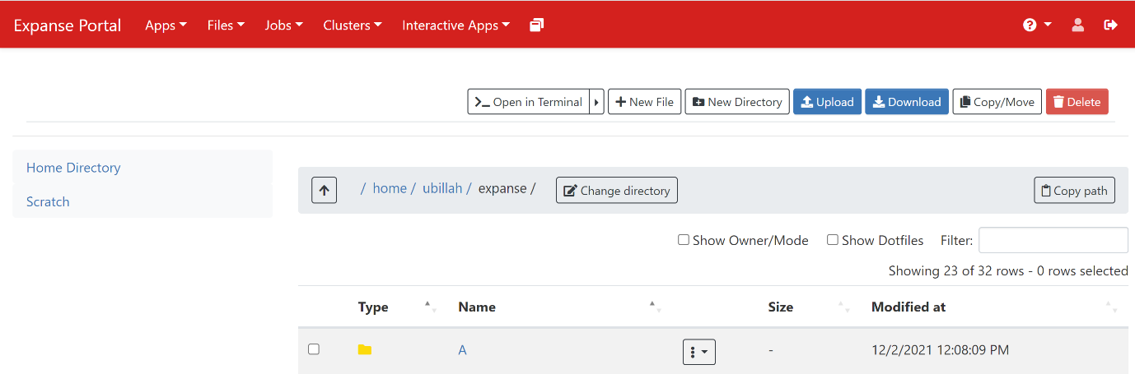
This will navigate you to the expanse dashboard which looks like following

- You can directly upload your files to expanse portal using the upload button. You can open a terminal using Open in terminal. Please navigate through the dashboard to make yourself comfortable.

Initial project setup

- First, you need to allow password-less login to local host (without it, you can't run Map-Reduce). Login on Expanse. Then do
ssh localhost
This will ask for your password. Give the password and then exit using ctrl+D
- Generate RSA keys using
ssh-keygen -t rsa
(press enter at each line).
- Then do the following:
cat ~/.ssh/id_rsa.pub >> ~/.ssh/authorized_keys
chmod -R 750 ~/.ssh/authorized_keys
- You should be able to ssh localhost now without password.
- Edit the file ~/.bashrc in the home directory using a text editor like nano ~/.bashrc and copy the following lines at the end:
module load cpu/0.15.4 gcc/10.2.0 openjdk/11.0.2
module load slurm sdsc
SW=/expanse/lustre/projects/uot199/fegaras
alias run='srun --pty -A uot256 --partition=shared --nodes=1 --ntasks-per-node=1 --mem=2G -t 00:05:00 --wait=0 --export=ALL'

Don’t eliminate the other elements in your ~/.bashrc file.

Save and exit.
- Run this command to refresh bashrc:
source ~/.bashrc

- For running the given WordCount.java file do the following:
- Make a build file named wordcount.build and copy the following content in it:
#!/bin/bash

module load hadoop
module load openjdk

SW=/expanse/lustre/projects/uot182/fegaras
export HADOOP_HOME=$SW/hadoop-3.2.2
PATH="$HADOOP_HOME/bin:$PATH"

rm -rf WordCount.jar
rm -rf classes
mkdir -p classes

javac -d classes -cp classes:`hadoop classpath` WordCount.java
jar cf WordCount.jar -C classes .

chmod -R 750 classes
chmod -R 750 WordCount.jar
echo "Compilation completed."

- Now make another file named wordcount.local.run for running your program locally.
#!/bin/bash
#SBATCH --account=uot256
#SBATCH --job-name="Word Count"
#SBATCH --output="wordcount.local.out"
#SBATCH --partition=shared
#SBATCH --nodes=1
#SBATCH --ntasks-per-node=1
#SBATCH --mem=5G
#SBATCH --export=ALL
#SBATCH --time=10

module load cpu/0.15.4 gcc/7.5.0 openjdk hadoop/3.2.2
SW=/expanse/lustre/projects/uot182/fegaras
export HADOOP_HOME=$SW/hadoop-3.2.2
PATH="$HADOOP_HOME/bin:$PATH"

rm -rf output-wc-local
hadoop --config $SW/conf jar WordCount.jar WordCount wc-input.txt output-wc-local

# need to delete this directory to allow other users to submit map-reduce jobs
rm -rf /tmp/hadoop
- Now make another file named wordcount.dist.run for distributed run and copy the following:
#!/bin/bash
#SBATCH -A uot256
#SBATCH --job-name="Word count"
#SBATCH --output="wordcount.distr.out"
#SBATCH --partition=compute
#SBATCH --nodes=1
#SBATCH --ntasks-per-node=4
#SBATCH --mem=16G
#SBATCH --export=ALL
#SBATCH --time=29

export HADOOP_CONF_DIR=/home/$USER/expansecluster
module load cpu/0.15.4 gcc/7.5.0 openjdk

SW=/expanse/lustre/projects/uot182/fegaras
export HADOOP_HOME=$SW/hadoop-3.2.2
export MYHADOOP_HOME=$SW/myhadoop
PATH="$HADOOP_HOME/bin:$HADOOP_HOME/sbin:$MYHADOOP_HOME/bin:$PATH"

myhadoop-configure.sh -s /scratch/$USER/job_$SLURM_JOBID -i "s/$/.ib.cluster/"

cp $HADOOP_CONF_DIR/slaves $HADOOP_CONF_DIR/workers

start-all.sh

hdfs dfs -rm -r /user/$USER/*
hdfs dfs -mkdir -p /user/$USER

hdfs dfs -put wc-input.txt /user/$USER/wc-input.txt

hadoop jar WordCount.jar WordCount /user/$USER/wc-input.txt /user/$USER/output

rm -rf output-distr
mkdir output-distr

hdfs dfs -get /user/$USER/output/* output-distr

stop-all.sh
myhadoop-cleanup.sh
- Make sure the compilation script is executable, run this command:
chmod +x wordcount.build
- compile the file using : run wordcount.build
- Run the wordcount local run using: sbatch wordcount.local.run
- Run Hadoop in distributed mode using the sbatch command: sbatch wordcount.dist.run
Note: Please put the path for correct input files.

