**CSE3310-004 Fundamentals of Software Engineering**

**Fall 2024**

**Personal Health and Fitness Tracker (PHFT) Project**

**Part 1 - UML Diagrams**

[Group 11]

[Dillian Botello, dtb9096@mavs.uta.edu]

[Jeff Hernandez, jxh2250@mavs.uta.edu]

[Beau Lopez, bml4120@mavs.uta.edu]

[Lan Nguyen, ldn9964@mavs.uta.edu]

[Earl Sanchez, exs2756@mavs.uta.edu]

Submission Date: 10/01/2024

**Index**

**Activity Diagrams 3**

**General Application Activity Diagram 3**

**Subscription Payment Activity Diagram 4**

**Class Diagrams 5**

**Inheritance-Focused Class Diagram of PHFT App 5**

**Composition-Heavy Class Diagram of the PHFT App 6**

**Component Diagrams 7**

**Simple Component Graph 7**

**Component Expansion Graph 8**

**Sequence Diagrams 9**

**Schedule Activity Sequence Diagram 9**

**Create Activity Sequence Diagram 10**

**Edit Fitness Goal Sequence Diagram 11**

**State Diagrams 12**

**Goal Setting State Diagram 12**

**Payment Integration State Diagram 13**

**Use Case Diagrams 14**

**Role of General User in PHFT App 14**

**Role of Guest User in PHFT App 15**

**Role of Personal Trainer in PHFT App 16**

# **Activity Diagrams**

## General Application Activity Diagram

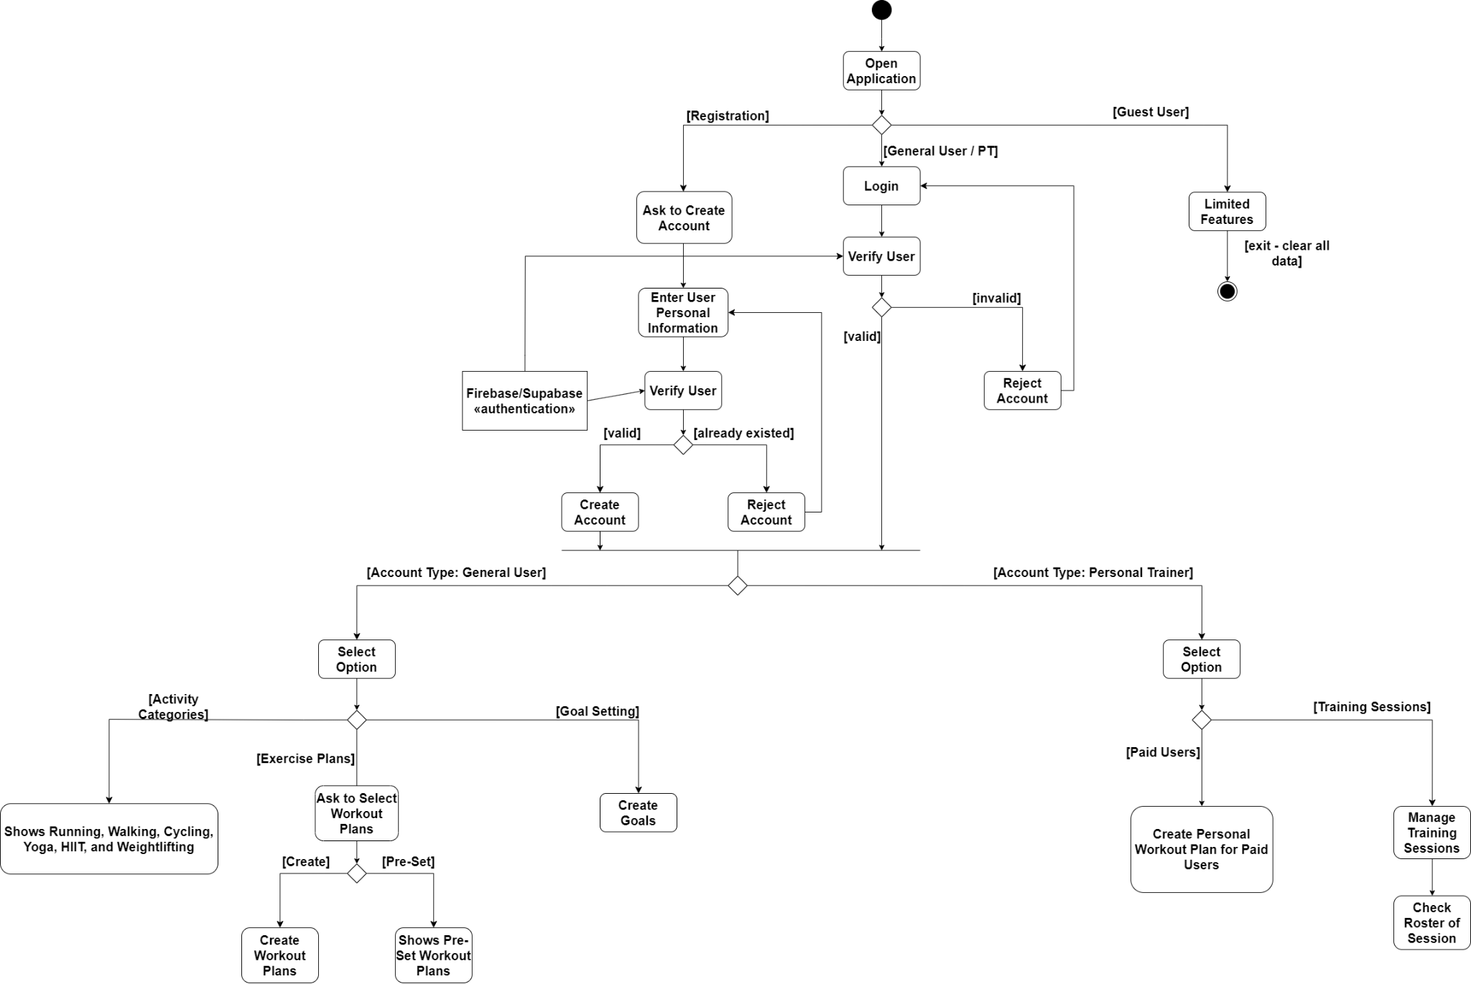

This activity diagram illustrates the flow of the PHFT application from initial startup through its core functionalities. It progresses from the app's startup to showcase the main functionalities, including creating fitness goals, developing workout plans, tracking activities, and other features of the PHFT application.

## Subscription Payment Activity Diagram

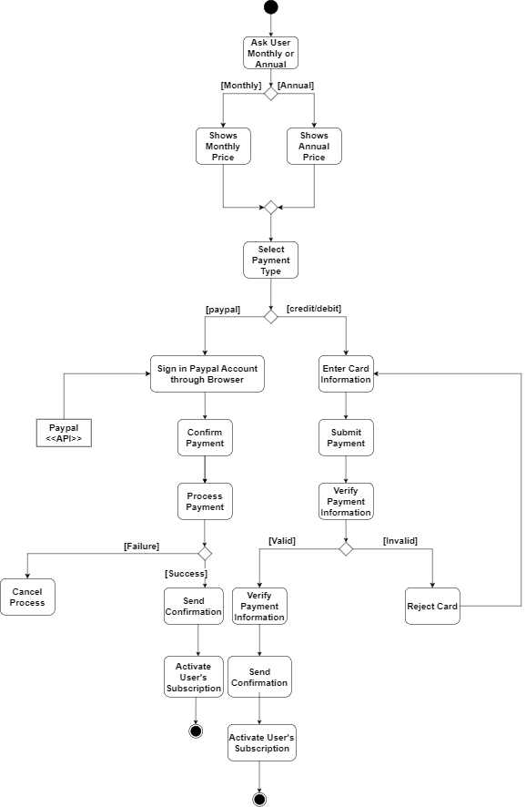

This activity diagram illustrates the complete payment process, starting from the selection of a subscription type to sending a payment request, verifying user information, and processing the payment.

# **Class Diagrams**

## Inheritance-Focused Class Diagram of PHFT App

The above diagram is a class diagram showing the relationships and ratios between different proposed classes in the PHFT application and mainly highlights the possible forms of inheritance integration related to users, activities, and advertisements.

## Composition-Heavy Class Diagram of the PHFT App

## 

The class diagram above shows the associations between proposed classes for the PHFT application with an emphasis on compositional relationships, specifically within the user classes.

# **Component Diagrams**

## Simple Component Graph

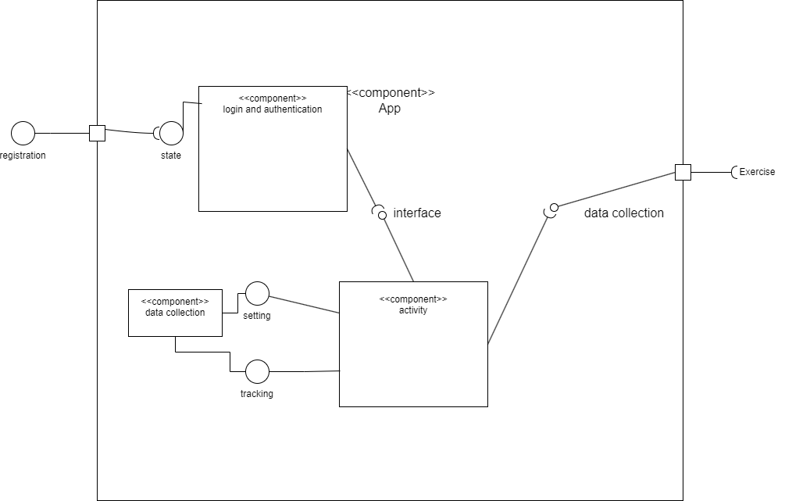

This component diagram delves into the simplicity of the app. It deals more with how simple it can be with collecting data which will be involved with setting and tracking activities to what can be done inside the app. The logic and authentication is what leads to different interfaces and activities depending on the user whether they are a guest, non-paying or paying customer, or even a trainer.

## Component Expansion Graph

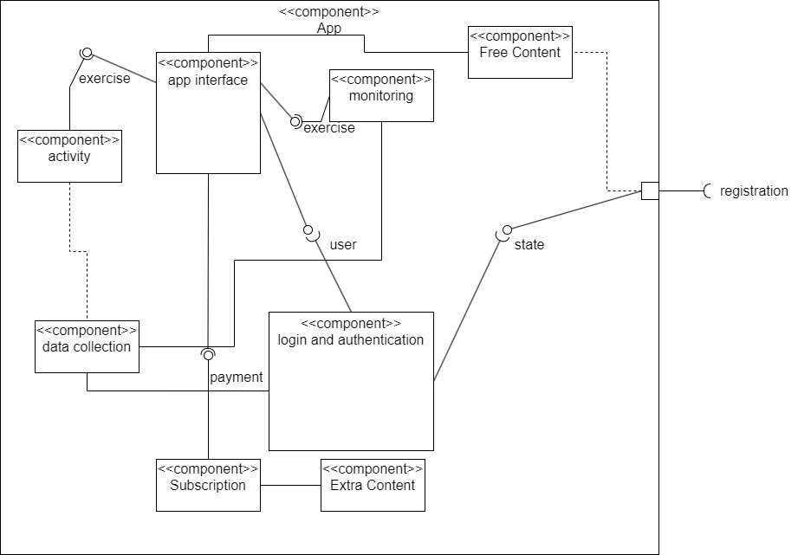

This graph corresponds more with the specifications of the app when dealing with free and non-paying users. As long as a user is registering, then they should be able to see the state of their account. This will then be connected to a specific type of user in which the app interface would have been set up. Then the app interface interacts with multiple components to separate any functions and unlike the first component graph, is much more strict on what is and isn’t allowed. This allows for allocation to certain components instead of dealing with overlapping ideas. Of the two component graphs, this can be seen as a better one to work with and modify.

# **Sequence Diagrams**

## Schedule Activity Sequence Diagram

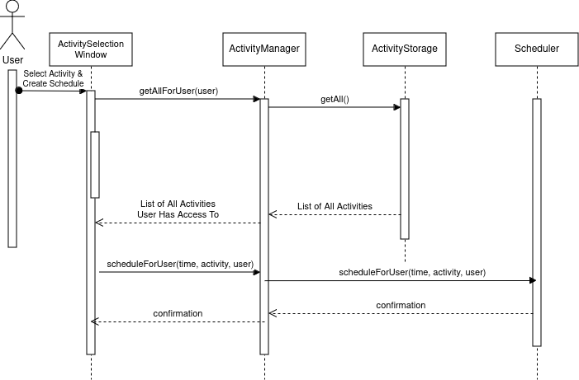

This diagram depicts the sequence of calls and returns that is part of a user scheduling an existing activity in the PHFT app.

## Create Activity Sequence Diagram

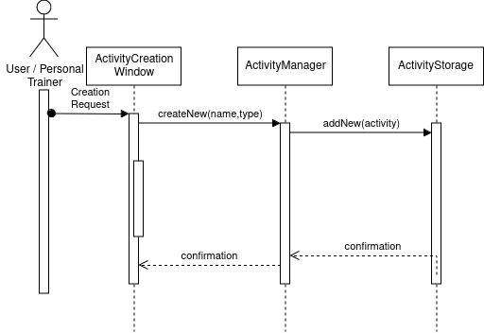

This diagram depicts the sequence of calls and returns for a user to create a new activity in the PHFT app.

## Edit Fitness Goal Sequence Diagram

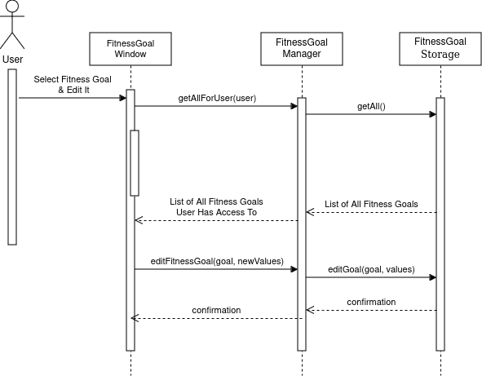

This diagram depicts a sequence of events for a user to edit an existing fitness goal in the PHFT app.

# **State Diagrams**

## Goal Setting State Diagram

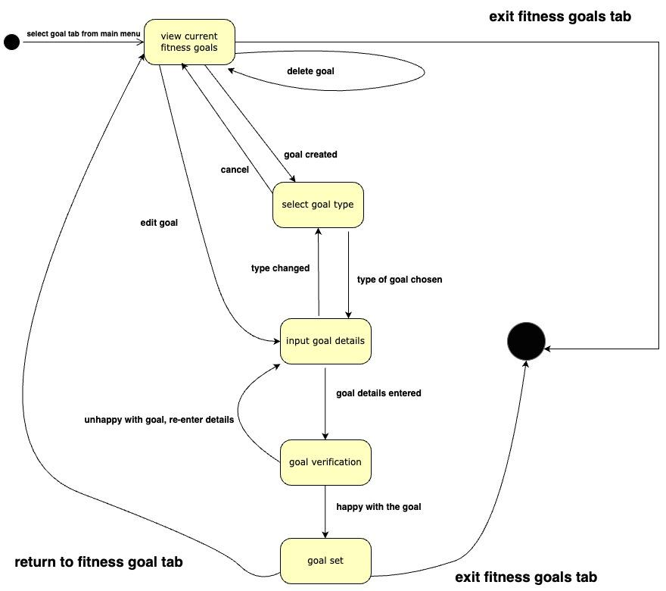The diagram illustrates the different states a user may go through while setting a personal fitness goal in the PHFT app.

* States are represented by the nodes of the diagram.
* Events are represented by the arcs of the diagram and are bolded.
* Idle state represented by black circles.

## Payment Integration State Diagram

## 

The diagram illustrates the different states the system may go through when a user interacts with the payment integration features of the PHFT app.

* States are represented by the nodes of the diagram.
* Events are represented by the arcs of the diagram and are bolded.
* Idle state represented by black circles.

# **Use Case Diagrams**

## Role of General User in PHFT App

This diagram is a use case diagram from the role perspective of a general user of the PHFT application. With a general user as the actor, it displays all the possible tasks a user can perform and associations between certain tasks and the user. After login, main interactions between different parts of the application consist of viewing, buying, and/or sharing.

## Role of Guest User in PHFT App

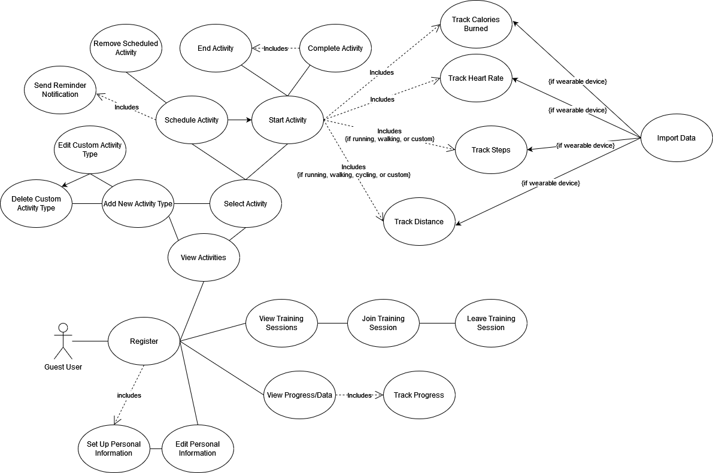

This use case diagram represents the actions that a user of the PHFT app can perform from the role perspective of a guest user. It demonstrates the comparatively smaller scope of actions a guest user can perform when compared to a general user, shown in the previous diagram. The tasks are only related to registration, activities, training sessions, and fitness data.

## Role of Personal Trainer in PHFT App

## 

The above diagram is a type of use case diagram from the perspective of a personal trainer. The tasks and sequences of tasks a personal trainer user can accomplish in the PHFT application are shown, which consist of the login system, client dealings, and training session management.