# 描述: my logo

Realtek Automotive

Switch Tool User Guide

Rev. 2.6

2020-12-03

|  |  |
| --- | --- |
| 描述: CIS Shortened | **Realtek Semiconductor Corp.**  **No. 2, Innovation Road II, Hsinchu Science Park, Hsinchu 300, Taiwan**  **Tel.: +886-3-578-0211. Fax: +886-3-577-6047**  **www.realtek.com** |

**COPYRIGHT**

©2018 Realtek Semiconductor Corp. All rights reserved. No part of this document may be reproduced, transmitted, transcribed, stored in a retrieval system, or translated into any language in any form or by any means without the written permission of Realtek Semiconductor Corp.

**DISCLAIMER**

Realtek provides this document ‘as is’, without warranty of any kind. Realtek may make improvements and/or changes in this document or in the product described in this document at any time. This document could include technical inaccuracies or typographical errors.

**TRADEMARKS**

Realtek is a trademark of Realtek Semiconductor Corporation. Other names mentioned in this document are trademarks/registered trademarks of their respective owners.

**USING THIS DOCUMENT**

This document is intended for the software engineer’s reference and provides detailed programming information.

Though every effort has been made to ensure that this document is current and accurate, more information may have become available subsequent to the production of this guide.

**REVISION HISTORY**

| Revision | Release Date | Summary |
| --- | --- | --- |
| 1.0 | 2018-05-01 | First release |
| 2.0 | 2018-06-28 | Revision for RTL905X |
| 2.1 | 2019-03-04 | Revision for Auto Switch Tool 2.X.X version |
| 2.2 | 2019-03-15 | Modify description of general configuration |
| 2.3 | 2020-03-19 | Add new FW path selection & Image Generation (for Flash Programmer) |
| 2.4 | 2020-10-16 | Add "5.1 Prerequisites" for version ES2/ES3 |
| 2.5 | 2020-11-06 | Update "2 Tool Components" |
| 2.6 | 2020-12-03 | Update "2 Tool Components" |

Table of Contents

1. General Description 5

2. Tool Components 5

3. System Requirements 7

4. Functions Overview 8

5. Functions Introduction 10

5.1. General Configuration 10

5.2. Switch Configuration 13

5.3. Image Generation/Update 15

5.4. Image Generation (for Flash Programmer) 19

5.5. Tool Config Export/Import 23

5.6. Packet Counter & Packet Generator 24

# General Description

This document describes how to use “Realtek Automotive Switch Tool” and what functions it provides.

Currently it supports the following Realtek automotive switches:

* **RTL904xA Series (RTL9047AA, RTL9044AA, RTL9044AB, RTL9043AA)**
* **RTL907X_6XA Series (RTL9075A, RTL9072A, RTL9068A)**

The tool allows users to configure Realtek automotive switch functions via I2C/MDCMDIO/SPI/Ethernet at runtime (supported interface might be varied depends on connected chip). Even if there’s no connection between PC and the switch at the time, user can still generate binary file by the tool and update the binary file afterwards.

# Tool Components

Please unzip the archive file of tool (RTKAutoSwitchTool_version.zip), then several files will be unzipped in “RTKAutoSwitchTool_version” folder(**Figure.1**). The main program is “RTKAutoSwitchTool_version.exe”, others are necessary library/config files for program running. In order to open the tool (RTKAutoSwitchTool.exe) successfully, please make sure all the files listed below exist in the folder after tool archive unzipped.

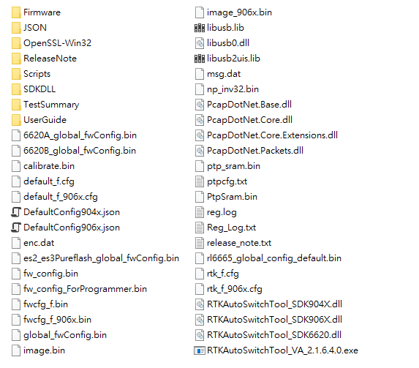

**Figure.1. Unzipped Folder.**

|  |  |
| --- | --- |
| **File/Folder Name** | **Description** |
| RTKAutoSwitchTool_version.exe | Main program |
| RTKAutoSwitchTool_SDK904X.dll | Dll file of the switch SDK for RLT904xA series |
| RTKAutoSwitchTool_SDK906X.dll | Dll file of the switch SDK for RLT907X_6XA series (ES1) |
| RTKAutoSwitchTool_SDK6620.dll  (RTKAutoSwitchTool_SDK6620_ES2.dll)  (RTKAutoSwitchTool_SDK6620_ES3_patch.dll)  (RTKAutoSwitchTool_SDK6620_ES3_pureflash.dll) | Dll file of the switch SDK for RLT907X_6XA series (ES2/ES3/VA)  **Note:** If you want to use the specified version, you should rename “RTKAutoSwitchTool_SDK6620_ version.dll” to “RTKAutoSwitchTool_SDK6620.dll”. |
| fwcfg_f.bin, image.bin  default_f.cfg, rtk_f.cfg  fwcfg_f_906x.bin, image_906x.bin  default_f_906x.cfg, rtk_f_906x.cfg | Referenced files for image generation |
| DefaultConfig904x.json  DefaultConfig906x.json | Tool default configuration file |
| PcapDotNet.*.dll | DLL files for .Net WinPcap features |
| usb2uis.dll, libusb2uis.lib, libusb0.dll, libusb.lib | DLL/LIB files for USB adapter |
| OpenSSL-Win32/Scripts directory, msg.dat | Secure image function related files/scripts |
| Folder "Firmware" | Corresponding firmware |
| Folder "JSON" | Corresponding JSON files: JSON datasheet, default JSON files and V2/V3/VA comparison Chart |
| Folder "ReleaseNote" | Release Note: Simple and detailed notes |
| Folder "SDKDLL" | Corresponding SDK DLLs |
| Folder "TestSummary" | Test Summary |
| Folder "UserGuide" | User Guide |

**Table. 1 Tool components description**

# System Requirements

Realtek Automotive Switch Tool environment requirements are shown in the table below.

|  |  |
| --- | --- |
| **Component** | **Version** |
| Windows | 7/8/10 |
| .Net Framework | 4.6.1 (minimum) |
| Visual C++ Redistributable | 2013/2015 |
| WinPcap | 4.1.3 (minimum) |
| Window drivers for usb2ish/USB2IO | - |
| pycrypto-2.6.win-amd64-py2.7.exe  (optional for secure image function) |  |
| python-2.7.amd64.msi  (optional for secure image function) |  |

**Table. 2 Tool components description**

Refer to the **Figure.2**, the installers of prerequisite components are placed in “Pre-installation” folder in tool archive. Please ensure all components have been installed before opening Realtek Automotive Switch Tool.

**Note: Switch tool version v2.0.x only works with new USBIO board on the Figure.3:**

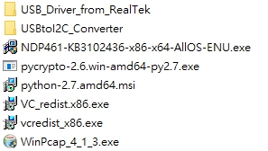

**Figure.2. Pre-installation Folder.**

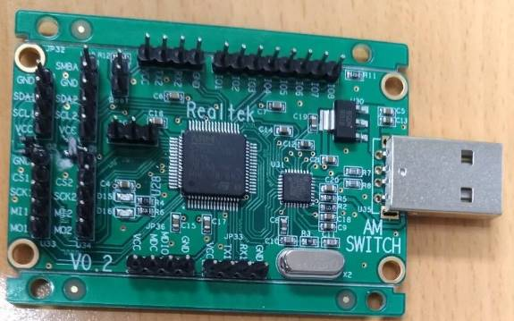

**Figure.3. New USBIO board.**

About windows driver of USB2IO driver installation steps, please refer to

**“.\RTKAutoSwitchTool_version\Pre-installation\USB_Driver_from_RealTek\USB2IO_Install_Guide.docx”**

# Functions Overview

As **Figure.4** shows, “Realtek Automotive Switch Tool” is a software that integrates several functions for the switch configuration. When the switch is connected to PC through the supported interface, user can start configuring the switch settings dynamically. The tool also enables the user to generate the image file according to the user-defined configuration set on tool’s UI. And the image file is capable of being uploaded through the same connection used for runtime configuration.

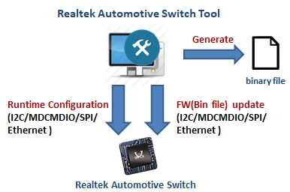

**Figure.4.** **Realtek Automotive Switch Tool Function.**

The current version of “Realtek Automotive Switch Tool” provides four options (I2C/MDCMDIO/SPI/Ethernet) for connecting PC (Tool) to the switch EVB, please refer to the **Figure.5**.

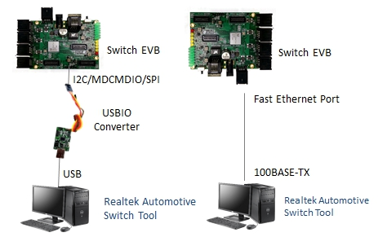

**Figure.5.** **Switch Tool Conection Methods.**

# Functions Introduction



## Prerequisites

If users want to use the specified versions that are ES2 or ES3, users should rename “RTKAutoSwitchTool_SDK6620_ version.dll” to “RTKAutoSwitchTool_SDK6620.dll” to make Switch Tool work normally.

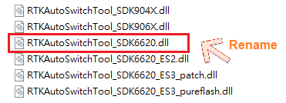

When users open Switch Tool and see this error, users might try to determine the above situation.

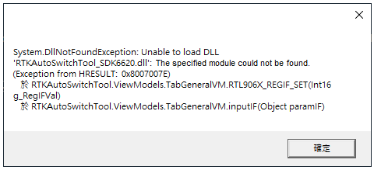

## General Configuration

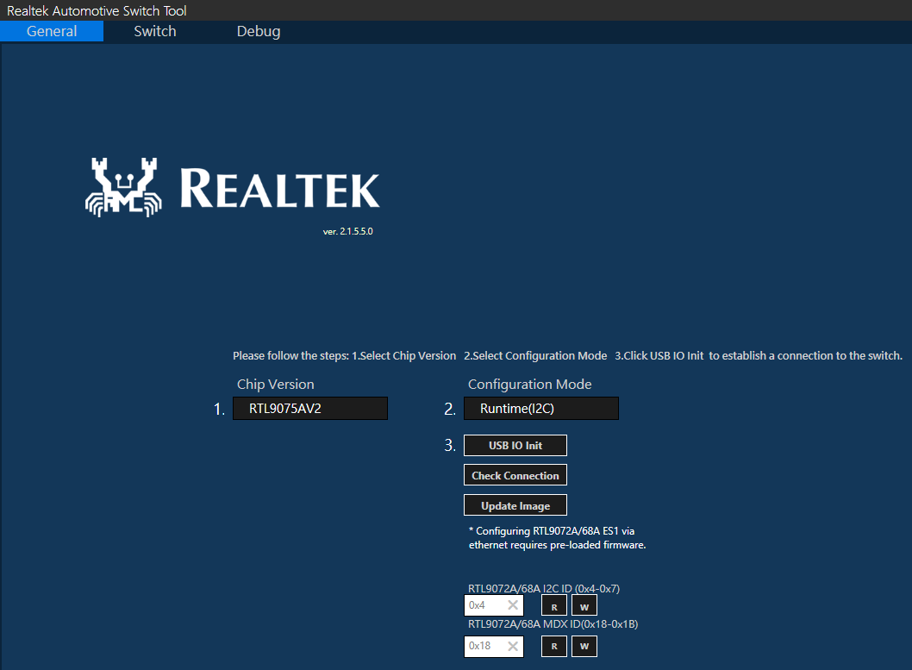

**Figure.6.** **Switch Tool General Page.**

When users open “Realtek Automotive Switch Tool”, general configuration page will be shown at first (**Figure.6**). There are two different settings “Chip Version”, “Configuration Mode”:

**Chip Version:** this setting will decide what functions/ports will be presented on other configuration panels according to the specification of this chip. EX. Supported functions are different between from RTL904xA series and RTL907X_6XA series. Configurable ports on different chip version are also various.

**Configuration Mode:** this selection provides **“Runtime(I2C)”**, **“Runtime(SPI)”**, **“Runtime(MDCMDIO)”**, **“Runtime(Ethernet)”** and **“Make Image Mode”**. After certain runtime mode is chosen, clicking “Check Connection” can help check if the connection between the switch and the tool (PC) is built successfully.

**Update Image:** is only available for runtime mode. Please also be noted that configuration items and behavior on other configuration panels would vary between “runtime mode” and “image generation mode”

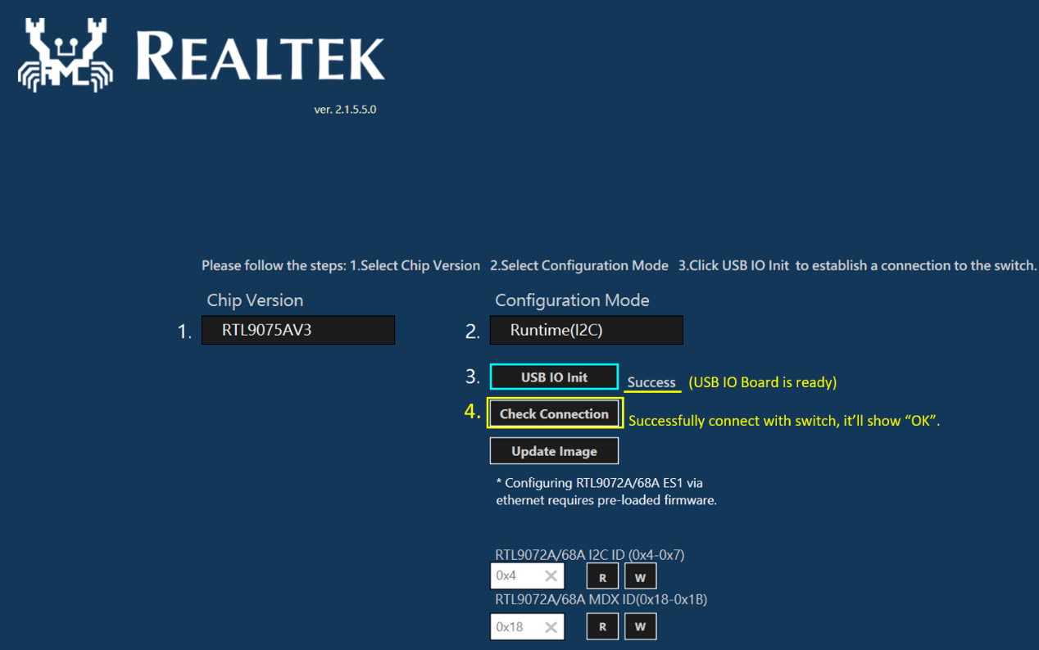

**Figure.7.** **I2C, SPI, MDCMDIO Setting Steps**

Refer to the **Figure.7**, please follow the steps below to properly set the connection between tool and switch when you select “I2C”, “MDCMDIO” or “SPI” mode: **1. Select chip version**

**2. Select configuration mode**

**3. Initialize USB IO**

**4. Check if connection is established**

Note. If chip version is changed (re-selected) while USB IO initialization has been already made with previous connected chip version, please unplug and plug USB connector of USB board on PC and click “USB IO init” again to re-build USB IO connection for connecting chip.

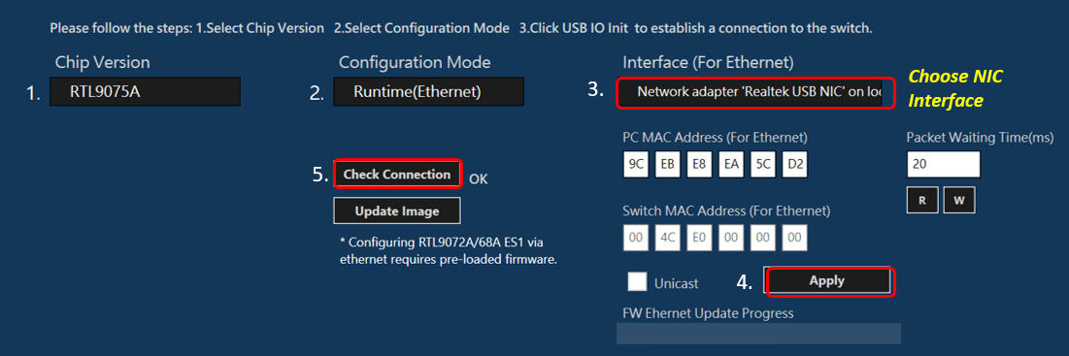

**Figure.8.** **Ethernet Setting Steps**

Refer to the **Figure.8**, when runtime (Ethernet) is selected as configuration mode, the tool will soon open the corresponding options. Choose the interface which is connecting to the switch, then PC MAC address will be filled in automatically.

For the switch MAC address, if unicast is preferable for packet transmitting (including runtime control or image file packet), filling the MAC address is mandatory (default is 00-E0-4C-00-00-00). Otherwise, using broadcast without specific MAC address.

**Please remember to Click “Apply” button when all Ethernet configurations are set.**

And then user can click “check connection” to see if the connection is built without any issue.

## Switch Configuration

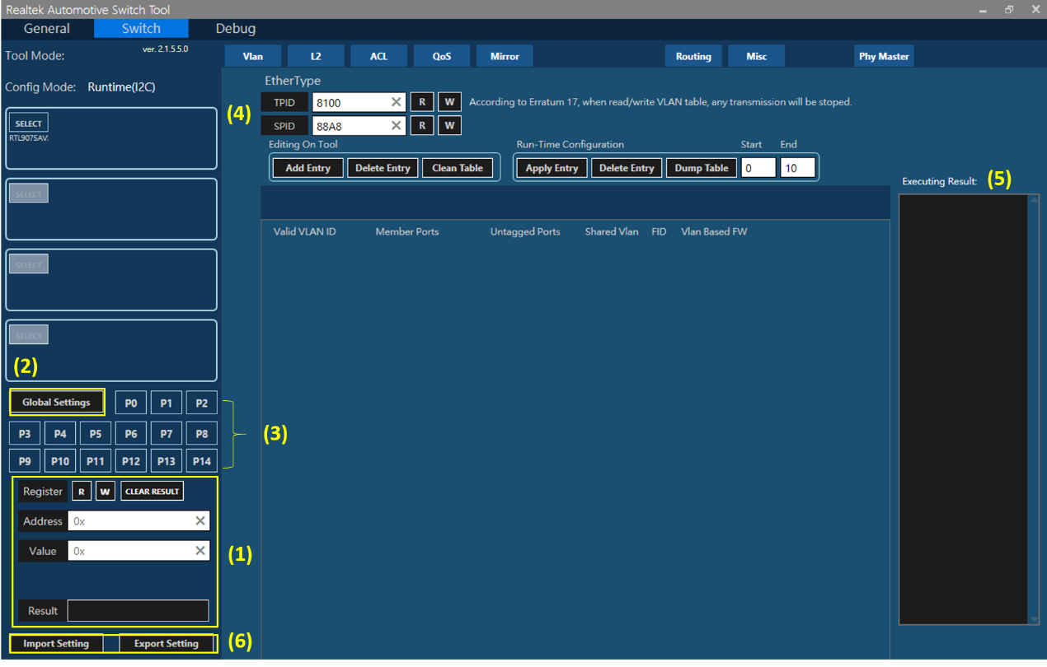

**Figure.9.** **Switch Panel Introduction.**

Switch Configuration panel consists of several components:

1. Register quick Read/Write panel

2. Switch function configuration (Global)

3. Switch function configuration (Port)

4. Main console of function configuration

5. Executing result panel - displays the result of run-time operation

6. Import/Export settings - allow users to backup or restore tool configurations.

Note: The setting of VLAN, L2, ACL, QoS... etc. Please refer to their application note.

The interface cannot be switched arbitrarily in runtime mode.

## Image Generation/Update

**FW Image Naming Rule**

After RTKAutoSwitchTool v2.1.5.6.0, users could determine make Pure Flash image or Patch image for their requirement. Users just import a FW file before making image, then the tool would create a corresponding image**(fw_config.bin)** in the file. There are two kinds of FW file, one is Pure Flash and another one is Patch. The FW naming rule as the tale on the **Figure.10.** Take “RTL907X_6XA-V2-PureFlash_Firmware_V2.2.**0**.1 60120.bin” for an example, this FW is for pure flash and its size would be larger than patch FW.

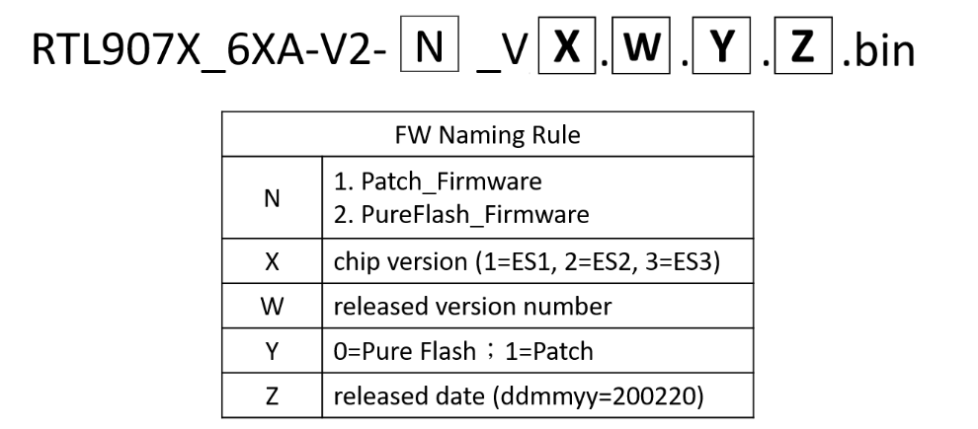

**Figure.10.** **FW Image Naming Rule.**

**Image Generation:**

To Generate Image file, please select **“Make Image Mode”** as configuration mode on “General” configuration panel.

Once “Make Image Mode” is selected, all the runtime-related configuration items/buttons on “Switch” panel will be hidden. And then edit/adjust the function settings using existing offline controls – every modification will be stored while generating image file. After the configuration is completed, simply click **“Make Image File”** button and the page will pop up a window for making image.(Refer to the **Figure.11**) Please follow the steps below to make image file.

**Step1.** Select firmware path and import the FW what you need, “Pure Flash” or “Patch”. The firware folder is also in the switch tool folder.(**Figure.12**)

**Step2.** Input Self-Defined Binary Version and click “OK”.

**Step3.** The generated image file **“fw_config.bin”**will be placed in the same folder as tool program.

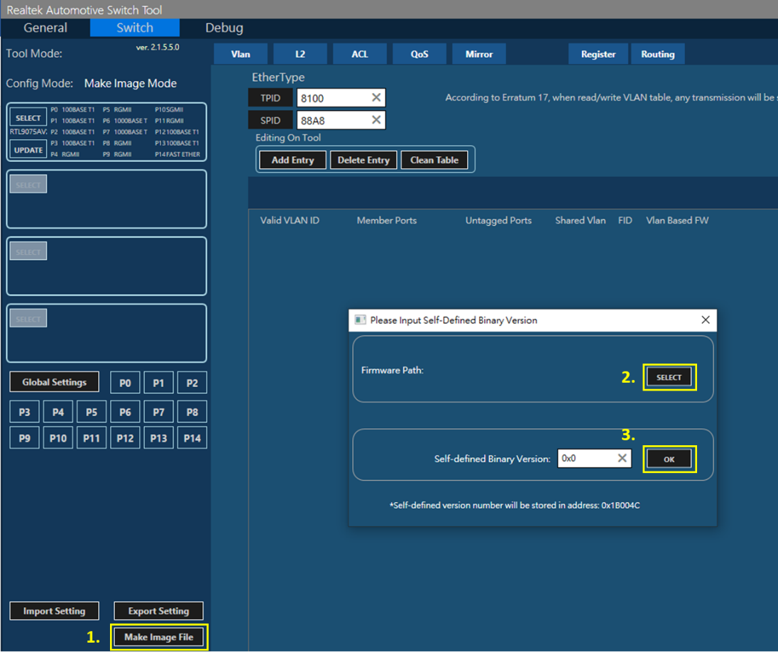

**Figure.11.** **Make Image File.**

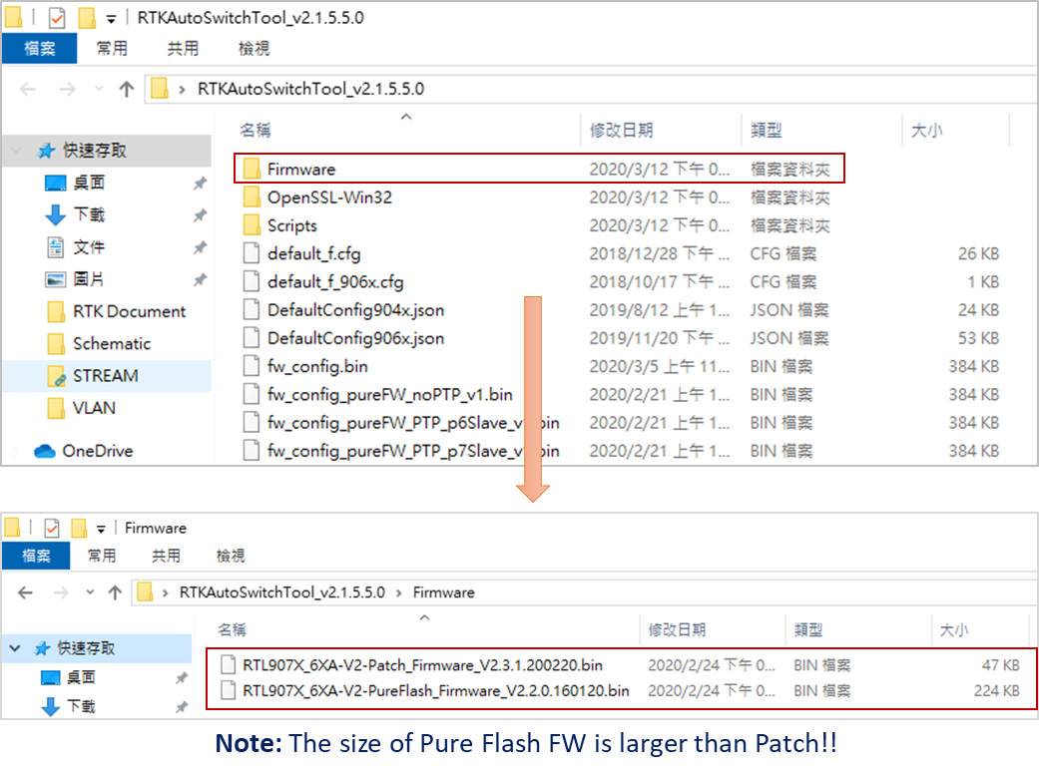

**Figure.12.** **FW Path.**

**PS.** To verify the accuracy of image file, there will be two log files generated along with image file.

**sdk_log.txt:** The log helps user check if there’s any incorrect setting existing on Tool.

**reg.log:** The log records modified register address/value.

**Image Update (RTL904xA):**

Go back to **“General”** configuration panel, Select **“Runtime(Ethernet)”** or **“Runtime(I2C)”** depends on the interface you connect. Click **“Update Image”** and then select the image file generated earlier. (For Ethernet connection, please make sure all Ethernet setting is correct before updating image file.)

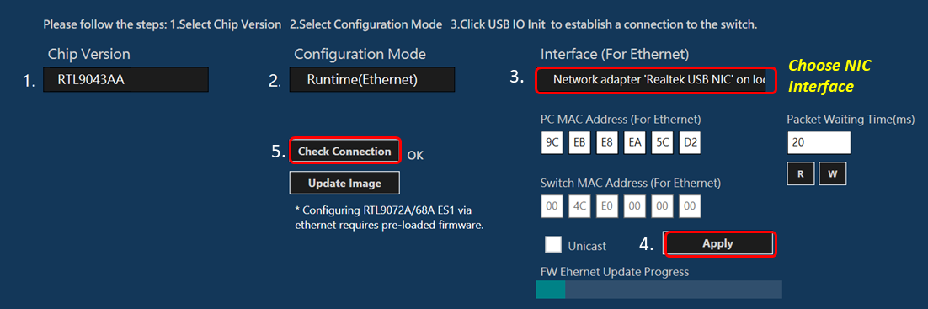

**Figure.13.** **Update Image by Ethernet.**

And please wait until “Update Image Completed” message popped up.

**Image Update (RTL907X_6XA):**

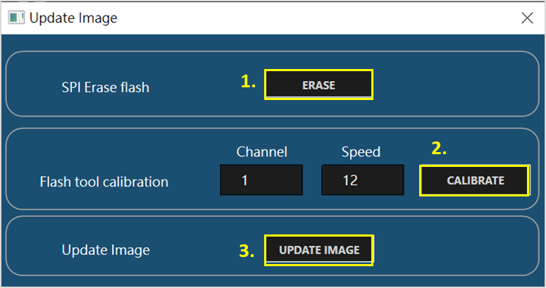

**Figure.14.** **Update Image.**

**Note:** Refer to the **Figure.14.** Please ensure SPI flash has been erased before updating new binary image file and follow the steps to complete update image.

**SPI erase flash:** Erase content of SPI flash.

**Flash tool calibration:** Calculate and store SPI calibrated value in for following control.

**Update Image:** Select the “fw_config.bin” in the switch tool folder.

## Image Generation (for Flash Programmer)

This section will teach you how to generate an image that is for flash programmer used. There are two methods for generating image, one is manually and another is automatically. Please follow the steps below to complete it.

* **Manually Generate Image: (For switch tool before v2.1.5.6.0)**

**Step1.** Make sure USB IO board and switch board have connected well by I2C/SPI/MDCMDIO.(Note: You can click “USB IO Init” & “Check Connection” to verify this step.)

**Step2.** Follow section 5.3 to generate image “fw_config.bin”.

**Step3.** Click “Update Image” on the General configuration page and Erase Flash.

**Step4.** Click “CALIBRATE” and it will generate a “calibrate.bin” in the switch tool folder. **(Figure.15**)

**Step5.** Use Editor to open “calibrate.bin” and “fw_config.bin” in the switch tool folder. And refer to the **Figure.16** to revise image address 40000h & 40022h in “fw_config.bin”. Please remember to save it.

**Step6.** The new “fw_config.bin” is only for Flash Programmer. (**Figure.17**)

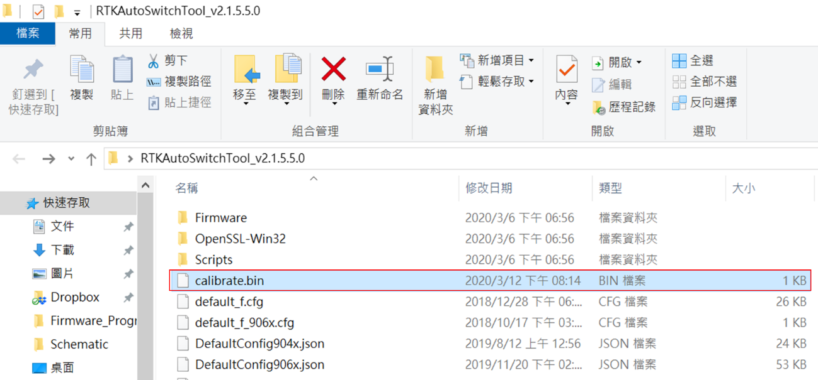

**Figure.15.** **calibration.bin.**

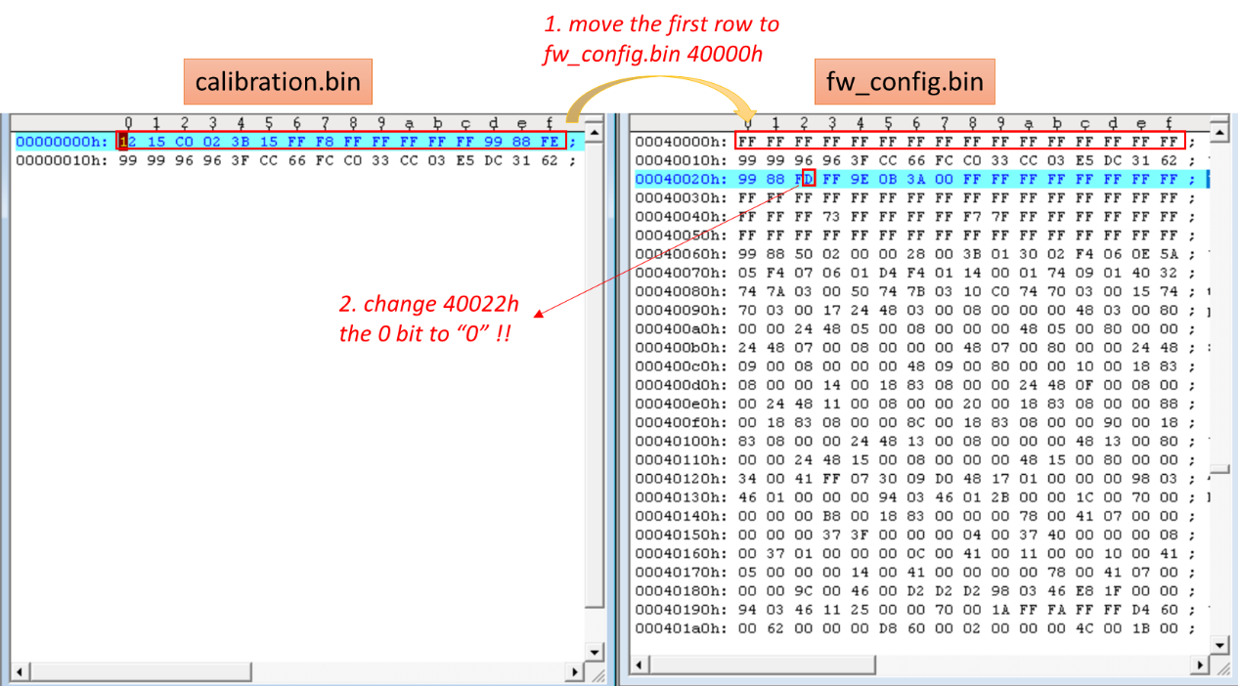

**Figure.16.** **Revise fw_config.bin**

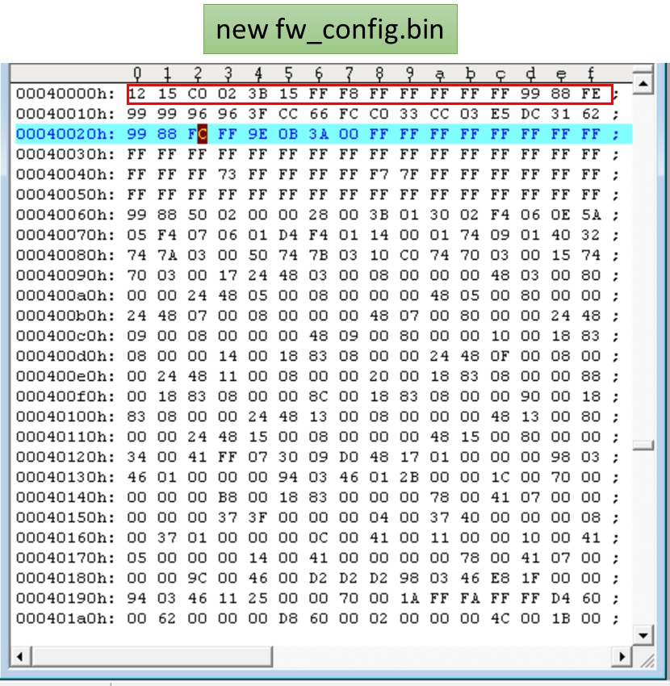

**Figure.17.** **New fw_config.bin**

* **Automatically Generate Image:** **(For switch tool after v2.1.5.7.0)**

Please follow below steps to complete automatically generate image for flash programmer.

**Step1.** Make sure USB IO board and switch board have connected well by I2C/SPI/MDCMDIO.(Note: You can click “USB IO Init” & “Check Connection” to verify this step.)

**Step2.** Click “Update Image” on the General configuration page and Erase Flash.

**Step3.** Click “CALIBRATE” and it will generate a “calibrate.bin” in the switch tool folder. **(Figure.15**)

**Step4.** Turn to Switch page and complete switch’s configuration. Then click “Make Image File”.**(Figure.18)**

**Step5.** After Step4, a “fw_config_ForProgrammer.bin” will be created in the switch tool folder. This image is only for Flash Programmer. **(Figure.19)**

**Note:** You could open “fw_config_ForProgrammer.bin” by Editor, and the address 40000h & 40022h had been revised automatically. So Flash programmer could adopt it directly.(**Figure.20**)

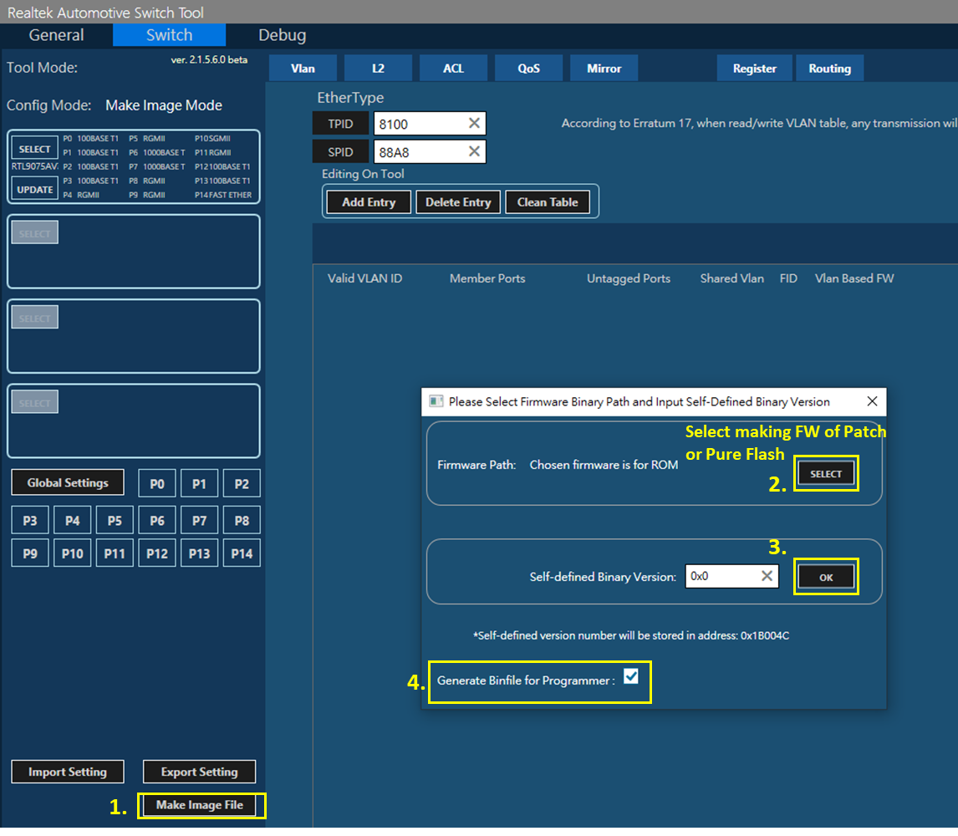

**Figure.18.** **Automatically** **make image file.(After v2.1.5.7.0)**

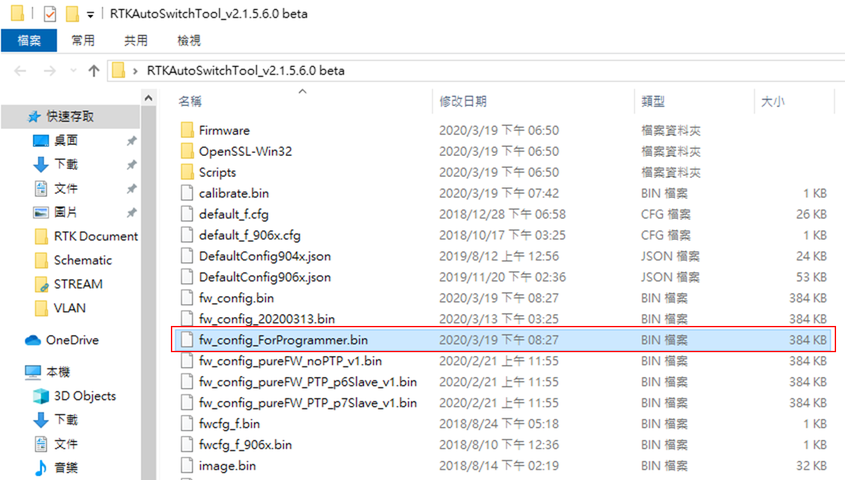

**Figure.19.** **fw_config_ForProgrammer.bin in the folder (After v2.1.5.7.0)**

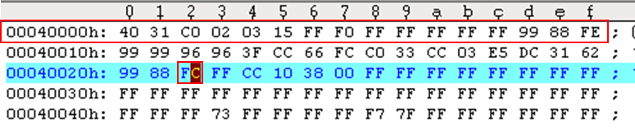

**Figure.20.** **fw_config_ForProgrammer.bin in the folder**

## Tool Config Export/Import

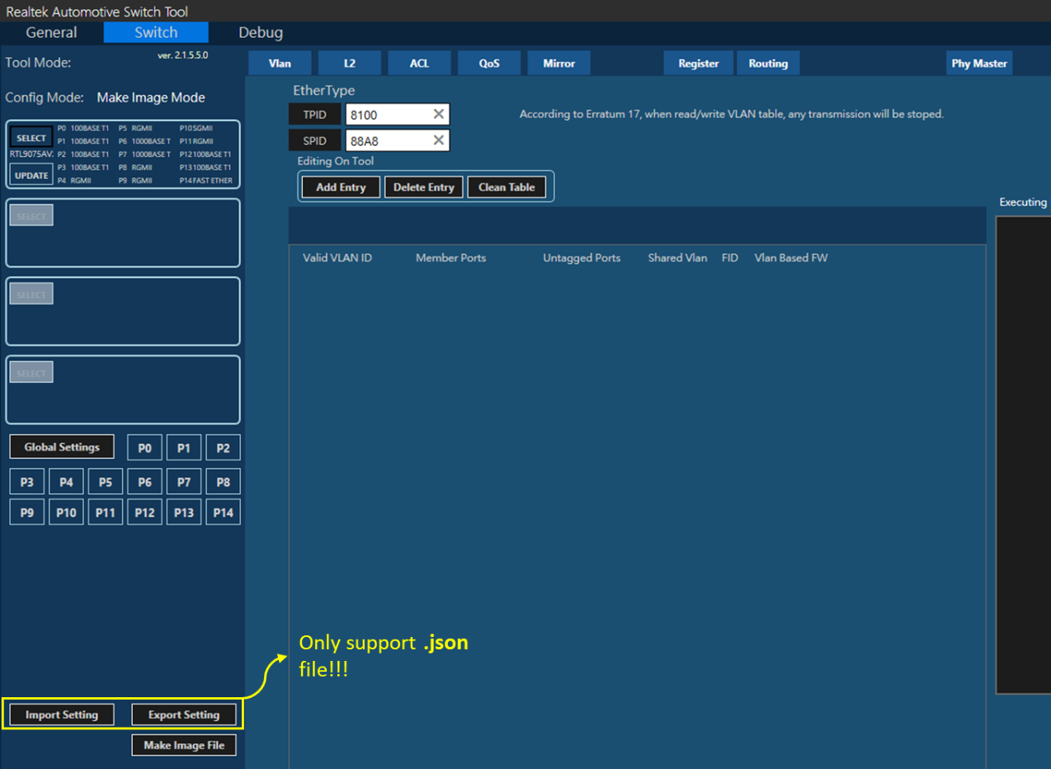

**Figure.21.** **Import/Export Setting.**

On **“Switch”** configuration panel, **“Export/Import Settings”** enables users to backup/restore any modification on Tool’s UI. No matter import or export, switch tool only support .json file.

## Packet Counter & Packet Generator

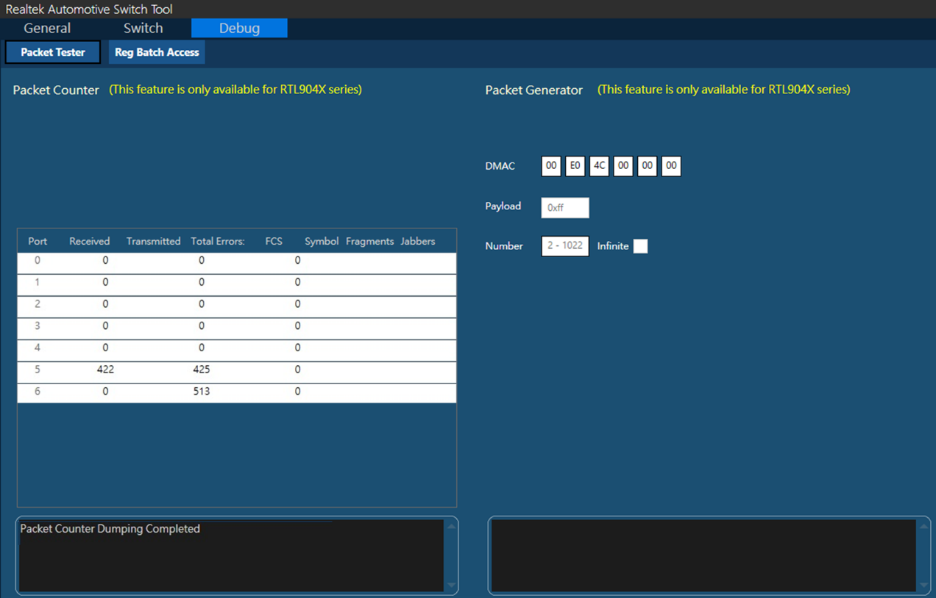

**Figure.22.** **Packet Counter & Generator(Only for RTL904X Series).**

On **[Debug] -> [Packet Tester]**, RTK automotive switch tool provides packet counter and generator for debugging purpose.

**Packet counter** can help list the numbers of received, transmitted, and errro packets from each ports. Please click **“Enable”** button before start dumping pcaket counter information.

**Packet generator** help generate a certain amount of packets with pre-defined payload content to the specific destination MAC address from the switch. Please click **“Pre Config”** button before asking the switch to generate packets.

Configurations:

**[DMAC]:** thedestination MAC where packets will be sent to.

**[Payload]:** the payload of packets. (0x00 – 0xFF)

**[Number]:** the amount of packet will be sent. (2 - 1022)